About Us
Our School:

Our school is situated in open country on the edge of Whittington village. Our pupils come from Whittington village and the surrounding rural areas. We also have the Defense Medical Services Headquarters (formerly Whittington Barracks) in the catchment area and approximately 20% of our pupils come from Service Families.

Our pupils enjoy school and all the opportunities offered, both curricular and extra-curricular. For example we are very successful in sporting competitions and take part in many musical performances outside school.

The site includes a Yurt and ‘Daily Mile’ track (both pictured),a junior playground, infant play ground with adventure play area, foundation stage outdoor play area, playing fields and an environmental area.

Our active and supportive PTA has recently raised money for us to buy iPads, and books and is currently raising money for computers.

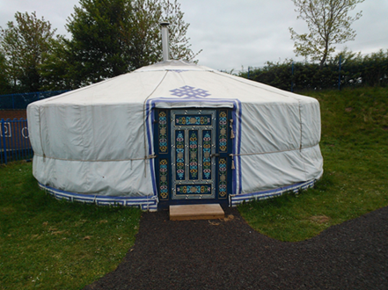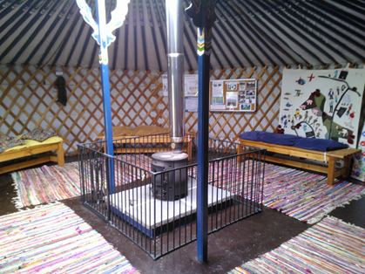

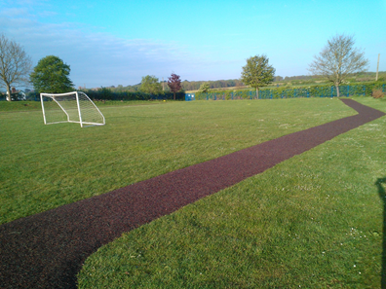

Please have a look at our website to get some feel of what being at Whittington means to our staff and pupils.
(www.whittington-school.co.uk)

