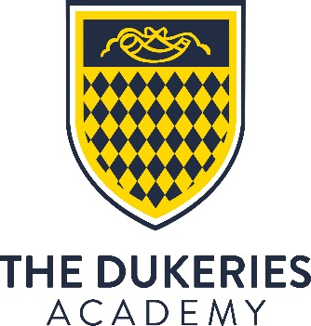

COVER SUPERVISOR
NJE Grade C, Point 14-18 (actual £14,847 to £15,846)
Term time only, 37 hours per week

The Dukeries Academy
Whinney Lane, New Ollerton, Newark, Notts, NG22 9TD

Required as soon as possible

A fantastic opportunity to join an OFSTED rated ‘good’ school (October 2016)

The successful candidate will provide effective cover supervision for absent teachers to ensure continuity of student education as well as providing additional support for other activities. The role includes invigilation and administration to support teachers to focus on student learning.

You will have excellent literacy and numeracy skills and be a competent IT user. Good verbal and written communication skills together with an ability to deal with a wide range of student behaviour are essential.

The Dukeries Academy is a unique 11-18 school with a range of extended provision supported by a strong reputation for partnerships and inclusivity.

Our sponsor, Academy Transformation Trust, will provide outstanding support and challenge, and are committed to transforming learning, aspirations and opportunities for all pupils, and the communities in which they live. This commitment also extends to staff who are key to this success.

For further information or to arrange a visit please call the academy on 01623 860545.

To apply now, please visit www.academytransformationtrust.co.uk/vacancies and complete the online form.

Closing date: Midday 28 September 2018
Interview date: TBO

Academy Transformation Trust is committed to safeguarding and promoting the welfare of children and the successful applicant must undertake an enhanced DBS disclosure and reference checks.

