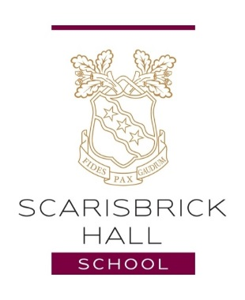

Teacher of Humanities (Combination of RS, Geography, History & Classics)

Full time Permanent

Closing Date – 09/03/18

Salary – negotiable based upon experience

Due to the continuing expansion and development of Scarisbrick Hall School, we now have an exciting opportunity for an innovative, passionate and suitably qualified teacher to join our School from September 2018.

Scarisbrick Hall has been awarded Grade 1 in all areas and phases by the independent schools inspectorate with the following headline statement: “The pupils’ excellent achievement reflects exemplary attitudes to their learning and a willingness to think for themselves.”

This is an exciting moment to join a successful and forward thinking team. The successful applicant will possess the necessary skills to deliver the highest quality Humanities teaching at Scarisbrick Hall School.

The successful applicant must:

- Be an outstanding classroom practitioner
- Be a team player
- Be an excellent communicator
- Have a proven track record with results
- Possess excellent organisational skills
- Have the ability to support SEN and stretch GAT

Scarisbrick Hall School is proud to have a reputation for high academic standards and teachers who will go ‘above and beyond’ to secure the best possible outcomes for all students.

The school is set in the beautiful surroundings of Scarisbrick Hall Park including woodland, lake and attractive surroundings. The post holder will play a key role in developing the Humanities provision at the school and must possess the drive and ambition to ensure that the school provides a world class education for all of our students.

This school is committed to safeguarding and promoting the welfare of children and young people and expects all staff and volunteers to share this commitment. The successful applicant will require an enhanced disclosure from the DBS (Disclosure Barring Service).

Contact:
Headmaster’s PA
Mrs Lynn Massam
massaml@scarisbrickhallschool.co.uk
01704 842203

