Waddesdon Art Department - April 2018

The Art Department at Waddesdon has a strong reputation amongst students, parents, staff and the wider community that has been established over many years. Significant numbers of students opt for its range of subjects at GCSE and A Level. Typically, we have six groups opting for GCSE each year and between seventy and eighty students follow the art courses in Years 12 and 13. Students at GCSE follow a three-year curriculum starting in Year 9. This builds upon a comprehensive introduction to our Art and Design mastery programme taught at Key Stage 3. This very well resourced department, born out of the legacy of the school’s previous Visual Arts Specialist Status for a period of nine years, allows students to develop knowledge skills and understanding from a broad range of subject choices including Art, Craft and Design, Graphic Communication and Photography. Exam results have been consistently high for a very long time.

The department is made up of five purpose-built studios which it moved into in 2003. These include two digital suites of iMac computers with industry-leading software such as Adobe Creative Suite and three open-beamed and north light-facing studios. With the facilities and excellent equipment that we have, we are able to support most art disciplines ranging from clay, printmaking, painting and drawing and new media. We also have a multi-purpose room that acts as a photographic studio used mainly for sixth formers with various lighting, backdrops and black-out as well as additional computers, SLR cameras and digital printers.

The team of five teachers and a technician is led by a subject leader supported by a SAM (Student Achievement Manager). The team work well together and are very experienced and highly professional, the newest recruit arriving more than seven years ago. Colleagues work in an environment where they are able to develop new ideas and share good practice and are constantly reflecting and reviewing upon the success of project material and student progress. A huge wealth of resources, teaching aids and exemplar work has been built up over time which continually changes and grows.

Huge emphasis is put on growing each student creatively and artistically by drawing on the broad range of expertise and resources on offer. It has always been the intention to avoid a house style, but rather develop an understanding of individual learning need and support accordingly. This results in a diverse range of outcomes, creative, exploratory and academic, with each individual in mind.

Students spend a significant amount of their spare time working in the Art Department, be it at lunchtime, attending the Art Zone which is run four nights a week, and for Sixth Formers many “live” in the studios in their study periods. All years are involved with school visits to galleries, exhibitions and other cultural destinations. These vary from local visits as well as further afield to London and additionally for Sixth Formers to galleries in Europe.

The department has been at the forefront of art education for over twenty years, raising the profile of the school at a regional and national level. This has included working with QCA, OFSTED, SSAT, Arts Council England and Teachers TV. Students engage in local and national competitions as well which has proved particularly successful for them and the school. Currently, for example, we have a mural in an Aylesbury shopping centre and student work on the London Underground.

Currently the department follows OCR for GCSE, AS and A Level for Art, Craft and Design, Photography and Graphic Communication. This enables a diverse creative curriculum choice and fits very much with our vision of a broad artistic curriculum. 2017 exam results at GCSE were outstanding, with the average grade being an A- in Art, an A- in Graphics and a B+ in Photography. 85.7% achieved FFT20 targets in Art, 100% in Graphics and 95% in Photography. There was no real gap in the performance between boys and girls. Also, Disadvantaged students performed in line with their peers and all other subgroups performed at or above expectations. At A level ALPS scores were 2 in Art and in Graphics and 4 in Photography. In

September 2017, ten students went on to university to pursue a range various Art and Design courses. We regularly have a good number following Art and Design as a career choice.

In partnership with the Technology Department, we have an annual exhibition each year that takes over the department and our gallery corridor. This is a key event in the school calendar, attended by many year groups and staff during the day and parents and relatives at the private view in the evening. We have rolling exhibitions over the year in the gallery corridor and the studios. These are done completely by the students who have become well versed in displaying their own work as well as valuing and improving their own exhibitions.

Just to give you a flavour of a little bit of what the students do, follow this link to the video of the 2017 summer exhibition which is at the bottom of the Art page on the school website:
http://www.waddesdonschool.com/subjects/art-design/

We think it is an excellent department to work in, with wonderful creative students who can be nurtured into fantastic artists and designers and we are looking forward to meeting you.

_______________________________________________________________________________________

Sarah Davis
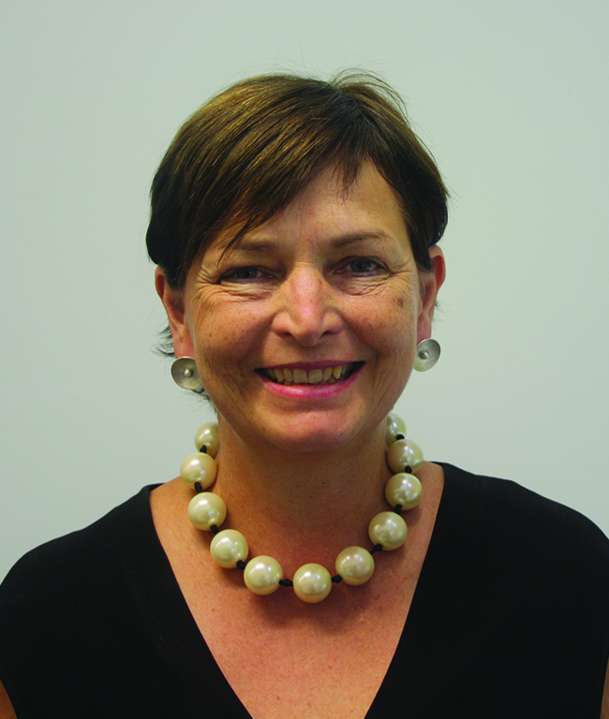
My first association with Waddesdon was as an Artist in Residence during 2004. I was quickly persuaded (by the wonderful ethos and working environment in the school) to train here as a teacher via the Graduate Training Programme. I have been teaching Art, Design and Photography at the school ever since. I was appointed Student Achievement Manger for the department in 2007, responsible for Key Stage 3 and supporting the Head of Art in the day to day running of the department. As a team, we have developed an engaging and exciting Key Stage 3 curriculum that prepares students for the next phases. We are always delighted with the high level of take-up of our creative subjects at Key Stages 4 and 5.

As a classroom teacher, I am passionate about inspiring the development of pupils’ curiosity, creativity, self-expression and artistic development in all three Key Stages. I want to see students travel as far and as fast on their creative journey as their talents, personal artistic interests and commitment will take them.

Before becoming a teacher, I had an exciting and varied career in the Creative Industries which culminated in becoming a Director of a prestigious magazine publishing company. I took a career break to bring up my children and at the same time I pursued my passion for Art and Design through a degree in Ceramics and Glass. I have exhibited in galleries, public spaces and worked for private clients. I believe my experience working outside the education sphere allows me to embed into my teaching practice the soft skills required to succeed beyond school.

I am proud to work at Waddesdon because of the wonderful experience the school offers to students both educationally and to flourish into rounded young people who are ready to take on the challenges of the twenty-first century in a caring and compassionate way.

Sharon Evans
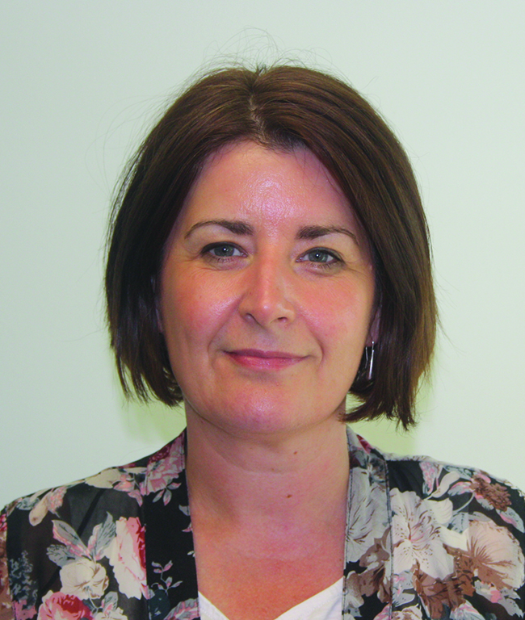
I graduated from Belfast University specialising in Design and continued to the University of the West of England to complete my PGCE. I have now been teaching for nineteen years, having spent two years at The Grange School and eight years as Head of Art at John Colet School. I’m in my ninth year at Waddesdon and it’s my forever teaching home. Waddesdon is such a fantastic place to work and is a very supportive and happy school. I love that I can teach a number of disciplines to enthusiastic students in a vibrant and inspiring environment. That’s why I moved to this school. We are a passionate team in the Art Department and synchronise together, all dedicated to bring out the best and the artist within all young people.

I’m more of an illustrator at heart and enjoy all elements of digital media. I am a practising artist exhibiting once a year at Art on the Hill, having been the most sold artist two years in succession. I am a mum to lovely daughters aged 14 and 11, the eldest of whom is currently in Year 9 and my youngest will start Waddesdon this September. I am a very happy that we are all part of Waddesdon!

Laura Lenander
Whilst completing a degree in Fine Art at Central Saint Martin’s I developed the vision and passion I had for teaching when I realised I really wanted to see others thrive in their creative practice. When I myself was a teenager I was quite unwell and missed a significant amount of school – Art was the thing that really brought me through and I had some fantastic teachers who inspired me greatly to pursue teaching.

I started my time at Waddesdon nearly eight years ago when I was an NQT. After my first year teaching I pursued an MA in Artist Teachers and Contemporary Practices at Goldsmiths University. This was fundamental in developing my critical reflective developing a strong theoretical basis for pedagogy. For the past two years, alongside teaching Art, Photography and Graphics I have also been working as Professional Tutor, overseeing the work we do with trainee teachers and as Research Champion which has grown this year to work with the Oxford University Education Department. It’s really exciting working across staff and departments, overseeing some fantastic research projects.

I love working in the Art Department at Waddesdon. It is a place where students from all social backgrounds thrive and we are all passionate about getting the best results for our students. We all work hard and very well collaboratively, sharing practice and developing new schemes and projects together. We are fortunate to have some great facilities and this, along with some great colleagues, enables students to produce a high standard of work, which leads to great outcomes, including many students entering university with unconditional offers in art-based courses with direct entry from school. As a classroom teacher, I am passionate about the power of Art & Design to enable students to develop skills to express themselves. I love working with students to develop their creative practice by journeying with them to developing my own practice alongside them. This involves me making my own projects alongside classes I teach – I find they love to see how I’m responding to themes and topics and it exemplifies to them ways to develop and stretch themselves.

Outside work I love being a wife and mum to a 13 year-old daughter; we have a dog who I go running with regularly. I really enjoy taking photographs and painting. I am involved a lot with my local church where my husband and I lead a service for young adults. I lead creative worship and preach regularly.

Rebecca Raynor
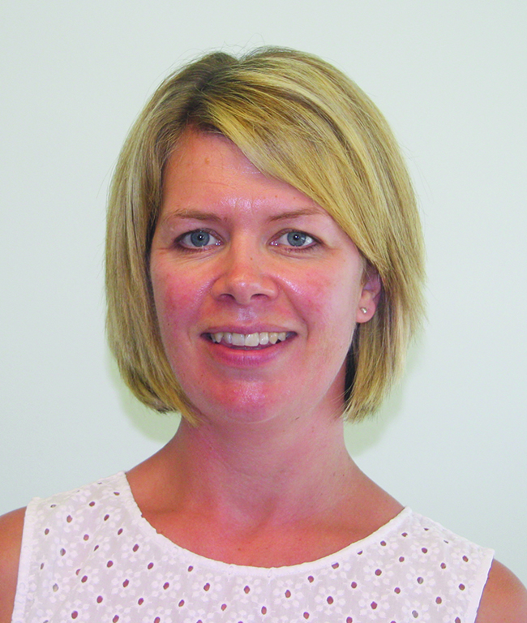
Following my PGCE with Oxford Brookes, I started as an NQT at Waddesdon in 2004 and have had the pleasure of teaching in the Art Department ever since. Throughout my career at Waddesdon, I have taught all key stages, as well as working with many of our partner schools as a community link teacher, aiming to raise standards in art in Primary Schools. Previously, I have also worked in an advisory capacity at Cressex School in High Wycombe, aiding their Art Department to significantly improve performance. More recently, I have also taught Textiles and Product Design in the Technology Department.

Prior to my teaching career, I completed a degree in Fashion and Textiles in Birmingham, freelanced as a textile designer and worked for three years for Marks & Spencer in buying. These experiences have enriched my teaching and equipped me with a variety of transferrable skills that I often draw on in the classroom.

I feel immensely privileged to work with our young people to enable them to express themselves creatively and feel great pride in seeing them grow and flourish. It is highly gratifying to work in a school that holds Art in such high regard and it is a pleasure to be part of a highly-dedicated team of art teachers with an array of varied specialist skills.

Anne Golder
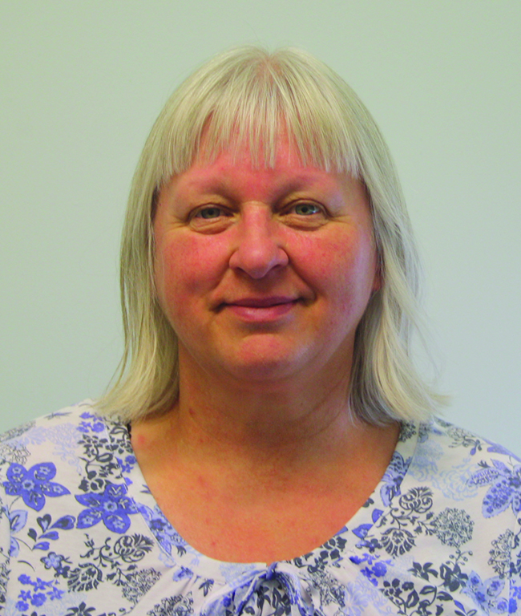
Anne has worked in the department since 2002. She is the ‘go to’ person when students lose their work or need resources or equipment. Under the direction of the subject leader she does all the ordering and stocktaking and keeps the studios clean, tidy and in good order. She also archives the vast array of work that the students produce. She works with a smile.

