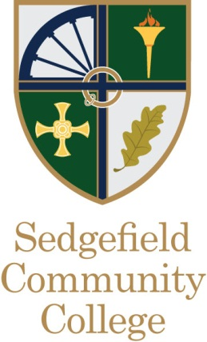
Ref: DD / PW
Date: May 2018

Dear Applicant,

Re: Teacher of Modern Foreign Languages - MPS/UPS

Thank you for your interest in the post of Teacher of Modern Foreign Languages at Sedgefield Community College.

Housed in a recently opened, well equipped building, Sedgefield is acknowledged as one of the North East’s highest achieving 11-16 schools whilst also being recognised nationally through inclusion in the Sunday Times list of the UK’s top 50 schools (11 to 16). In addition, Sedgefield has been judged by OFSTED as an ‘outstanding’ school overall, and one where inspectors described student conduct as ‘impeccable’. We are currently looking to further strengthen our teaching team with the appointment of a high calibre Teacher of French.

Whilst the college is situated within the picturesque market town of Sedgefield within a rural area of County Durham, its student intake is quite comprehensive in nature with students attending the college from a range of communities within a variety of socio economic settings. However,
students enter year seven with levels of attainment above national average and with both levels of SEN and free school meals on par with national averages.

The Modern Foreign Languages faculty is made up of a committed team of specialist teachers delivering both French and Spanish at key stage 3, and French at key stage 4. At Key stage four increasing numbers of students follow Languages, these students being typically the college’s most able students, the majority of whom also being highly aspirational and committed to achieving the highest grades possible across all subjects followed. In recent years student attainment in MFL has steadily improved however students do not yet make the levels of progress seen across other subjects at Sedgefield.

If you feel you are ready to accept the challenge this role presents, have the experience and skills we need and feel that Sedgefield is right for you, then both the governors and myself would welcome your application.

Please apply by letter (no more than two sides of A4) addressing the person specification and the Person Specification/Criteria for Selection.

The closing date for applications is: Monday 21st May 2018 (12 noon)
Interviews to be held on: To be confirmed

Should you wish to discuss this post further or visit the college then please contact my PA Penny Walmsley on 01740 617777 or e-mail p.walmsley@sedgefield.cc

Yours Sincerely

Mr D. Davies
Headteacher

