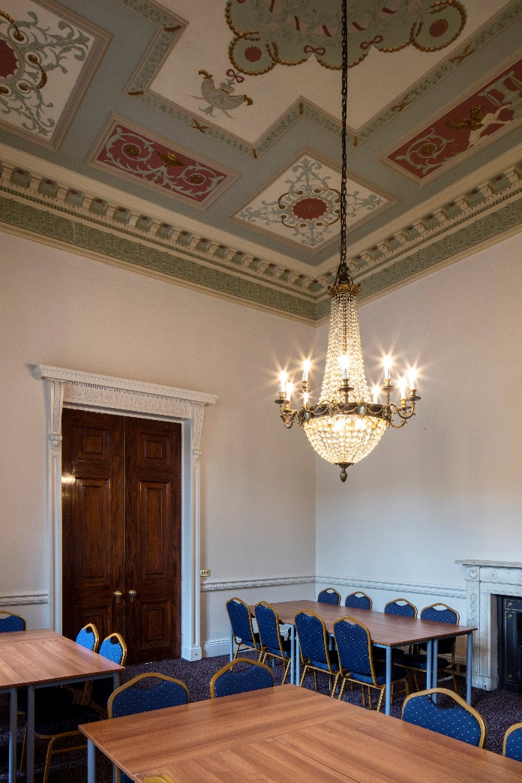

Appointment of Deputy Head (Pastoral)
April 2018

Eaton Square Upper School, Mayfair is a brand new independent co-educational senior school opened on Piccadilly in September 2017. It is the only Senior School in Mayfair, a stone’s throw from the hundreds of acres of green space afforded by the Royal Parks. Following on from the tradition of Eaton Square School, the education we provide will have a traditional British foundation, but a modern and international outlook. We celebrate the diverse skills and aptitudes of London pupils, and maximise the benefits of their learning from and interacting with each other.
Initially, we opened in 2017 with Years 7, 8, and 9, and the school will grow organically, taking its first VIth form students in September 2020. We expect the VIth form to be at the site of 106 Piccadilly to begin with, though in time the VIth form may move to a new site.

A positive can-do attitude is essential, along with an ability to create schemes of work, show initiative, and be self-sufficient. An ability and willingness to teach more than just one subject, and to contribute towards sporting and other co-curricular activities of the school will also be key qualities of many of the inaugural members of staff.

Our educational philosophy and aims
We offer a breadth and depth of education that goes beyond examination success and into every sphere of life. Intellectual, artistic, aesthetic, physical and musical pursuits enjoy equal emphasis. We want children to learn moral and spiritual values, too, that will help them to be happy and confident in themselves. We aim (in no particular order)
- To offer a well-balanced, all-round education leading to pupils who are themselves well balanced, well attuned, and well in mind and body

- To develop a purposeful attitude, self-confidence with respect for others, and a strong sense of community

- To develop intellectual curiosity and an instinctive love of learning which lead naturally to academic aspiration and examination success

- To teach pupils to persevere, and to equip them to overcome adversity and setbacks

- To give pupils the knowledge and skills to allow them to fulfil their potential, to assist them in further education and adulthood, and to enable them to take on and thrive in leading roles in their future lives

We will maintain class and group sizes small enough for tuition in lessons to be highly student focussed, giving emphasis to pastoral care within the school day to deliver a highly personalised education. We promote a reflective culture among the teaching staff, with a commitment to learning and professional development. London’s nearby galleries, museums, parks, and other iconic landmarks, act as an extended classroom for the school, to promote culture, all-round education, and a sense of belonging in the capital.

Further information on the post of Deputy Head (Pastoral):

The post of Deputy Head (Pastoral) is a new position within the school, and we are looking for a dynamic and highly driven individual to become an intrinsic part of the Senior Leadership Team. The post holder will report directly to the Headmaster and will ensure that pupil welfare, particularly in relation to recent technological advances, is given highest priority. They will also hold a crucial role in whole-school strategy and development. There will be an appropriate Senior School teaching commitment with the post dependent upon the applicant’s specialist subject.
The new post-holder will be an ambassador for the school, it is expected that the post holder will have a significant understanding of the nature and manner of a co-educational school and the specific pastoral concerns that may arise.
The Deputy Head (Pastoral) will work closely with the Headmaster to ensure that the highest standards of behaviour, learning and academic attainment prevail across the School and in maintaining and extending the School’s reputation for values-led education and extra- curricular success and participation. The Deputy Head (Pastoral) will work with the Headmaster to establish key strategic goals, which will themselves be set within the framework of the Development Plan. It is a challenging role in a school which is looking to offer aspiring leaders a wealth of opportunity.

JOB DESCRIPTION: Deputy Head (Pastoral)
Job Title | Deputy Head (Pastoral)
Summary of the Role | To effectively lead and manage the pastoral life of the school, ensuring the delivery of a safe and secure environment for the school community, and holding responsibility for the welfare of all students. Assisting the Headmaster as an integral member of the Senior Leadership Team
Line Manager | The Headmaster
Key responsibilities  Safeguarding | Safeguarding Lead (Designated Person for Child Protection and Safeguarding) for the entire school. (Level 3 safeguarding training)  Ensuring that the School and its staff remain committed to safeguarding and child protection; and that all members of staff have appropriate training and guidance to ensure that they are equipped to discharge their responsibilities in this respect  Being committed to training and maintaining a developed understanding of the use of mobile technology for all students  Monitoring the keeping, confidentiality and storage of records in relation to child protection  Maintaining links with the LADO (Local Authority Designated Officer) and their Deputy, as appointed  Keeping parents informed of action to be taken under safeguarding procedures in relation to their child (with reference to the Referral Assessment Team/Headmaster before discussing details with parents if required)  Monitoring records of pupils in the School on specific registers (LA) to ensure that this is maintained and updated as notification is received  Where students leave the school, ensuring that their destination school is made aware of any safeguarding /child protection issues in line with national, regional and school policies  Advising the Headmaster on all pastoral matters, especially with regard to safeguarding, mobile technology and the Internet

The pastoral curriculum and life of the School, in particular the Senior School | Overseeing the creation and maintenance of the whole school policies and to update accompanying handbooks and the staff handbook, where they relate to the curriculum
i) Discipline and sanctions | Monitoring students’ curriculum and social progress and supporting Heads of Year and Form Tutors in the monitoring, supporting, encouraging and disciplining of students, as appropriate  Have responsibility for ensuring that the highest standards of discipline are maintained, working closely with the Headmaster to ensure that incidents are dealt with in the most appropriate way in order that the School’s behaviour policy is implemented consistently and effectively  Determining levels of appropriate sanction up to, but not including, exclusion, in liaison with the Headmaster and Directors if appropriate  Oversight of the scheduling and organisation of sanctions, including detentions  Leading and having oversight of the online School Merit Systems
ii) Transition | Responsibility for cross-phase liaison with the Prep School and management of all transition arrangements, in conjunction with the Head of Year 7  Lead, implement and manage an effective careers programme, including advice for A-Level choices and beyond
iii) PSHME and Enrichment | Oversight of student committees, such as the Student Council Oversight of the House system, educational trips, selection of prefects  Oversight of the Personal and Social Health Education provision within the School  Leading and managing staff who organise residential trips and day excursions, ensuring a variety of educational, cultural and sporting opportunities are offered to the pupils  Acting as the Educational Visits Co-ordinator for the School and overseeing the risk assessments for each trip and excursion
Administration and Strategic | Leading and managing the school’s pastoral development plan  Chairing the Health and Safety meetings and have an oversight of issues within the school, including those relating to risk assessments, fire regulations and works and maintenance issues

Planning the yearly school calendar with the Head and the Director of Studies and ensure that the full calendar is completed and issued at the beginning of each academic year

Oversight of supervision arrangements, ensuring that all areas of the School are appropriately supervised by members of staff

Ensuring with the Headmaster that appropriate disaster contingency and critical incident plans are in place

Implementing and assisting in the delivery of new staff induction Assisting the Headmaster with pupil admissions policy
Being aware of all pupil assessment and monitoring, including oversight of
CEM’s attitudinal testing
Staff management | Leading and managing the Form Tutors and Heads of Year; to encourage, support and challenge them to maintain and raise the already high pastoral standards (e.g. in relation to the Enrichment Programme)  To chair all Heads of Year/Form Tutor meetings
General responsibilities | Organisation of assemblies and rotas Planning and oversight of major school events  Staff recruitment in conjunction with the Headmaster  Ownership of school-wide Report Systems and National Records of Achievement and Prize Giving  INSET organisation and the beginning and end of term arrangements with the Headmaster  Assisting the Headmaster with the school’s staff appraisal system Assisting with the preparation of EQI, EYFS and Compliance Inspections  Assisting the work of the Learning Support Department and to liaise over pastoral provision for SEN pupils.

The Job Description is not exhaustive and is expected to be discussed with candidates, and as a result may be subject to agreed change.

Person Specification Head of Pastoral Care
The successful candidate for the post of Head of Pastoral Care will have at the very least a good first degree from a recognised university and strong management experience. He or she will display leadership and vision in pastoral matters and will also:

Have a good track record of leading and managing staff; be motivational, sympathetic, constructive and, where necessary, challenging with colleagues
Be experienced as a pastoral leader and an expert in his or her own subject(s)
Be extremely proficient in the use of information technology
Be able to communicate clearly and persuasively, both orally and in writing, with staff, students and parents alike
Be highly articulate and precise in writing
Be passionate about maintaining outstanding standards of pastoral care
Be very well-organised and extremely hard-working
Be able to work accurately and calmly, and show resilience, when under pressure
Be able to work collaboratively with colleagues within the School and with key contacts in other organisations; have a proven ability to work as a member of a team
Be patient, determined and enthusiastic
Be prepared and able to initiate and manage change, where necessary
Be devoted to the pastoral and educational needs of the individual pupil
Be committed to continuing personal and professional development
Display absolute commitment to the highest standards of professional behaviour and, at all times, to promoting the welfare and safeguarding of children
Be knowledgeable about pastoral issues concerning 2-16 schools in general and senior schools in particular
Be able to act at all times as an outstanding ambassador for the school
Be willing and able to contribute to the wider extracurricular and pastoral life of the school

Characteristics
The following lists provide the Essential and Desirable Characteristics, Skills, Qualities and Experience for the Head of Pastoral Care
Essential

University Degree and a relevant teaching qualification
An ambitious person with great energy and clear leadership
Proven record of high level of administration
Excellent communicator (written and verbal) with parents, pupils and colleagues
Experience of leading and managing a pastoral team
High levels of energy and commitment
Personally committed to continuing professional development
Ability to maintain confidentiality appropriate to the setting, specifically in relation to Safeguarding
A team player with sound interpersonal skills and sensitivity
An excellent level of competence in ICT
Honest and hard-working
Ability to see the wider picture
An eagerness to participate fully in the life of a busy school
Enthusiasm and a keen sense of humour
Committed to safeguarding the physical, emotional and mental well-being of young people

Desirable

Prior experience of Senior Management
Evidence of recent professional development e.g. NPQSL
Experience of managing professional development
Remains positive and enthusiastic under pressure

