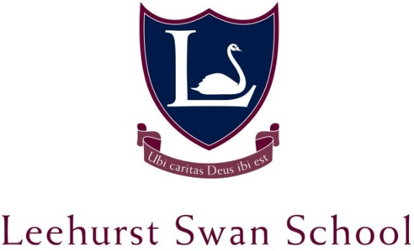

TEACHER OF MUSIC – KEY STAGE 3 & 4
CANDIDATE PACK
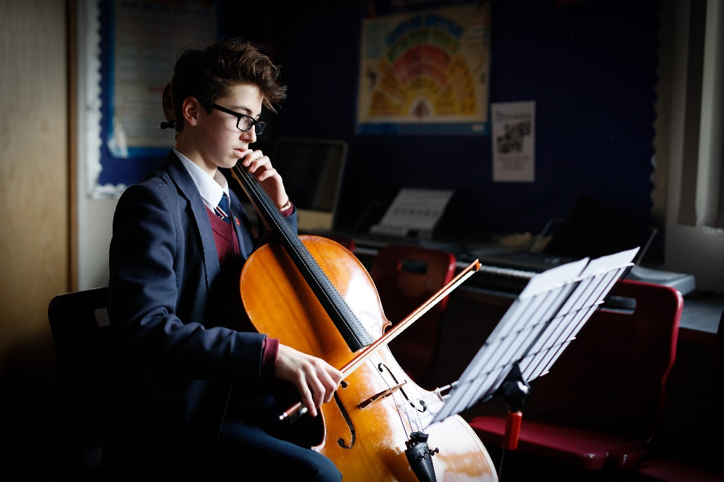

THE SCHOOL
Leehurst Swan is a leading independent day school based in the city of Salisbury, Wiltshire. With currently over 200 pupils on roll aged 4 to 16, and an Outstanding ISA inspection rating in 2018; the School is under the leadership of Mr Stuart Morgan-Nash BSc (hons) MEd.
At Leehurst Swan, our pupils are at the heart of everything we do. We recognise the uniqueness of each child and it is our privilege to guide them on the road to discovering their talents and achieving their true potential. We offer a family-friendly, nurturing environment based on Christian values, and a broad and varied education which both stimulates and challenges. We seek to encourage a true enthusiasm for learning, and to help pupils grow in knowledge, wisdom and understanding, whilst preparing them for their future beyond school.
We have been educating children on this site for over 100 years and our academic record is very strong. However, we also firmly believe learning should be imaginative and fun, and we place learning and laughter at the heart of all that we do. We are a small school, which allows us to provide individual attention, exciting opportunities and creative activities for all our children while preparing our pupils for their future beyond school

MUSIC
Pupils explore all musical genres participating in a wide variety of listening, performing, and composing activities, with an emphasis on practical work and enjoyment.
At Key Stage 4 pupils can opt to study music for GCSE. Pupils spend time developing their performing and composing skills. In addition, specific areas of study include World Music, Western Concert Music, Twentieth Century Experimental Trends, and Popular Music in Context.
We have choirs and orchestras and we stage numerous concerts and productions throughout the year.

THE ROLE
This is a maternity cover position on a fixed term contract for 6 months – starting after October Half Term (with a handover in October). We offer a competitive salary re-numeration and free on-site parking.

APPLICATION PROCESS AND IMPORTANT DATES
Applicants should download and complete the following documents from the school website:
- The application form;
- Write a covering letter highlighting any strengths and reasons for applying for the post;
- Submit a current copy of their curriculum vitae.
Applications should be sent to the HR Manager in hard copy and be emailed to patohm@leehurstswan.org.uk
Applicants must be willing to undertake a full enhanced DBS check, complete a health declaration form and be willing to undertake any screening for child protection reasons.
If you would like further details about the school, or you would like to have a look around the school, please contact the School Office in the first instance.
Closing Date for Applications: Thursday 20th September 2018
Interview Date: Monday 1st October 2018
Start Date: October Half Term 2018

JOB DESCRIPTION
Teacher of Music – Key Stage 3 & 4 is responsible to the Headmaster and Deputy Head for delivering musical tuition in the Senior School, specifically:
musical performances and assisting with the planning and co-ordinating the programme of musical events including assemblies, Carol Service and the school’s annual Wassail event
reporting and celebrating achievements
creating and fostering links with the wider community
the development of music and performance in the senior years

Responsibilities include:
to teach and direct to the highest standard
to foster links with feeder schools, competitor schools and musical associations
to support and develop the school’s best musicians, developing appropriate programmes for them
to encourage representative achievements, putting forward pupils for regional and national representation as appropriate
to liaise with all visiting teachers about the students they are teaching to provide the Marketing Department with articles with regard to achievements in music of both pupils and orchestras
to ensure that notices are posted to inform the school of extra-curricular practices
- to maintain a high standard as a performing musician
- to arrange a range of performance opportunities for solo performers and ensembles.
- to plan a series of concerts throughout the year, ranging from lunchtime informal concerts to those with major ensembles both at school and at other venues.
- to work, as part of the music department team, to manage the School’s stock of instruments, arranging repairs where necessary, purchasing new instruments as appropriate.
- With the help of the peripatetic teachers, through demonstrations, encouraging students to learn instruments, particularly rarer instruments that they might not necessarily consider
- to be pro- active in the health and safety issues of the department and to deal with or report any areas of concern immediately

PERSON SPECIFICATION

Degree or equivalent
Teaching Qualification
QTS status achieved
Further qualifications
High level achievement in instrumental performance
Experience in leading musical groups eg; orchestras, choirs
Curriculum knowledge
Relevant experience
Range of teaching strategies
Inspiring teacher
Enthusiastic about music
Team player
Empathetic
High pastoral care
Supports school ethos
Respect for Colleagues
Sense of Humour
Flexibility
Effective communicator
Role model
Emotionally intelligent
Resilient
Good time-management skills
Good listener
Accept criticism
Inspire confidence in pupils
Communicates well with Parents

