Teacher of ICT

Salary Range: Main Pay Scale (£22, 917 to £33, 824)

St Aidan’s is a small Academy with a strong ethos of ‘we are destined for greatness’.

We are looking for an ambitious individual who is knowledgeable in their subject and is committed to supporting and developing the vision for St Aidan’s, has a passion for playing a key role in ensuring young people succeed and thrive on working as part of a fantastic team.

The ideal candidate will:
- Be an outstanding classroom practitioner and role model, demonstrating high personal and professional standards
- Demonstrate outstanding pedagogy practice, sharing it within the department.
- Support colleagues so that appropriate standards of behaviour are established and maintained.
- Fully support the extra-curricular activities of the Academy.

Generous R & R is available for an outstanding candidate.

Should you wish to visit the school, please contact Alex Simpson, PA to the Principal, on 01325 373778 to arrange a date/time.

Further details and an application form are available from Alex Simpson, Tel: 01325 373778 or Email: A.Simpson@staidansacademy.org.uk or alternatively downloaded from our website: www.staidansacademy.co.uk.

Applications must be returned to Alex Simpson via email.

Closing Date: Wednesday 23 May, 12noon

The Academy is committed to safeguarding and promoting the welfare of children and expects all staff to share this commitment. The post is subject to a successful DBS clearance and pre-employment checks will be undertaken before an appointment is confirmed.
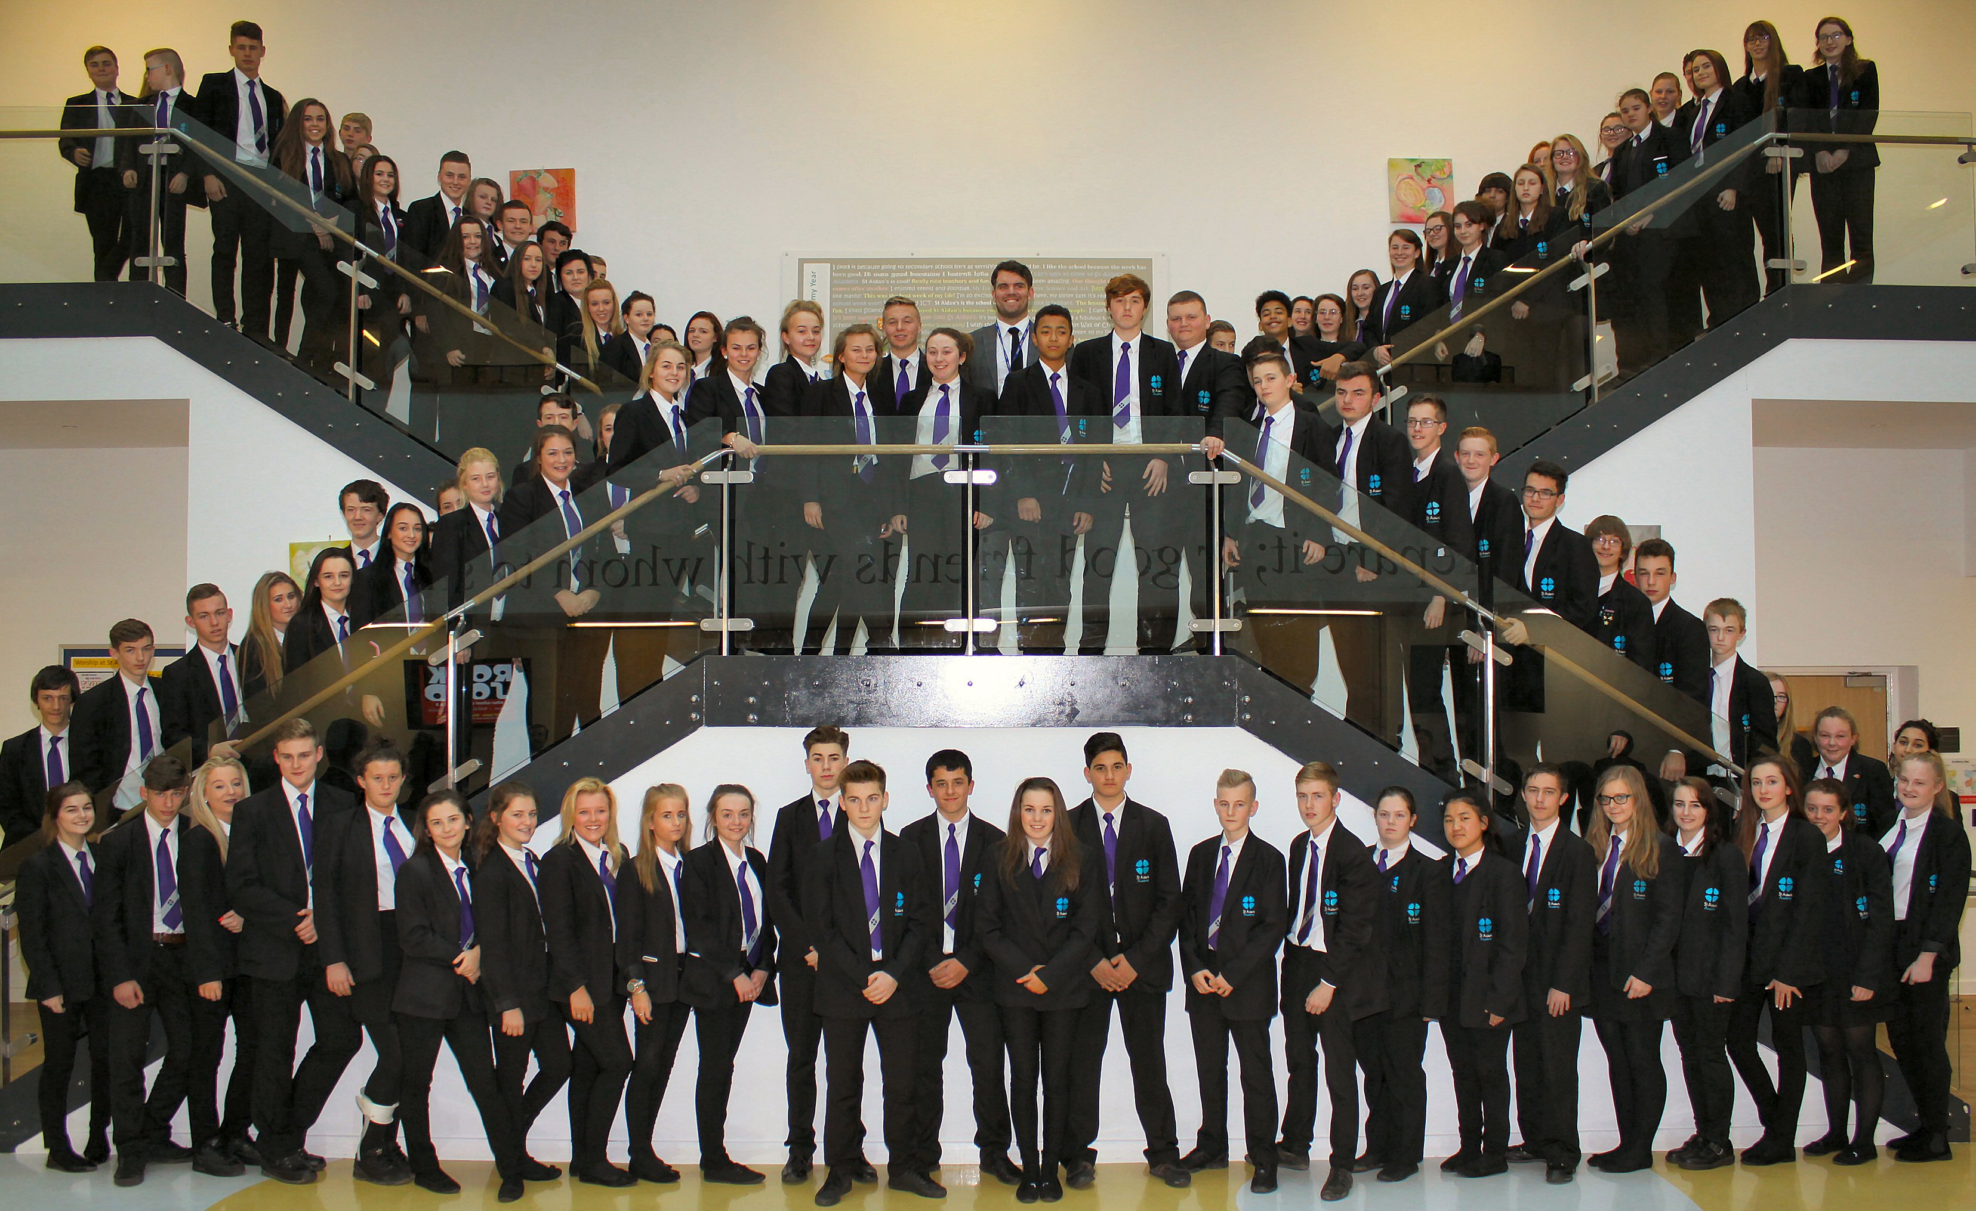
St Aidan’s Church of England Academy
Hundens Lane, Darlington
DL1 1LL

Phone: (01325) 373770

Principal: Mrs N Gibbon

