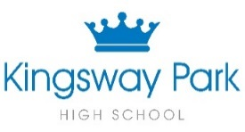
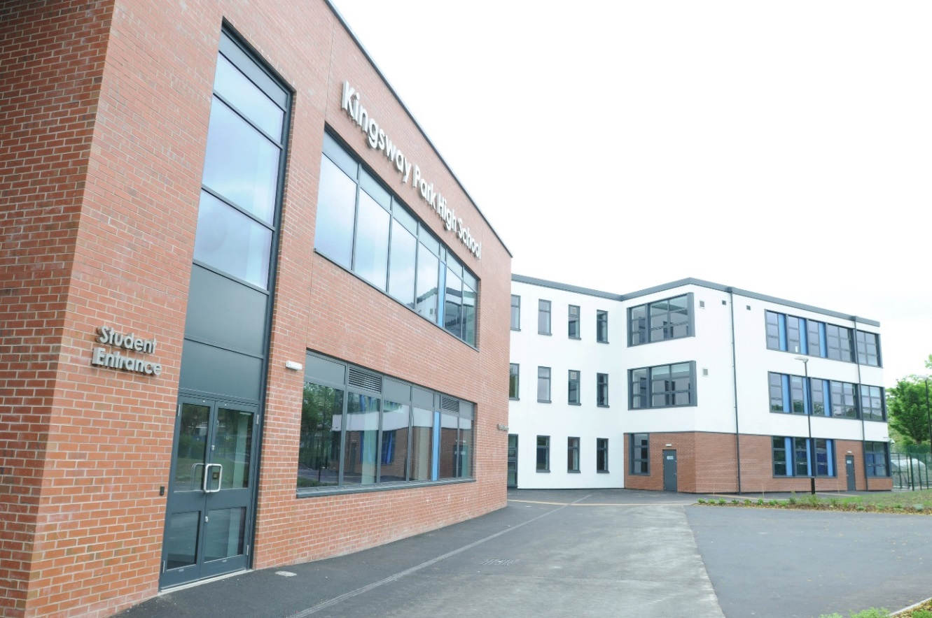

Title: Citizenship/PSHCE Teacher

Candidate Information Pack

To start September 2018

Contents

Welcome and Introduction ………………………………………. 3
Background Information ………………………………………. 4
Kingsway Park High School Vision ……………………………………… 4
Making your Application ………………………………………. 5
Job Description & Overview ………………………………………. 6

March 2018

Dear Colleague
I am delighted to provide an application pack for the role of Citizenship/PSHCE Teacher at Kingsway Park High School. The successful candidate will join a newly created Social Science department and will have the opportunity to be a crucial part in the development and success of this new department.
Hopefully you will find the information provided in this pack useful and it will help you decide if this is a post you wish to apply for.
Our school motto is Aspire, learn, achieve which encapsulates the whole vision for Kingsway Park High School. We want to create learners that want to and have a desire to do well, know where they are going and what they have to do to get there.
We expect at all times a “Can do” attitude and we want all staff and students to be PROUD and have PRIDE in everything they do, day in and day out. We are a forward thinking, reflective learning community. We want all our staff to inspire, motivate and encourage our students to excel in their learning, behaviour and achievement.
I am very proud to be the Headteacher at Kingsway Park High School.
The appointment and retention of the right staff is crucial and we have a strong commitment and belief in developing staff at all levels. There is a high quality induction, appraisal and staff development programme for all.
Finally, if after reading all of the contents of this pack you wish to apply for the post advertised then I would like to take this opportunity to thank you for your application, investment of time and whatever the outcome, I wish you well in the future.
Yours faithfully
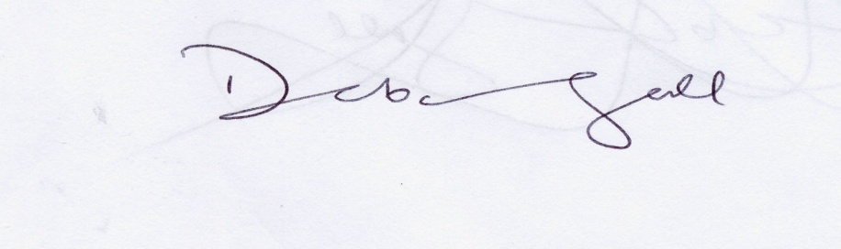

Deborah Ball Headteacher

Background information

Kingsway Park High School opened as a new school in September 2010 due to the closure of two neighbouring schools (Springhill High School and Balderstone Technology College).
There are presently over 1100 students (Yr7 – 11) and 170 staff who attend or work at the school. In September 2013 the school moved permanently into the new facilities on the Turf Hill Road site. The school has state of the art facilities and resources and we are very proud of the high quality facilities, resources and environment that we provide for both staff and students.
In July 2017 an OFSTED inspection took place and the outcome was that the school continues to be a GOOD school. There are a lot of things to celebrate in the OFSTED letter (found on our website or on the OFSTED report website). It truly encapsulates the ethos, vision and culture of the school. I strongly recommend that you read it so you have a clearer picture of what we are as a school.

Mission Statement

As our society evolves and becomes ever-more demanding for our young people and future leaders, we recognise and welcome the challenge of preparing our students to step up and take their place at the forefront of tomorrow’s society. Our diverse student body enables enrichment for all of us on a daily basis.
Kingsway Park High School transforms students’ lives. Through our relationships, we strive to instil both resilience and an intrinsic motivation to become confident, creative and highly skilled students, capable of meeting tomorrow’s challenges head on.
We strive to establish a culture rooted in achievement and progress that encourages our students to grow academically, personally and socially; equipping them with the values of equality, fairness and openness.
We pride ourselves on our relentless drive to achieve outstanding, high quality teaching that provides a safe, supportive and encouraging environment for all our students to be able to realise their academic potential in pursuit of educational excellence.

Making Your Application and the Assessment Process

I hope that having read this pack you are inspired to apply for the post. If you are, then this is what you need to do:-

Application
Complete the application form and send it either by email to ksmith@kingswaypark.org or post to:-

Karen Smith – PA to Headteacher
Kingsway Park High School
Turf Hill Road
Rochdale
OL16 4XA

Actual Salary Scale: Mainscale 1 to UPR3
To start September 2018

The deadline for this post is 12 noon on 17th April 2018
Interviews week beginning 23rd April 2018

If you wish to discuss any details regarding the post or you wish to make an appointment to visit the school please contact Karen Smith on 01706 716761.

Job Description & Overview

We are seeking to appoint a passionate, enthusiastic teacher of Citizenship/PSHCE. The successful candidate will be a member of a newly created Social Science department that includes another 3 members of teaching staff (one being the Head of the Social Science department). This new department is a blend of RE and Citizenship teaching staff and will allow for a more structured and coherent approach to the teaching of RE and Citizenship to all students at Kingsway Park High School.

The facilities are outstanding and the present staff are working hard to create stimulating and creative teaching resources for all teaching groups and year groups. In September 2018 the whole social science dept will be relocated into a newly created 8 classroom block. This block will be shared with the Languages Department. The Head of Social Science has a real vision, passion and drive to ensure that this dept is a successful and vibrant dept.

There are exciting times ahead in the next couple of years for the newly created Social Science department and the successful applicant will play a significant part in the development and success of this newly created department. The person will need to have ambition, drive and energy and a real vision and passion for what Citizenship teaching should look like at Kingsway Park High School.

