May 2018

Dear Applicant

Thank you for your interest in this post as Head of Year at Archbishop Tenison’s.

This vacancy has occurred as one of our Heads of Year is moving jobs within his subject this summer. We are taking the unusual step of advertising this role externally at a relatively late stage because of a series of other, unrelated changes, which make it important that we increase our teaching hours for September. Since our Heads of Year are much valued and important members of our school leadership, it has for some time been my ambition to be able to advertise any new role more widely than only to existing staff. Hence we are taking this opportunity, even though the process will have to be done swiftly.

We have separate Heads of Year for all years from 9 to 13, who move through the school with their year groups. We also have two fixed.roles: Head of Years 7 and 8 and (now) a Head of Year 8 who works with her. Our Heads of Year benefit from having relatively small year groups (of only 120) and from the supportive atmosphere of a smaller school community. Through our system of progression, they also have the chance to nurture their year group and develop a vision for them over 5 years, as well as the opportunity to experience dealing with the challenges and rewards of two different key stages. In our school the role is focused on all three aspects of our school mission statement: academic excellence for each person as part of a Christian community. Needless to say, for this role you also need the attitude behind our school motto: Tenaciter.

Archbishop Tenison’s is a lively, friendly and high achieving school, with a large Sixth Form, where pupils take their studies seriously. As a Church of England school we are always pleased to receive applications from those keen to help develop our Christian ethos.

We look forward to receiving your application and discussing the role further to those called for interview. In your letter please include the following points:
- why you would like to take up this post at this time.
- which experience and qualities make you particularly suitable for the post.
- how you would approach the significant leadership responsibilities in this role

Please see our website for further details about the school. The current Year 8 is a good year group with much potential.

Yours sincerely
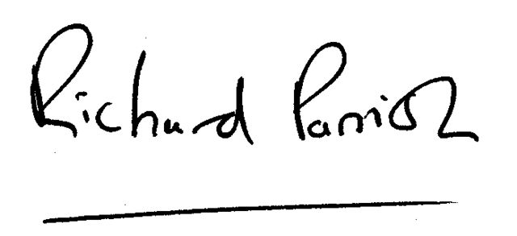
Richard Parrish
Headteacher

