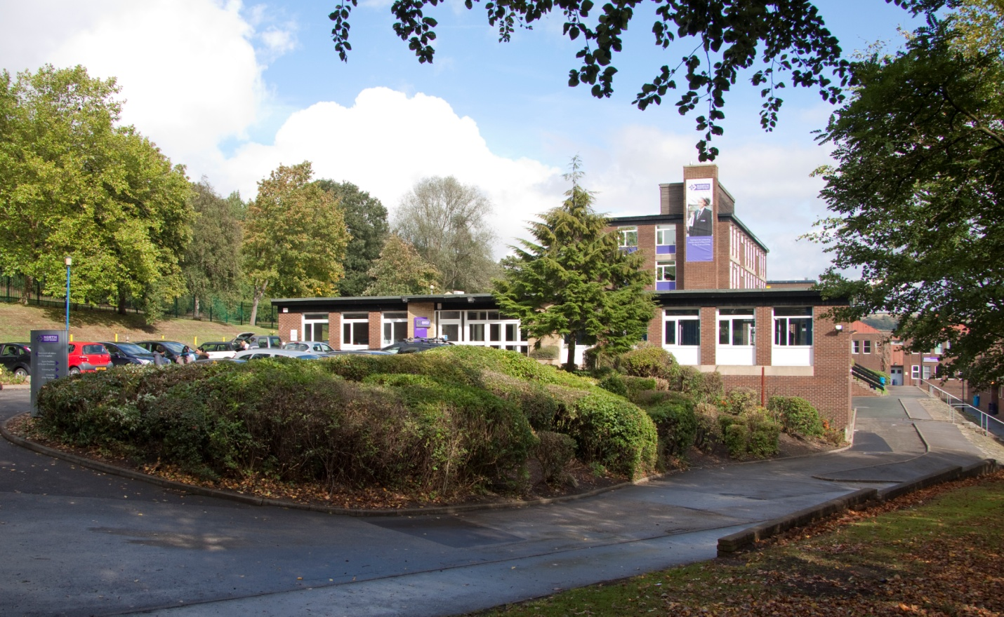

Vacancy: Science Teacher
Applicant Information Pack

Welcome

Thank you for your interest in this vacancy at North Huddersfield Trust School. We hope that you find the information within this pack useful and that it helps you to build a good picture of the exciting opportunities at the school.

North Huddersfield Trust School continues to move from strength to strength, our growing student numbers reflect that families are recognising the hard work of staff and students in creating a school of which the local community can be justifiably proud.
Ofsted has recognised us as a “Good” school which is outstanding in its work in keeping students safe and secure and for students’ personal development and well-being. We will continue to drive forward standards and ensure that we provide the best education for our students. Above all, our main priority is that we have a happy school where students feel safe, well-supported and able to thrive to achieve their full potential, so that when they leave us at 16 they are well-rounded, confident young people who will willingly contribute to their local community and far beyond.
Whilst we are aware of the fantastic progress we have made we will not rest on our laurels and have a clear plan for further improvement. There are a whole range of challenges ahead, but with these challenges come opportunities and excitement.

Thank you again for taking in interest in North Huddersfield Trust School and we look forward to hearing from you.

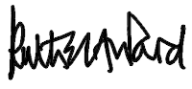
Miss Ruth Ward
Head Teacher

Vacancy Details
Teacher of Science

MPS/UPS: £23,720 - £39,406
Closing date: 14th December 2018 (Midday)
Start Date: ASAP (fixed term post until 31st August 2019)

"Pupils wear their uniform immaculately. They are proud of their school and the opportunities it provides for them. Pupils and their families value the support of their teachers and staff."
Ofsted 2017

North Huddersfield Trust School is recognised by Ofsted as a 'Good' school which is outstanding in its work around students' personal development, well-being, safety and security. We continually drive forward standards and are passionate about maximising the potential in all. Our caring and nurturing approach to education within and beyond the classroom contribute to what makes our school a special place both to work and to learn.

We place great value on the fulfilment and well-being of our colleagues; our successes to date are in no small part down to their hard work, commitment and determination and as a relatively new school, our growing student roll enables us to provide opportunities for both personal and career development.

We are seeking to appoint a Teacher of Science starting as soon as possible and welcome applications from NQTs.

The successful candidate will be able to inspire and enthuse students through excellent, creative and innovative teaching and have the ability to:
• plan, prepare and deliver high quality, differentiated lessons with pace and challenge
• build and maintain positive relationships with students, parents and staff
• work on their own initiative and as part of a team
• contribute to extra-curricular

If you would like further information please contact the Head Teacher, Miss Ruth Ward.
If you wish to apply for this post please apply through the TES Website www.tes.com or North Huddersfield Trust School website www.nhtschool.co.uk. If applying through the school’s website aapplications should be returned to
Mrs Nora Brown, Operations Manager, via email to nbrown@nhtschool.co.uk by
12 midday on Friday 14th December.

We are committed to safeguarding and promoting the welfare of children and young people. An enhanced DBS is required for successful candidates.
Woodhouse Hall Road, Huddersfield, West Yorkshire, HD2 1DJ 01484 452100
www.nhtschool.co.uk

JOB DESCRIPTION
Role | Science Teacher
Grade (SCP) | MPS/UPS
Weekly hours | Full time

Role Summary
Under the direction of the Head of Department, develop and deliver the national curriculum in the subject area. To shape the vision for the department and to promote a love of the subject across the school. To be accountable for quality student learning and the expected standards of student attainment and achievement with the department through a systematic focus on high quality and innovative teaching.
Key Responsibilities:
- Teaching and Learning
- Personal Development
- General

Duties
Key accountabilities | Key tasks
Teaching and Learning | - Fulfil the professional responsibilities of teacher standards  - Work within the boundaries of school policy, including appropriate consideration of school budget and resources  - Contribute to the design and delivery of departmental and whole school development plans  - Responsible for the learning and achievement of all students in allocated classes, ensuring an inclusive and differentiated approach  - Responsible and accountable for achieving at least good outcomes for all students  - Create and maintain a vibrant and positive learning environment where students can thrive  - Responsible for continually driving standards to ensure that all students have the opportunity to maximise their potential  - Adhere to deadlines for all assessment, reporting and other aspects of school life as agreed or directed  - Set an excellent example to students of good behaviour, professionalism and respect  - Consistently uphold the school’s behaviour policy  - Build and maintain positive working relationships with stakeholders, including colleagues, students and parents, ensuring that communication is timely and accurate and in line with the school’s ethos
Personal development | - Develop self and others through the participation in the school’s continual professional development programme  - Continual development of teaching skills, seeking and / or embracing new and creative techniques and technologies  - Contribute to the school’s extra-curricular and / or transition programmes  - Develop leadership skills through the occasional supervision of classroom support colleagues
General | - Undertake the role of Form Tutor and fully participate in the work of the Year Team  - Always uphold the school’s PRIDE agenda  - Adhere to strict standards of confidentiality  - Ensure compliance with data protection, equal opportunities, health and safety and safeguarding regulations, policies and guidance

This job description is not necessarily a comprehensive definition of the post and may be subject to modification or amendment at any time after consultation with the post holder. Additional duties may be requested from time to time which are commensurate with the post.
We are committed to safeguarding and promoting the welfare of children and young people and all post-holders are expected to share this commitment.
Reports to: | Head of Department
Responsible for: | -

PERSON SPECIFICATION
 | ESSENTIAL | DESIRABLE
Education / training | - Degree and Qualified teacher status (or working towards), with direct experience in the subject area
Experience | - Experience of working with students aged 11-16  - Teaching all ability ranges | - Experience of teaching to GCSE level  - Contributions to wider school life
Specialist knowledge / skills | - National Curriculum at key stages 3 and 4  - Excellent level of specialist subject knowledge, including an awareness of current updates and issues  - Highly effective teaching and learning styles  - Monitoring, assessment, recording and reporting of student progress  - Excellent classroom leadership and management skills | - Familiarity with data collection and analysis
Personal skills | - Professional, well organised and well presented  - Ability to build strong and positive working relationships with adults and children  - Outstanding communication skills  - Professional resilience  - A sensitive and diplomatic approach  - A willingness to embrace and enrich school life
General | - Excellent understanding of safeguarding guidance | - A good understanding of school policies

