 | Sir John Leman High School  “Achievement for All”  DESIGN & TECHNOLOGY DEPARTMENT | 
OVERVIEW OF SUBJECT AREA
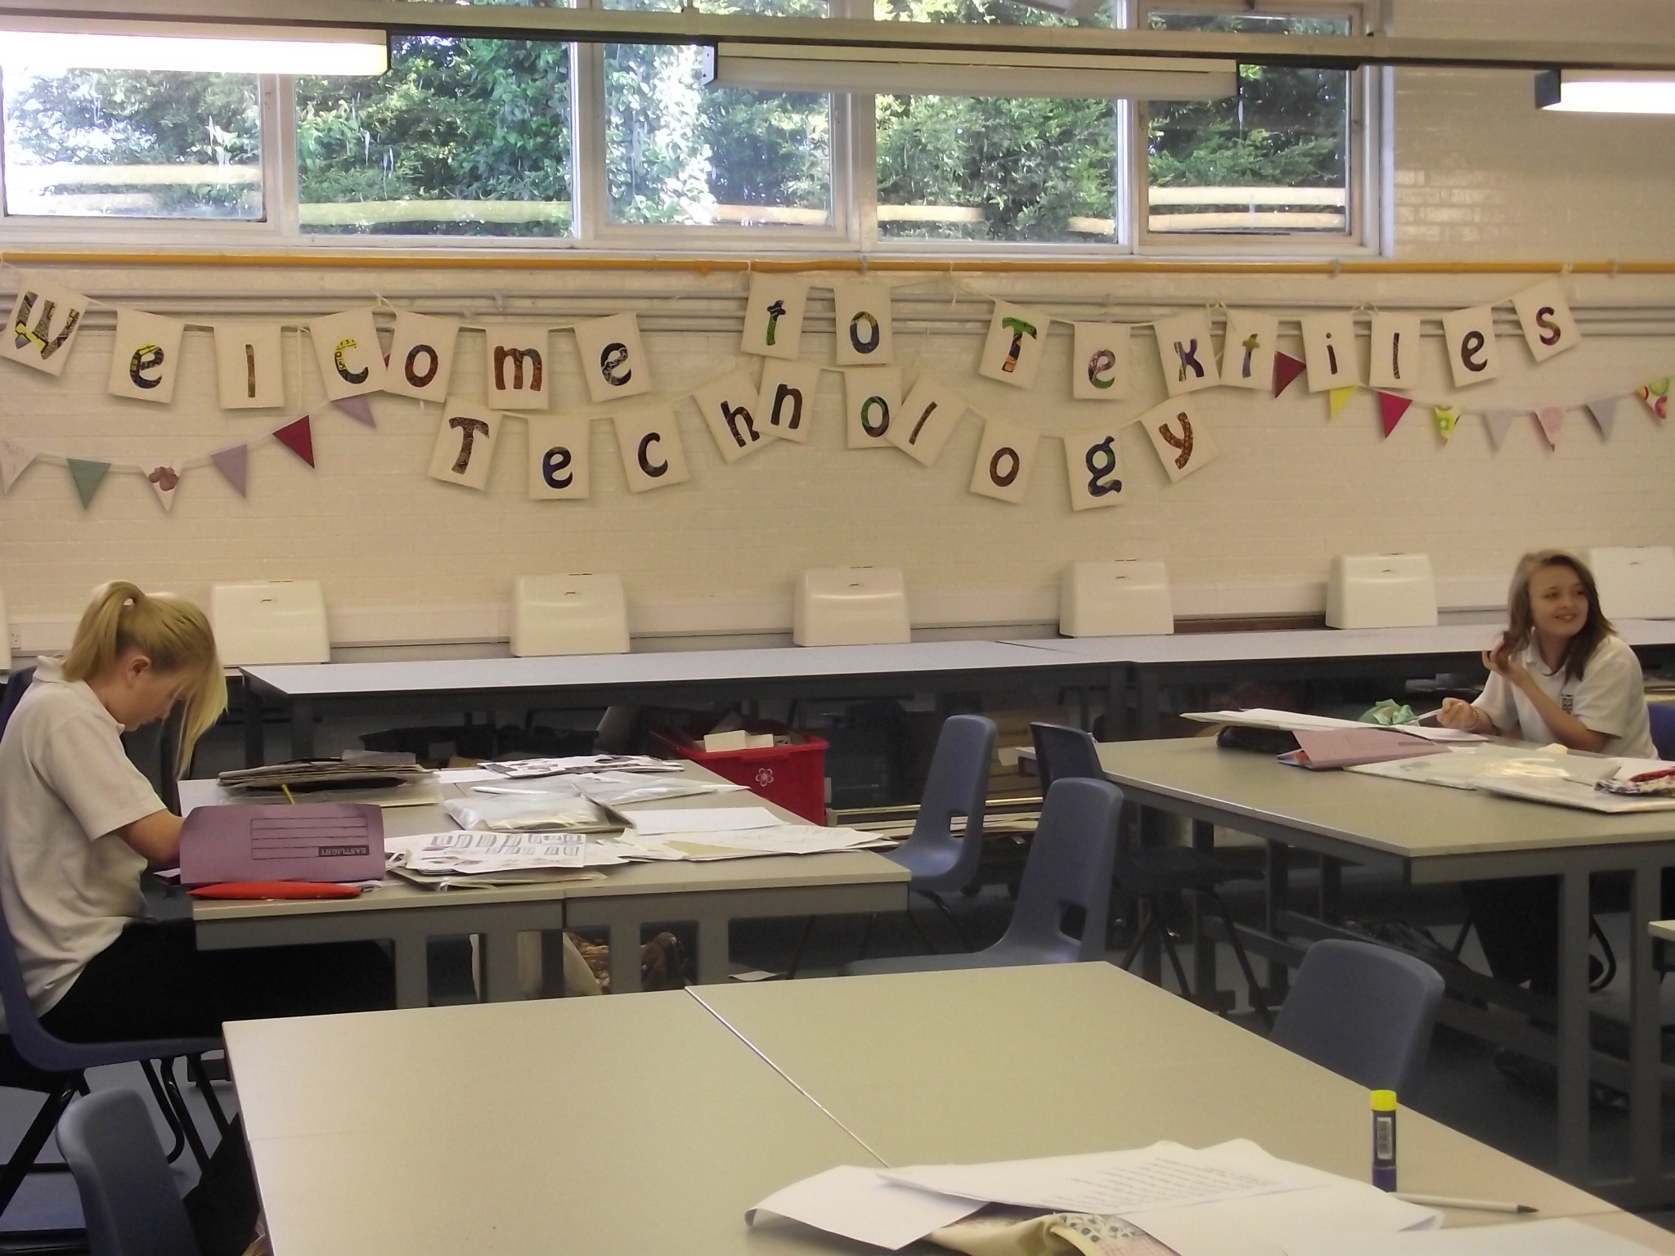
As one of the consistently highest performing faculties in a high performing school Design and Technology is central to the identity and ethos of Sir John Leman High School raising ‘achievement for all’. We offer an expanding range of GCSE and post 16 courses, and are used to guiding over 200+ students to exam success each year. With an experienced staff base the department has undergone a process of modernisation, including the development of resources and teaching spaces that provide learning opportunities both within and beyond the classroom. With the recent changes to KS4 & 5 exam specifications, we are currently reviewing and developing our curriculum to provide learning experiences to ensure inspiration, aspiration and success for all our students.

STAFFING
The academic year 2018-19 the D&T Department will potentially comprise of 5 full time and 2 part time members of teaching staff supported by 3 technicians:

Director of Technology
Leader: Design (KS4 & 5)
Leader: Food (KS4 & 5) tbc
Food & Textiles (KS4 & 5)
Vacancy – D&T (KS3)
D&T (KS3) / Art (KS5)
Photography (KS3, 4 & 5)
Technician (Workshops)
Technician (Textiles)
Technician (Food)

FACILITIES & RESOURCES
The Department is well resourced with a range of specialist purpose built teaching rooms including:

- 2 Food Technology Rooms
- 2 Food Technology Classrooms
- 1 Textiles Studio (with 12 IT Stations)
- 2 Materials Workshops
- 1 ICT / Digital Fabrication Suite
- 1 Mac Suite (25 stations) shared between Photography & Media

THE CURICULUM
Key Stage 3
At KS3 groups are taught on a carousel system, acquiring knowledge and skills in a variety of material areas in Year 7, before developing a foundation understanding of the key concepts that underpin the design process through Design & Make Assignments in Years 8. In September 2018 we hope to develop or Year 9 curriculum to cover a significant part of the ‘core technical principles’ of the new GCSE D&T Specifications, facilitating students to opt, Sept 2019, for a ‘specialised material’ of study from materials or textiles in Years 10 & 11. D&T is a popular option choice with many students choosing to continue to study it at GCSE.

Key Stage 4
At KS4 we currently offer full GCSE courses (OCR) in Food Preparation & Nutrition, (OCR) D&T: Textiles, (AQA) D&T: Resistant Materials, (AQA) D&T: Product Design, (AQA) A&D: Photography and (BTEC) Level 2 Diplomas in Engineering. The changes in the D&T GCSE structure in September 2017 saw an introduction of (AQA) D&T: Materials route with future plans to bring a D&T: Textiles route into the dept.

Key Stage 5
At KS5 we offer an extensive range of courses at AS and A2 study including (AQA) Product Design: 3D Design, (AQA) Product Design : Textiles, Level 3 Award in Food , (AQA) A&D: Photography and are introducing a L3 Diploma in Engineering for September 2018. The majority of our KS5 students take up places on subject related undergraduate courses at HE institutes.

We are always keen to evolve our curriculum to meet future needs of all learners.

EXAM RESULTS
Sir John Leman High School is one of the highest performing schools in North Suffolk. The suite of KS4 & 5 courses offered by the Design & technology Faculty are regularly the highest performing subjects (for Value Added) in the whole school. In 2017 we achieved the following success:

GCSE
Food Technology 75% A*-C
Resistant Materials 83% A*-C
Textiles 85% A*-C
Product Design 75% A*-C
Engineering 100% Distinction

A-Level
Food 100% A*-C
Product Design 100% A*-C
Photography 83% A*-C

We are currently identifying further strategies through the analysis of micro group data to improve achievement by our least able, most able and vulnerable students.

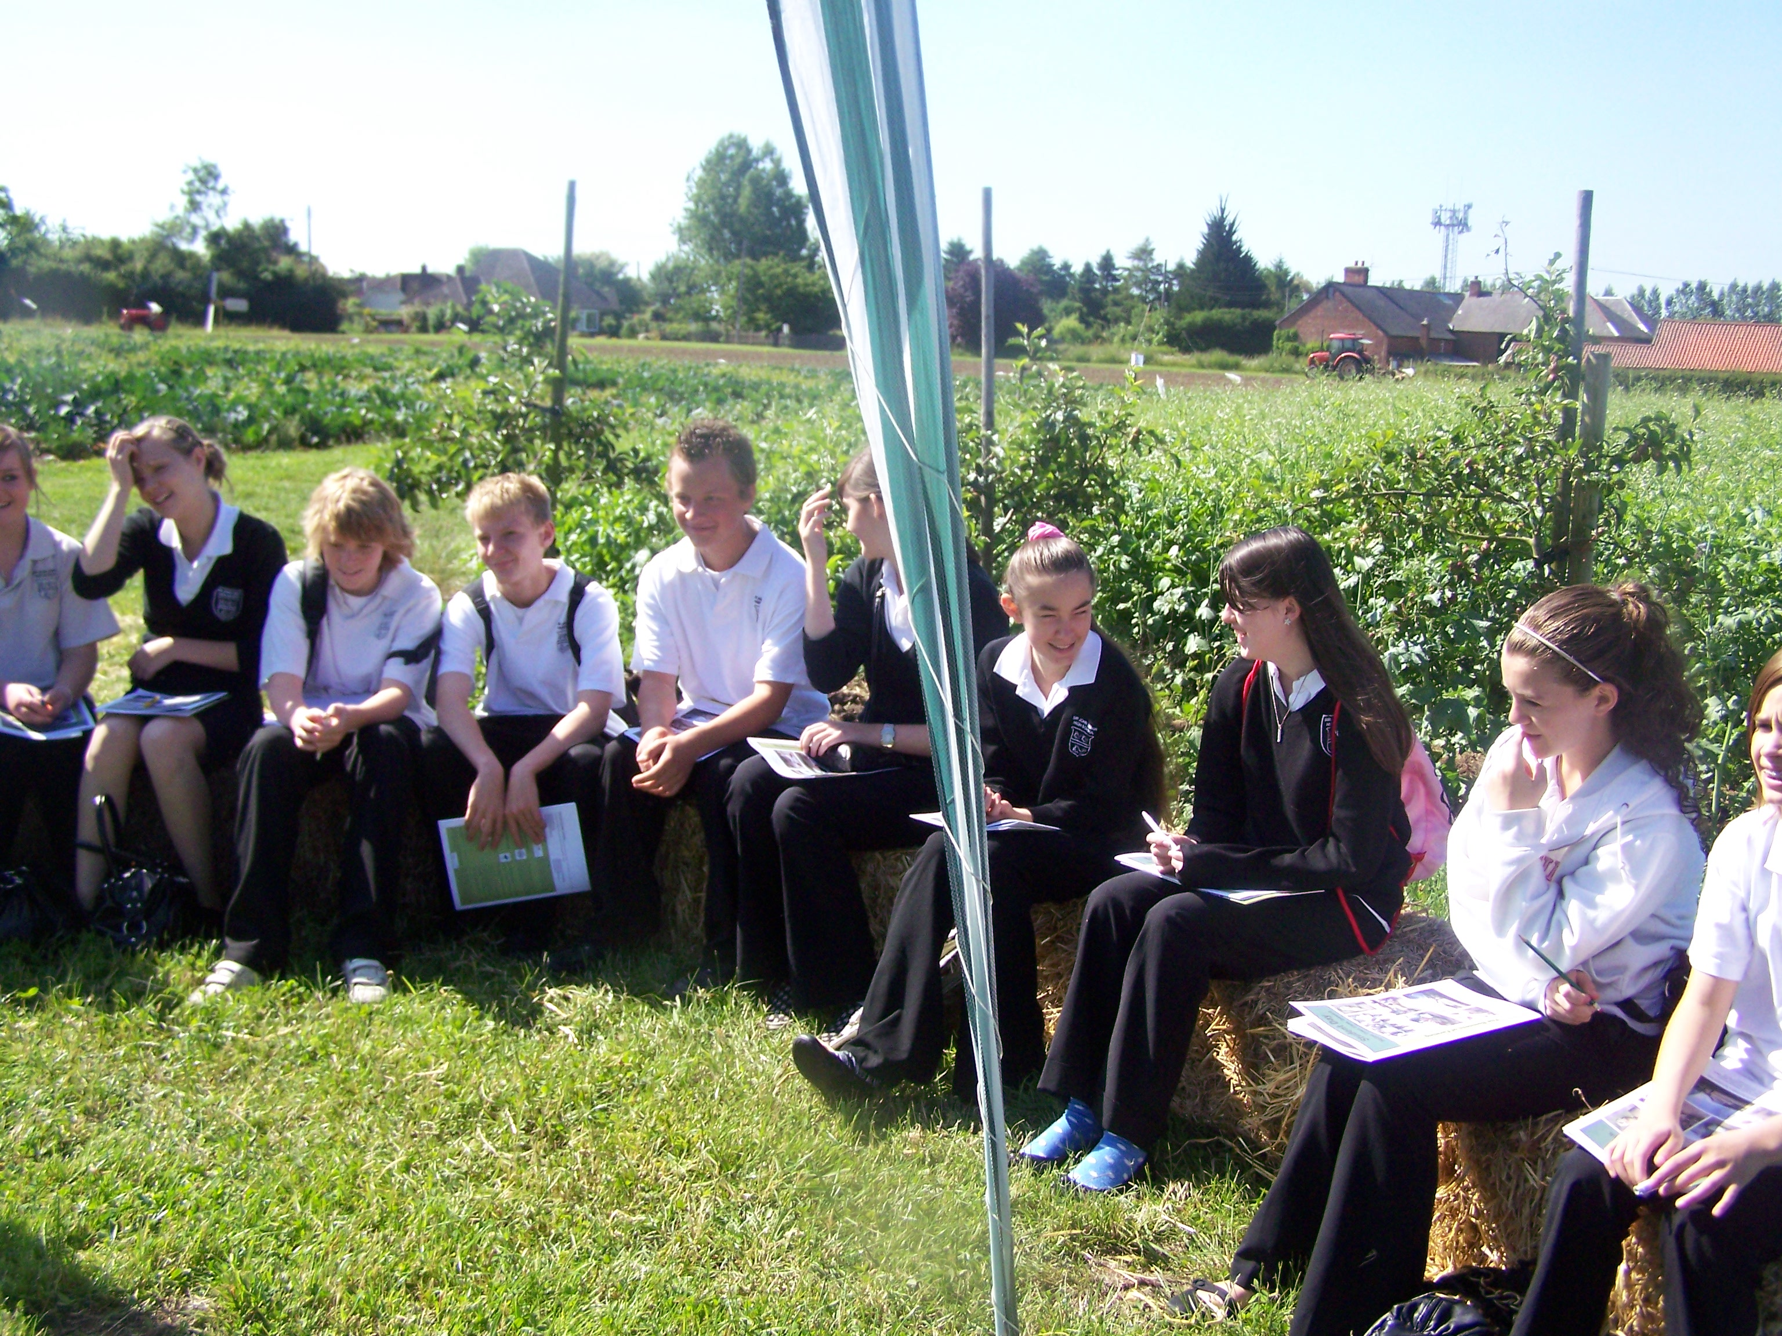
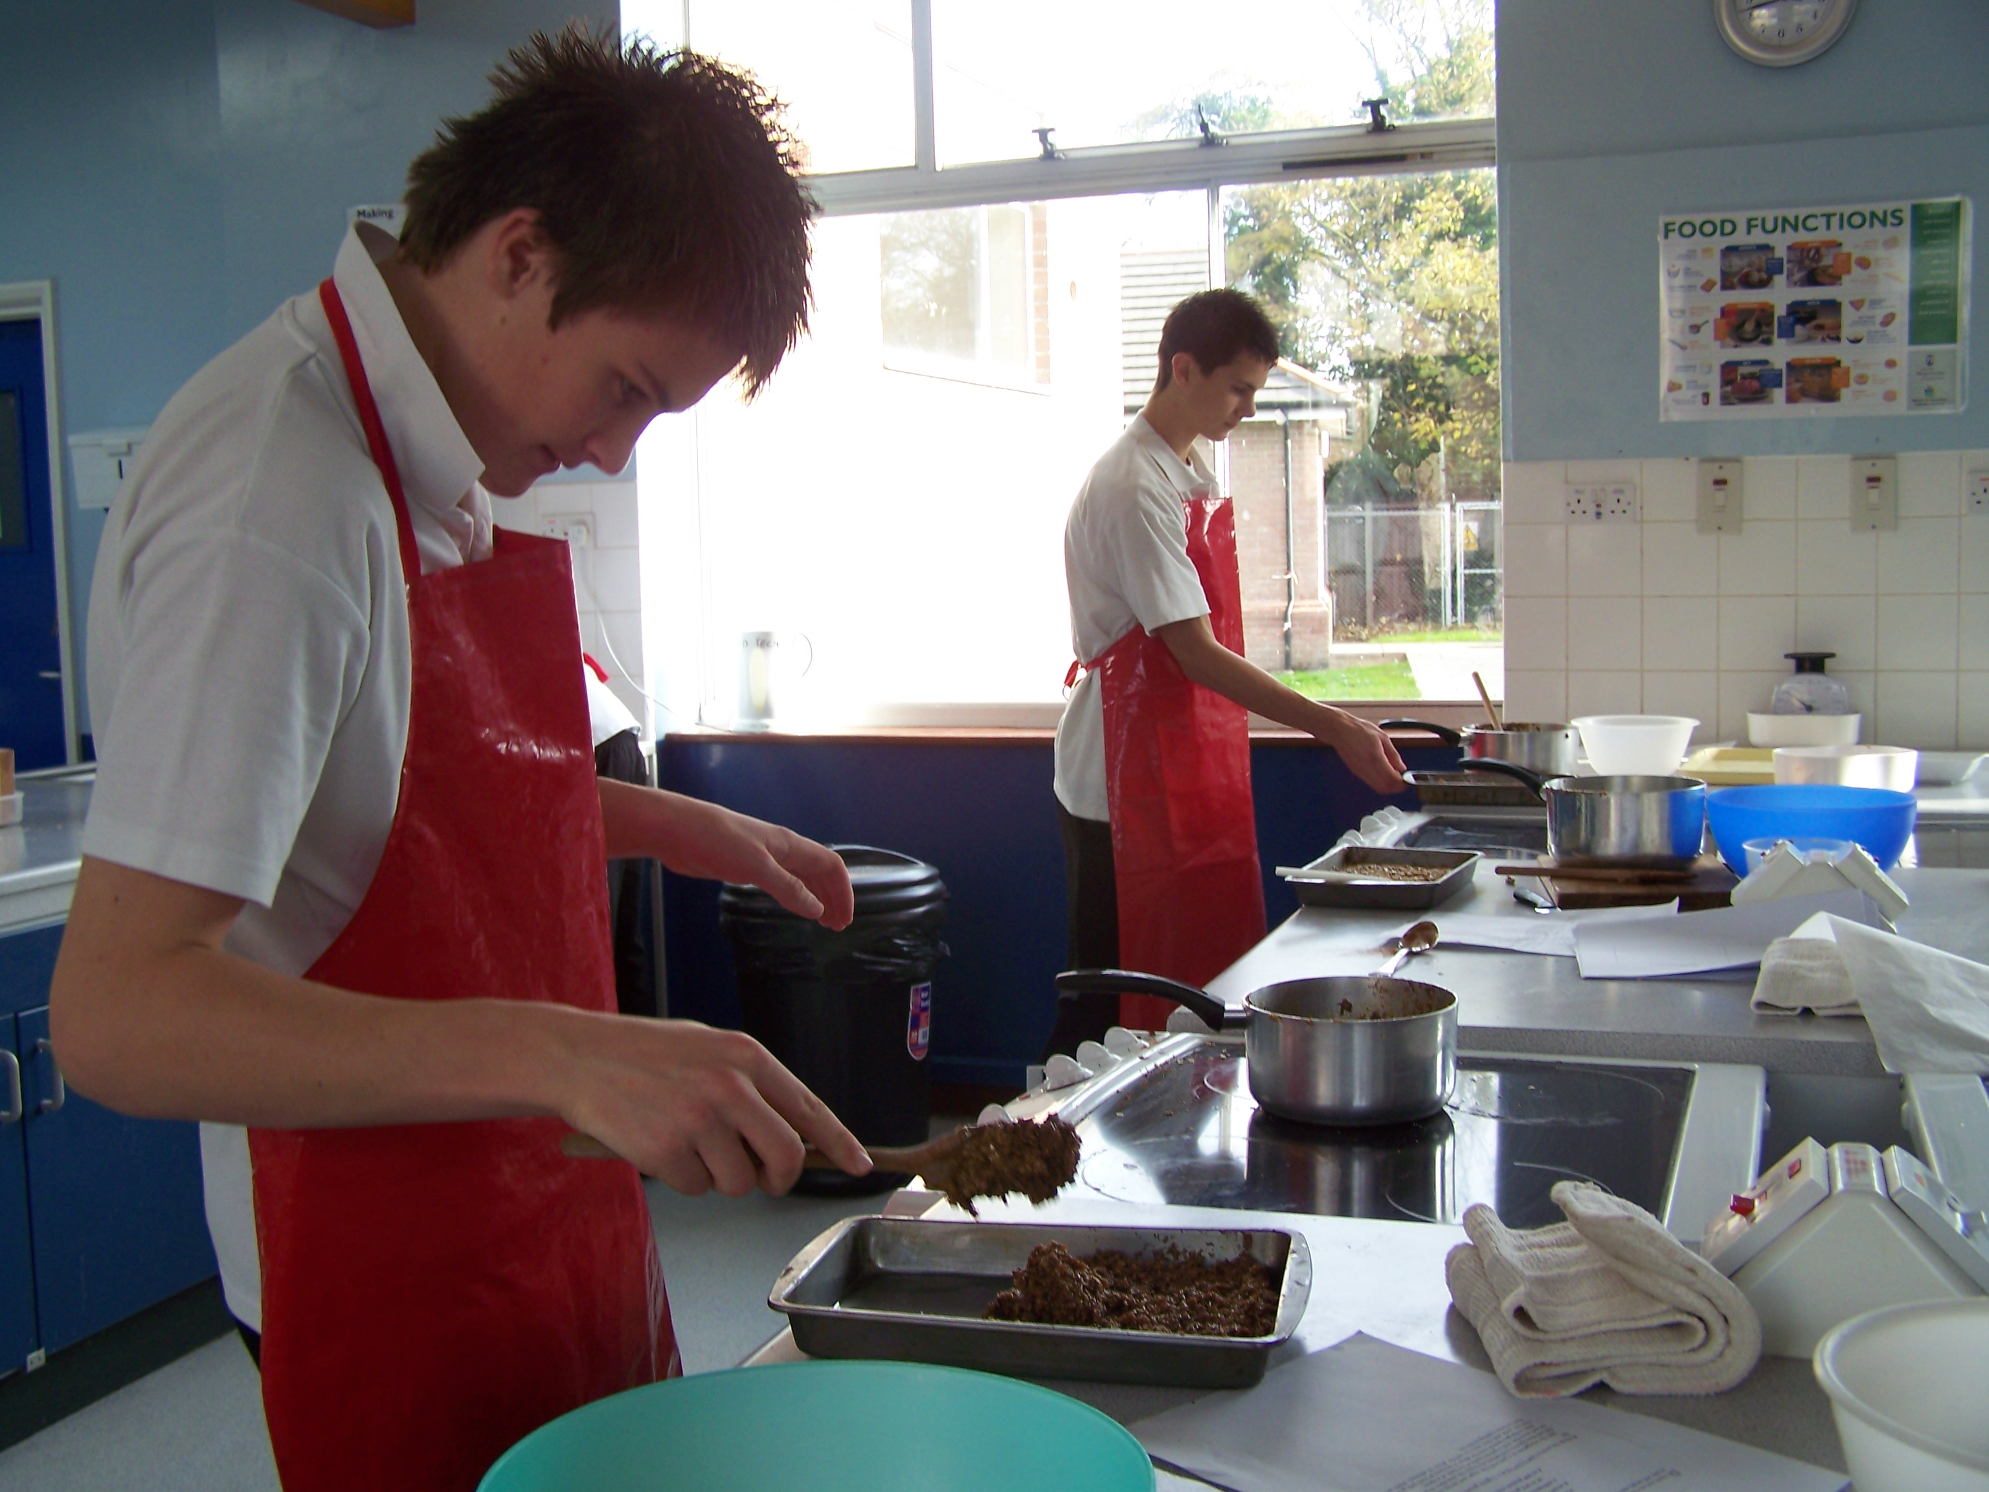
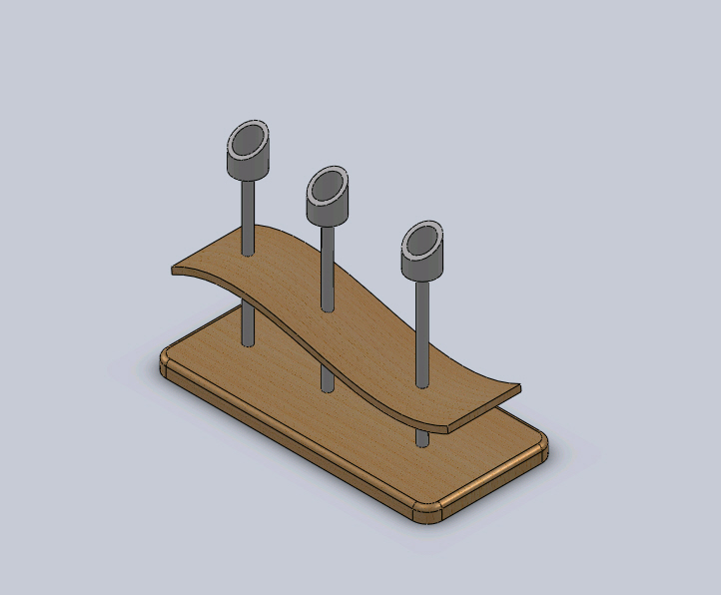
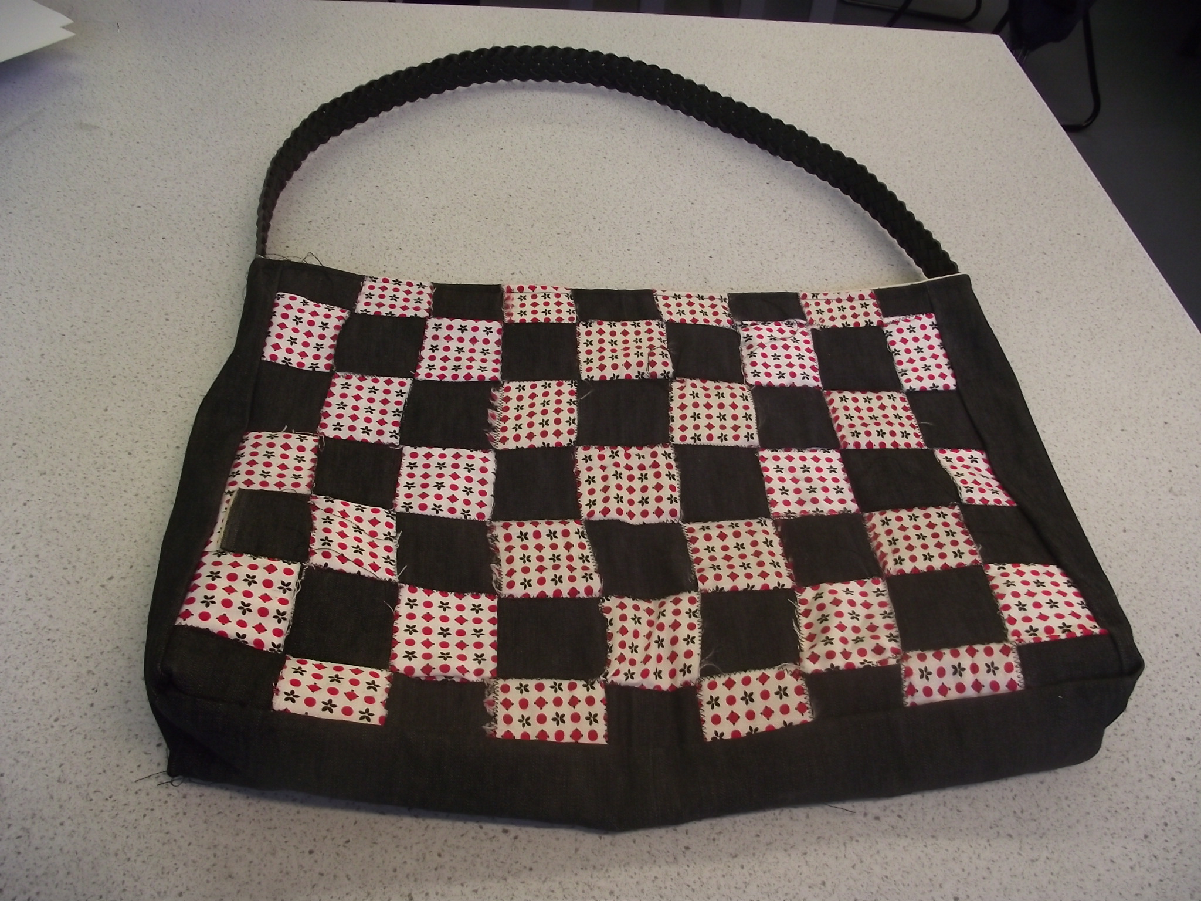

ENRICHMENT AND EXTRA CURRICULAR ACTIVITIES
The Department is keen to extend students learning experiences through the application of their knowledge, skills and understanding in innovative contexts. A variety of educational trips have / are provided including Food & French trip to the Opal Coast, Clothes Show Live, New Designers, 3D Print Fair, Science and V&A Museum, Big Bang STEM Fairs and visits to local industries and higher education providers. Alongside extensive support for KS4 & 5, we also offer a very popular after school KS3 club as well as participation in regional and national schemes and awards, such as the F1 in Schools. In collaboration with other subjects we offer a STEM fortnight of activities in July, which sees opportunities delivered by both school staff and outside providers to students from across all years, culminating in a celebratory STEM Fair.

D&T is also a core driver and participant in the innovative Year 7 ‘Skills’ curriculum we offer, and various members of the department help deliver this area of the School’s curriculum.

