
BUTTERSHAW BUSINESS &
ENTERPRISE COLLEGE

Application Pack

TEACHER OF ICT



Acting Head of School – Mr R J Humphreys (M.Ed NPQH)
Executive Headteacher – Mrs S J Tiller (Headteacher – Immanuel College)

Buttershaw Business and Enterprise College
Reevy Road West
Bradford
West Yorkshire
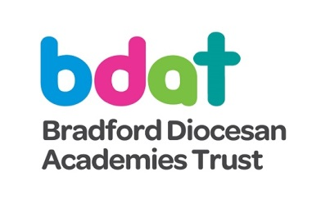
BD6 3PX
tel: 01274 676285
fax: 01274 679228
email: admin@buttershaw.net
school website: www.buttershaw.net
BDAT website: www.bdat-academies.org

BUTTERSHAW BUSINESS &
ENTERPRISE COLLEGE

CONTENTS

About BBEC

The ICT and Business Department

BBEC and the Future

About BDAT

The BDAT Employee Pledge

Making your Application

Job Description

Personnel Specification

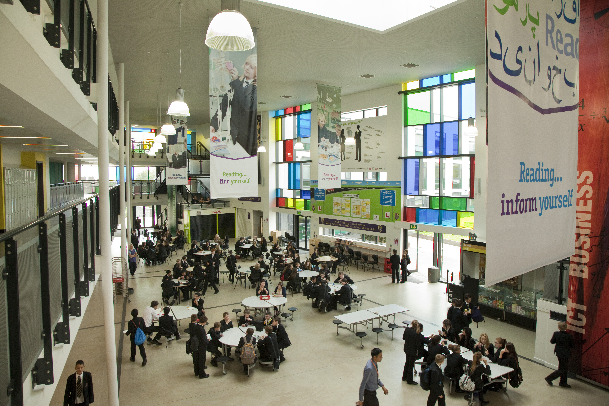

ABOUT BBEC

Buttershaw Business & Enterprise College is an ambitious, community focused academy of 1400 students serving an area of social deprivation on the southern edge of Bradford and seven miles from Leeds. It is popular locally and has been a significant shaper of the new educational landscape in Bradford. In September 2016 we became an academy within the Bradford Diocesan Academies Trust (BDAT). Within BDAT, there is an exciting opportunity to work across a variety of growing diverse schools. This could include significant career development for the right candidate.

We moved into brand new school buildings in September 2008 funded by Building Schools for the Future.

- Departments are arranged in suites of rooms around increasingly well-used breakout spaces
- All teachers have a laptop
- All classrooms are equipped with projectors and the vast majority with interactive whiteboards
- All classrooms are provided with student laptops

The school is a harmonious community and students are almost always polite, pleasant and respectful. A new behaviour policy is focused on improving attitudes to learning and we are pleased with its impact. Student experience is a strength of the school and our recent SMSC audit was very complimentary.

The school is on a trajectory of significant improvement with the Progress 8 figure rising from -0.63 in 2015 to -0.35 in 2016 and -0.15 in 2017. Last summer, over 90% of subjects improved GCSE progress. Sixth form results are also on an overall improving trend.

Our partnership with BDAT is an exciting support to our strategy for further improvement in every aspect of school life. Buttershaw staff are already becoming involved in work across the Trust’s four secondary schools. As a new sponsored academy we will not be inspected until 2018; our clear ambition is that Ofsted inspectors will recognise consistent excellence in provision when they return.

There is a cohesive and ambitious staff team who place student success at the heart of their endeavours. Many of our students face multiple challenges and it is through clarity of vision, professionalism and determined support for each other and for students that we are bringing about improvement. Whilst this job is not for the fainthearted, it offers great opportunity and a chance to make a difference to some wonderful young people.

A rigorous approach to quality assurance and a significant commitment to Continuing Professional Development are at the heart of our plans for improvement. Pedagogy is enthusiastically discussed and over recent years we have had 40 teachers who have undertaken an external project or embarked on a masters course, with 14 having experienced a middle leadership programme organised jointly with our partners at a Bradford company. External support for leadership and teaching is used, especially through our growing partnership with Immanuel College, and this will provide other opportunities for the successful candidate.

For the successful candidate, this would be an ideal time to join what is an exciting and supportive team environment. It is also a great chance to make a difference for some wonderful young people.

We look forward to hearing from you.

THE ICT AND BUSINESS DEPARTMENT

The ICT and Business team consists of five full time teaching staff and a Progress Support Leader. The teaching staff have a well-developed team ethic, commitment and a shared passion for the subject and to developing their pedagogy. They are committed to developing practice to improve the learning experience of students.

The department vision is to create an environment and ethos where learning is outstanding and all students excel. The belief is that we will achieve this by working together to support the development of teaching skills and practices in ourselves and colleagues.

The department boasts five specialist ICT suites that all contain an interactive whiteboard, at least 30 desktop computers and a visualiser.

Students study one lesson of ICT in Years 7, 8 and 9 and then can choose to opt for ICT or Business in Years 10 and 11. Current courses ar KS4 include:
- Edexcel GDA
- Computing GCSE
- Business GCSE
- IFS Personal Finance
ICT and Business are also popular post-16. In 2018/19, students will be studying BTEC ICT, Business (OCR) and Personal Finance (IFS).

BBEC AND THE FUTURE

The pace of educational change is rapid and we believe, at Buttershaw, that we have positioned ourselves to help shape that future, ensuring that moral purpose is at the heart of structural change and that our young people benefit significantly from the new arrangements.

THE FUTURES LEARNING PARTNERSHIP

In concert with our key primary partners, we continue to develop the Futures Learning Partnership. This is a formal partnership with our seven primary partners to ensure consistent working in three areas of importance:

- student commitment
- student skills
- student aspiration

Each school has committed to key principles and activities including, for example, the establishment of a 4-19 life plan and close co-operation in English and maths.

www.futureslearning.org

BDAT SUBJECT NETWORKS

BDAT plays an increasingly important part in the development of Buttershaw; the opportunities for CPD across the Trust are increasing, as well as opportunities for promotion. The Trust has a strong philosophy of developing its staff, and works proactively to develop its teachers through cross-school working.

Subject networks, including English, have been instrumental in enabling the four secondary schools to work together. Already important initiatives around schemes of learning and assessment have brought improvements to all schools.

BRADFORD DIVIDEND – STUDENT LOAN REIMBURSEMENT SCHEME

All eligible teachers in Bradford are able to apply for a reimbursement of their student loan payments made in the first ten years of their careers, starting from September 2018.

To be eligible for reimbursement you must be employed in a secondary or special school in Bradford and been awarded QTS in the period 2013/14 – 2018/19. In addition, you must teach in one of the following subject areas: languages, physics, chemistry, biology or computer science.

You are eligible for reimbursements for the ten academic years following the year in which you were awarded QTS. The first academic year for which you can claim is 2018/19. The amount you receive is dependent on your salary and consequently the amount of loan you would repay.
For more information, please follow the link below:

www.bradfordteaching.org/bradford-dividend/student-loan-reimbursement-scheme/



ABOUT BDAT
Buttershaw Business and Enterprise College is an academy within Bradford Diocesan Academies Trust. If you are successful in being appointed, the Trust will be your employer.

GENERAL INFORMATION AND BACKGROUND
Bradford Diocesan Academies Trust (BDAT) is a Multi-Academy Trust (MAT) supporting a number of primary and secondary academies in Bradford. BDAT is the only Church of England MAT operating in Bradford, as part of the Diocese of Leeds. BDAT is a charity governed by a board of trustees who are responsible for, and oversee, the management of the company. The Memorandum and Articles are available on the Trust’s website at www.bdat-academies.org.

OUR MISSION STATEMENT
“The Trust’s mission is to provide an education of the highest quality within the context of Christian belief and practice.” We believe every child only has one chance at a good education. In practice, as a Trust, we seek to work with and alongside the academies in our Trust to provide a good quality of education to all children in our academies. The Trust does this through operating a light touch support role for academies at times of challenge and by establishing collaborative structures and processes to enable our academies to work together and share good practices. As our family of academies continues to grow, we are constantly looking at how we can continue to improve to establish effective and efficient ways of partnership working.

OUR GROWTH
As of September 2017, the Trust has academy orders to support 14 Church and non-Church academies across Bradford. This includes four secondary academies (Immanuel College, Buttershaw Business and Enterprise College, Belle Vue Girls and Bradford Forster Academy) and ten primary academies. We envisage we will continue to grow at a sustainable pace over the next few years, in line with the Government agenda that all schools will become academies by 2022, to a maximum size of approximately 20 schools. We believe this will mean we are big enough to achieve business economies of scale whist being small enough to retain our family of schools approach where we truly able to know, understand and support each other.

OUR CHRISTIAN ETHOS
BDAT is a proudly Christian organisation committed to providing high-quality education for all within an ethos which encourages academic, vocational, mental, physical, and spiritual opportunities and development for each member of its academies. Whilst robust Christian principles underpin the work of the Academy, everyone is encouraged to explore their own spirituality and to recognise and understand that of others. It is for this reason that we choose to support and sponsor Non-Church of England academies, as well as those within the faith.

THE BDAT EMPLOYEE PLEDGE
Bradford Diocesan Academies Trust recognises that if our schools are to succeed, our teachers and school staff are our most valuable asset. As such we work hard to be an employer and the schools of choice in Bradford.

WE DO THIS BY:
- Relentlessly only recruiting the highest calibre of teachers who share our aspiration and ambitions for out pupils to succeed;
- Developing our teams by talent spotting and rewarding our next generation of leaders
- Making sure BDAT is a good place to work so that retain and grow the expertise and skills of our people. Keep reading to find out more about our our employee pledge which sets out what you can expect from us if you choose to join BDAT and what we will expect of you.
WE WILL OFFER YOU:
- Work in a values driven, student centred organisation where every child is support to reach their academic potential and accomplish their individual goals. http://www.bdat-academies.org/about-us/bdat-mission-statement/
- The prospect of working for an increasingly successful and growing Trust which is committed to providing high quality education for all of its students and to be the schools of choice. www.bdat-academies.org
- A separate annual career development discussion with a senior leader resulting in a bespoke career development plan in addition to Performance Management.
- Ongoing assistance in developing your ‘craft’ of teaching
- Assistance with career progression both within and outside the Trust
- A competitive employees’ benefit scheme http://www.bdat-academies.org/aboutus/employee-benefit-scheme/

WE WILL PROVIDE YOU WITH THE OPPORTUNITY TO:
- Have a week’s placement in one of the BDAT schools within the first two years
- Shape the curriculum developments in an ever- changing world
- Work with like-minded subject colleagues from the other trust schools
- Shadow colleagues both within the school and across BDAT
- Support the development of teachers new to the profession or to their role
- Gain the experiences required to meet external leadership qualifications such as Specialist Leadership in Education

THE BDAT EMPLOYEE PLEDGE (continued)

IN RETURN, WE EXPECT YOU:
To Model
- The values of BDAT and your school at all times
- Professional behaviours at all times
To Be
- A consistently good teacher on a day to day basis
- Committed to ongoing professional development
- A team player and to adopt a ‘can do’ attitude
To
- Place safeguarding of students at the heart of the work
- Engage in constructive professional dialogue, giving and listening to feedback
- Contribute to the development of students and staff
- Meet Teachers’ Standards and Trust Leadership standards as appropriate to career stage expectation

Thank you for taking the time to read this information.

CONTINUING PROFESSIONAL DEVELOPMENT AT BUTTERSHAW
At each career stage, we have a clear commitment to professional development to match the growing expectations of staff.

NQTs and RQTs receive significant support from the school, including appropriate mentors in the NQT year. All teaching staff have an agreed CPD programme and additional training is provided where necessary. Every member of staff has the right to an annual study day, often looking at good practice in another school, and there can often be contributions to the cost of further study.

Staff development needs are summarised in an individual development plan; this is the basis for decisions about, and entitlement to, CPD.

MAKING YOUR APPLICATION
We hope that having read this pack you are inspired to apply for the post.

Job packs and application forms can be downloaded from the TES website – there is a link on our website www.buttershaw.net under Staff/Current Vacancies.

If you would prefer a paper copy, or would like to speak to someone about the vacancy, please contact Anna Krywyszyn at Buttershaw Business and Enterprise College on 01274 676285, or by email at alk@buttershaw.net.

In order to apply, please complete the BDAT application form. To aid our shortlisting process, it would be helpful if you could complete the evidence column of the person specification, indicating how your knowledge, skills and experience to date enable you to meet or exceed the listed attributes. Your application should be accompanied by a covering letter of no more than one side of A4, detailing what makes you the ideal candidate for the role.

Applications must be received by the closing date of 9am on Thursday 22 March. Interviews to be held in w/c 26 March 2018.

Visits to the school are recommended, and can also be arranged by contacting Anna.



JOB DESCRIPTION |  | TEACHER OF ICT
Purpose |  | To teach and facilitate learning for a range of students including preparing them for qualifications where appropriate.
Responsible to |  | Achievement Leader for ICT and Business
Salary |  | Main/upper teachers’ scale
MAIN (CORE) DUTIES
Teaching  (65%) |  | - Working in line with the National Standards for Teachers  - Marking work, giving appropriate feedback and maintaining records of students' progress and development  - Planning, preparing and delivering lessons to a range of classes including putting up displays in the classroom  - Selecting and using a range of different learning resources and equipment  - Managing student behaviour in the classroom and on school premises, and applying appropriate rewards and effective measures in cases of misbehaviour  - Preparing students for qualifications including external examinations and administrating and invigilating  - Undergoing regular observations and participating in regular in-service training (INSET) as part of continuing professional development (CPD)  - Researching new topic areas, maintaining up-to-date subject knowledge and then devising and writing new curriculum materials  - Devising and writing new curriculum materials under the guidance of the subject leader  - Supervising and supporting the work of teaching assistants, trainee teachers and newly qualified teachers.
Tutoring  (20%) |  | - Undertaking pastoral duties in the role of form tutor, and supporting students on an individual basis through academic or personal difficulties  - Encouraging high standards of work, behaviour and dress in students  - Creating a positive ethos and acting as a good role model  - Monitoring and reviewing students' current progress across the curriculum using data provided  - Keeping parents fully involved regarding students' progress, including curriculum related or behavioural concerns  - Participating in parents' evenings and report writing  - Being aware of social and personal factors relevant to students within and outside of school.
Contribution to the wider school  (10%) |  | - Participating in and organising extra curricular activities, such as outings, social activities and sporting events  - Participating in departmental meetings and whole school training events  - Liaising with other professionals, such as learning mentors, careers advisors, educational psychologists and education welfare officers.
Policies and Ethos  (5%) |  | - Being aware of and complying with policies and procedures relating to child protection, health, safety and security, confidentiality and data protection, reporting all concerns to an appropriate person  - Being aware of and supporting difference and ensuring all students have equal access to opportunities to learn and develop  - Contributing to the overall ethos/work/aims of the school  - Appreciating and supporting the role of other professionals  - Attending and participating in relevant meetings as required  - Participating in training and other learning activities and performance development as required.  - Supporting, upholding and contributing to the development of the School’s Equality Policy and practice in respect of both employment issues and the delivery of services to the community  - To undertake lunchtime and break supervisory duties as directed.
The duties and responsibilities listed provide an outline of the job. You may be asked to undertake other duties.

PERSONNEL SPECIFICATION – TEACHER OF ICT

 | Skills, Successful experience, Attributes | Score 1-3  (office use only) | Evidence
Teaching  (65%) | - Successful experience of teaching ICT at KS3-4  - Qualified Teacher Status  - A degree in a relevant subject  - Successful experience of teaching a range of abilities  - Ability to manage a classroom effectively, maintaining firm but fair discipline  - Successful experience of ICT in the classroom  - Successful experience of teaching in a comprehensive school with a significant number of PP students  - Ability to promote the study and value of ICT by motivating students of all abilities  - A record of achieving good results  - Knowledge of examination requirements in all key stages
Tutoring  (20%) | - Ability to relate well to students, setting clear and high expectations of behaviour, effort and achievement  - Competence in monitoring and assessing student progress
Support for the school  (10%) | - A willingness to ‘go the extra mile’  - Evidence of diligent and effective duties.  - Evidence of relevant training or willingness to undertake such training  - Flexibility to work across the Trust  - Good attendance and punctuality  - Not requiring to take time off during term time
Required personal qualities and attributes  (5%) | - Wisdom, integrity, justice, compassion, ambition  - A constructive approach to the management of difference  - Evidence of support for the school ethos and vision  - The ability to take initiative and make decisions  - Good oracy skills

