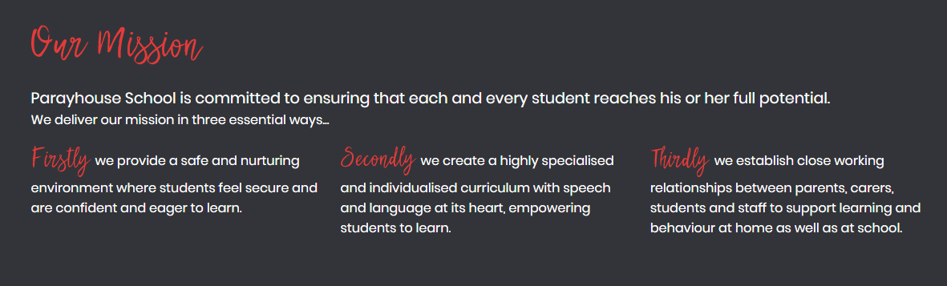



# HEADTEACHER CANDIDATE

# INFORMATION

The Governors/Trustees of Parayhouse School are seeking to appoint a new Headteacher for September 2018. At the end of the Summer Term 2018 the current head and founder of the school is retiring, after an extremely successful career.

Parayhouse is a ‘good’ school with ‘outstanding’ behaviour. The School is rigorous in ensuring that students have personalised curricula which meet their individual needs. The relationships within the School are strong and the resulting ethos is positive, caring and aspirational. The parents are extremely supportive and the Governors/ Trustees work closely with the Head offering both support and challenge.

Just over a year ago, Parayhouse School moved into premises at the Hammersmith and Fulham College, adjacent to the college’s own provision for SEND students from ages 16 to 25. There is the possibility of further development of the School within the college premises.

We wish to appoint an energetic and sensitive head with Senior Leadership experience in SEND.

Parayhouse is a special school which deserves an outstanding Headteacher to take it on its forward journey. We hope the new Head will both build on the School’s current strengths and take us in exciting new directions.

This timescale for the appointment has been arranged to ensure that the newly appointed head will have time to develop basic knowledge of the school and start to build relationships with students, staff and parents prior to taking up the post.

Please take time to read through all the information about the School and, if you think Parayhouse would be a place where you might like to work, it is essential that you make a visit. If you are then certain that Parayhouse is a school you would be happy to lead, please complete the application form writing to the person specification.

The deadline for applications is Monday 27th November 2017 and interviews will take place on Wednesday 6th December 2017.

## Letter from the Chair of Governors/Trustees

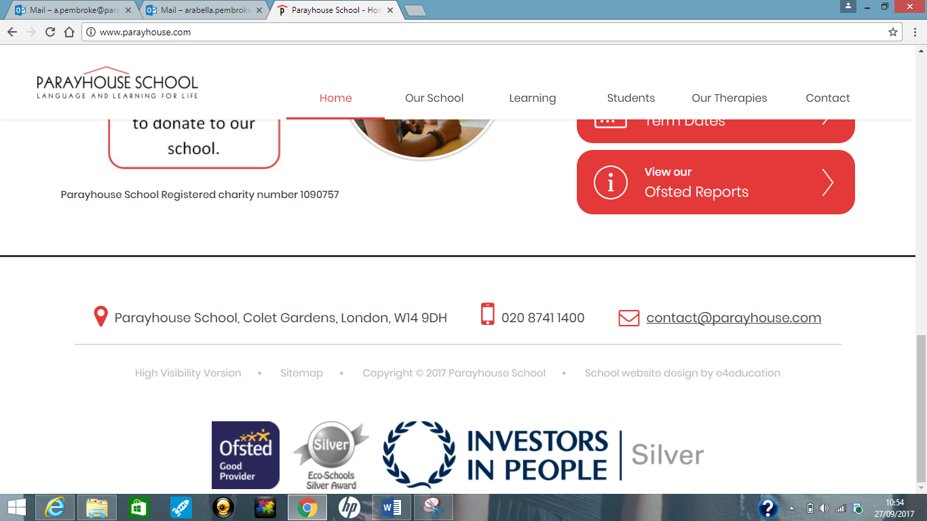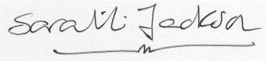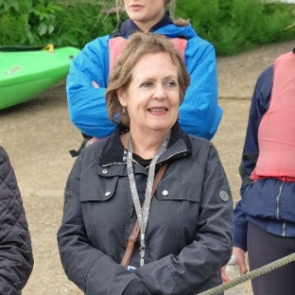

“We wish to appoint an energetic and sensitive head with senior leadership experience in SEND.”

**PARAYHOUSE SCHOOL IS AN EQUAL OPPORTUNITIES EMPLOYER**

We look forward to hearing from you,



**Randall S. Peterson**

**Chair of Governors/Trustees**



I have been the Headteacher of Parayhouse since it converted from a small preparatory school to an Independent Special Needs school in 1983. Having initially trained in Sheffield as part of the first ever cohort of teachers of children with moderate learning difficulties, I have always taught in special needs education.

Starting in a church hall with 6 students, over the years the School has grown to having around 48 students from 7 – 16 years of age. Since 2002 the School has been a registered charity and from 2007 onwards a non-maintained special school [NMSS]. We are the only NMSS in London, and in the minority of NMSS as a day special school.

Our students come from 12 London Boroughs and the majority are transported by their LAs in

minibuses and taxis. We are co-located in secure, self-contained ground floor accommodation with Hammersmith and Fulham College and have good links with the College’s Inclusive Learning

provision for students aged 16-25.

Whether you are looking for your first headship or you are an experienced head looking for a new challenge, this unique special school will make a great impression upon you, as it has on students, staff and families for 34 years now.

The ambition to get to Ofsted “Outstanding” across the board remains and there is a possible new build proposition for 2020 and beyond, so there is plenty of challenge for the new Head.

I would love nothing more than to hand over my hugely fulfilling role in this wonderful school to someone who will grow to understand why we all feel so deeply about it. I look forward to meeting all of you who come to visit the school.

**Sarah L. Jackson – Headteacher**

## Letter from the Current Headteacher

“The ambition to get to Ofsted “outstanding” across the board remains”

**Page 3 of 4**

School Newsletter

.



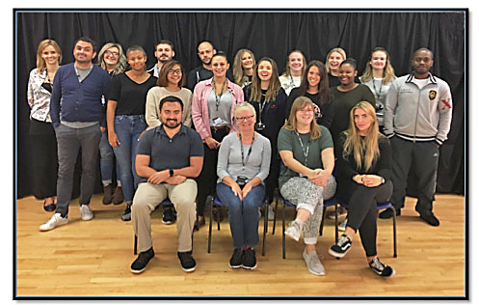

“The support the School gives to staff to develop is second to none; Parayhouse is such a blessing for all students and staff; every day we search for ways to improve, which is priceless!”

***Staff comment***

## Our staff

## Headteacher Job Description

## The headteacher will be responsible for developing a happy and motivating ethos within the School where we care for each other, learn together, celebrate success and involve all stakeholders in valuing the contribution of staff and the uniqueness and potential of every student at Parayhouse.

* Lead and manage an effective school in which student progress and achievement are consistently improving and students’ needs are identified and addressed appropriately
* Create, with all stakeholders, the educational vision for the school
* Liaise with all stakeholders, governors, parents, LAs and all external support services to ensure that the wellbeing of all students is at the heart of decision making
* Lead, manage and support a staff team that has the confidence to meet the needs of students



## Specific Responsibilities

* Act as Company Secretary to the Board of Governors/Trustees and to supervise the writing of the Annual Trustees Report for the returns to Companies House and the Charity Commission
* Ensure, in collaboration with Governors/Trustees, the effective and efficient management of all resources related to Parayhouse School
* Execute all decisions made by the Governors/Trustees pertaining to any aspect of the School
* Ensure that Governors/Trustees have full information about school development and progress
* Engage appropriately with all Governor/Trustee subcommittees

## Governors/Trustees

To ensure that:

* the school prioritises the health and safety of all students and staff and remains committed to the Safeguarding of all students
* safeguarding procedures fulfil all legal requirements
* the appropriate staff have First Aid Training which is renewed as necessary
* all recruitment procedures for staff include the requirements of the Safeguarding Vulnerable Groups Act 2006 and the Disclosure and Barring Scheme

## Safeguarding, Health and Safety

* the Single Central Register is maintained and that all employee contracts are current and relevant
* professional legal advice for employment issues is sought and advise the Board of Trustees accordingly
* all staff and Governor/Trustees have training in all the above areas and the Prevent Strategy
* e safety procedures are understood and followed by students, staff and parents

## Leadership and Management

To ensure that:

* student assessment data is used to inform the arrangements for teaching and intervention programmes
* the taught curriculum is appropriate and personalised for each student to meet her/his needs
* staff receive appropriate Continuing Professional Development to meet their needs and improve performance
* staff Performance Management targets result in increased student achievement, increased professionalism and appropriate action is taken where these are not achieved
* when students leave Parayhouse, they move on to fulfilling placements for the next stage in their development
* a School Development Plan is in place which is understood and committed to by all stakeholders
* a School Evaluation Document is available on a regular basis
* there are effective arrangements for the daily management of the school
* there is a team of teachers, therapists and support staff who can teach at an outstanding level
* arrangements are made for frequent monitoring of the quality of teaching and learning and student progress

## Succession Planning

## Parental Support

* To ensure that parents/carers are key in all decisions regarding student provision
* To co-ordinate and oversee all students’ Annual Reports and lead the Annual EHCP Review Meetings for all students
* To ensure communication with parents is relevant, appropriate, informative and empathetic
* To ensure the Family Support Officer works with parents in ways that are supportive, whilst assisting families to become more independent in the care of their children
* To ensure teachers and Speech Therapists meet with parents regularly to keep them up to date with their child’s performance and provide support to help them assist their child’s learning

## Documentation

To ensure that:

* the School Website meets all requirements, is accessible to OFSTED for information they require and is easy and friendly for parents and students to use
* all required school documentation is in place and that all documentation is reviewed appropriately by relevant stakeholders



* School Policies and Curriculum documentation reflect practice
* Ensure that the Assistant Heads have the skills and information to deputise for the Headteacher for short or extended periods
* Work with the Leadership Team in a way that shares responsibility and ensures a culture of shared leadership and accountability
* ‘talent’ spot and provide CPD for staff who demonstrate skills in areas which support the development of the school and the individual’s career development



## Experience

## Knowledge and Understanding

## Qualifications and Training

## Headteacher Person Specification

* Qualified Teacher Status (QTS)
* National Professional Qualification for Headship (NPQH) or higher-level degree or willingness to undertake
* Proven commitment to CPD in leadership & management and/or other relevant training
* Good working knowledge of a range of therapeutic disciplines, including speech and language therapy and occupational therapy
* Up to date knowledge of all safeguarding, health and safety principles and British values
* Commitment to Equal Opportunities
* Good understanding of performance management and its impact on school improvement and development
* In-depth knowledge of school evaluation and how this meets Ofsted requirements
* Up-to-date knowledge and understanding of the changing educational context and statutory requirements in relation to students with complex SEN in the UK
* Successful teaching in a mainstream or special school and a proven track record of leading school improvement and raising standards
* Working in, and leading, a collaborative, multi-professional team in line with Ofsted expectations
* Developing appropriate personalised curricula for students with a wide range of special educational needs, leading to optimum academic, social and personal outcomes
* Working productively with professionals from Health, Social Services and other key professionals who are supporting students and their families

## Leadership Skills & Management Abilities

The proven ability to:

* lead and motivate staff through collaboration and delegated leadership and establish a clear and shared set of aims, objectives and values for the school
* organise, plan and direct, ensuring the smooth running of the school on a daily basis
* coach and mentor staff, especially in relation to succession planning
* be a visible leader, involved and available to staff, students and parents
* hold staff to account
* work with Governors/Trustees to ensure the continued, collaborative drive for improvement
* communicate with, and write effectively to, different stakeholders including parents, teachers, governors, support services and the wider community

## Personal Qualities

* Loyal, hardworking, resilient and able to become passionately committed to the School, its ethos and collaborative practice
* Prepared to innovate while determined to protect and preserve the culture of the school
* Supportive of all staff in their professional and personal development
* Willing to listen to others and incorporate their advice and expertise
* Empathetic, firm and fair, with a warm sense of humour





**School Business Manager:**

a.sullivan@parayhouse.com

**Headteacher:**

s.jackson@parayhouse.com

**Chair of Governors/Trustees:**

r.peterson@parayhouse.com

**Postal Address:**

Parayhouse School

Hammersmith and Fulham College

Gliddon Road

London, W14 9BL

**Phone:**

020 8741 1400

## School Information