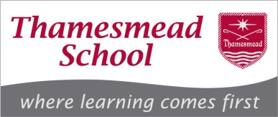
Teacher of History
Person Specification
Category | Essential | Desirable | Evidence form
Education and Training | - Qualified Teacher Status.  - Graduate or equivalent in appropriate subject.  - Evidence of continuing professional development | - Good Honours Degree (First or Second Class) | Application form
Experience | - Successful teaching practice or experience teaching History to students aged 11-16.  - Up to date knowledge and understanding of current educational issues.  - ICT competence and interest in using ICT in the classroom. |  | Application form  Letter of application
Knowledge | - Knowledge of statutory curriculum, assessment, recording and reporting requirements for History.  - Understanding of the characteristics of high quality teaching in History.  - Knowledge of strategies for raising student attainment. | - How to use comparative data, together with information about students’ prior attainment, to set targets for improvement. | Interview  References
Skills | - Good oral and written communication skills.  - The ability to prioritise, plan and organise.  - The ability to solve problems and make decisions.  - The ability to take responsibility for continuous professional self-development.  - The ability to inspire students and staff.  - The ability to work under pressure and to meet deadlines.  - The ability to analyse, understand and interpret relevant information and data.  - The ability to use ICT appropriately. | - Professional proficiency and experience in the use of ICT. | Interview  References
Attributes | - Self confidence and initiative.  - Reliability, resilience and integrity.  - Energy, enthusiasm and imagination.  - Personal impact and presence.  - Intellectual ability.  - Be suitable to work with children. | - Willing to contribute to the wider life of the school.  - Interests and experiences outside teaching. | Interview  References

