EXETER SCHOOL

RECRUITMENT OF

DIRECTOR OF DEVELOPMENT AND ALUMNI

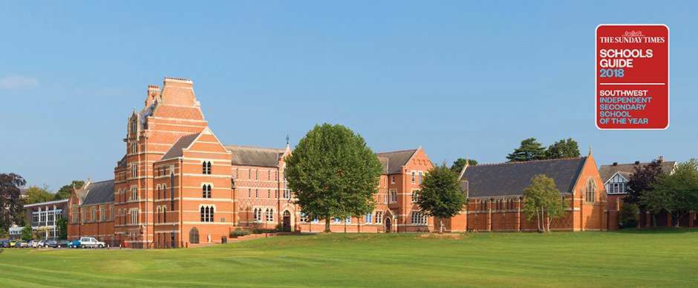

Registered Charity Number: 1093080
Exeter School: a Company Limited by Guarantee and registered in England. Company Number: 04470478 Registered Office: Victoria Park Road, Exeter, EX2 4NS

DIRECTOR OF DEVELOPMENT AND ALUMNI
Exeter School seeks to appoint a Director of Development and Alumni to set the vision and strategy for fundraising and alumni relations from 2018 onwards.

THE SCHOOL
Exeter School is a leading HMC co-educational day school, with 920 pupils, providing a first class education to girls and boys between the ages of 7 and 18. It comprises a Senior School, with an embedded Junior School, on a 20-acre site close to the city centre.

The Sunday Times has recently named Exeter School ‘South-West Independent Secondary School of the Year 2018’. The 25th edition of its annual Schools Guide, Parent Power, has awarded the top place to the co-educational independent school, based on its outstanding academic achievements and overall educational provision. They commented “The school is the dominant independent school in the far South West with a deserved reputation for academic excellence and providing an outstanding all-round education.”

It developed from a school established in 1633 which provided education for the sons of Freemen of the City of Exeter. This school operated from a medieval building (St John’s Hospital) where, from 1636, the Blue Boy School, designed mainly to drum the three ’Rs’ into orphans and sons of the poor, also operated. A Royal Charter was granted by Charles 1 in 1637 to establish St John’s Hospital as a corporate body to administer both schools, thus establishing the link between today’s Exeter School and its continuing concern to address the needs of those in poverty and those needing assistance with the payment of school fees.

The School was a Direct Grant School from 1945 until 1975 when it became independent. The fees are amongst the lowest in the South West and are deliberately set at levels which enable parents from less well-off backgrounds to consider sending their children to the School. As such, the ethos reflects that of its traditional grammar school origins, with high standards delivered in an unpretentious style. Great care is taken in selecting staff: those who work with our pupils are known for their ability, enthusiasm and positive approach. Value for money with cautious investment to maintain appropriate facilities are hallmarks.

The School continues to build upon its strong academic and extra-curricular traditions to deliver a broad education for its pupils. There is something for everyone and the over-riding ethos is one that supports the enjoyment of school life in the widest sense. Well-established pastoral care systems and very good teaching enable us to get the best out of our pupils and our balanced programme of subjects, cultural pursuits, outdoor activities and expeditions is designed to challenge and inspire our young people.

THE ROLE
The Alumni office has been established and successfully led by the retiring Director of Alumni Relations, John Davidson, since 2013. In that time it has built up a data base of 8,000 alumni, of whom over 5,500 may be reached via current contact information.

The new, full-time role will build on John’s success and lead the next stage of the School’s fundraising and alumni relations, including major capital projects, regular (annual) giving and legacy programmes and a bursary fund, as well as managing and expanding a well-established programme of alumni events.
Line-managed by the Bursar, the successful candidate will work closely with the Headmaster and Chair of the Foundation Committee of the Governors.

SPECIFIC AIMS
- To create and implement a long-term fundraising and alumni relations strategy that will help build a sustainable culture of giving and in doing so generate the necessary additional income to fund the School’s ambitious capital development plans and bursary programme.
- Establish and build relationships with a wide range of alumni, locally, nationally and internationally and facilitate their involvement in curricular and co-curricular activities including careers events, Sixth Form programmes, workshops and other activities
- To increase engagement with existing supporters and identify and win the support of potential new donors, sponsors, benefactors, legators, trusts and foundations.
- To cultivate excellent relationships with all members of the Old Exonian community, parents, staff and other groups in order to secure a robust and continuous body of support for the School’s fundraising efforts.

A more detailed job description is included as Schedule 1 below.

PERSON SPECIFICATION
This post provides an excellent opportunity to make a real and positive difference to one of the South West’s leading co-educational schools. The successful candidate will possess a wide range of experience, skills and personal attributes as set out in Schedule 2 below.

REMUNERATION
The role is full time Monday to Friday with some evening and weekend work required to successfully execute the role. The ability and willingness to occasionally travel nationally and possibly internationally are requirements of the post.

The salary will be set according to qualifications and experience. As well as a competitive salary, benefits include a contributory private pension scheme and death-in-service cover. Paid holiday entitlement is five weeks per year together with statutory holidays.

APPLICATION PROCESS
Interested candidates should complete the School’s application form and submit this, with a covering letter, to the Bursar’s PA, Mrs Julie Furniss, on bursarspa@exeterschool.org.uk.

Applications will close at 12pm on Friday 9 March. Candidates invited for interview will be notified by 4pm on 12 March. They will then be welcome to visit the School for an informal tour with the Bursar between 13 and 19 March.

The Interviews will be held on 22 March. Candidates will be required to make a short presentation of no more than 10 minutes as part of the process.

Please note that Exeter School is committed to safeguarding and promoting the welfare of children and young people and expect all staff to share this commitment.
Schedule 1 – Job Description

Fundraising
- In conjunction with the Head, Bursar and Foundation Committee of the Governors, research, develop and implement a strategic fundraising plan to support the School’s strategic aims.
- Develop, implement and report on a programme of fundraising mechanisms, including major gift strategy, annual giving, individual donations, sponsorship, legacies and alumni and other fundraising events.
- Research, approach, cultivate and steward potential major donors.
- Draw up appropriate policies and procedures for the receipt of gifts, ensuring income is handled as tax effectively as possible for all parties.

Alumni Relations
- Plan, implement and promote the overall alumni relations strategy for former pupils, across all age ranges, as well as former staff and parents.
- Ensure accurate and complete alumni records, collected and maintained in line with current data protection legislation and managed in a way to maximise support for the broader development plans.
- Establish and build relationships with a wide range of alumni, locally, nationally and internationally and maintain regular communication through direct contact, e-mail, the alumni website, social media and printed matter.
- Facilitate the involvement of alumni in curricular and co-curricular activities including careers events, Sixth Form programmes, workshops and other activities.
- Support the activities of the Old Exonian Club and maintain effective links with their committee.

Management and Leadership
- Head up the Development and Alumni Office and communicate its aims, purpose and outcomes to the School, alumni and wider community as appropriate.
- Line manage the Alumni Secretary and other staff as required.
- Manage the Development and Alumni Office budget.
- Act as secretary to Foundation Committee of the Governors.
- Ensure all relevant office policies and procedures are in place with regard to data protection, gift acceptance and ethical fundraising policies.
- Attend key school events, representing and promoting the Development and Alumni Office
- Maintain the profile of the School by attending and speaking at relevant conferences and being an active member of relevant organisations such as IDPE.

Additional
- Keep up to date with developments in fundraising, charity law and other relevant legislation, refreshing skills as necessary
- Support the aims of the School, attend such meetings as are required, participate in staff training, and adhere to Health and Safety and Safeguarding policies.
- Carry out other duties as may be reasonably requested by the Bursar or Headmaster

This job description may develop over time in line with the changing needs of the School.

Schedule 2 - Person Specification

 | ESSENTIAL | DESIRABLE
Qualifications/ Professional | - Educated to graduate level or equivalent | - Fundraising Management qualification  - Membership of the Institute of Fundraising
Experience | - Previous demonstrable, successful fundraising  - Identifying prospective major donors and securing meetings with them  - Asking successfully for major gifts face to face, and also in writing  - Providing a high level of care to donors across an organisation  - Using a fundraising or relational database for both inputting and analysis of data. | - Fundraising for a major capital campaign  - Fundraising in an educational institution  - Fundraising from donors who are not resident in the UK  - Alumni relations within an educational institution  - Annual fund campaigns  - Leading and managing a team
Skills/ Knowledge | - Excellent written and verbal communication skills  - Numerate and confident in handling financial data  - A meticulous researcher with excellent attention to detail  - A thorough proof-reader  - Knowledge of Microsoft and other IT packages  - The ability to:  - work independently and imaginatively, and also as part of a team  - communicate effectively with a wide variety of people  - manage a diverse workload within tight deadlines | - Awareness and understanding of safeguarding and welfare of children
Personal Attributes | - Highly motivated and target-driven  - An exemplary degree of personal integrity and maturity  - The credibility to represent the School in interactions with prospects and donors  - Able to use own initiative and work without supervision  - The commitment, drive and determination to set up and successfully undertake regular face to face meetings for fundraising purposes  - The ability to establish and maintain excellent relationships  - Keen interest in and support for the ethos of Exeter School  - Experience of and a commitment to independent education  - Willing to travel in the UK and overseas, and to work outside normal office hours  - Diplomacy and tact  - A good sense of humour  - Common sense  - Creativity  - An exemplary attendance record in his/her past and present employment | - A willingness to be involved in the wider life of the School

