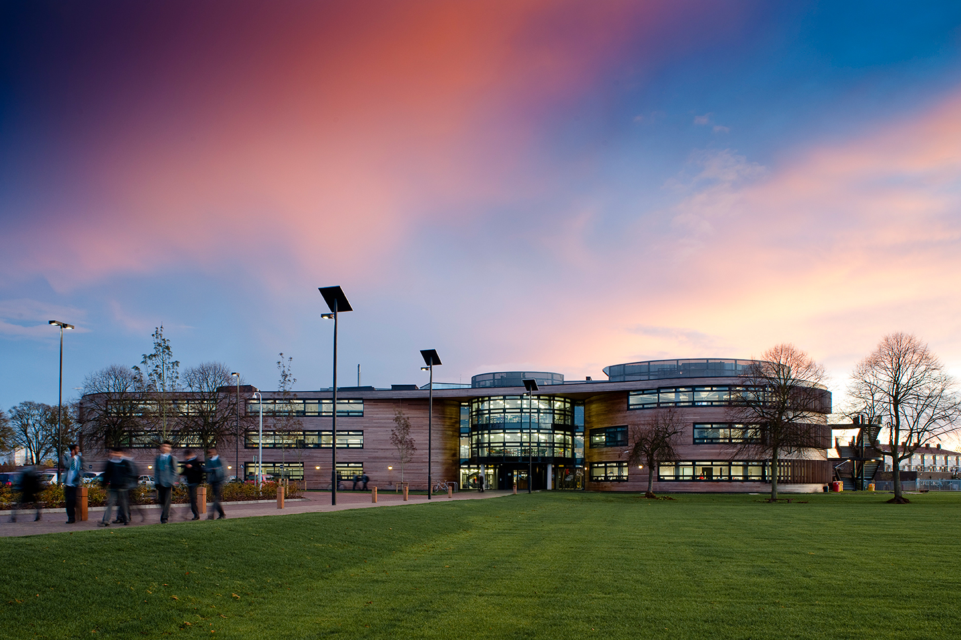

The Langley Academy Secondary
Slough, Berkshire
English Teacher
Application Pack

Thank you for your interest in the Teacher of English at The Langley Academy Secondary.

This pack contains:
- Letter to candidates
- Details about the Sponsor and The Annabel Nicoll Foundation
- Information about The Langley Academy Secondary
- Information about The Langley Academy Primary and the Parlaunt Park Primary Academy
- The job description and person specification
We hope that you find the pack informative and useful. If you do have any further questions, then please contact the Personnel Manager via the details below:
Barbara Davies
barbara.davies@langleyacademy.org
01753 214468

You can also visit our Trust website at www.langleyacademytrust.org

Contents

Dear applicant
I am delighted that you are showing an interest in the Teacher of English position here at The Langley Academy Secondary. I want to set out the reasons why we think it is so exciting. The Multi-Academy Trust (MAT) encompasses The Langley Academy Secondary, the Langley Academy Primary and the Parlaunt Park Primary Academy. Our vision is to ensure we provide an outstanding education for every child in the Trust through high aspirations and quality learning through curiosity, exploration and discovery. By 2021, when The Langley Academy Primary has a full complement of year groups, we will have approximately 2,500 students and 350 staff working in the Trust.
All of the Trust’s member academies will have significant support through The Langley Academy Trust at HR, Finance and Premises level. The role of Teacher of English will provide high quality teaching for students up to A’Level and enable effective use of resources and high standards of learning and achievement for students. This will be within an atmosphere in which students feel challenged, valued and secure and help and support colleagues within Langley Academy by sharing good practice in teaching and learning.
One of the greatest qualities of the Trust is the Sponsors. Having worked with them since my appointment as Principal of The Langley Academy in April 2012, I cannot praise them highly enough. Annabel Nicoll as the Sponsor has boundless energy and enthusiasm all directed at giving youngsters a better life. As a result of her work, students here have quite simply been afforded opportunities that many young people elsewhere in the country just would not get. The successful applicant will be able to draw on this support and networking opportunity to develop their own career and importantly contribute towards bettering education for the young people across the Trust.
We are aspirational and want to be the best MAT in the country with each school rated Outstanding as soon as possible. We believe the economies of scale, the cross-phase opportunities for students and staff development, the ability to respond to each other’s needs quickly and the ‘can do’ approach to everything we do, will make the working environment extremely exciting.
Please apply if you understand what we are trying to achieve and you would like to be a part of our journey.
Yours sincerely

Rhodri Bryant
Executive Principal

About the Sponsor and the Trust
The Annabel Arbib Foundation is a registered charity (number 296358) that supports the philanthropy of Sir Martyn Arbib and his daughter Annabel Nicoll. Sir Martyn set up the Henley-on-Thames based Perpetual Investment business in 1974 and established the Arbib Foundation in 1987. The Foundation has provided charitable donations and financial support to organisations and causes around the UK, with a focus on the Thames Valley. Sir Martyn Arbib, and the Foundation, took a leading role in establishing the River & Rowing Museum in Henley-on-Thames that opened in 1998 and attracts over 100,000 visitors per year. The Annabel Arbib Foundation continues to be the main sponsor of the educational side of the museum.
The principal beneficiary of the Annabel Arbib Foundation is The Langley Academy Trust in Slough. The Annabel Arbib Foundation is the sponsor of The Langley Academy Trust, which comprises The Langley Academy, Parlaunt Park Primary Academy and The Langley Academy Primary. Annabel Nicoll is Sponsor at The Langley Academy Trust.
In 2015 Sir Martyn Arbib retired as Chairman of The Arbib Foundation and his daughter Annabel took up the Chair and uses the Foundation, which has been renamed The Annabel Arbib Foundation, to support her own philanthropy continuing the focus on The Langley Academy Trust.
The Langley Academy Trust is a unique Trust that serves the young people of Langley, Slough and further afield. Our Trustees are a Board of interesting and experienced professionals who bring energy, enthusiasm and wisdom to their role. They share the ambitions of the Trust senior leaders to achieve the best possible outcomes for all children and students within the Trust.
The Langley Academy Primary is a three-form entry Free-School, sponsored by The Langley Academy Trust. It opened in September 2015 with 90 very excited Reception children and parents; the intake will grow year on year until it reaches capacity of 630 children in September 2021.
The Trust’s strong vision, high aspirations and determination to succeed in providing an outstanding education for children in the community are clearly evident throughout The Langley Academy Primary’s positive learning environment. Our supportive ethos, child-centred approach, rich curriculum based on first-hand experiences have ensured children are confident, independent learners, displaying Curiosity, Exploration and Discovery.
Although still in our early days, we have received very positive feedback from a DfE monitoring visit and the Local Authority Early Years Team. The visits confirmed the Trust’s review of the school and highlighted that the likely judgment in any future Ofsted inspection would be outstanding.
Throughout our growth period, under the guidance of The Trust and by working closely with Parlaunt Park Primary Academy, The Langley Academy Primary looks forward to shaping a new 21st Century Educational Experience.
Parlaunt Park Primary Academy was a popular school with recently modernised buildings that converted to a sponsored Academy within The Langley Academy Trust in September 2014.
Parlaunt Park Primary Academy caters for children between the ages of 3 and 11 years. The school was originally built in 1952 as a separate Infant and Junior School. The two schools were amalgamated in 1987 under one Headteacher. Major works were undertaken to enlarge its buildings following an expansion to a three- form entry school in 2009. The school has 635 children on roll plus a part time 39 fte Nursery provision.
The pupils come from diverse ethnic backgrounds which is typical for Slough, with the major groups being White British, Indian and Pakistani. There are smaller proportions of pupils from a wide range of other minority ethnic groups including Eastern European as well as a small group of Traveller children. The proportion of pupils with learning difficulties and/or disabilities is average. Just over a third of pupils speak English as an additional language. The proportion of pupils known to be eligible for free school meals is average. There is a breakfast and an after-school club.
Every child who attends Parlaunt Park Primary Academy is viewed as unique and treated as such. Children are encouraged to become independent thinkers with a love for life and learning Their enthusiasm is stimulated by dedicated staff members who share the ambitions of The Langley Academy Trust to motivate the pupils to be inquisitive and thoughtful learners who will go on to success at Secondary School and beyond.
Parlaunt Park Primary Academy has developed holistically since it joined the Trust in September 2014. The curriculum has been honed to reflect the learning needs of the children and the strengths of the staff. RWI and T4W [Read Write Inc/Talk for Writing] are two key components of our literacy pathway and the successful candidate would be expected to champion, encourage and extend these twin approaches. The wider curriculum is under review with both The Langley Academy Primary and Parlaunt Park Primary Academy embarking on an exciting journey over the next six years to map a new Primary curriculum and educational direction for the children encompassing first hand experiences, based on a thematic approach to learning and linked to visits and journeys and encompassing Museum Learning.
About The Langley Academy Secondary
The Langley Academy is housed in an iconic building, it specialises in Science, pioneers the use of museum learning and aims to become a centre of excellence for sports, notably rowing and cricket. We have won our first rowing competition on the water and we have several National and European indoor champions. We are the only state school that runs an MCC Foundation Hub to spot cricket talent in Slough. At the heart of our vision, The Langley Academy aims for the highest achievement for all and to provide a welcoming, imaginative and creative environment which enriches the lives of all involved. You will see this in our building. We aspire to instil traditional values and promote respect for other beliefs. The Academy strives to be at the forefront of Science education and has developed links with national and regional museums to add an external dimension to learning. We are proud of what we and our students have achieved and we are confident that we will continue to achieve high standards for all our students and our local community.
In our most recent Ofsted inspection in February 2013, The Langley Academy was rated “good with outstanding elements”. The Ofsted report states that:
The main reason why achievement is good is because the majority of teaching is typically good and sometimes outstanding, and it is well matched to the needs of most students. Students have outstanding attitudes to learning. Behaviour is excellent. Relationships throughout the academy are extremely positive and this ensures that the academy is a calm, purposeful environment in which to learn. The sponsors’ vision permeates all aspects of academy life and the Principal, Leadership team and those who lead subjects and house groups are relentless in driving improvement.
Overall our VA data for the years 2011/12, 12/13, 13/14 have all been sig+ with 9 out of the 18 KPI as sig+. We had a slight dip in 2014/15, although still above NA but we are now back up to 1023 VA with a progress 8 score of +.36 and 67% 5A*-C including English and Maths. We now believe we would be judged as an outstanding academy. You will be able to find out more about our results and trends if you are invited for interview.
Job Description
Teacher of English
Salary/Grade

Mainscale plus fringe

Purpose of the job

To provide high quality teaching, and enable effective use of resources and high standards of learning and achievement for students, within an atmosphere in which students feel challenged, valued and secure.

Reporting to

Head of Faculty

KEY FUNCTIONS

To teach the subjects, classes and groups as allocated by the Head of Faculty for English and the Leadership Team

To ensure that high quality teaching and learning takes place in all allocated classes

To support and participate in the curriculum development work of the English Curriculum Area, including the writing of schemes of work and programmes of study

To assist the Head of Faculty for English in the maintenance of high standards of work and behaviour within English

To be a House Tutor or Sixth Form Tutor and to carry out the specified duties in accordance with the job description of a House or Sixth Form Tutor

To support the Leadership Team in the effective operation of the Academy

SPECIFIC RESPONSIBILITIES

The main responsibilities of the post are to:

- teach the classes allocated, and provide a well-planned, challenging and purposeful learning environment for students

- support and carry out policies and practices to promote positive student behaviour and achievement in English within the framework of the Positive Discipline policy

- set homework on a regular basis and mark student work promptly

- assess, monitor, record and report on student achievement in line with Academy and Curriculum Area policy, including writing student reports and attending parents meetings

- assist in the identification of student special educational needs, and support the work of the Learning Support Team, including participation in the writing and review of individual education plans

- share in the development of course outlines, syllabuses and schemes of work in English

- follow the course outlines, syllabuses and schemes of work agreed by the English Curriculum Area

- make effective use of student performance data, and student and staff target-setting; and provide relevant information to the Head of Faculty, Heads of House and Academy Directors

- monitor and record student attendance in line with Academy and Curriculum Area policy, and support the Head of Faculty and Academy Directors in the maintenance of high levels of student attendance

- prepare for and attend English Curriculum Area and House or Sixth Form Team meetings and support the work of the English Curriculum Area and the House or Sixth Form Team

- actively support and participate in the museum learning programme

- actively support and participate in the link school arrangements with Eton College

- participate in and support the Performance Management Policy

- assist in the development of the Academy Improvement Plan and its review mechanism

- undertake specific duties within the English Team as agreed with the Head of Faculty

- undertake such other duties as reasonably required by the Executive Principal

Person Specification

Qualifications and experience | Essential | Desirable
QTS, Degree or equivalent teaching qualification in English or other relevant subject
Relevant CPD Training Courses
Successful teaching experience
Provision of differentiated activities
Evidence of consistently good and outstanding teaching and pupil progress
Evidence of commitment to ensuring the highest level of achievement for all students regardless of background and/or ability
Evidence of continuing personal and professional development
Current educational thinking and trends
Effective use of ICT in the teaching
Current developments in the teaching of English

Professional Knowledge & Understanding  The successful applicant will need to demonstrate knowledge and understanding of: | Essential | Desirable
Excellent subject knowledge
Effective practice and approaches to teaching and learning
How to use data and information to effect improvement
Strategies for raising student achievement
Evidence of successful behaviour management
Ability to contribute to collaborative planning and schemes of learning
Ability to teach in Key Stages 3 and 4
Ability to teach in Key Stage 5
Experience of constructive co-operation with parents and carers
Experience in raising student achievement
Successful school-based training in secondary age range
Ofsted framework for school inspection/self-evaluation

Personal Qualities and Skills  Ideally, we are looking for someone who: | Essential | Desirable
Can lead, motivate, enthuse and inspire staff and students, and win the confidence of parents and governors
Has the ability to think strategically with imagination, vision and originality
Is reflective, self-critical and open
Is self-confident, motivated and ambitious
Has passion and believes that every student can succeed
Is an effective communicator and presenter
Can plan, organise and delegate effectively
Possess excellent interpersonal skills
Can make tough decisions
Has sound judgement, especially when working under pressure
Has a life outside school
Has a fantastic sense of humour

How to apply
Please send your completed application to:
Barbara Davies
The Langley Academy Trust
Langley Road,
Langley,
Berkshire, SL3 7EF

or email it to:
barbara.davies@langleyacademy.org

Closing date: Friday 9 December 2016

Interview date: TBC

References will be sought when we shortlist. Your application will be treated in the strictest confidence

The Arbib Foundation and The Langley Academy Trust is committed to safeguarding and promoting the welfare of children and young people and expects all staff and volunteers to share this commitment. This post is subject to Funding Agreement and subject to pre-employment checks. References will be sought and successful candidates will need to undertake an enhanced Disclosure & Barring Service (DBS) check. LAT is an equal opportunities employer.

