Candidate
Information Pack- 2018/19
Admissions and Front of House
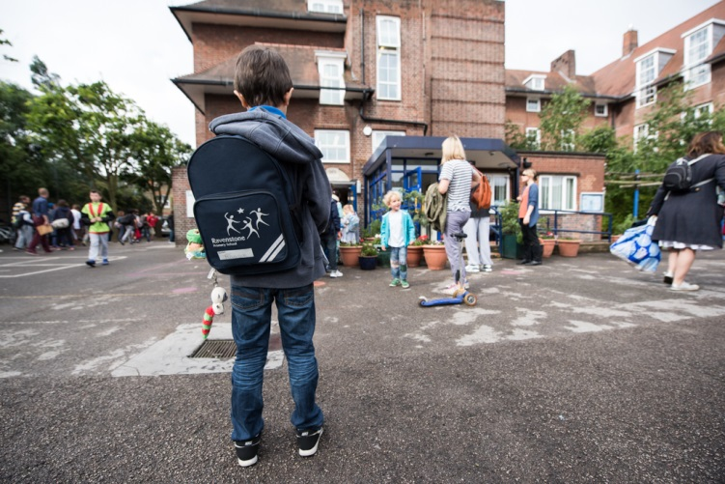

RAVENSTONE PRIMARY SCHOOL
Admissions and Front of house
May 2018

Welcome and thank you for considering Ravenstone. I hope that this application pack gives you everything you need to consider working with us.
Ravenstone is a fantastic school. Every child that steps through the gates is welcomed into an aspirational, creative community that focuses on allowing children to flourish as individuals and reach their potential academically.
As Headteacher I passionately believe that we should allow our children to experience a wide range of creative enrichment opportunities and develop as confident, caring individuals who excel academically, and reach their full potential. It is this mixture that makes Ravenstone so special. We will not sacrifice any of these elements.
I believe that the success of a school is down to its teachers and I am proud to say that everything we focus on and do is to develop as professionals and deliver the best possible education for every child in our school. We constantly strive to improve and introduce initiatives that will inspire every pupil to achieve and become motivated individuals who can succeed in their futures.
The school building is one of the school’s biggest strengths. We have wonderful grounds with a purpose build site that allows our children to be active and engage with learning outside.
I am incredibly proud of our exceptionally talented staff that strive to get the very best out of every child. I want to continue to provide my team with the best possible career opportunities to thrive as teachers and future leaders.
Please do get in touch if I can help in any way possible.
Joe Croft

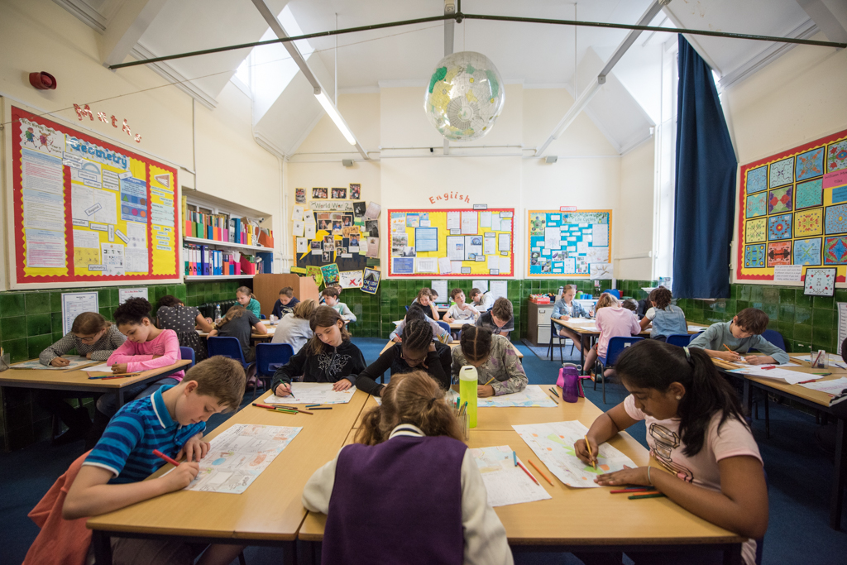
About Ravenstone
Ravenstone is a community primary school in Balham, funded by the London Borough of Wandsworth. The school has served the local community for the last 100 years. We are conveniently placed for public transport links – Balham main line train and tube station is 3 minutes away with easy access to all of London, Kent, Surrey and Sussex. We also have parking available onsite. The open space of Tooting Bec Common and the vibrant Balham centre are a few minutes from the school.
School organisation
380 children are currently on roll including full-time and part-time nursery children. These are arranged in 15 classes and the nursery. We are a two form entry school.
School focus
We are committed to the continuous improvement of every aspect of school life for children at Ravenstone. We seek to deliver an outstanding educational experience of the highest quality for children of diverse backgrounds and abilities. Enthusiasm, enjoyment, creativity, imagination and high expectations of both pupils and staff are at the centre of a wide variety of learning activities.
Our school vision is ‘Children reaching their potential in the heart of the community’ and our core values are Happy, Kind, Creative, Honest, Determined. We promote this in everything we do and we strive to allow our children to be confident individuals are understand themselves and will grow into well rounded adults who add to the world we live in.
As a school we focus on developing the adult as much as the child. We believe if every member of staff is the best they can possible be while constantly looking at ways to improve then this will provide our children with an outstanding environment to learn within.
Our ultimate aim is to become outstanding and continue to become a centre of excellence within the local community and beyond.
Community
We are proud to serve and be supported by our community. We offer a vibrant and rewarding environment with a committed team of hardworking staff, supportive governors and enthusiastic parents. The children are happy and keen to learn. We pride ourselves on the friendliness, confidence and character of our children.
The partnership between school and home is very important to us. We value parental involvement and have a thriving parents’ and carers’ association, Friends of Ravenstone, which organises social events and raises funds for the school which are used to enhance the children’s educational experience. Recently funds have been used to develop our music provision, the redevelopment of parts of the playground, the purchase of IT equipment and contributions to school trips and school journey.
We welcome volunteers from both the parent body and the local community to help in the school with reading, gardening, chess and newspaper clubs.
Everyone is encouraged to make a positive contribution to the wider community; on a local level, the school council recently organised a collection for a nearby foodbank. Looking further afield, for the last 14 years, we have had a partnership with a school in Yameriga, Ghana and Ravenstone children have been very active in supporting projects there.
Listening to pupils
The children elect representatives from each class to participate in the school council and discuss topics that are meaningful to the children. We value hearing pupils’ views and opinions and present them with regular opportunities in lessons and assemblies to voice these. Such information can offer ideas on how to improve their learning experience.
We have an established peer mentoring and mediation scheme so that the trained mentors can support their peers in the playground.
Curriculum enrichment/Ravenstone Entitlement
The Ravenstone entitlement is an offer to every child in the school. This offer includes at least one external trip, one inspirational internal visit and a curriculum themed day every term. We believe that every child deserved to learn in an engaging and purposeful learning environment that inspires them to become curious and ambitious.
Ravenstone celebrates each child’s participation and achievement in a wide range of activities including languages, food, art, sport, music and dance. We want all pupils to experience London’s rich diversity and we organise school trips as well as visits to the school by outside speakers.
Sport is one of the cornerstones of the school’s identity. We are fortunate to have a full time dedicated sports teacher and part time dance teacher and Ravenstone regularly excels in inter-school competitions. We have represented Wandsworth in athletics and swimming at the London Youth Games. Though competition is encouraged, children understand that sport is primarily undertaken for enjoyment and can be accessed by all, regardless of ability or experience.
Extra-curricular
We run a number of clubs before and after school and during lunchtimes: for example, choir, gardening, chess and newspaper club. We also have several externally-run clubs.
Working at Ravenstone
- A focus on work life balance and managing workload
- A culture of learning together
- Additional planning/leadership release at the end of every half term and term.
- A good school on the journey to outstanding
- A school that allows for teachers to flourish and allocates a large percentage of their budget to staff development
- An exceptionally well-resourced learning environment
- An Outstanding leadership team who think differently
- Excellent professional development and career progression opportunities
- A collaborative and caring school community which is culturally diverse and inclusive
- Wonderful pupils
Maths Hub

The London South West Maths Hub aims to support schools in seven boroughs (Wandsworth, Merton, Sutton, Kingston, Richmond, Hillingdon and Hammersmith & Fulham) through a range of national and local projects each year. The core purpose of the Hub is to engineer a school based support network to develop Mastery style teaching at all levels of education.

As a school Ravenstone has embraced the support offered by the maths hub and our lead teacher is a mastery specialist and works with a range of other local schools.

Hillingdon and Hammersmith & Fulham) through a range of national and local projects each year. The core purpose of the Hub is to engineer
a school based support network to develop Mastery style teaching at all levels of education.

Wandle Teacher School Alliance

Ravenstone works as part of the Wandle Teacher School Alliance. The Alliance consists of a wide range of schools from different phases and specialisms and institutions who work together in a variety of ways to identify and tackle key issues within schools. We have a dedicated and enthusiastic staff in all phases and sectors. This depth and breadth of experience offers trainee teachers a unique opportunity to explore the many complex and exciting areas of teaching and learning. Whatever stage you are in your career the Teaching School and its partners offer a comprehensive package to support both career and professional development right through to Headship and Masters qualifications.

JOB DESCRIPTION
Position: Admissions and Front of House – Term-time only
Grade: Scale 5 points - 22-25
Responsible to: Headteacher and Business Manager

Purpose of the Job

Responsible for undertaking administrative, organisational and front of house responsibilities within the school. To be the key member of the front of house team to welcome and support parents/visitors with their needs while reporting and working within local authority guidance.

- ORGANISATION
- Deal with complex reception and visitor matters
- Contribute to the planning, development and organisation of support service systems, procedures and policies within the office
- Organise school trips/events etc.
- Communicate with parents and follow school based systems for induction and admissions
- Receive and check deliveries and match to purchase orders
- Sort and distribute mail
- Undertake typing and word processing

- ADMINISTRATION
- Manage manual and computerised records and information systems
- Analyse and evaluate data and information and produce reports, information and data as required
- Undertake typing and word-processing and complex IT based tasks
- Provide personal – administrative and organisational support to other staff
- Provide administrative and organisational support to the Governing Body
- Undertake administration of complex procedures
- Complete and submit complex forms (including pupil census), returns etc., including those to outside agencies e.g. DfE, LA
- Undertake the administration of payroll matters
- Undertake the administration of human resources matters including contracts of employment
- Attend admissions meetings as required
- Liaise with the LA regarding whole school in year admissions
- Actively play a role in increasing pupil role (including marketing of the school to prospective parents).
- Oversee secondary transfer applications
- Keeping SIMS up to date with pupil and parent information
- Input September and other intakes of pupils onto SIMS
- To lead on induction of new pupils into the school

- RESOURCES
- Monitor and manage stock within an agreed budget, cataloguing resources and undertaking audits as required
- Manage uniform, snack and other ‘shops’ within the school
- Provide advice and guidance to staff, pupils and others
- Undertake research and obtain information to inform decisions, especially focused on marketing the school and increasing pupil role
- Assist with procurement and sponsorship
- Assist with marketing and promotion of the school
- Manage administration of facilities including use of school premises

- RECEPTION DUTIES

- Receive visitors ensuring good customer care
- Answering the telephone
- Taking and passing on messages
- Support the Headteacher with day to day organisation/routines
- Signing in all visitors and ensuring child protection procedures and carried out when people visit the site
- Ensure the reception area is tidy and welcoming
- Work within the team and support with the Business Manager
- Ensure complaints and concerns are dealt with tactfully, attempting to resolve minor matters before escalating

- RESPONSIBILITIES
- Comply with and assist with the development of policies and procedures relating to child protection, health, safety and security, confidentiality and data protection, reporting all concerns to an appropriate person
- Be aware of and support difference and ensure equal opportunities for all
- Contribute to the overall ethos, work and aims of the school
- Establish constructive relationships and communicate with other agencies and professionals
- Attend and participate in regular meetings
- Participate in training and other learning activities and performance development as required
- Recognise own strengths and areas of expertise and use these to advise and support others
- To be fully aware of and understand the duties and responsibilities arising from the Children Act 2004 and Working Together in relation to child protection and safeguarding children and young people as this applies to the worker’s role within the organisation
- To also be fully aware of the principles of safeguarding as they apply to vulnerable adults in relation to the worker’s role
- To ensure that the worker’s line manager is made aware and kept fully informed of any concerns which the worker may have in relation to safeguarding and/or child protection

PERSON SPECIFICATION

- EXPERIENCE
- Experience of development, management and operation of administrative systems

- QUALIFICATIONS
- Experience in relevant discipline
- Very good numeracy, computing and literacy skills

- KNOWLEDGE AND SKILLS
- Effective use of ICT and other specialist equipment/resources
- Full working knowledge of relevant polices and codes of practice and awareness of relevant legislation
- Very good ICT skills
- Ability to relate well to children and adults
- Work constructively as part of a team, understanding school roles and responsibilities and your own position within these
- Ability to self-evaluate learning needs and actively seek learning opportunities
- Ability to develop equal opportunities and inclusion for all pupils

t
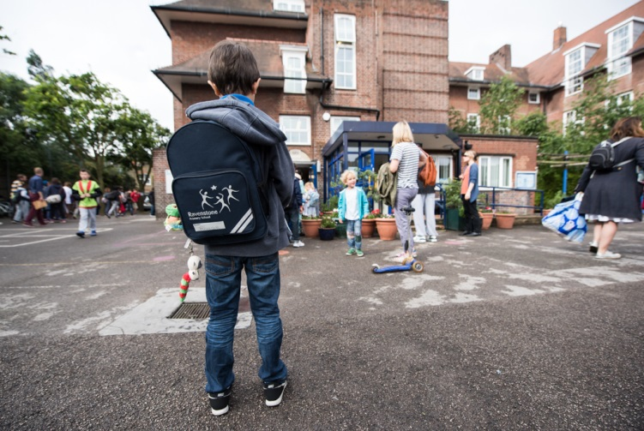
24. Ability to comply with Health & Safety regulations to ensure that al
Contact us;
Telephone: 0208 673 0594020 7622 1619
Email:
Info@ravenstone.wandsworth.sch.uk

RAVENSTONE PRIMARY SCHOOL
Admissions and Front of House
May 2018

Experience of front of house work? Quick to learn, good ICT skills? An eye for development? Looking to work in a dynamic and very committed team who strive towards improvement and excellence?
Job Purpose
Responsible for undertaking administrative, organisational and front of house responsibilities within the school. To be the key member of the front of house team to welcome and support parents/visitors with their needs while reporting and working within local authority guidance.
Visits are welcome and actively encouraged as you will be able to gain an overview of the school and the school community. Please phone 020 8673 0594 to arrange a mutually convenient time.
To apply please download an application and details from this web page or from the Wandsworth Council website https://jobs.wandsworth.gov.uk/

Completed applications should be returned to the school by email on: info@ravenstone.wandsworth.sch.uk or head@ravenstone.wandsworth.sch.uk

School tours: Week commencing 16th
Closing Date: Monday 23rd April and Interviews: Friday 27th April
We are committed to safeguarding and promoting the welfare of children, young people and vulnerable adults and expect all staff and volunteers to share this commitment. This post is subject to an enhanced DBS check. CVs are not accepted.

