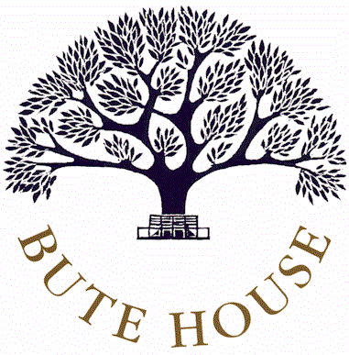

**JOB DESCRIPTION**

**FORM TEACHER**

**Reporting to: Deputy Heads**

**Key Responsibilities:**

* To be responsible for the pastoral care, welfare and social well-being of the pupils in the form.
* To monitor the academic, personal and social development of the pupils in the form.
* To act as the first link between the pupils, home and teaching staff within the school.
* To build relationships with all the pupils and be available when needed to listen and offer support and encouragement.
* To maintain and encourage high standards of punctuality, uniform, homework, attitude and behaviour.
* To complete the attendance register during the morning, and afternoon when necessary.
* To disseminate school information when required.
* To write an annual Form Teacher report for each child in the form and help collate and edit the whole report for each child in the form.
* To attend Parents’ Evenings to discuss the pastoral development of the girls in your form.
* To support and assist with specific tasks associated with the year group including residential and day trips.

June 2015