**“My school”**

***Children’s views on life at Bowling Park***

“I think that teaching at our school is excellent because teachers help us when we are stuck. They take their time so that we can catch up when we don’t understand”.

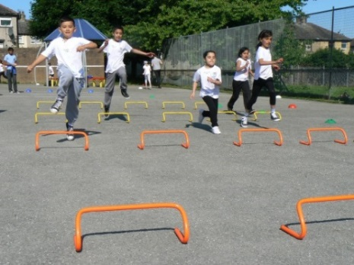

“I believe our school is the best school because teachers challenge our ideas and push us to make a big difference to our learning”.

“I love our school because we have kind teachers. I like fun weeks like SMILE week, residentials and assemblies such as Golden Learner and Child of the Week.”

“Bowling Park is amazing because we learn lots and the teachers help us to get higher levels. We do lots of different things, for example the Oliver Twist and Street Child performances. We showed them to the whole school!”

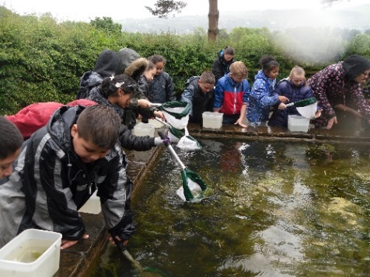

“I think Bowling Park is great because people treat you like a family. Teachers have a great sense of humour and it is really fun”.

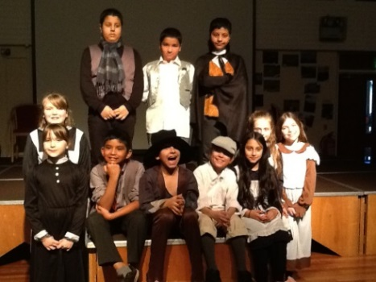

“I like school because it helps me to improve my writing and my behaviour.”

“Teachers turn boring lessons into fun lessons”.

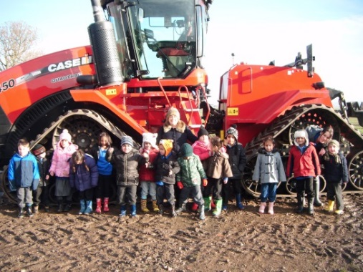

“The teachers help us to improve our attitude and help us make progress. The teachers give us challenges so that we push ourselves to do our best.”

“I think that teaching and learning at our school is brilliant because we are always given next steps to improve and we know our mistakes. I think that people learn really well that way”.

**What qualities do you want your teacher to have?**

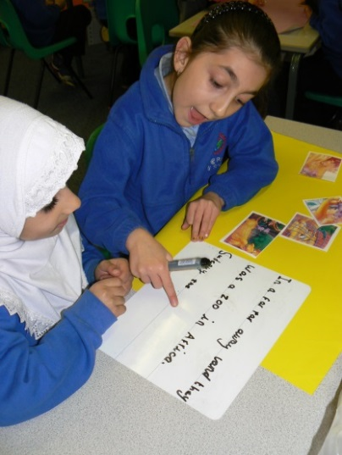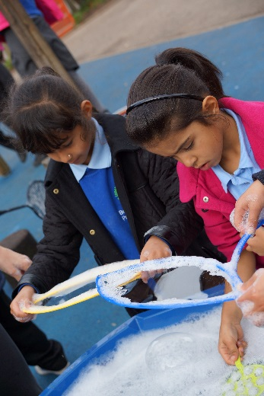

We want somebody who:

* Has a lovely personality
* Is skilful
* Goes the Extra Mile
* Is helpful
* Is caring and kind
* Puts a smile on our faces
* Pushes us to make progress
* Makes learning exciting
* Is fair but not strict

**By the School Council**