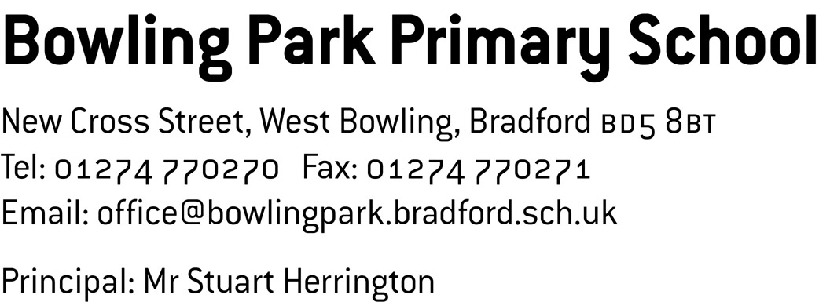

March 2018
Dear Prospective Teacher,
I am glad our advert caught your attention and I am pleased to provide you with further information about teaching opportunities at our school. We are looking to recruit at least 2 teachers to join us for September 2018. Because we want to recruit the very best candidates we are flexible about what year group or key stage teachers will be placed in. We will also consider applications from NQTs with a strong track record and proven capacity for development and growth.
In this pack you will find:
- “My School” – children’s views on life at Bowling Park Primary
- “What is it like to work at Bowling Park Primary?”
- Our ethos and vision
- Class teacher job description
- Class teacher person specification
- An application form.
We believe that we are a unique school; we are a 3 form entry school, with just under 700 pupils, situated on 2 sites that are approximately one mile apart, both of which provide education from nursery to Year 6. We have a highly mobile pupil population that includes a significant number of families arriving from Central Eastern European (including many Czech and Slovakian children. 20% of our school is of Gypsy Roma heritage). In addition, nearly 50% of pupils are supported by Pupil Premium funding.
Before I was appointed as Principal in September 2008, the two sites were totally separate schools and were both struggling to help children achieve. At that time, one of the schools had been in Special Measures for longer than any other school in the country. In February 2013 and March 2017, Ofsted judged all aspects of school to be ‘Good’. This year we were featured in the Parliamentary Review for education and have recently received a letter from Nick Gibb MP celebrating the fact that we are in the top 2% of schools nationally for pupils’ progress from Key Stage 1 to Key Stage 2. Naturally we are all proud of these outcomes, as it reflects the challenging journey we have been on and the distance our school has travelled from a very low starting point.
Our teaching staff work very hard and this reflects their commitment and loyalty to school. Staff morale is high, and because of this they energise each other and collaborate well in planning teams and curriculum developmental groups. We work together as reflective practitioners; consistently thinking about how we can improve learning and outcomes for children. Our supportive team-work ethos means that we are not the right school for people who prefer to work independently, we are genuinely looking for team players who are a pleasure to work with. As we are a large school, it is really important that we promote and support consistency across all year groups.
A key strategy for school is to grow our own teachers and leaders. Currently 6 of our class teachers, including an NQT, were previously graduate support staff in school. Each year we have a few people enrolled on the SCITT teacher training programme in school. The majority of these people have all already completed a year’s experience in school as a graduate teaching assistant. All our middle leaders have started their career at Bowling Park and the majority of SLT have been promoted internally.
We take the induction, support and development of staff seriously. We have a dedicated team of Lead Practitioners who support and develop teaching and learning. In addition, we benefit from being part of the ‘My BD5’ network (a partnership of local primary schools). As part of this, we run a BD5 NQT network, writing moderation events, an Early Years’ network, Bedtime story events at the Media Museum and a SENDCo network with our local schools.
We are pleased with the many recent developments in school and their impact on our children, including our 2 book approach which ensures that children challenge themselves, take pride in their work and are productive. We are a ‘Centre of Good Practice for New Arrivals’, which means we provide support to other schools with high percentages of EAL children. However, we are also honest and optimistic about the challenges that we still face in raising attainment, accelerating pupil progress and improving the life chances of our children. Our optimism and drive is regularly reaffirmed by children, families and many visitors, for example:
“Bowling Park has taught me to believe in myself and never give up. We are taught that when we reach the top of the mountain, to aim for the clouds. I think this is really important.” Year 6 pupil
To get a glimpse into life at Bowling Park, please visit our school blog (www.bowlingparkprimary.net) and join the many people who have already found out about our exciting learning!
There are also a number of opportunities to visit school in person so you can see and feel if this is the type of school where you believe you would be happy and would professionally excel’:
- Tuesday 27th March, 9.30 to 11.30am
- Tuesday 27th March, 1.00 to 2.30pm
- Tuesday 17th April, 9.30 to 11.30am
- Tuesday 17th April, 1.00 to 2.30pm
Please email gill.camm.bp@gmail.com to arrange and confirm this. You will have the chance to meet the leadership team and teaching colleagues, but most importantly you will get the opportunity to meet the children on both of our school sites.
If you feel excited about the opportunity to work with us in September and change children’s lives, then we would welcome your application.
Good luck and best wishes,

Stuart Herrington,
Principal.

