Information for applicants for the position of: SEND Primary Teacher
Full time and permanent
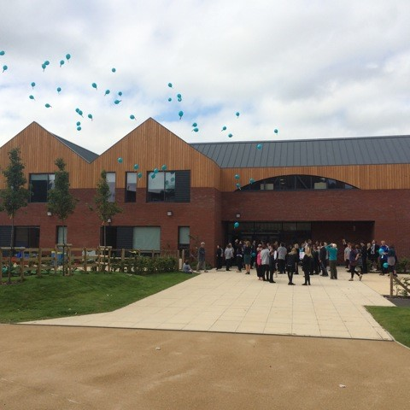
September 2018
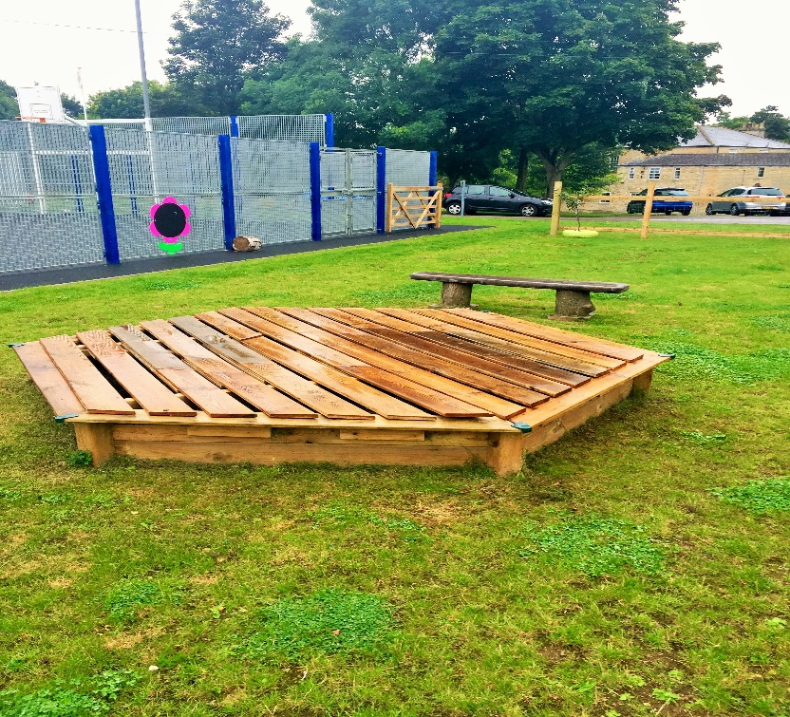
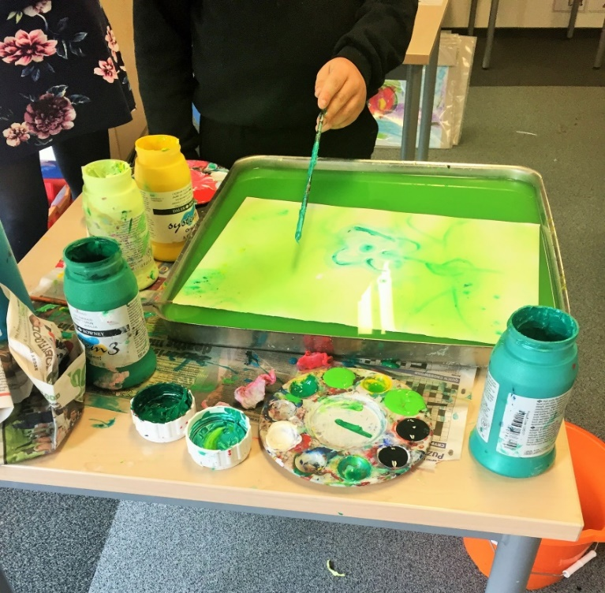
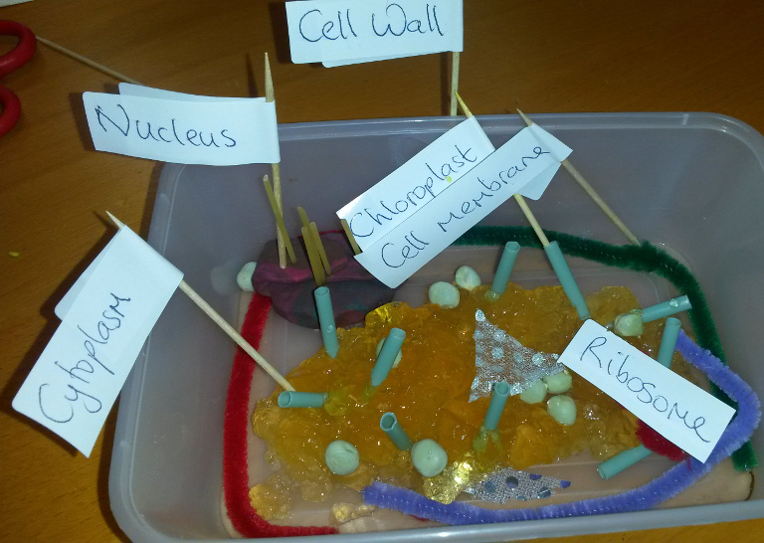

SEND Primary Teacher
MPS/UPS with SEN allowance (from £2,106 - £4,158) - starting September 2018
If you have a passion for working with young people with SEND, then we have the children for you! Join us as we continue to transform the lives of learners with SEND.
Welcome to the The Springfields Academy and the life-transforming education and residential care we provide for young people with ASD and associated difficulties. Springfields is a fantastic, vibrant and caring learning community that engages pupils and develops positive attitudes to learning. At Springfields staff, parents and outside agencies work together to build positive relationships, break down barriers, build self-esteem and challenge disaffection.
The academy provides a structured, learning environment, which fosters success through challenge, personalisation and innovation. The position of Primary Teacher is an exciting opportunity for a passionate (and compassionate) individual to provide the creativity, consistency and enthusiasm to secure outstanding outcomes for our young people.
This booklet provides only a glimpse into the provision, ethos, curriculum (and fun!) that our pupils and staff have as they learn and grow together. Consequently, potential applicants are encouraged to visit the academy, or phone, for an informal discussion about the role.
If our vision and passion resonates with you then I look forward to reading your application.
Jon Hamp
Headteacher

If you have a passion for SEND and a commitment to outstanding provision then Springfields is the place for you!
A Primary Teacher is required to join the academy from September 2018. Our Primary teachers are a crucial part of the Springfields team: they re-engage children in learning; establish basic skills and support our young people with regulating their emotions and anxieties. The academy works closely with the National Autistic Society, whom we are accredited with, and all academy staff receive ongoing training in supporting learners with autism. We also work with a host of other organisations and professional bodies, including the Chartered College of Teaching, for whom we run a Wiltshire hub. The academy is also an Apple Regional Training centre, with all staff given the opportunity to become an Apple Teacher. If you are looking for a school that is at the forefront of education then Springfields is the place for you.
This post requires a colleague with a good grounding in Primary education; they should be confident to teach across the full Primary age and ability range with flexibility a key quality that we look for. The ability to offer expertise within a particular area is desirable. We are a small, but phenomenally diverse teaching team and all colleagues are supported, and expected, to show leadership and expertise as they become established in their role.
Teachers at Springfields require creativity, flexibility and a commitment to meeting the needs of our pupils through innovative provision and pedagogy. What this really means is a high degree of creativity and personalisation, allowing you to create a bespoke curriculum that will enthuse and engage our learners! The ability to think about learners as individuals is essential, however, the opportunities to be creative in your planning are exceptional- we firmly believe in learning outside the classroom and that every space is a learning space. Like everyone at Springfields you will also be a team player who builds effective working relationships with others to further the development of Teaching and Learning at the Academy.
You will be supported by a team of enthusiastic and highly skilled support workers- our Learning Mentors and Pupil Support Workers. We also have an on-site team of professionals, such as an Occupational Therapist, based in our on-site Therapy House. You will also be supported by a vastly experienced pastoral team.
Part of the excitement of working at the academy is the broad range of individuals that you care for. Our young people may have sensory needs, speech and language difficulties, or other conditions such as autism, social, emotional and mental health needs. Some of our young people may have a combination of these, and of course, like any school we have many gifted and talented individuals. A key aspect of working at Springfields is taking the time to get to know pupils and their individual needs, and given their complexity, being able to create a safe, stimulating and supportive learning environment is crucial. If your ethos is to see the child behind the target then Springfields could well be the place for you!
What we can offer you:
- Friendly and supportive staff committed to the success of the young people we work with
- Commitment to your CPD- whether you are a NQT or an aspiring middle leader we have a CPD package for you and will support your development
- Staff laptop
- Croner Employee Assistance Programme
If, like us, you are passionate about transforming the lives of vulnerable and complex young people then we look forward to receiving your application. Visits to the academy, or a phone call, for an informal discussion regarding the role are welcome. For further information, please contact: dparker@springfields.wilts.sch.uk
Closing date: 27th March 2018 Interviews: W/C 2nd April 2018

