### St John’s School & Sixth Form College – A Catholic Academy: Location - 20 minutes from Durham/Darlington, 15 minutes from the A1

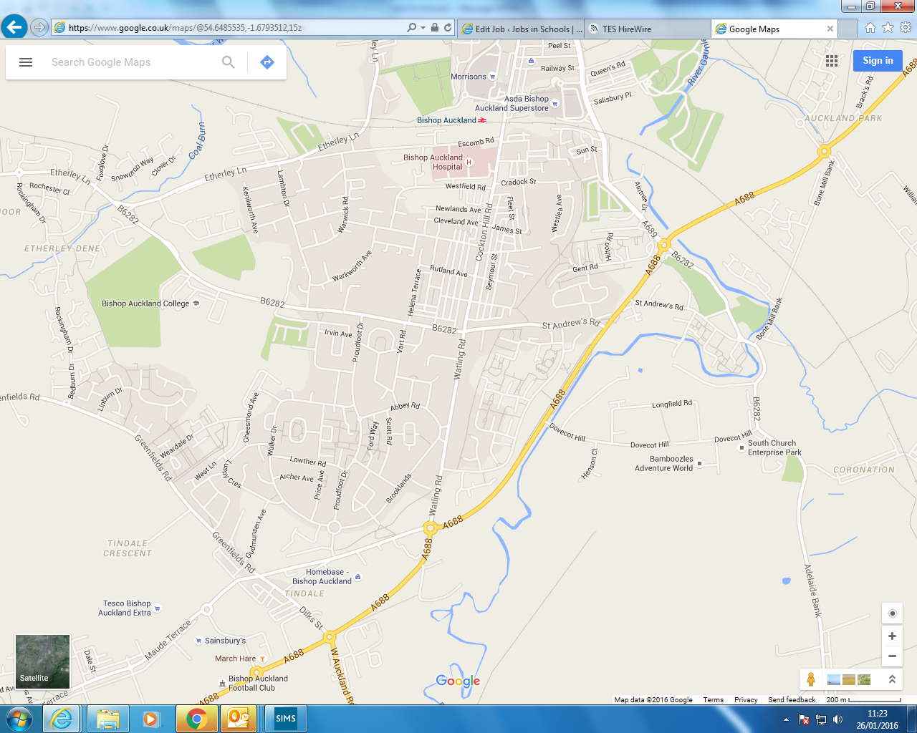

St John’s School