Greenford High School  Lady Margaret Road  Southall  Middlesex  UB1 2GU  Tel: 020 8578 9152  Fax: 020 8747 7891  Email: office@greenford.ealing.sch.uk  Visitors to school please note:  - Approach to school is from Lady Margaret Road through the road between Freshwater court and shops.  - Limited parking available on site.  - Please avoid parking on service road next to Freshwater court due to clamping in place with very high fee for release. | 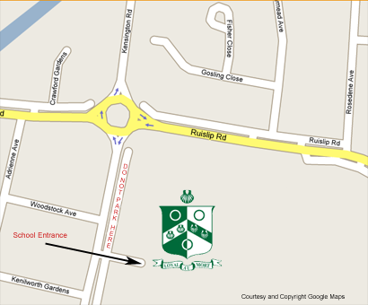
Directions
By Public Transport  Our nearest stations are Greenford Station (Central Line), Northolt Station (Central Line) and Southall Station (National Rail). Travelling by Tube from London, Ealing Broadway Station has better bus links E7 E9 E10 stop outside the school. Plus E1 E2 and E3 which stop at Greenford Broadway then a 15 minute walk from there.  From Greenford Station  Take bus E6 (from the bus stop directly opposite the station) and stop at Greenford Sports Centre.  From Northolt Station  Take bus 120 (from the bus stop directly opposite the station) towards Hounslow and stop at Kenilworth Gardens.  From Southall Station  Take bus 120 towards Northolt and stop at Kenilworth Gardens  By Car  SAT-NAV code: UB1 2GU (This may not work on older systems, if this happens, enter UB6 9RX)  Alternatively you may want to use the postcode to the shopping parade outside the school grounds UB1 2NP | 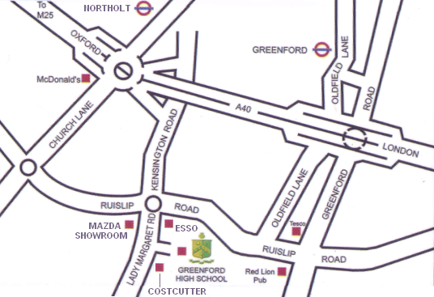  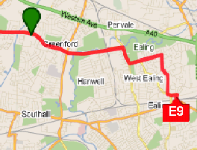
Bus routes to Greenford High School
E1 E2 E3 (from Ealing B’Way plus 15 min walk from Greenford B’Way)
E7 (from Ealing B’way Route shown above) - E9 (from Ealing B’way Route shown above) and E6- E10
– 95 – 105 - 120 -282 all stop outside the school.

