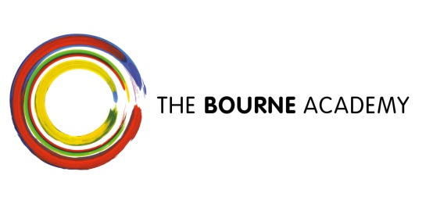
ETHOS

The Bourne Academy vision outlines our central belief that everyone is a learner and everyone is a teacher. Our purpose is that we develop literate, numerate global citizens who are Ambitious, Self-confident, Physically Literate, Independent Learners, Resilient and Emotionally Literate.
Through the Academy’s specialism of English, all teaching is underpinned by literacy as the key to personalised learning. Each student’s progress in literacy is related to their ability to think and learn. It opens up personal pathways to success and is central to personal expression and active participation in global society, economy and culture. The recent Ofsted inspection noted that 'the proportion of students making and exceeding the progress expected nationally in English is very much higher than average, resulting in high attainment in GCSE at grades A* - C.'
Through the Academy’s specialism of Engineering & Design, all learning & teaching is underpinned by numeracy as the key to accessing the building blocks of human society and making informed decisions based on numerical data and on logical thought.
We enable every student to:
- Have belief in, and a positive vision for themselves, their future and their school
- Be literate and be able to communicate ideas clearly and confidently
- Think clearly and be able to question, make decisions and solve problems
- Understand and apply engineering and design principles to make life better for people
- Be well prepared to participate in the community and as a global citizen

