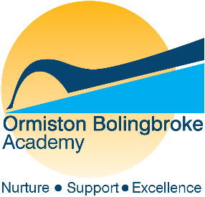

ORMISTON BOLINGBROKE ACADEMY
Barnfield Avenue, Runcorn, Cheshire, WA7 6EP Tel: 01928 711643

Contents

Welcome 3
The Sponsor 4
Background 5
Location 6
Summary of our Ofsted report 7
Academy Development Plan 8
Strategy Map 9

Welcome

Ormiston Bolingbroke Academy is part of a national network of academies supported by the Ormiston Academies Trust. As such, the Academy has access to a wide network of resources and national best practice.

OAT is part of Ormiston Trust, a national charity formed in 1969 to improve the life chances of children and young people so they can fulfil their potential and lead happy and productive adult lives.

We hope that you will enjoy reading about OBA.

The Sponsor

Ormiston Academies Trust

OAT is a not for profit sponsor of primary and secondary academies since 2008. Our vision is for all young people to have the highest academic, social and practical skills to allow them to lead a fulfilling life. We are determined to become the Trust that makes the biggest difference and to be the most effective network of academies.

OAT academies currently serve over 25,000 students and their families; providing a great education that will make a difference to them and to the communities in which they live. We want our children to achieve well, but also to have enrichment opportunities which will have a huge impact on their adult lives.

Our academies work as a team to support improvement and to make sure that students are getting the education they deserve. One thing that always impresses me about the OAT family of schools is how effectively they collaborate both within and across local authority boundaries.

Our principals include those who are very experienced and in their second headships, colleagues new to this demanding and rewarding role, and those at all points in between. It is important that we understand this range of experience and work closely together to ensure maximum mutual support.

It is our intention to provide training and development that reflects the differing needs of our new principals, as we develop the next generation of senior leaders in OAT academies.

Ormiston is one of the leading academy sponsors in the country and is playing an increasingly significant role in the development and delivery of the education strategy nationally. With the school’s academy status, successful applicants will be able to contribute to the further development of the network, as well as leadership of their own academy.

Background

Welcome to Ormiston Bolingbroke Academy, which joined the Ormiston Academies Trust in September 2010. It proudly serves the community of Runcorn new town and had its new building opened in September 2013 by Professor Toby Salt, Peter Murray and John Bishop, comedian and former student of the predecessor school. We are a growing and oversubscribed school in Runcorn with three specialisms of English & Literacy, Mathematics and Applied Learning that permeate the culture and ethos of the Academy. We offer a rigorously academic curriculum, supplemented by a wide choice of creative and performing arts, careers-focused disciplines, technology and sport.

We enjoy warm and mutually supportive relationships with our local and wider community. Our top-class facilities provide exciting learning opportunities for our community, from a working hair salon and fully equipped motor vehicle workshop, to an extensive ICT infrastructure.

Visitors often note the warmth and sense of community at our Academy. Students and their families are supported by our committed pastoral teams within a traditional year group structure, as well as a house system.

The then Prime Minister, David Cameron, chose OBA in June 2015 as the venue to deliver his keynote speech on welfare and education live to the nation via a TV broadcast. Speaking of the Academy’s rise in results since 2010, in particular the success with disadvantaged students, he said, ‘A school like this demonstrates we can tackle underachievement…you're an inspiration to schools in very wealthy areas of our country who don't get results as good as this.’

Most students are white British and the number of students eligible for the Pupil Premium is well above average. The proportion of students who are disabled or have special educational needs is average.

Our Academy has a calm, supportive environment where students work hard. We are strong on discipline and have high expectations for the whole school community. Good manners, courtesy and appropriateness of dress are demanded. We expect all students to conduct themselves with dignity and show consideration both in and out of school. Great relationships are the foundations of outstanding teaching and learning. At OBA we only appoint highly qualified staff who love their work and are prepared to go ‘the extra mile’ for our students.

All staff at Ormiston Bolingbroke Academy have the highest expectations for every child. We want our students to leave us with a strong desire to continue to further their education, to continue active citizenship and fulfil their own ambitions. To this end we will set our students challenging targets, coupled with expert guidance and advice for a career path which will continue to challenge and motivate them. Our students are all allocated an academic mentor from the first year who will meet regularly with them to consider their aptitudes, strengths and where their talents may take them. We will help them research local and national universities and support them in gaining the necessary qualifications to ensure their destination of choice.

.

Location

Ormiston Bolingbroke Academy is situated in Barnfield Avenue, Runcorn just off the A533. We are easily accessible from the Greater Merseyside area, particularly with the opening of the new Mersey Gateway Bridge that has ‘on and off’ ramps just minutes from the Academy

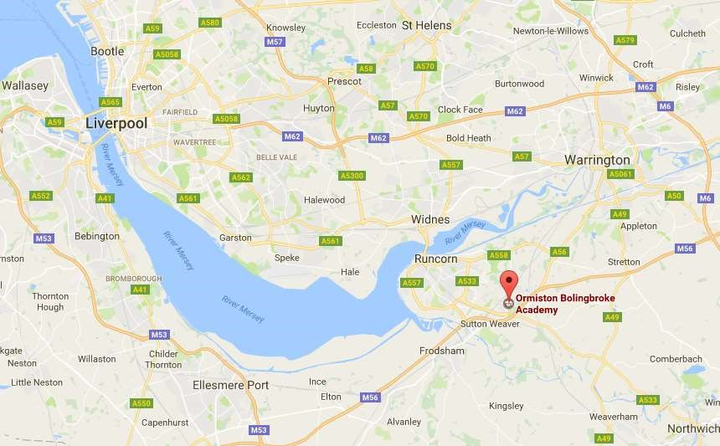

Summary of our Ofsted Report

Ormiston Bolingbroke Academy (OBA) was inspected in October 2017.
The inspectors picked out a number of strengths of the school. Ofsted says that students' results are improving, that teaching is strong in numerous subjects, particularly English, music and vocational subjects, and that the support we give to students with special educational needs is strong.
The report acknowledges the hard work of parents, students and staff in relation to student outcomes in 2017. Ofsted said “2017 exam results are in line with the national average across a broad range of subjects, including high outcomes in compulsory examination subjects, business, computing and sport”. Our score for Progress 8 is positive, showing that its students make more progress than that expected of them, as well as above the national average and the local authority average. In 2017, OBA’s students also achieved the new, harder Grade 5 in Mathematics and English at a rate higher than the local authority average. This has fallen in 2018 and is a priority in the new Academy Development Plan. The inspection report also acknowledges the strength of pupil outcomes in the Sixth Form in 2016 and states that 2017 results indicate that outcomes in the sixth form ‘remain strong’.

I am really pleased that Ofsted rated personal development, behaviour and welfare as Good, and I am delighted that Ofsted agrees that our students behave well, and are safe and well cared for in the school. Our students' good attendance and behaviour is also highlighted. We have worked very hard as a school to set the standards very high for our students, and this includes uniform, attendance, punctuality, courtesy and behaviour and I am glad that inspectors saw the positives in this. I know these are a high priority for a new teacher or leader joining the school and something that the whole staff here takes very seriously and work very hard to maintain.

Overall, however, Ofsted have concluded that we are in the Requires Improvement category. This is due to the variability in the school both within and between departments that means as present outcomes in some subjects are not as strong as they are in many areas. Our challenge is to work together to make sure that we achieve greater consistency in teaching and learning and pupil outcomes. What is very pleasing is that Ofsted has also said that our academy is well-placed to achieve these improvements, and I have no doubt that we will do so. The full report can be read on our website.

In terms of what we need to do to progress, the report is also clear that the school's leaders, including our governors who it describes as experienced and expert, have a good understanding of the areas that need to improve. Indeed an action plan to address these has already been put in place, and Ofsted says that these actions are already having a positive effect. We know our school, and what we need to do to improve.

We made three changes and appointments to the SLT in 2017-2018, this will be key in the reduction in the variability in the school. We will also make good use of the strong network of support provided by our sponsor, Ormiston Academies Trust, and are working with the local Teaching School Alliances. My own background and expertise is in school improvement, as I previously headed a local Teaching School Alliance.

Most parents, told Ofsted you were pleased with how the school is led, and we remain a popular school, and are over-subscribed in each of the last three years.

Overall there are many positives of our academy, and much that we can build on. We are already heading in the right direction; our staff and I will continue to work incredibly hard to ensure that we are successful in delivering the highest quality of education to your children.

