St Edmund’s Nursery School and Children’s Centre

Mission Statement

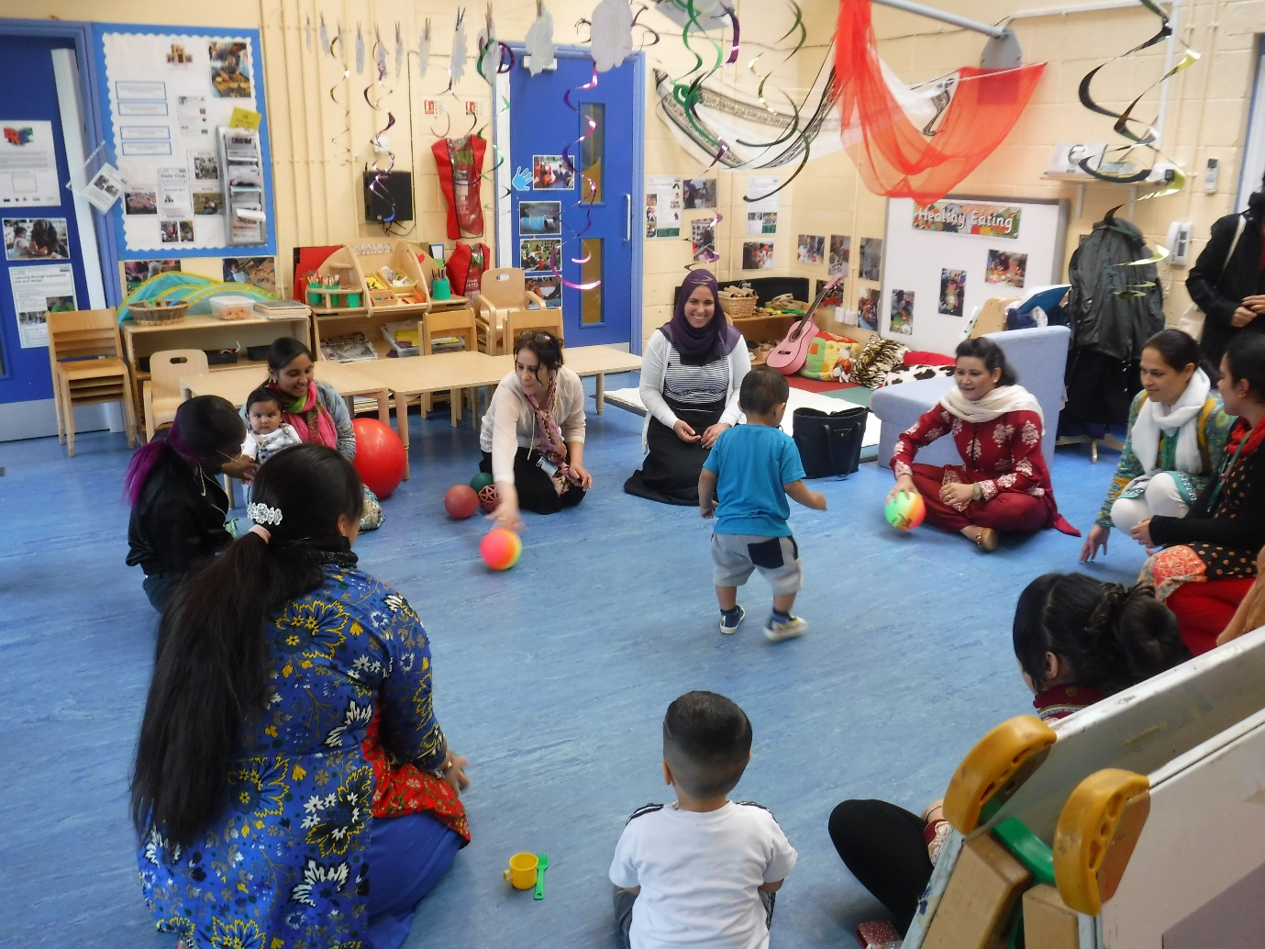
Putting children and families at the centre of learning.

