Thank you for your interest in working at Drumbeat.

The Drumbeat School is a purpose built, special school for students with autism aged 4 to 19.It is a split site building based at Downham for Early Years through to Key Stage 3 and Brockley for KS4 and Sixth Form. There are 171 students on the school roll. The school’s facilities are exceptional and it is a wonderful place for young people to learn and grow and also for teaching and support staff to work and learn in.

Drumbeat School serves the diverse community of Lewisham and provides a unique outreach and extended service for families with autistic children. They are taught by a specialist team of teachers and support staff and schools and the community value highly the support that teams provide.

There is a committed, dedicated and hardworking team of teachers and support staff led by a strong leadership team. The whole team is focused on raising standards and improving the quality of teaching and learning and improving the quality of life and opportunities for our young people.Visits, by appointment, from potential candidates are welcome. Please contact the school to arrange a suitable time.

This is an exciting time to be at Drumbeat a school which is a beacon of excellence for autism in education.

Thank you for your interest and I look forward to receiving your completed application form and personal statement which needs to be linked to the person specification and job description. ​

Kind Regards,
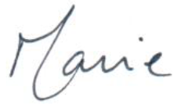

Marie Neave
Executive Headteacher

