Directions
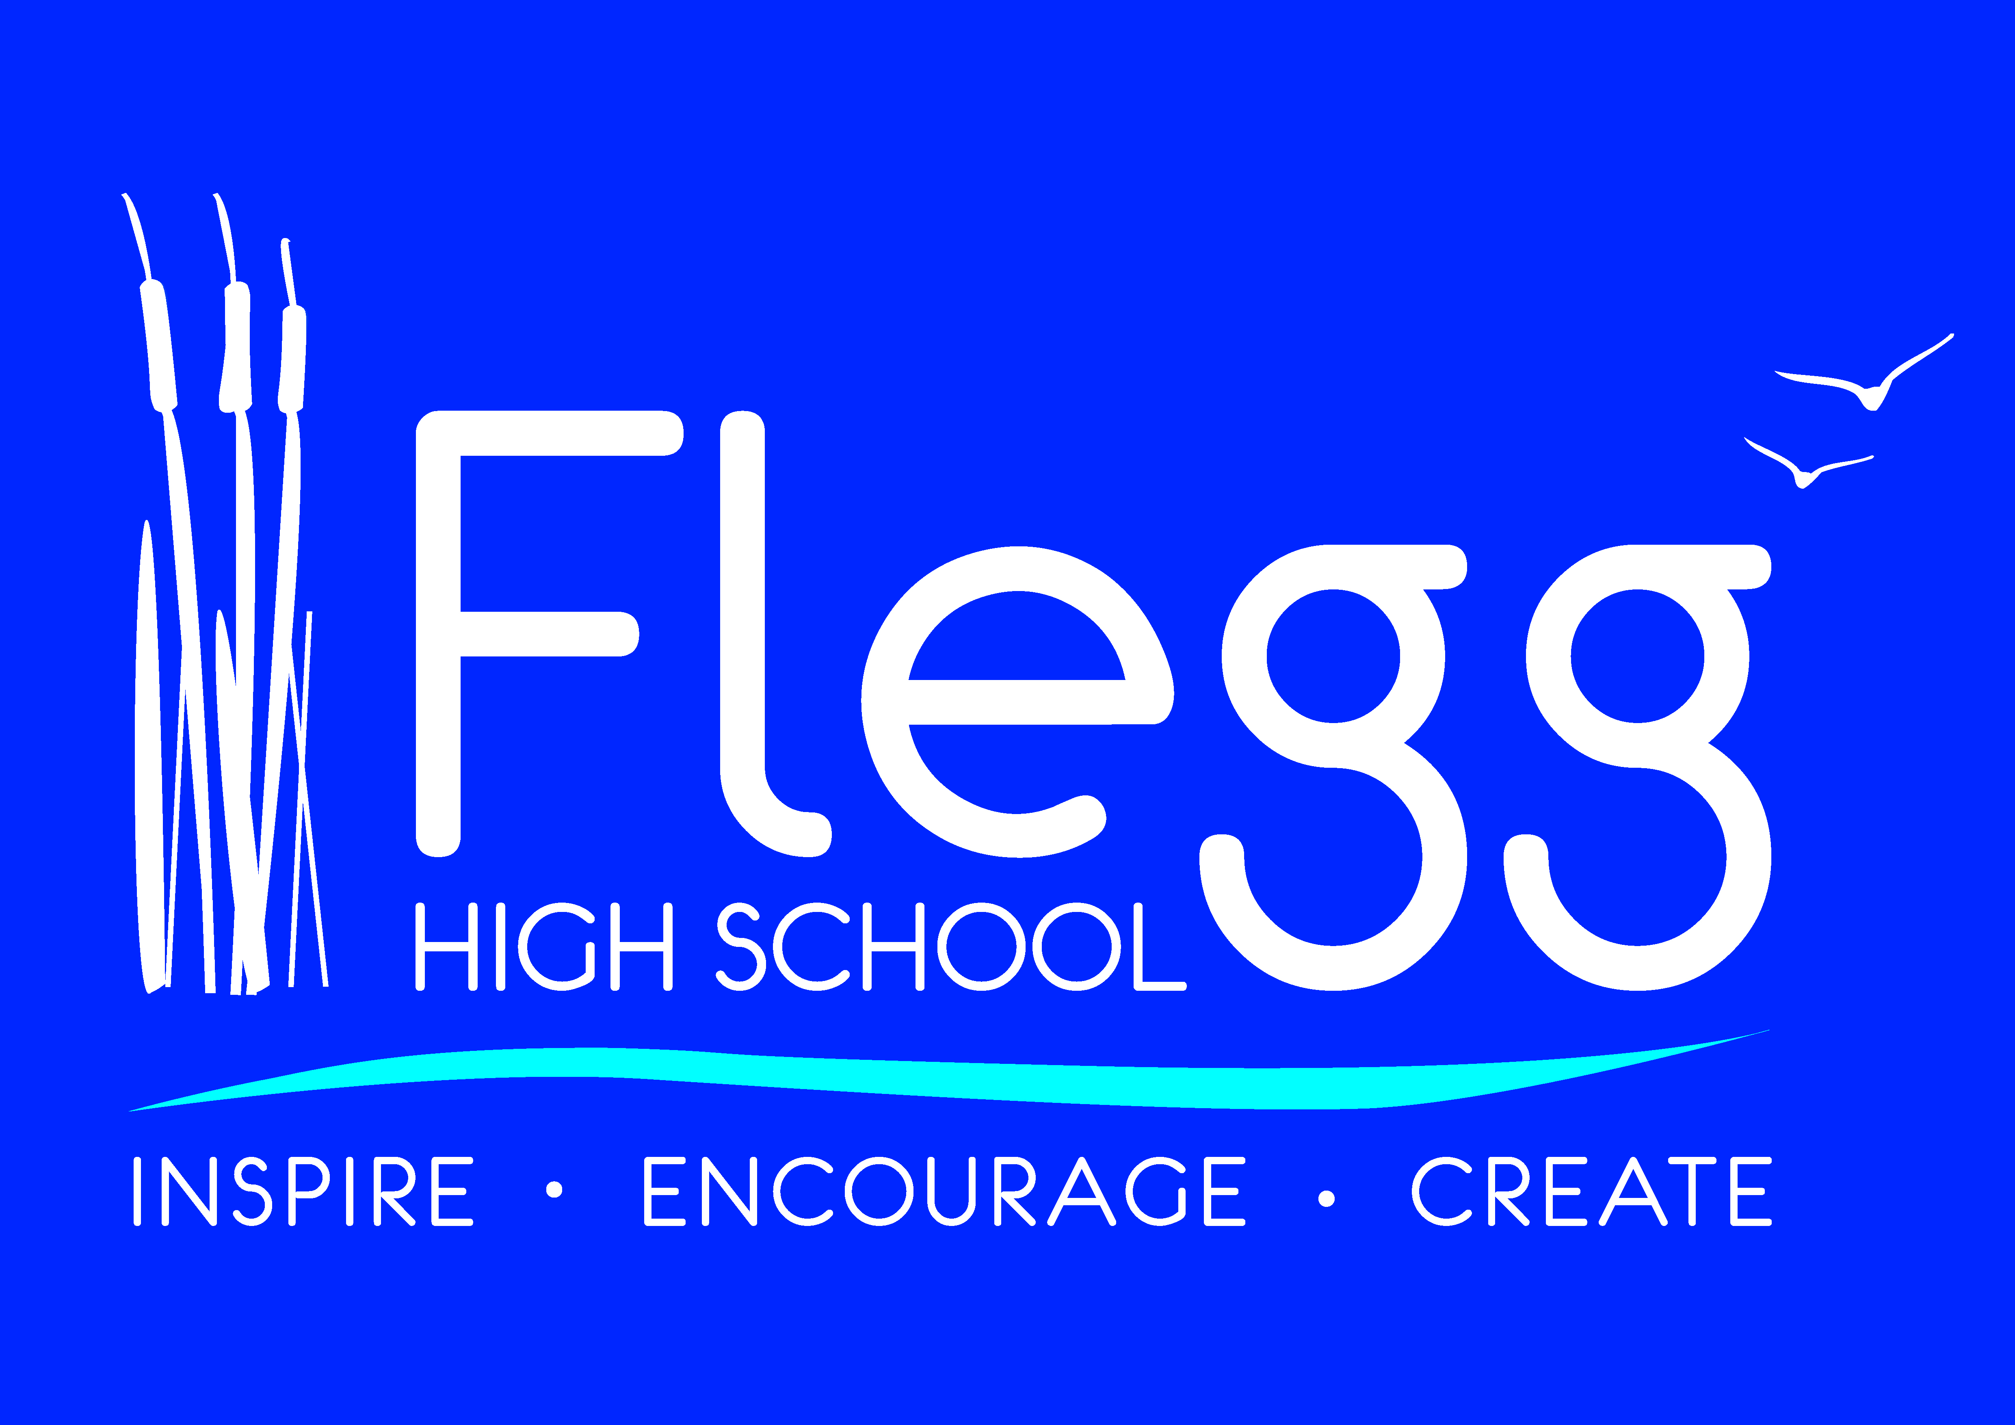
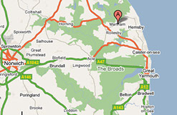
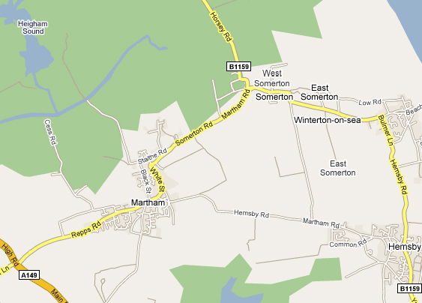
Flegg High School

B1152

Travelling by road
From Norwich
From Norwich take the A47(T) in Great Yarmouth direction. At roundabout at the far end of the Acle bypass take B1064 towards Hemsby and Caister. After going over the Acle Bridge and straight on for 800 metres, turn left on the B1152 towards Martham. After 3.5 miles turn right (still on B1152) and straight across A149 into Martham. Remain on the B1152 toward West Somerton, through the village (there are a number of sharp bends until you get clear of the village).
The school is the last set of buildings on the left as you leave the village, the wind farm should be in the distance on the right.
From Great Yarmouth
From Great Yarmouth follow the A149 Northwards toward Caister. Bypass the village by turning left at the roundabout just past Yarmouth Stadium. Continue along the A149 for 4 miles until you reach the village of Rollesby. When you reach the pub (Horse and Groom) on your left take a right turn towards Martham which is 1 mile further on. After 1 mile you enter the village. At the junction (with the zebra crossing) turn right. Follow the B1152 through the village (there are a number of sharp bends until you get clear of the village).
The school is the last set of buildings on the left as you leave the village, the wind farm should be in the distance on the right.

