Ethos Vision and Values
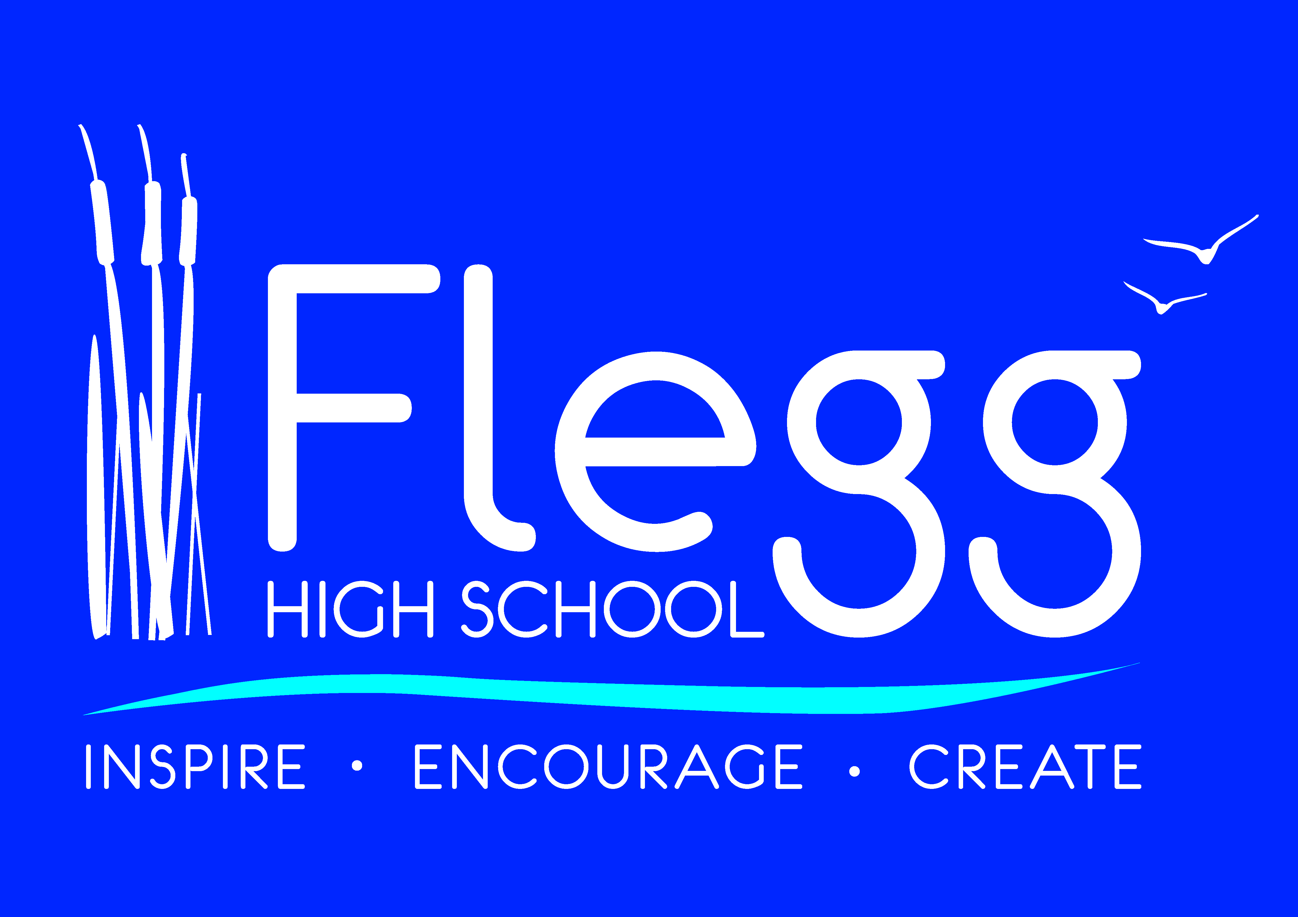

The students, parents, staff and Governors are all incredibly proud of our school, and we believe it is the ideal environment for young people to become the best they can be. We encourage our students to approach every task and opportunity to the best of their ability, and they are determined to succeed.
We recognise the importance of those skills which are relevant to the world of work and so we encourage students’ personal development through our six defining aspects; Inspiring, Encouraging, Creative, Determined, Supportive and Ambitious.
As a result of excellent pastoral support students feel able to explore to the limits of their potential in a way that plays to their strengths, unleashes their creativity and is fuelled by their ambition. We also ensure that through the ‘Flegg Pledge’ students have access to a wide range of opportunities designed to further enhance their experience and allow them to explore the wider world.
Working here and spending time with young people who live in Norfolk opens your eyes to the deep connection they feel with this area, and more importantly the passion they speak with when they talk about making the region a better place for all of us. They are a constant inspiration to all the staff here and they constantly remind us of why we became education professionals.
We want to encourage you to learn more about our school, and to uncover exactly what it is that makes Flegg High such a special place to learn. I feel proud and privileged to be Principal here and would welcome visitors to come and see what we offer, meet the students and staff and feel part of our very special community.
'We aim to foster creative and enquiring minds to enable all members of our school community to be life-long learners. We will develop ambitious learners who have the courage to face challenge, are inspirational in achieving excellence, have the determination to overcome difficulties, are encouraging and supportive of others and who are proud of their achievements. We will promote tolerance, respect, diversity, equality and our shared values so that our school is a welcoming, safe and secure place to learn and live.'

