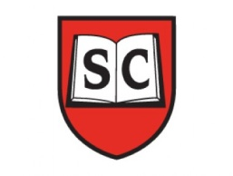
Our Vision and Ethos
I can, I can, I can

Our vision is that all children who are educated at Sayes Court, will learn to become the very best version of themselves that they can be; academically, socially and emotionally.
The keys to our vision are our Learning Behaviours, our British Values, our staff, and Sayes Court stakeholders, all of whom share the highest expectations, who expect and deliver nothing but the best, who believe in all children regardless of their background and who teach our children to believe and have confidence in themselves.

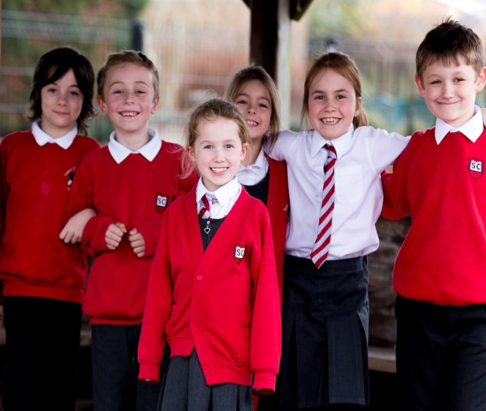

I’m never going to put boundaries on myself. I’m never going to say I can’t do it. I’m never going to say ‘maybe’. I’m never going to say, ‘I don’t think I can.’ I can and I will.
Nadia Hussain

Learning Behaviours
Definition: The way in which you should behave when you are learning
OR
Behaviours you should be displaying when learning.

At Sayes Court, we teach children about behaviour which is key to becoming a successful learner.
We currently have the following Learning Behaviours:
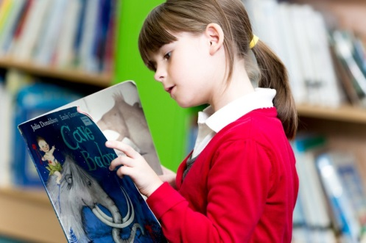
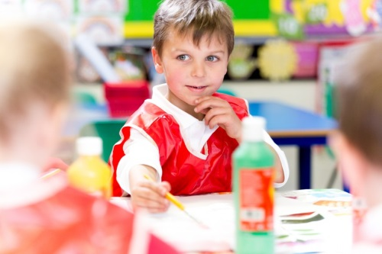
Ambition

Independence

Reflection
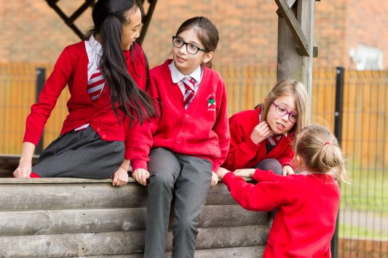
Determination

Resilience

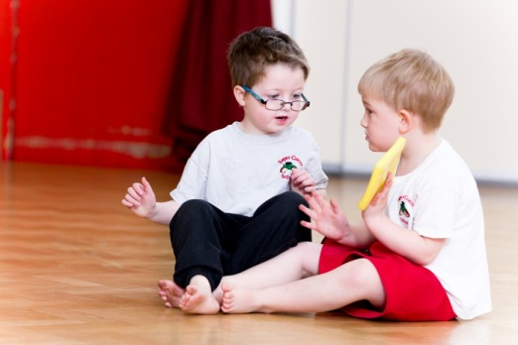
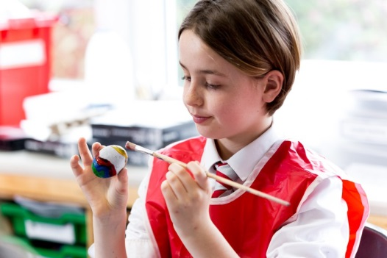
Pride

Motivation

Self-Belief

These behaviours are shared and discussed in weekly assemblies. Teachers and support staff also focus on these in class, giving children specific examples of how these can be applied and developed. House and Dojo points are given when these behaviours are displayed.

