ITEM 19A – STUDENT WELFARE PROCESS

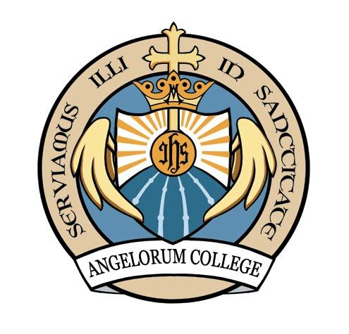

Opus Angelorum Inc.
ANGELORUM COLLEGE
Opus Angelorum Inc. is the governing body of Angelorum College.

STUDENT WELFARE PROCESS
The student welfare process for Angelorum College is set out in and governed by the following policies:
- Child Protection Policy; and

- Child Risk Management Strategy.
A copy of each of these policies is attached.

Opus Angelorum Inc.
ANGELORUM COLLEGE
Opus Angelorum Inc. is the governing body of Angelorum College.

Child Protection Policy
Purpose: | The purpose of this policy is to provide a policy as part of Angelorum College’s (“the School”) written processes about how the school will respond to harm, or allegations or harm, to students under 18 years old, and the appropriate conduct of the school’s staff and students, to comply with accreditation requirements.
Scope: | Students and employees, including full-time, part-time, permanent, fixed-term and casual employees, as well as contractors, volunteers and people undertaking work experience or vocational placements at the School College and covers information about the reporting of harm and abuse.
Status: | Approved. | Supersedes: Together with the Child Risk Management Strategy policy it supersedes and replaces the Student Welfare Processes policy adopted in January, 2016.
Authorised by: | President of Opus Angelorum Inc. being the school governing body. | Date of Authorisation: 19 June, 2017
References: | - Child Protection Act 1999 (Qld)  - Education (General Provisions) Act 2006 (Qld)  - Education (General Provisions) Regulation 2006 (Qld)  - Education (Accreditation of Non-State Schools) Act 2001 (Qld)  - Education (Accreditation of Non-State Schools) Regulation 2001 (Qld)  - Working with Children (Risk Management and Screening) Act 2000 (Qld)  - Working with Children (Risk Management and Screening) Regulations 2011 (Qld)  - Angelorum College Dispute Resolution/Complaints Handling Policy  - Angelorum College Dispute Resolution/Complaints Handling Procedure  - Angelorum College Child Risk Management Strategy (for the Working with Children (Risk Management and Screening) Act 2000 (Qld))  - Angelorum College Work Health and Safety Policy (for the Work Health and Safety Act 2011 (Qld))
Review Date: | Annually | Next Review Date: 18 June, 2018
Policy Owner: | Opus Angelorum Inc. the school governing body

Definitions
- Section 9 of the Child Protection Act 1999 - “Harm”, to a child, is any detrimental effect of a significant nature on the child’s physical, psychological or emotional wellbeing.
- It is immaterial how the harm is caused.
- Harm can be caused by—
- physical, psychological or emotional abuse or neglect
- sexual abuse or exploitation.
- Harm can be caused by—
- a single act, omission or circumstance
- a series or combination of acts, omissions or circumstances.

- Section 10 of the Child Protection Act 1999 - A “child in need of protection” is a student who—
- has suffered significant harm, is suffering significant harm, or is at unacceptable risk of suffering significant harm
- does not have a parent able and willing to protect the child from the harm.

- Section 364 of the Education (General Provisions) Act 2006 - “Sexual abuse”, in relation to a relevant person, includes sexual behaviour involving the relevant person and another person in the following circumstances –
- the other person bribes, coerces, exploits, threatens or is violent toward the relevant person
- the relevant person has less power than the other person
- there is a significant disparity between the relevant person and the other person in intellectual capacity or maturity.

Health and Safety

The school has written processes in place about the health and safety of its staff and students in accordance with relevant workplace health and safety legislation.

Responding to Reports of Harm

When the school receives any information alleging 'harm” to a student (other than harm arising from physical or sexual abuse) it will deal with the situation compassionately and fairly so as to minimise any likely harm to the extent it reasonably can. This is set out in the school’s Child Risk Management Strategy.
Information relating to physical or sexual abuse is handled under obligations to report set out in this policy.

Conduct of Staff and Students
All staff, contractors and volunteers must ensure that their behaviour towards and relationships with students reflect proper standards of care for students. Staff, contractors and volunteers must not cause harm to students.

Reporting Inappropriate Behaviour
If a student considers the behaviour of a staff member to be inappropriate, the student should report the behaviour to: -
- Ms Elyse Beck (Senior Teacher); or

- Mr David Ward

Dealing with Report of Inappropriate Behaviour
A staff member who receives a report of inappropriate behaviour must report it to the President of Opus Angelorum Inc. (the governing body of the school). Where the President is the subject of the report of inappropriate behaviour, the staff member must inform a member of the management committee of Opus angelorum Inc. (but not the President). Reports will be dealt with under the school’s Dispute Resolution/Complaints Handling Policy

Reporting Sexual Abuse
Section 366 of the Education (General Provisions) Act 2006 states that if a staff member becomes aware, or reasonably suspects in the course of their employment at the school, that any of the following has been sexually abused by another person:
- a student under 18 years attending the school
- a pre-preparatory aged child registered in a pre-preparatory learning program at the school
- a person with a disability who: -
- under section 420(2) of the Education (General Provisions) Act 2006 is being provided with special education at the school
- is not enrolled in the preparatory year at the school.
then the staff member must give a written report about the abuse or suspected abuse to the Ms Eltse Beck (the Senior Teacher) or to a member of the management committee of Opus Angelorum Inc. which is the school’s governing body immediately.
The management committee members are:
President: Mrs Lucy Robinson
Treasurer: Mrs Kate Hoey
Secretary: Mr Craig Robinson
The school’s Senior Teacher (Ms Elyse Beck) or the management committee member of the Ous Angelorum Inc. must immediately give a copy of the report to a police officer.
(Under section 366B of the Education (General Provisions) Act 2006 the directors of a school's governing body may delegate the directors' function under section 366 to an appropriately qualified individual (this cannot be the Principal or any other staff member of the school). Directors should ensure they are well briefed about the requirements of section 366B before delegating this function, including identifying the delegation in this policy and informing the school community of the delegate/s name/s their contacts, and their role in the school’s processes.)

If the first person who becomes aware or reasonably suspects sexual abuse is the school’s Senior Teacher (Ms Elyse Beck), the Senior Teacher must give a written report about the abuse, or suspected abuse to a police officer immediately and must also give a copy of the report to a member of the management committee of Opus Angelorum Inc.
A report under this section must include the following particulars: -
- the name of the person giving the report (the first person)
- the student’s name and sex
- details of the basis for the first person becoming aware, or reasonably suspecting, that the student has been sexually abused by another person
- details of the abuse or suspected abuse
- any of the following information of which the first person is aware: -
- the student’s age
- the identity of the person who has abused, or is suspected to have abused, the student
- the identity of anyone else who may have information about the abuse or suspected abuse.

Reporting Likely Sexual Abuse
Section 366A of the Education (General Provisions) Act 2006 states that if a staff member reasonably suspects in the course of their employment at the school, that any of the following is likely to be sexually abused by another person: -
- a student under 18 years attending the school
- a pre-preparatory aged child registered in a pre-preparatory learning program at the school
- a person with a disability who: -
- under section 420(2) of the Education (General Provisions) Act 2006 is being provided with special education at the school
- is not enrolled in the preparatory year at the school.
then the staff member must give a written report about the suspicion to the Principal (in the case of Angelorum College, it should be the Senior Teacher) or to a director of the school’s governing body (in the case of Angelorum College it must be to a member of the management committee of Opus Angelorum Inc.) immediately.
The school’s Principal (in the case of Angelorum College, the Senior Teacher) or the director of the school’s governing body (in the case of Angelorum College, a member of the management committee of Opus Angelorum Inc.) must immediately give a copy of the report to a police officer.
(Under section 366B of the Education (General Provisions) Act 2006 the directors of a school's governing body may delegate the directors' function under section 366 to an appropriately qualified individual (this cannot be the Principal or any other staff member of the school). Directors should ensure they are well briefed about the requirements of section 366B before delegating this function, including identifying the delegation in this policy and informing the school community of the delegate/s name/s, their contacts and their role in the school’s processes.)

If the first person who reasonably suspects likely sexual abuse is the school’s Principal (In the case of Angelorum College, the Senior Teacher) , the Principal (In the case of Angelorum College, the Senior Teacher) must give a written report about the suspicion to a police officer immediately and must also give a copy of the report to a director of the school’s governing body (in the case of Angelorum College, a member of the management committee of Opus Angelorum Inc.).
A report under this section must include the following particulars: -
- the name of the person giving the report (the first person)
- the student’s name and sex
- details of the basis for the first person reasonably suspecting that the student is likely to be sexually abused by another person
- any of the following information of which the first person is aware: -
- the student’s age
- the identity of the person who has abused, or is suspected to be likely to abuse, the student
- the identity of anyone else who may have information about suspected likelihood of abuse.

Reporting Physical and Sexual Abuse
Under Section 13E (3) of the Child Protection Act 1999, if a doctor, a registered nurse or a teacher forms a 'reportable suspicion' about a child in the course of their engagement in their profession, they must make a written report.
A reportable suspicion about a child is a reasonable suspicion that the child: -
- has suffered, is suffering, or is at unacceptable risk of suffering, significant harm caused by physical or sexual abuse
- may not have a parent able and willing to protect the child from the harm.
The doctor, nurse or teacher must give a written report to the Chief Executive of the Department of Communities, Child Safety and Disability Services (or other department administering the Child Protection Act 1999). The doctor, nurse or teacher should give a copy of the report to the Principal (in the case of Angelorum College, to the President of Opus Angelorum Inc.).
A report under this section must include the following particulars: -
- state the basis on which the person has formed the reportable suspicion
- include the information prescribed by regulation, to the extent of the person’s knowledge.

Awareness
The school will inform staff, students and parents of its processes relating to the health, safety and conduct of staff and students in communications to them and it will publish these processes on its website.
This Child Protection Policy is included in the staff guidelines. The policy and processes are included in induction and training programs for both staff and students to raise awareness of the provisions and facility in their access and use. The policy is often communicated through assemblies, home room groups, staff briefings and referred to in parent presentations. Staff, students and parents are frequently made aware of the ways in which they can access information about student safety and welfare processes.

Training
The school will train its staff in processes relating to the health, safety and conduct of staff and students on their induction and will refresh training every two years.
Training about the student protection processes and procedures is provided for all staff during induction programs and through regular in-service sessions. Various representative scenarios are addressed so that staff members are readily familiar with the range of events and conditions that trigger action, whether initiated by staff or students, along with the processes required under legislation and the College’s policies.

Implementing the Processes
The school will ensure it is implementing processes relating to the health, safety and conduct of staff and students by auditing compliance with the processes annually.
The College has established a register of events concerning student protection in general, reports that have been lodged and other actions that have been undertaken. It also maintains a log of awareness and training events that have been delivered. The ongoing implementation of student welfare and protection processes is monitored continuously through the inclusion of a standing item on the matter in regular reports by the Senior Teacher to Opus Angelorum Inc.

Accessibility of Processes
Processes relating to the health, safety and conduct of staff and students are accessible on the school website and will be available on request from the school administration.
Written policies, processes and procedures about health, safety and conduct of staff and students are published and readily accessible to students, staff and parents on the College website or in printed form from the President, Opus Angelorum Inc.

Complaints Procedure
Suggestions of non-compliance with the school’s processes may be submitted as complaints under Angelorum College - Complaints Procedure.
The College and its governing body, Opus Angelorum Inc., operate a broad complaints procedure which makes specific provision for the resolution of complaints where it is claimed that there is non-compliance with written processes concerning health, safety and conduct of staff and students.
The procedure sets out:
- the person or persons to whom a complaint can be made;
- the format in which a complaint must be recorded;
- the process for hearing, investigating and acting upon a complaint;
- the time-frame in which a response can be expected or redress of the circumstances will be undertaken; and
- the person, persons or entity to which a matter may be referred should the complainant not be satisfied with the determination of the complaint or the resolution outcome, including the parameters within which such an appeal may be made.

Opus Angelorum Inc.
ANGELORUM COLLEGE
Opus Angelorum Inc. is the governing body of Angelorum College.

Child Risk Management Strategy
Purpose: | The purpose of this strategy is to eliminate and minimise risk to child safety to ensure the safety and wellbeing of all students
Scope: | Students and employees, including full-time, part-time, permanent, fixed-term and casual employees, as well as contractors, volunteers and people undertaking work experience or vocational placements.
Status: | <<Draft/Approved>> | Supersedes: Together with other policies supersedes the previous Student Welfare Processes adopted in January, 2016.
Authorised by: | The President, Opus Angelorum Inc. the school’s governing body. | Date of Authorisation: 19 June, 2017
References: | - Working with Children (Risk Management and Screening) Act 2000 (Qld)  - Working with Children (Risk Management and Screening) Regulation 2011 (Qld)  - Child Protection Act 1999 (Qld)  - Education (Accreditation of Non-State Schools) Act 2001 (Qld)  - Education (Accreditation of Non-State Schools) Regulation 2001 (Qld)  - Education (General Provisions) Act 2006 (Qld)  - Education (General Provisions) Regulation 2006 (Qld)  - Education Services for Overseas Students (ESOS) Act 2000 (Cth)  - Education (Overseas Students) Regulation 1998 (Qld)  - Education (Queensland College of Teachers) Act 2005 (Qld)  - Education and Care Services National Law (Queensland) Act 2011 (Qld)  - Education and Care Services National Regulation 2011 (Qld)  - Child and Youth Risk Management Strategy Toolkit
Review Date: | Annually | Next Review Date: 18 June, 2018
Policy Owner: | Opus Angelorum Inc. The school governing body.

Policy Statement and a Statement about Commitment

Angelorum College is committed to the safety and wellbeing of students enrolled at the school. In accordance with sections 171 and 172 of the Working with Children (Risk Management and Screening) Act 2000 (Qld), Angelorum College is dedicated to eliminating and minimising risks to child safety through this Strategy which includes and refers to various other policies and procedures to effectively ensure the safety and wellbeing of children in the school’s care.
This Child Risk Management Strategy is evidence of Angelorum College commitment to the safety and wellbeing of children and the protection of children from harm in fulfilment of the requirements of section 3(1)(a) of the Working with Children (Risk Management and Screening) Regulation 2011 (Qld).

Implementation
In practice, Angelorum College’s commitment to acting in accordance to the Working with Children (Risk Management and Screening) Act (“the Act”) to ensure the safety and wellbeing of students means that it will implement the measures outlined below in points 1 - 8.

Code of Conduct
At Angelorum College we expect our employees to conduct themselves as follows:
School employees are expected to always behave in ways that promote the safety, welfare and well-being of children and young people. They must actively seek to prevent harm to children and young people, and to support those who have been harmed.
Specific responsibilities include:
- Employees should avoid situations where they are alone in an enclosed space with a student.
- When physical contact with a student is a necessary part of the teaching/learning experience, employees must exercise caution to ensure that the contact is appropriate and acceptable. Employees must always advise the student of what they intend doing and seek their consent.
- Employees must not develop a relationship with any student that is, or that can be interpreted as having a personal rather than a professional interest in a student.
- Employees must not have a romantic or sexual relationship with a student.
This commitment is evidence of Angelorum College’s fulfilment of the requirements of section 3(1)(b) of the Regulation.

Recruitment, Selection, Training and Management Procedures
Angelorum College is committed to recruiting, selecting, training and managing employees in such a way that limits risks to children. In particular, Angelorum College will:
- Ensure that its recruitment and selection procedures act to reduce the risk of harm to children from employees via:
- Accurate position descriptions, including whether the successful applicant must be a teacher registered with the Queensland College of Teachers (who has been subject to relevant police and other safety checks), whether a Blue Card is necessary for the successful applicant, the responsibilities and supervision associated with the position, the nature and environment of the service provided to children, and the experience and qualifications required by the successful applicant.
- Advertising the position with a clear statement about the school’s commitment to safe and supportive work practices and identifying that candidates will be subject to a teacher registration check or Blue Card screening, a police check, referee checks, identification verification and the requirement to disclose any information relevant to the candidates’ eligibility to engage in activities including young people.
- A selection process that includes assessing the application via an interview process and referee and other checks (as identified above) based on the accurate position description.
- A probationary period of employment, which allows the school to further assess the suitability of the new employee and to act as a check on the selection process.
- Ensure that its training and management procedures act to reduce the risk of harm to children from employees via:
- Management processes that are consistent, fair and supportive.
- Performance management processes to help employees to improve their performance in a positive manner.
- Supportive processes for staff when they are experiencing challenges, such as mentoring, mediation, conflict resolution, coaching, additional training, and external support and counselling services.
- An induction program which thoroughly addresses the school’s policies and procedures, particularly its expectations regarding child risk management and to assist employees to understand their role in providing a safe and supportive environment for children.
- Training new and existing staff on an ongoing basis to enhance skills and knowledge and to reduce exposure to risks, as follows:
  - the school’s policies and procedures
  - identifying, assessing and minimising risks to children
  - handling a disclosure or suspicion of harm to a child.
- Keeping a record of the training provided to employees.
- Exit interviews to assist the school to identify broader issues of concern that may impact on the safety and wellbeing of children at the school.
This commitment is evidence of Angelorum College’s fulfilment of the requirements of section 3(1)(c) of the Regulation.

Handling Disclosures or Suspicions of Harm
Any of the types of concerns or reports below should be reported and managed under Angelorum College’s Child Protection Policy and the Child Protection Procedure, as follows:
- all staff with concerns about sexual abuse or likely sexual abuse
- teachers with concerns of sexual or physical abuse
- all staff who have received a report of inappropriate behaviour by another staff member.
In accordance with the Child Protection Act 1999, if a staff member, teaching or non-teaching, is aware or reasonably suspects harm has been caused to a student under 18 years and the harm has not been reported under the Child Protection Policy, the staff member must report the harm to the school’s Principal. The types of harm reported may include emotional or psychological abuse or neglect or sexual exploitation.
If the Principal is aware or reasonably suspects the harm has been caused and that the student is in need of protection, the Principal must report the harm or suspected harm to the Chief Executive of the Department of Communities, Child Safety and Disability Services (or other department administering the Child Protection Act 1999). In assessing whether a student is in need of protection, the Principal will consider the “Significant Harm Test” and the “Parent Willing and Able Test” <<as detailed in Angelorum College’s Child Protection Procedure>>, as well as utilise the Department of Communities, Child Safety and Disability Services’ Child Protection Guide resource.
Please refer to Angelorum College’s Child Protection Procedure as well as to Independent Schools Queensland’s Child Protection Decision Support Trees for information of the process for reporting all types of harm, including sexual abuse.
To report any type of harm, all staff members should use the Report of Suspected Harm or Sexual Abuse Form in Appendix 2 of this Strategy.
Furthermore, and in accordance with section 76 of the Education (Queensland College of Teachers) Act 2005, the Principal of Angelorum College will report to the Queensland College of Teachers any investigations into allegations of harm caused, or likely to be caused, to a child because of the conduct of a relevant teacher at the school.
This commitment is evidence of Angelorum College’s fulfilment of the requirements of section 3(1)(d) of the Regulation.

Managing Breaches of this Child Risk Management Strategy
Angelorum College’s is committed to appropriately managing breaches of this Child Risk Management Strategy in accordance with its other relevant policies as appropriate in the circumstances, such as its Child Protection Policy, Dispute Resolution Policy and Procedures, and this is evidence of fulfilment of the requirements of section 3(1)(e) of the Regulation.

Implementing and Reviewing the Child Risk Management Strategy
This Strategy in its entirety and its related policies and procedures are evidence of fulfilment of the requirements of section 3(1)(f)(i) of the Regulations relating to implementation.
The introduction to this Child Risk Management Strategy and the “Compliance and Monitoring” section below state Angelorum College’s commitment to reviewing the Strategy annually and are evidence of fulfilment of the requirements of section 3(1)(f)(i) of the Regulation relating to review.

Blue Card Policies and Procedures
Angelorum College committed to acting in accordance with chapter 8 of the Act relating to the screening of employees in such a way that limits risks to children. In particular, Angelorum College will:
- Require relevant prospective or current employees, volunteers, trainee students and school board members to apply for a Blue Card or Exemption Notice, and check the validity and appropriateness of any currently held notices as appropriate, in accordance with Angelorum College’s position descriptions and the Act
- Complete an Authorisation to confirm a valid card application when necessary
- Submit a Change in police notification form when notified by employee that such a change has occurred
- Not allow a person to continue to work with children if their Blue Card or Exemption Notice is cancelled or suspended or a negative notice is received after a change of police information
- Submit a No longer with organisation form when appropriate
- Appoint a school contact person who will be responsible for managing the screening process and all related documentation and records
- Keep written records of all the above actions, decisions and outcomes, including the dates of expiry of Blue Cards and Exemption Notices
- Ensure that all information in relation to Blue Cards and Exemption Notices is kept confidential
- Act to remind employees to keep their Blue Card or Exemption Notice up to date
This commitment is evidence of Angelorum College’s fulfilment of the requirements of section 3(1)(f)(ii) of the Regulation.

High Risk Management Plans
Angelorum College is committed to identifying risks, assessing risks, eliminating and minimising risks and the monitoring of risk to the safety of children on an ongoing basis. Angelorum College will utilize various risk management tools to assist it in this process and will keep appropriate records of decisions made and actions taken in relation to risks to children.
This commitment is evidence of Angelorum College’s fulfilment of the requirements of section 3(1)(g) of the Regulation.

Strategies of Communication and Support
Angelorum College’s commitment to making this Child Risk Management Strategy available to students, parents and employees via its enrolment procedures, employee engagement procedures and school website is evidence of fulfilment of the requirements of section 3(1)(h)(i) of the Regulation.
Angelorum College is committed to training employees in relation to risks to children and will conduct this training regularly via annual training events, informal updates at staff meetings and regular discussions between managers and their staff>>, and this is evidence of fulfilment of the requirements of section 3(1)(h)(ii) of the Regulation.

Responsibilities
Angelorum College is responsible for developing and implementing this Child Risk Management Strategy and related policies and procedures to ensure it fulfils its obligations.
All employees at Angelorum College are responsible for acting in compliance with this Child Risk Management Strategy and related policies and procedures.

Compliance and Monitoring
Angelorum College is committed to the annual review of this Strategy. Angelorum College will also record, monitor and report to the management committee of Opus Angelorum Inc regarding any breaches of the Strategy.
In addition, Angelorum College is committed to other various compliance and monitoring arrangements made under relevant policies and procedures.

Related Documents
- Angelorum College Child Protection Policy
- Angelorum College Dispute Resolution Policy
- Angelorum College Blue Card Register
- Angelorum College Child Protection Procedures
- Angelorum College Dispute Resolution Procedures

Appendices
- Appendix 1 - Summary of Reporting Harm

- Appendix 2 – Report of Suspected Harm or Sexual Abuse Form

Appendix 1
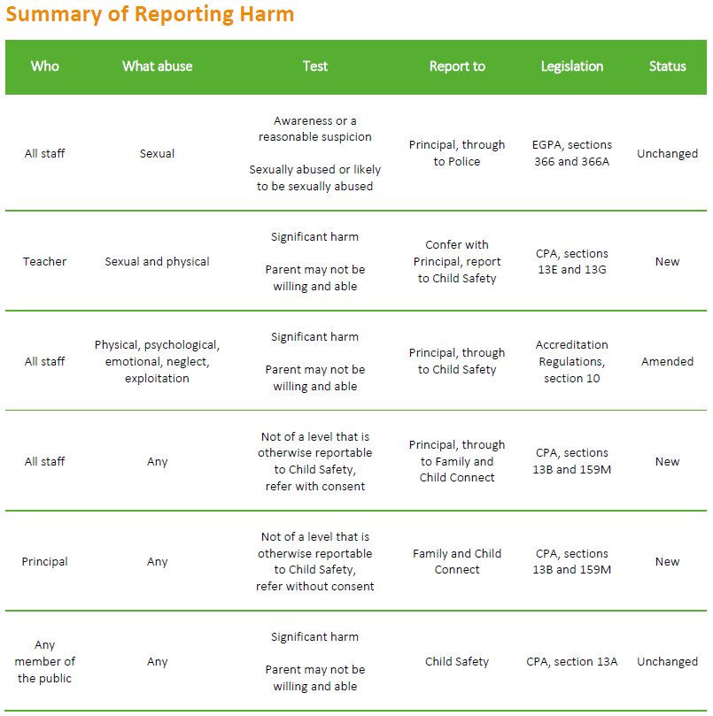

Appendix 2

Private and Confidential

Report of Suspected Harm or Sexual Abuse

Date:
School:
School Phone:
School Fax:

DETAILS OF STUDENT/CHILD HARMED OR AT RISK OF HARM/ABUSE:
Legal Name: | Preferred Name:
DOB: | Gender:
Year Level: | Cultural Background:
Aboriginal ☐ Torres Strait Islander ☐ Aboriginal and Torres Strait Islander ☐
Does the student have a disability verified under EAP:  Yes ☐ No ☐ | Disability Category:
Student’s Residential Address: | Phone:
 | Student’s Personal Mobile:

FAMILY DETAILS
Parent/caregiver 1: | Relationship to Student:
Address (if different from student):
Phone: (H): (W): (M):
Parent/caregiver 2: | Relationship to Student:
Address (if different from student):
Phone: (H): (W): (M):
Is the student in out of home care: Yes ☐ No ☐

PERSON ALLEGED TO HAVE CAUSED THE HARM OR ABUSE
☐Adult family member ☐Child family member ☐Other adult

☐Student/other child ☐Unknown

PROVIDE ALL INFORMATION YOU HAVE WHICH LED TO THE SUSPICION OF HARM OR ABUSE (Attach extra pages if necessary).
Details of any harm and/or sexual abuse to the student – please include: Time and date of the incident; source of information; details of person alleged to have caused the harm or sexual abuse; physical appearance of any injury; immediate and ongoing safety concerns; any disclosures made by student; any previous incidents of harm; behavioural indicators of harm; presence of any medical needs or developmental delays; and if the information relates to an unborn child, the alleged risk to the unborn child.

Please indicate the identity of anyone else who may have information about the harm or abuse

Additional information provided as an attachment YES ☐ NO ☐

Name of staff member making report to the Statutory Agency if not the Principal:  Position: | Signature: |  | Date:
Principal: | Signature: |  | Date:
Principal’s email address:
Response requested by school:

ACTION TAKEN
Form was faxed or emailed to (please tick which agencies the form was sent to): | □ | Queensland Police Services (QPS)
 | □ | Department of Communities (Child Safety Services)
 | □ | Family and Child Connect
(Adapted from EQ SP-4 Report of Suspected Harm or Risk of Harm)
Confirm receipt of faxed or emailed form and ensure original is stored in a secure location along with any other documentation collected for the purpose of this report.

