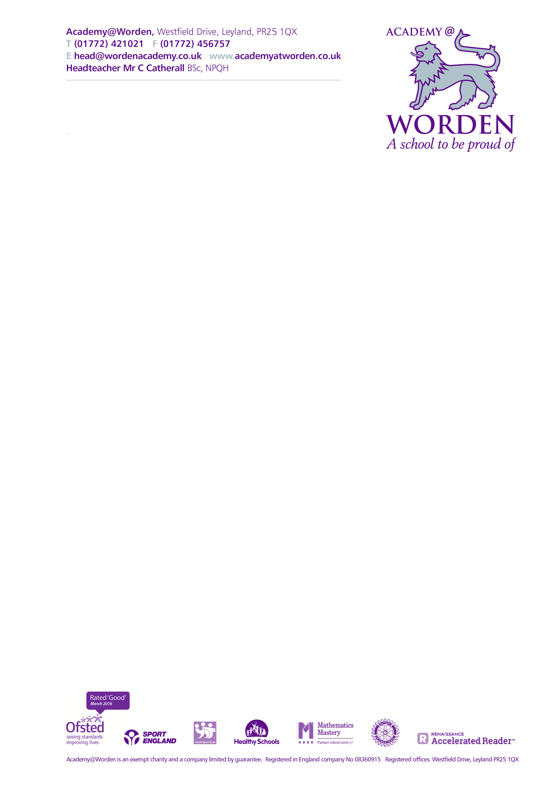October 2018

Dear applicant

Thank you for your interest in the position of Part Time Teacher of science. I am extremely proud to be the Headteacher of such a successful and rapidly improving school with an innovative and personalised curriculum which provides a stimulating education within a friendly and supportive community.

Worden is a comprehensive Converter Academy that has a proven track record of sustained improvement and growth. In February 2016 the school underwent a successful one day short inspection which highlighted the fact that *Pupils leave the school with brighter prospects due to a passionate and driven leadership team working alongside teachers who care and meticulously plan for each unique cohort.*

The successful candidate will work along a well-resourced department of committed professionals whilst maintaining the extremely high standards in order to drive forward further improvements. If you are a committed professional, enjoy a challenge and are passionate about raising standards and making a difference, you are the person we want working with us.

Please take time to read through all the documentation and familiarise yourself with the ethos and aims of Worden and I look forward to receiving your application shortly.

Yours sincerely

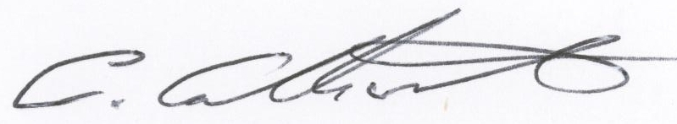

Mr C Catherall

Headteacher