Teacher of Science (maternity cover)-Job Description

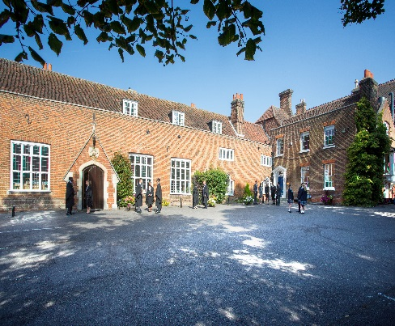

Introduction
Chigwell School is seeking a well-qualified, energetic and committed teacher to join our highly successful science department for a maternity cover. It is anticipated that the successful candidate will have had experience in a similar role in another maintained or independent school. The successful applicant will be expected to teach KS3, iGCSE and possibly A Level.

Background
Founded in 1629 by Samuel Harsnett, the son of a Colchester baker who went on to become Archbishop of York, Chigwell School stands on it original site with the original school building still in use. However, whilst Chigwell of today is conscious of its long-standing history, it is a forward-looking, ambitious, co-educational independent school of 930 pupils aged four to eighteen. It enjoys excellent facilities, a dedicated staff, bright and hardworking pupils, and a site of 100 acres.

Chigwell School is located in the picturesque village of Chigwell just over ten miles from central London and on the Central Line. The extensive, beautiful grounds are close to the edge of Epping Forest and it is rare for a school to have so much space and yet be so close to the centre of the Capital. Most pupils are day pupils but in the Sixth Form, there is a small community of international boarders, roughly twenty five from sixteen countries, and these live in four small boarding houses. They bring an international influence to the Sixth Form as a whole.

a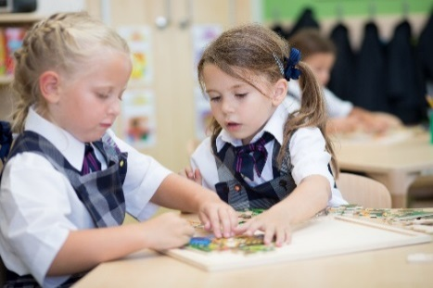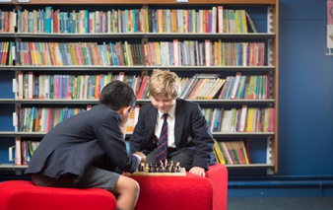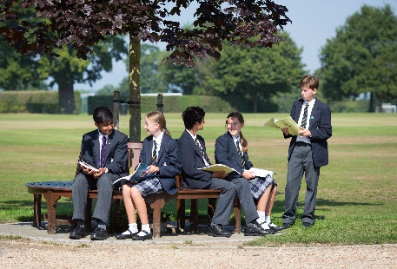
As well as being an academic school, Chigwell has the reputation for providing a rich and full education, with plenty of opportunities for all pupils who are enthusiastic, co-operative and able. Chigwell is a caring and friendly school, with a close sense of community, not least between colleagues. As the 2015 Good Schools Guide reports: Academically, pupils are put through their paces but it all seems to be done in such a civilised and pleasant manner that you are more likely to hear pupils talk about opportunities and prospects than pressure and stress. “Anyone who wants to do well here, will do well” said one student, and I can’t think of a nicer place to succeed.”

The School Development Programme
Over recent years, the School’s facilities have been extensively developed in order to enhance the educational experience that pupils receive. The development programme has included the following additions:
- 2008 Wilson Building teaching block
- 2008 Floodlit AstroTurf pitch
- 2009 Junior School library extension
- 2010 Complete redevelopment of catering facilities
- 2010 Sixth Form coffee shop
- 2010 Harsnett’s and Church House converted into boys’ boarding houses
- 2012 The Old Chigwellian Club and land was incorporated into the school estate
- 2013 Pre Prep School built and opened
- 2013 Two new science labs created
- 2014 Drama Centre balcony extended to provide additional music and drama rehearsal space
- 2016 The Risham Sarao Sixth Form Centre was completed

The extension of the Dining Hall is underway. In the future we plan to:
- Renovate the Chapel
- Develop the Sports Centre
- Expand our music facilities
- Further expand our provision of bursaries

The School
Some pupils join in Reception and there are two classes in each of the three Pre Prep year groups. A small number of other children join the Junior School at 7+ (Year 3) and there are two or three classes in each of the KS2 year groups. At 11+ (Year 7), there is a further entry with four classes making up Years 7 to 11. Again, there is a small entry into the Sixth Form. Entry at each stage is selective and although there are three main sections to the School (Pre Prep, Junior School and Senior School) these sections work closely together and there is a common ethos running throughout.

There are over a hundred teachers and together with the support staff, there is a friendly, mutually-supportive atmosphere. All teaching staff contribute to the extra-curricular programme.

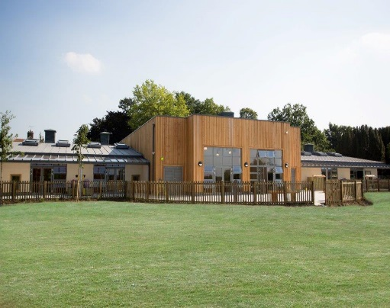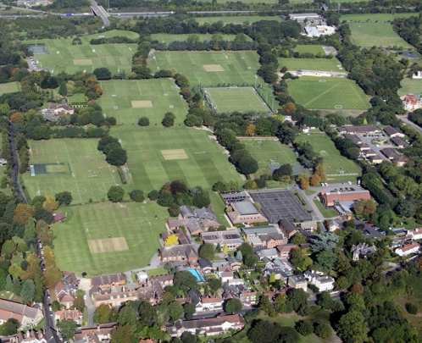

The Department

In Year 7 pupils follow a science course based on the National Curriculum. From Year 8 pupils study Chemistry, Biology and Physics as separate subjects where they are taught many of the underlying principles needed for the GCSE course, which pupils start in Year 9. The Edexcel iGCSE syllabus is followed with separate subject courses offered to those able and willing to cope within the same teaching time as those following the Double Award course. The majority of pupils now follow separate science courses.

At A level all three subjects follow the OCR syllabus. Between 20 and 30 students per year group choose to study each science to AS and A2 levels indicating the strength of these subjects in the Sixth Form. In the last three years most students have achieved an average A*/A/B pass rate of approximately 80% at A level.

Students are also offered a large range of activities and experiences beyond the classroom. A Level students regularly participate in Olympiad competitions with considerable success. There are a wide variety of field trips, academic lectures and essay competitions for all year groups throughout the year.

The science facilities are very good, the department having benefited from a number of refurbishments and extensions over the years. Practical classes are extremely well serviced by dedicated technicians. Chigwell School is increasingly using ICT as a teaching, learning and administrative tool. All laboratories and offices are networked; they have integrated whiteboards and are fitted with projectors, and all teachers receive a laptop.

The science department, indeed the whole School, provides a very friendly and supportive environment and this appointment would suit someone wishing to gain further teaching experience in this highly academic school. The successful applicant will be appointed onto the main national salary scale (incorporating London Fringe). There is an additional scaled Chigwell Allowance.

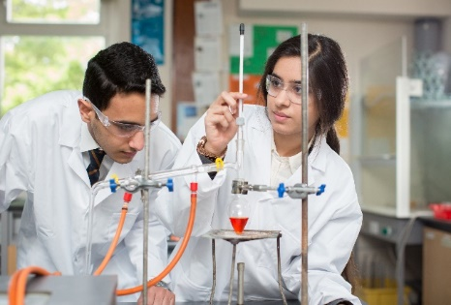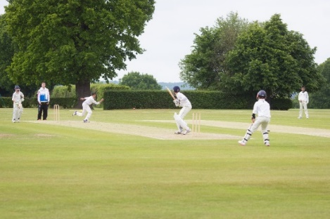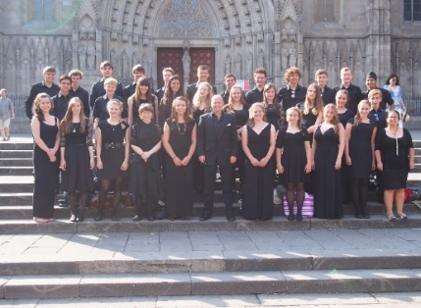

Applications

Applicants should complete the teaching staff application form which can be accessed directly from our website: www.chigwell-school.org (Vacancies) and sent to the Headmaster’s P.A.: hmpa@chigwell-school.org by Monday 16th^{th} October 2017. Early applications welcome. The Head of Science, Mr Paul Eardley, will be happy to answer any questions; he can be contacted at the School by telephone 020 8501 5701 or by e-mail to peardley@chigwell-school.org

Chigwell is committed to safeguarding and promoting the welfare of children and young people and expects all staff and volunteers to share this commitment. Applicants must be willing to undergo child protection screening including checks with past employers, prohibition orders and enhanced DBS.

