TEACHER OF PE

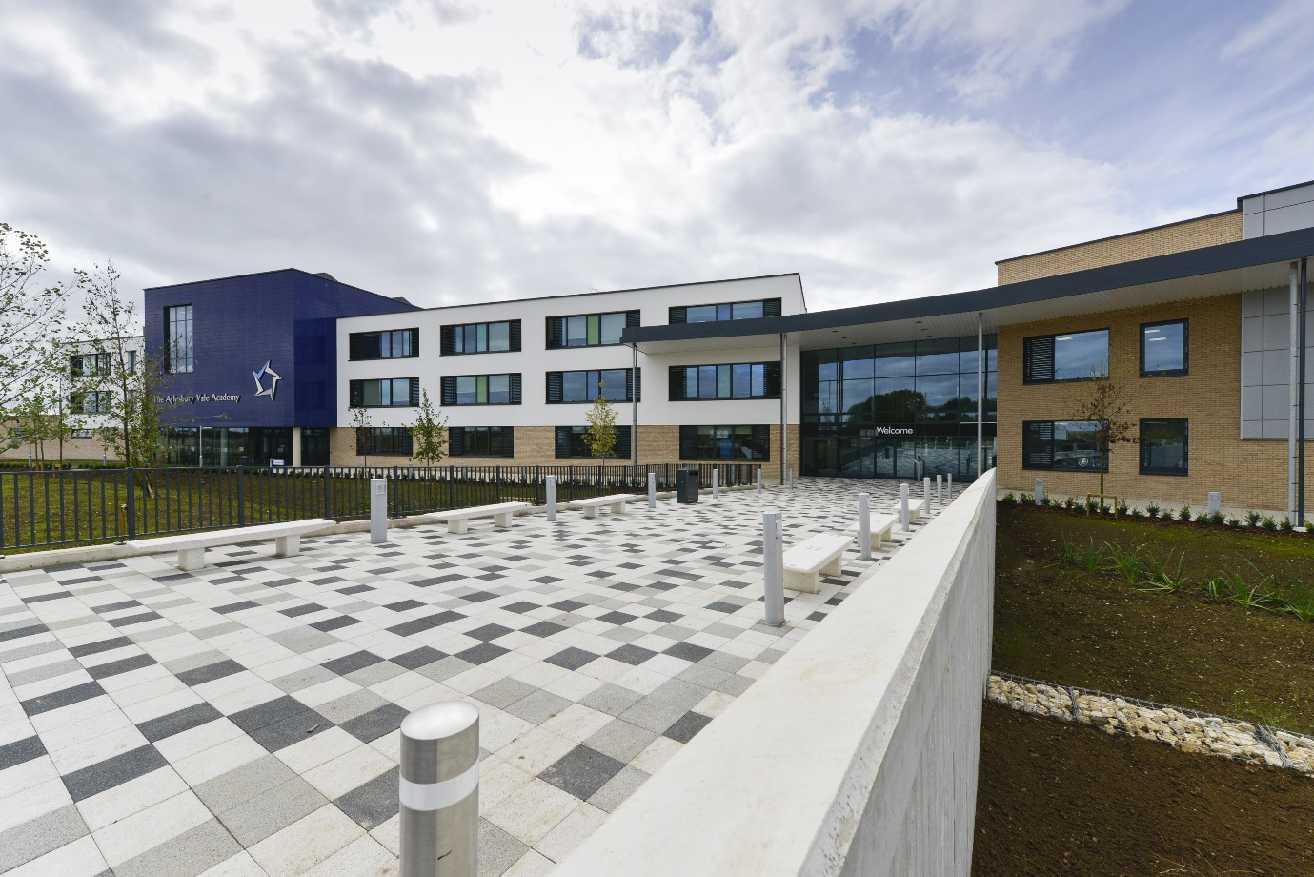

Chair of Governors: Mr Simon Weaver Executive Principal: Mr Roger Burman

TEACHER OF PE

JOB DESCRIPTION

GENERAL DESCRIPTION OF THE POST

The holder of this post is expected to carry out the professional duties of a classroom teacher as described below. All teachers at Aylesbury Vale Academy are expected to take the initiative when faced with problems, to share and develop ideas with their line manager and to ensure successful outcomes from their classes.

MAIN PURPOSE:

• To teach excellent PE lessons as timetabled ensuring all students are engaged in PE as part of a fit and active lifestyle.

• To be responsible for the provision of an appropriately broad, balanced relevant and differentiated curriculum for students studying in the curriculum area.

• To inspire staff and students to participate in a comprehensive enrichment programme with a rich and varied provision which enhances student relationships with staff and each other and helps develop students’ lifelong learning skills.

DUTIES AND RESPONSIBILITIES:

• To help develop an engaging and challenging curriculum that enables all students to enjoy the subject and achieve at the highest level, support by detailed schemes of work which ensure consistency and coherence across the curriculum area.

• To interpret and act upon student performance and behaviour data effectively using it to modify planning and personalise support.

• To ensure that improvements in Literacy, Numeracy and ICT are priority targets for all students.

• To ensure students acquire the skills necessary to conduct inquiry and research and show independence in learning.

• To support the ethos and policies of the Academy and promote high levels of achievement and attainment in lessons.

• To provide evidence across each phase that students make appropriate progress in relation to prior progress and national comparisons.

• To work as part of a team enhancing the quality of teaching and learning in PE and use your own classes as examples of high quality teaching and learning in your subject.

• To establish a dynamic and engaging learning environment that helps students develop study skills in order to achieve excellent learning and with increasing independence.

• To ensure that all Academy policies are implemented rigorously and consistently.

• To ensure that parents are well informed about the curriculum, targets, students’ progress and attainment through reporting and meetings.

• To support the development of links with parents of students in the Academy.

• To maintain a presence around the school to ensure that the highest standards of behaviour and site usage are upheld.

