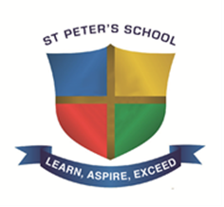

St Peters School Information for Applicants
St Peter’s School is a rapidly changing school as recognised by our ‘Good’ judgement from Ofsted in March 2017. Our students are well behaved, ‘well mannered, respectful and considerate towards each other and staff‘(Ofsted March 2017). They are positive about their learning and this is demonstrated by their attendance which is higher than similar schools. Students arrive on time to lessons, ‘follow instructions well, settle quickly to work’ (Ofsted March 2017) and are willing to learn. ‘Pupils’ behaviour for learning and their attitudes towards learning are good’ (Ofsted March 2017). What our students need are the best teachers who can grasp this enthusiasm and inspire them to succeed.
To support our staff a comprehensive professional development programme is run with a significant proportion delivered by our own staff that are proven effective practitioners with knowledge of which teaching strategies engage our students. We work in close co-operation with two local Teaching School Alliances in order to add breadth to our professional development activities and in most weeks deliver up to four such opportunities.
We recognise that our headline results need to further improve, but with our strengthened pastoral system and the focus on professional development we are positive that the outcomes for our ‘disadvantaged’ students will rapidly increase to match those of our ‘other ‘ students who make ‘progress that was significantly above the national average’ (Ofsted March 2017).
Thank you for taking the time to consider St Peters School.
Christopher Bennet
Headteacher

