Visiting Piano Teacher

(From September 2018)
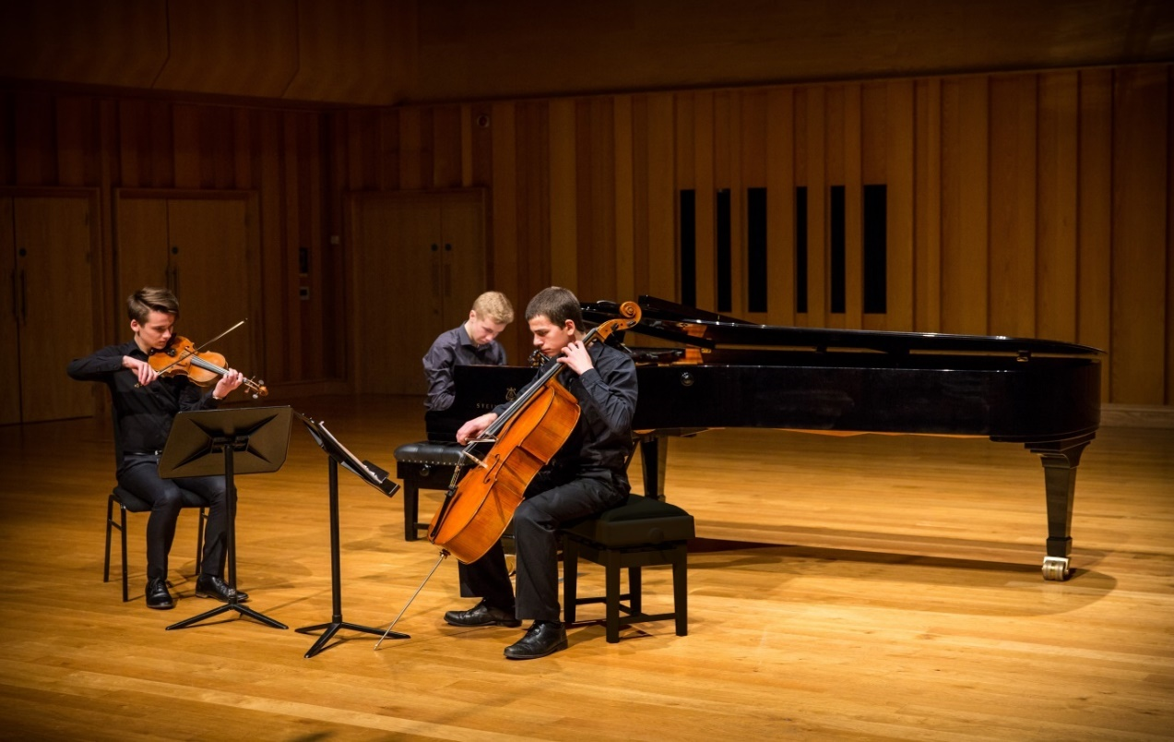

We are seeking to appoint a dynamic, inspirational and experienced Piano Teacher to join one of the largest school-based Music Departments in the UK.

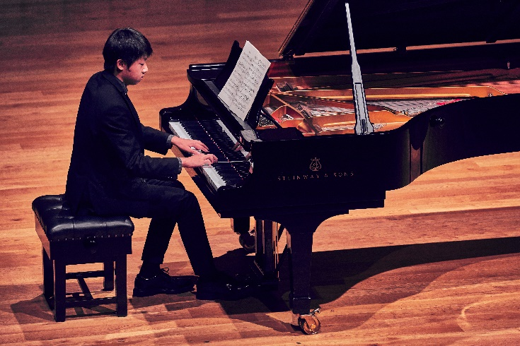
THE MUSIC DEPARTMENT

The Department

The Music Department at Millfield is one of the largest in the UK with world-class facilities. This, combined with a comprehensive and outstanding teaching staff, provides exceptional provision for our musicians both in the classroom and in practical music-making. Our facilities include:

- 350-seat concert venue, including a Steinway Model D Concert Grand
- Rehearsal rooms
- 5 teaching suites, each fully equipped with Macs
- Recording studios
- 25 teaching/practice rooms
- Specialist percussion room

All pupils study music from the moment they arrive and can opt to study it at GCSE and A level. We are proud of our pupils’ achievements in this wonderful arena. Many have secured places at major conservatoires, prestigious university music departments and with national orchestras and choirs. Millfield’s large ensemble provision includes: Junior Choir, School Choir, Symphony Orchestra, String Orchestra, Jazz Band, a close-harmony Vocal Group, Percussion Ensemble, Brass Ensemble, several vibrant Rock and Pop groups and an award winning Chamber Choir. In addition to this there are numerous chamber music ensembles rehearsing every week.

With a growing concert calendar featuring almost 50 concerts, performances range from solo recitals to large-scale ensemble concerts and chamber music concerts to contemporary evenings and musicals. The Music Department benefits from a high profile external performance calendar, participation in renowned music festivals and competitions, regular tours across the globe, whilst also hosting an International Concert Series, a programme of professional Masterclasses and a biennial Concerto Festival, in which pupils perform a concerto movement with a professional conductor and orchestra.

This is a fantastic opportunity to be part of a department that is on an exciting path to achieving its aspiration of having both a national and international reputation in the quality of its music-making.
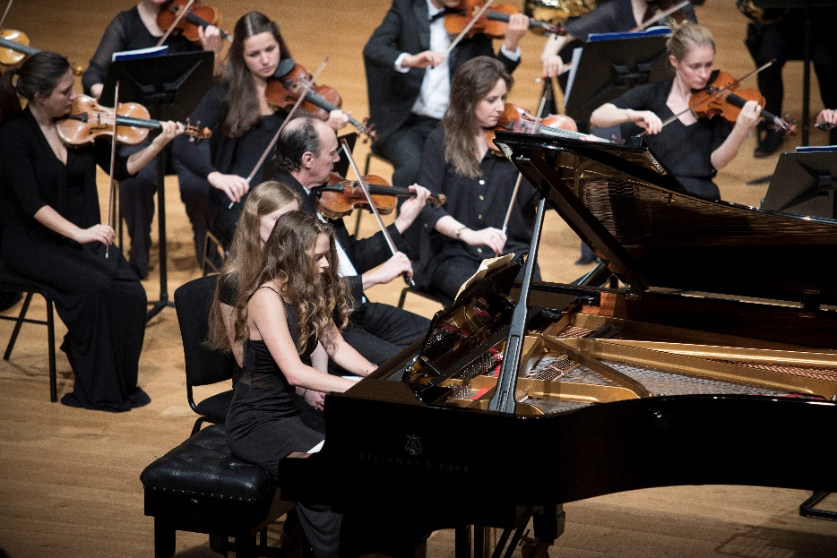

RESPONSIBILITIES
- An experienced and inspirational teacher capable of teaching individual Piano lessons to pupils aged 13 – 18;
- A musician capable of teaching a range of repertoire including Classical, Folk, Jazz, and Popular music;
- The ability to teach beginners and more advanced players with a similar enthusiasm;
- A teacher who will develop sight-reading and general musicianship skills with their pupils;
- The keeping of accurate records of lessons and basic report writing skills;
- Good communication skills in dialogue and correspondence with pupils, colleagues and parents;
- Availability for some occasional extra work available with pupils for school concerts would be helpful;
- An interest in the department’s Chamber Music programme;
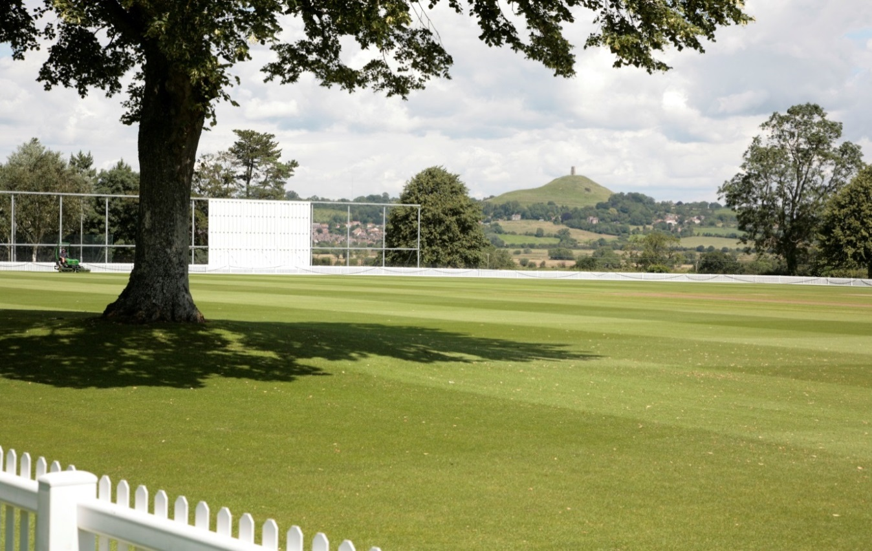
MILLFIELD

Millfield is the largest co-educational boarding school in the UK with over 1200 pupils, aged 13-18. The pupil body is comprised of 75% full boarders and 25% day pupils. Located in Street in Somerset, the school is set in 150 acres of beautiful campus with outstanding facilities including an Olympic sized pool, two gymnasiums, a golf course, equestrian centre, concert hall, theatre, art gallery and music centre. The Prep School, for ages 2-13, is located eight miles away at Glastonbury.

The school has in its 80 year history achieved significant growth. Established in 1935 by Jack ‘Boss’ Meyer with six princes from India, today it is an international, multi-faith school welcoming young people from all backgrounds and over 70 nationalities. Millfield may be one of the bigger independent schools, but its ethos remains to discover and develop the potential of every pupil. The school has been structured to make sure it is friendly, approachable and focused on the unique needs of each individual.

Millfield is a dynamic and incredibly rewarding place to work with a strong sense of community. For further information about this post, Mr Matthew Cook (Director of Music) would be happy to answer any specific questions. He can be contacted on cook.m@millfieldschool.com.

Short-listed candidates will be invited to the school for interview. The selection process will involve an interview and a short lesson observation.

Millfield School is committed to safeguarding and promoting the welfare of children and young people and expects all staff to share this commitment. Offers of appointment are subject to satisfactory references and DBS clearance.

