Vice Principal
Curriculum and Achievements
Candidate Brochure

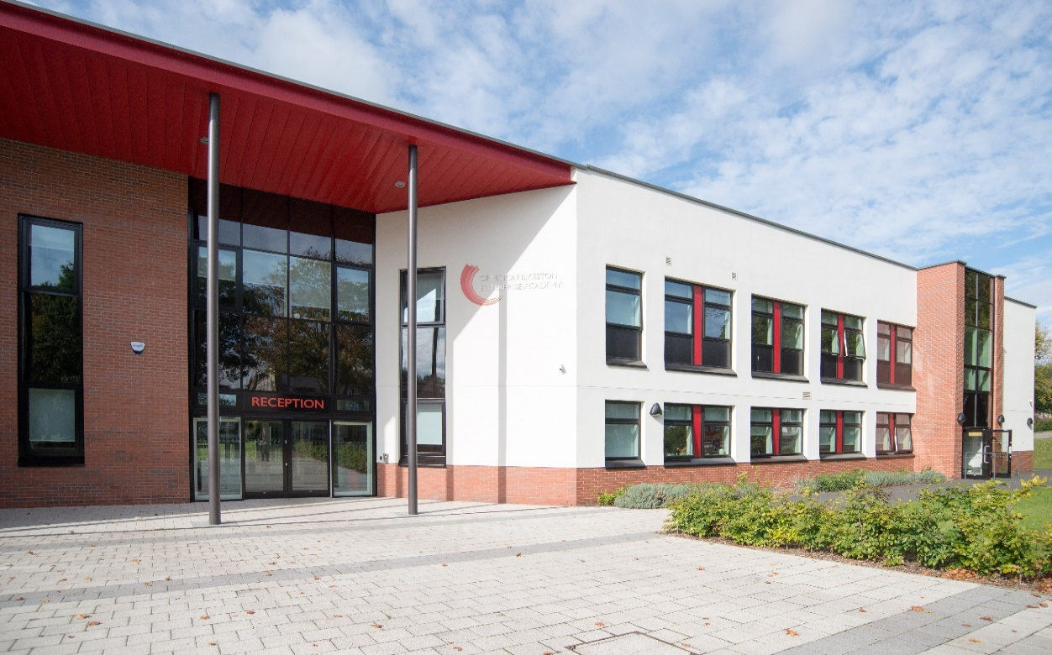

Believing that outstanding education transforms lives
Persisting until we succeed

OIEA
King George Avenue
Ilkeston
Derbyshire DE7 5HS
0115 930 3724

facebook.com/oieacademy @oieacademy www.oiea.co.uk

Contents

Key Facts and Statistics | Page 2
Welcome Message from the Principal | Page 3
About Ormiston Ilkeston Enterprise Academy | Page 4
Our Location | Page 5
Headline Measures for KS4 and KS5 | Page 6
Job Description | Page 7 - 8
Person Specification | Page 9 - 10
How to Apply | Page 11

Statistics

Type of School: | Secondary School
Age range: | 11-16
Location: | Ilkeston, Derbyshire
Number on roll: | 730
Average class size: | 28
Date school established: | 1914
% of PP students | 44.25%
SEN % in the academy: | 13.84%
% English as an additional language: | 3.56%

Welcome Message from the Principal

Dear Applicant
Thank you very much for your enquiry.

We are delighted that you are thinking of applying for this post at Ormiston Ilkeston Enterprise Academy and hope that you submit an application. Ormiston Ilkeston Enterprise Academy has been educating children since 1914. We are a popular and oversubscribed school that is forward-looking and with excellent standards and high expectations. Our last OFSTED Report stated that “students at OIEA are courteous and polite. They take pride in their work, their school and their appearance”. The OFSTED’s staff survey “confirms that morale is high”. The academy is “directed by the strong vision of the Governors and leaders, the staff prepare pupils well for life in modern Britain”.

Raising achievement is at the heart of all we do, based on clear educational values, well qualified staff and our strong traditions. Our students receive a good educational experience and we are highly ambitious for them. The quality of learning and teaching, combined with a broad and balanced curriculum enables students to achieve academic success and develop into confident, clear thinking young people with a sense of responsibility to others. We are equally committed to developing our students in all subjects, so that they can thrive in the future. We believe that our students can achieve highly, regardless of their starting points.

Ormiston Ilkeston Enterprise Academy enjoys a good reputation in the local community and with local primary schools. There is a clear commitment to the education of all of our students and we pride ourselves on being able to support them to develop their full potential.

Ormiston Ilkeston Enterprise Academy is a vibrant place to work, oversubscribed with great students, a dedicated staff team, engaged families, as well as a committed Governing Body. Come and join us!

Miss Nia Salt
Principal

About Ormiston Ilkeston Enterprise Academy

Ormiston Ilkeston Enterprise Academy is a school dedicated to achieving the highest standards of teaching and learning.

We work in partnership with parents and carers in order to ensure students achieve and are fully prepared for their next steps.

We pride ourselves on our calm and purposeful atmosphere around the academy, with high standards for every aspect of academy life.

We strive to work in an atmosphere of trust and to enjoy our education, developing a drive to explore the world in which we live.

Our vision is to be a hub for the whole community. Students will be supported to succeed whatever their ability, background and aspirations. They will leave ready for the world of work, and they will understand their role in the local, national and global community. A sense of equality, inclusivity and acceptance of diversity will be forged through a wide range of learning opportunities not limited to the classroom or school buildings.

Teachers will continue to learn and to develop their own skills, so that the academy always develops and continues to move forward. The mutual respect of lifelong learning in a nurturing, sharing and supportive culture will be clear to all.

The academy is committed to working with families in the spirit of Ormiston’s aims. Family learning will take place in the academy and in the community, working with external agencies. Support from local business people will help students to gain new insights and discover new opportunities into the world of work.

We strive to keep working as the local school for the local community. We have a reputation for supporting learners and their families to achieve their potential whilst fostering the community cohesion that makes Ilkeston so strong.

Our Location

Ormiston Ilkeston Enterprise Academy is located in Ilkeston in Derbyshire. It is easily accessible from the M1 junction 26.

The town centre is 0.4 miles from the Academy, offering a vast range of local independent and national shops and restaurants.

Ilkeston Station is a 15 minute walk away from the Academy.

The Academy is served by Trent Barton buses (The Two, Ilkeston Flyer and 23). Details can be found on our website – oiea.co.uk.

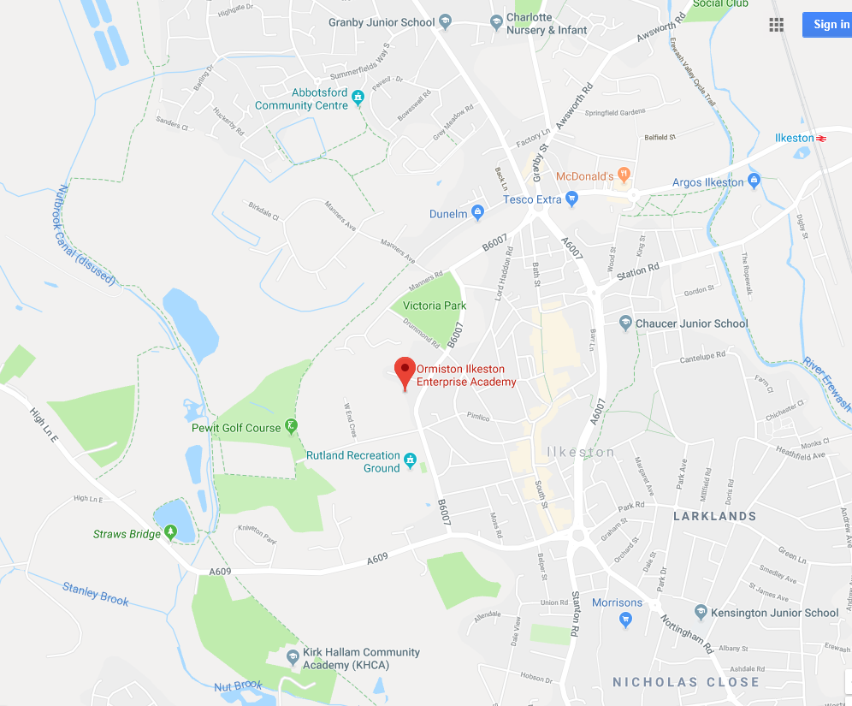

The academy is located here in the heart of the community

Headline Measures KS4

 | 2016 | 2017 | 2018
Progress 8 | -0.55 | -0.44 | -0.22
% of students that gained English and Maths GCSE grade 4-9 |  | 45% | 53%
% of students that gained English and Maths GCSE grades 5 – 9 |  | 21% | 33%
% of students that gained the English Baccalaureate |  | 11% | 10%

Job Description

To deputise for the Principal and provide effective day-to-day operational management of the school.

To lead by excellent personal example, with authority, presence and impact.

Commit to shape, share and embody the school’s vision and values in everyday work and practice.

To be responsive to the whole school community with the school’s values at the heart of your leadership.

To be accountable for ensuring that all students enjoy and benefit from an outstanding educational experience.

To provide strong leadership and management and thereby contribute to building and developing a staff team which continually enhances the quality of learning and relentlessly raises achievement.

To ensure the seamless organisation and management of the school and seek ways of improving organisational structures and functions based on ongoing self-evaluation.

To work collaboratively with all stakeholders and to carry out your responsibilities to this wide group.

To promote community cohesion and to have due regard for every student in the school.

To actively contribute to the effective safeguarding that permeates the school.

To model and secure outstanding behaviour for learning and respect for others at all times.

To possess the grit and ambition to deliver on ‘outstanding’ and beyond.

At all times to act professionally and responsibly, having due regard to appropriate confidentiality, loyalty and our strong moral purpose.
To develop your own professional learning, knowledge and skills, to benefit the school community and the profession.

Timetable

To review the timetable in order to ensure that it enables the best quality teaching and learning to take place.

To oversee construction of the timetable in liaison with the Timetable Co-ordinator.

To review academic staff requirements with the Principal.

Curriculum

To oversee the evolution of a whole school curriculum model that is innovative, embeds 21st century skills and progresses in difficulty, content and challenge to fully prepare students to excel at GCSE level and beyond.

To ensure that scheme of work, at all phases of the school, employ shared approach to pedagogy, are fully planned, implemented and annually reviewed in accordance with the latest changes to the National Curriculum.

To lead and evolve an extra-curricular activities programme in which pupils achieve a good or better measure of success and demonstrate group/individual achievements in sport, the performing arts and other clubs and societies that are considerable for their age.

To coordinate GCSE option arrangements.

Assessment and Reporting

To be responsible for whole school monitoring and development of assessment recording, reporting and target setting, including updating the Assessment Policy.

To support staff in the implementation of Parents events.

To oversee baseline and half-termly data collection, analysis, sharing ad using of data, with an emphasis on establishing and maintain high rates of progress throughout the school.

To oversee rigorous half termly data analysis and ensure that the results and key trends are shared with staff promptly, to enable them to implement timely and appropriate interventions.

Line manage the Examinations Officer to ensure the smooth running of both internal and external examinations.

Line manage the Data Officer.

Self-evaluation

Support the Principal and the SLT by playing a leading role in SMART self-evaluation activity that includes formative and measurable target setting and so clearly enhances teacher practice with an emphasis on:
- Driving excellent pupil progress in the short, medium and long-term with increasingly challenging material and pupils’ success in meeting targets evident in work scrutiny, observations and through half termly data capture;
- Eliminating significant differences in the rate of academic progress between groups of pupils or areas of learning;
- Highly productive pupil engagement and participation in lessons from all groups of pupils, bot individually or collaboratively.
Any other duties relating to the job as required from time to time by the Principal.
PERSON SPECIFICATION
 | Person Specification | Essential | Desirable | Application
Education and Training | Qualified Teacher Status (QTS) & DBS Check | ✓ |   | ✓
 | Good Honours Graduate in an appropriate subject | ✓ |  | ✓
 | Further relevant qualifications |  |  ✓
 | Recent professional development | ✓ |   | ✓
Experience | Proven record as a leader in a range of contexts | ✓ |   | ✓
 | Identify improved learning and progress of students as a result of your successful leadership of whole school priorities | ✓ |  | ✓
 | Demonstrate that you have led a curriculum initiative that has had a significant impact on student outcomes | ✓ |   | ✓
 | Provide evidence of outstanding teaching in an 11 – 18 environment as identified by an analysis of outcomes | ✓ |  | ✓
 | Provide evidence of successfully raising student achievement as a result of strategies you implemented and self-evaluation you undertook | ✓ |   | ✓
 | Provide evidence of meeting targets and raising whole school outcomes as a result of your use of strategic improvement and development planning | ✓ |  | ✓
 | Provide evidence of your ability to lead and interact with staff, students, parents and other stakeholders as required at a senior level | ✓ |  | ✓

Show the  following skills  and values  through  evidence or  performance | Person Specification (continued) | Essential | Desirable | Application
 | A passion for excellence in all areas, and an absolute commitment to raising standards across the whole school based on a strong sense of moral purpose | ✓ |   | ✓
 | An educational vision focused on students and their experiences of learning | ✓ |  | ✓
 | The ability to lead and motivate others | ✓ |   | ✓
 | The ability to work as part of a team | ✓
 | High quality, excellent, interpersonal and reflective skills | ✓ |   | ✓
 | Confident and proactive decision-making style | ✓ |  
 | Tenacity, energy, an ability to be flexible and a sense of humour | ✓ |  | ✓
 | Absolute commitment to equal opportunities and their implementation | ✓ |   | ✓
 | Excellent communication skills, proven ability to write concise reports and to give effective, oral presentations to a variety of audiences; excellent listening skills | ✓
 | Ability to demonstrate and articulate high expectations and lead by example | ✓ |   | ✓
 | Experience of working with a range of stakeholders to ensure inclusive provision of the highest quality | ✓ |  | ✓
 | Confidence in ICT skills | ✓ |  | ✓

DBS/SAFEGUARDING STATEMENT

Ormiston Ilkeston Enterprise Academy is committed to safeguarding all our students. Successful candidates will be required to undergo enhanced DBS checks and reference requests will indicate specific questions relating to their suitability to work with children.

Closing Date | 13th December 2018
Shortlisting Date | 14th December 2018
Interviews | 19th December 2018
Salary | Leadership—L19—L23
Start Date | Summer Term 2019
Title | Vice Principal (Curriculum and Achievements)
Reports to | Principal
Status | Permanent, Full time

We reserve the right to research applicants on social media platforms and the internet, and the Board of Governors may take this information into consideration during the recruitment process.

If you would like further information, or to arrange a school visit, please contact
Lyn Ashby on:

Switchboard: 0115 9303724

Email: lashby@oiea.co.uk

If you are interested in applying please download the information and complete the application form which can be found at www.OIEA.co.uk/vacancies . Please return your completed application form together with a covering letter saying why you feel you are suitable for the post to lashby@oiea.co.uk.

