St Michael’s Church of England High School
A Church of England Academy

Excellence within a Christian context

Teacher of Mathematics
Candidate Information
Therefore, choose
Thank you for your interest in the position of Teacher of Mathematics currently being advertised at St Michael’s CE High School, a Church of England Academy.
Letter from the Headteacher
St Michael’s is a special place to learn and work with a strong Christian identity. Our mission statement is:
As a vibrant learning community
we choose to serve God
pursue excellence
and
celebrate the uniqueness of each individual
We aim to achieve this mission through a Christian learning experience which focuses on opportunities for growth in body, mind and spirit:-
Where the safety, happiness and wellbeing of pupils are paramount. Where every child matters and more crucially, know that they matter.
Body

High expectations and aspirations in all areas of school life create a disciplined and ordered learning environment where creativity, passion and enthusiasm help to engender a life-long love of learning and secure excellent pupil outcomes.

Mind

Where pupils are supported to find for themselves the person that God wants them to be and really experience the joy and hope of ‘life in all its fullness’.
Spirit

As a thriving, oversubscribed Church of England Academy within the Diocese of Blackburn, our values are rooted in the Christian faith. Serving God, pursuing excellence and celebrating the uniqueness of each individual are at the heart of our distinctive ethos as we strive to ‘be the best that we can be’. We create and sustain our caring Christian community by encouraging positive supporting relationships based on Christian values and striking a genuine balance between the highest academic standards and opportunities for personal growth.
Worship is at the centre of our school life and is usually led by various staff, the Christian Youth Worker and/or pupils, with occasional support from local clergy or visitors. The school Chapel Choir (Hughes Tutorial) and the school Worship Band are regularly involved in worship helping to create a contemporary vibrant experience. Each day begins with a year group worship, assemblies and school prayers. In addition we hold Eucharist services in the school chapel throughout the year both at the start of the day and at lunchtimes. These services are led by various members of the local clergy who are always willing to support the school.
The chapel in the magnificent Armstrong Centre is also used for staff prayers and reflections which take place at the start of each working week. We hope that the school’s distinctive Christian ethos shines through in all aspects of our life and work here. We have numerous student leadership roles within school and an active charities committee. Each year group within school is linked to a particular charity.
St Michael’s has been in the top 10% of non - selective schools nationally for attainment for the last four years. In 2017 89% of pupils achieved 5+A*-C/ 9 -4 grades including English and mathematics. However, we are not complacent and are ambitious for further success because of the real life chances these results bring for our pupils.
We want all at St Michael’s to ‘be the best that they can be’. We are confident that our pupils are provided with a rigorous and productive learning environment where they are both challenged and supported. We have talented, dedicated, caring and dynamic staff who are willing to develop innovative approaches to learning and teaching for our young people, provide outstanding care and guidance and support our distinctive Christian ethos.

I hope the information provided on our website gives you a clear flavour of our ethos, of what to expect at St Michael’s and also helps you to prepare for the application process.
I look forward to receiving your application.
Yours sincerely
Jayne Jenks
Mrs Jayne Jenks
Headteacher
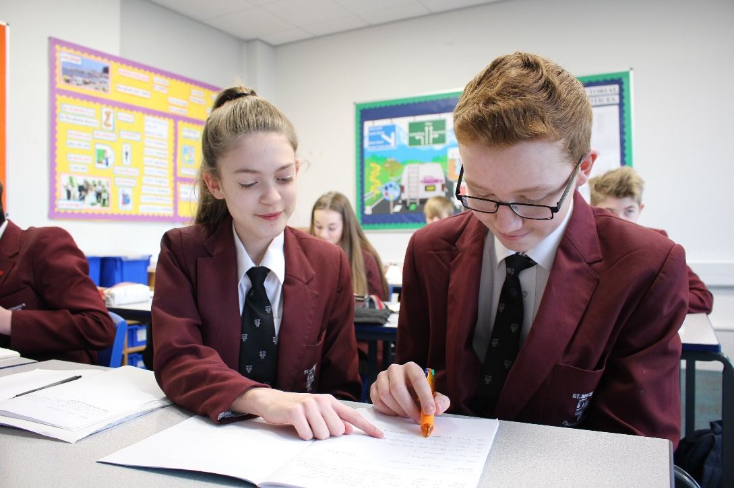

Information about the RE Department Department

Information about the Mathematics Department

The Mathematics Department is a leading area within the school, playing an instrumental role in shaping and enhancing whole school approaches to learning and teaching. The nine members of staff are all specialist teachers and are frequently called upon to model lessons for colleagues throughout the school and lead CPD in effective learning and teaching strategies.

Our mathematics curriculum aims to ensure that all pupils become fluent in the fundamentals of mathematics. Through varied and frequent practice with increasingly complex problems over time pupils go on to develop conceptual understanding and the ability to recall and apply knowledge rapidly and accurately. Our aim is that all pupils can solve problems by applying their mathematics to a variety of routine and non-routine problems with increasing sophistication, including breaking down problems into a series of simpler steps and persevering in seeking solutions.

Teachers work hard to prepare challenging lessons which use a wide variety of resources and activities to engage all learners. The successful candidate will have excellent teaching skills and the ability and interest to create lively and engaging activities which motivate all learners and bring the subject of mathematics to life.

The Mathematics Department has an extremely important role to play in the continued academic success of the school. With the change in the Mathematics curriculum the department has still maintained 93% of pupils achieving a grade 9-4, 73% achieving 9-5 and 27% achieving grade 9-7. Maths Progress 8 element is in the top quartile of schools.

In Year 7 pupils have four 40/45 minute lessons per week, five lessons in Year 8 and 9, increasing to six lessons a week in Year 10 and then five lessons a week in Year 11.
The curriculum area is well resourced, each of the seven classrooms has an interactive whiteboard, access to iPads and computer rooms within the school. The department offers ‘drop in’ help sessions at lunchtime and extra revision sessions after school which are well attended. Each year more than 100 students complete the UKMT Maths Challenge. A member of the department runs the schools STEM club and we also offer a gaming club for the students.

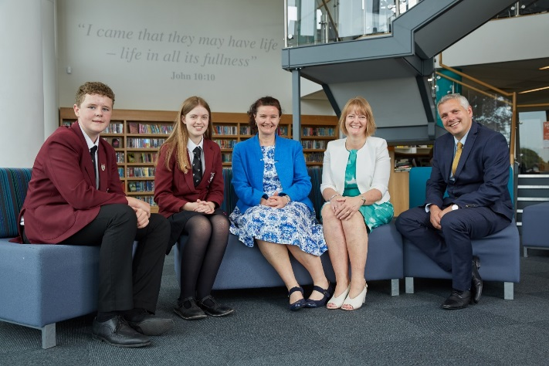

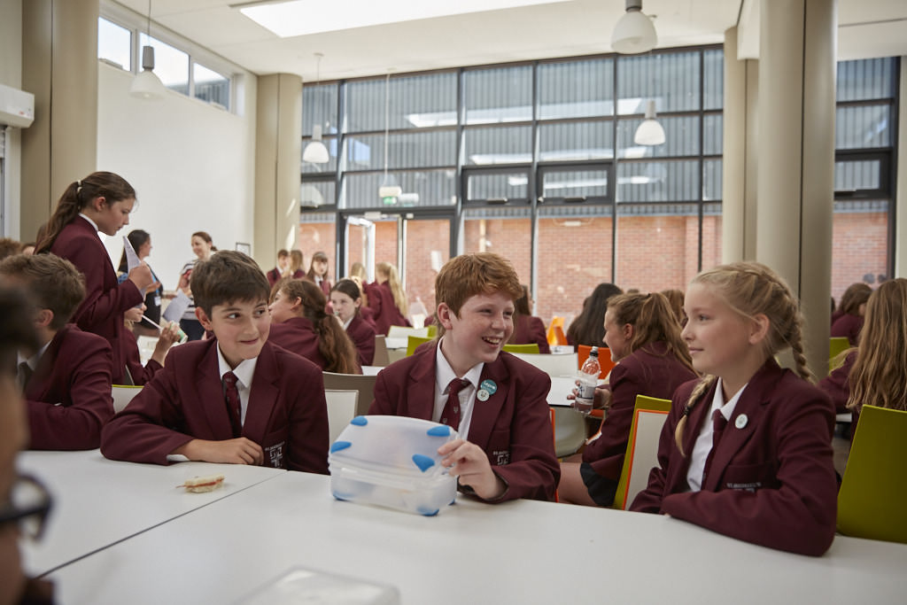
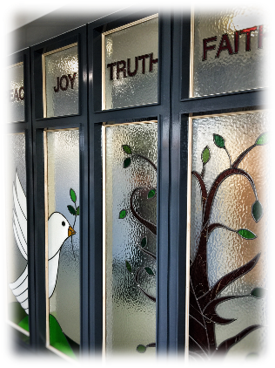
Letter from the Governors

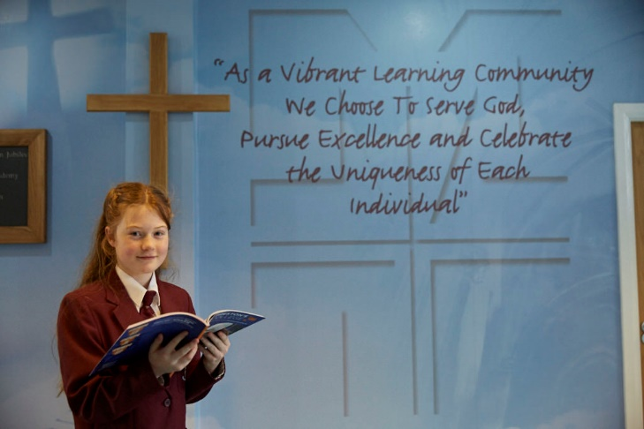

Thank you for requesting details for the post of Teacher of Mathematics at St Michael’s Church of England High School.

Most of the information you will need is displayed on the school website. However, the governors are proud to emphasise the ‘outstanding’ Ofsted inspection in 2009 and ‘outstanding’ SIAMS inspection in 2014. This was achieved by a whole school community approach of teachers, pupils and governors working together.

The strong academic, sport, and performing arts record is supported by the active Christian ethos apparent throughout the school; providing the opportunity for pupils to grow in body, mind and spirit. Staff focus on continually raising attainment, encouraged by inspiring, forward thinking leadership and management.

The governors will expect the successful applicant to continue to further the excellent achievements, enrichment activities and vision of the school and to support our distinctive Christian ethos.

Thank you for your interest and I look forward to hearing from you.

Yours sincerely

Mr C M Metcalfe
Chair of Governors
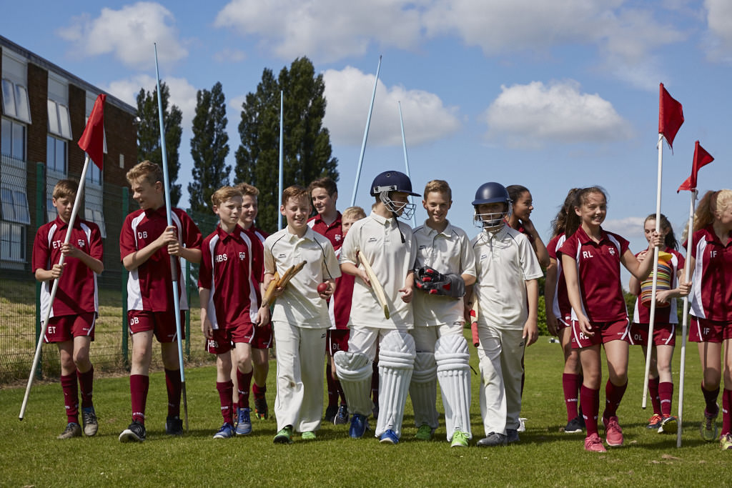
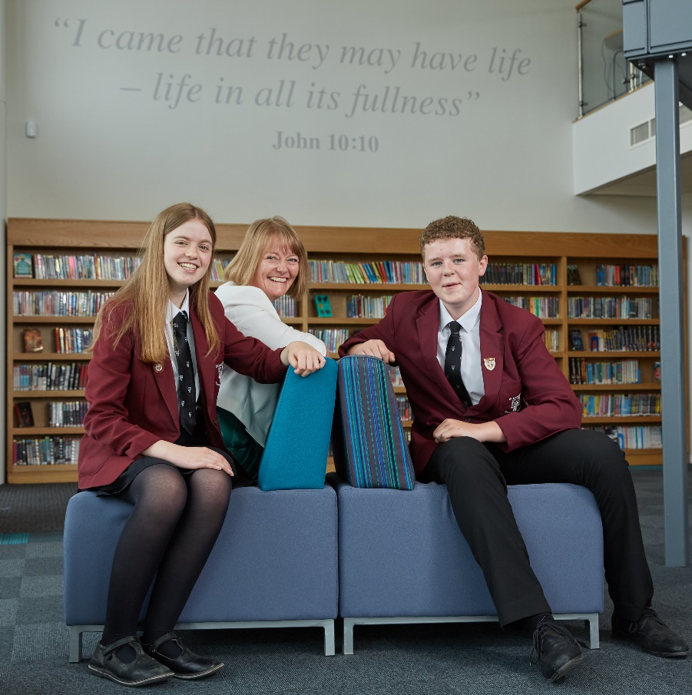
Head Girl and Head Boy Letter of Welcome
We appreciate your interest in the role of Teacher of Mathematics at St Michael’s Church of England High School. St Michael’s is an outstanding school with exceptionally high standards, allowing pupils to develop both academically, physically, spiritually and socially.
‘Team St Michael’s’ is a significant phrase used within our school life. The ‘team’ encompasses parents, pupils, staff and governors, who all work closely together allowing pupils to, “be the best that they can be”. This ‘team’ helps create a strong pupil teacher relationship which is necessary to create mutual respect and a sense of community. Exceptional examination results already demonstrate that this is in place.
Christianity is at the heart of all that happens at St Michael’s. ‘Excellence within a Christian context’ is the school’s philosophy and this can be seen throughout school. At St Michael’s, pupils’ faith in Christianity is developed and encouraged. Each year group has a weekly worship, tutorial worship and prayers every morning and Christian values are embedded within lessons, helping to produce a compassionate environment.

St Michael’s Church of England High School really is a fantastic place to learn. Pupils experience engaging and productive lessons, which challenge and support us.
‘Celebrating the uniqueness of each individual’ is another key focus, which is already well integrated into school life. We hope the new Teacher of Mathematics will be passionate and enthusiastic and eager to become part of ‘Team St Michael’s’.

Yours sincerely
Emily and Lewis
(Head Boy and Head Girl 2017- 2018)

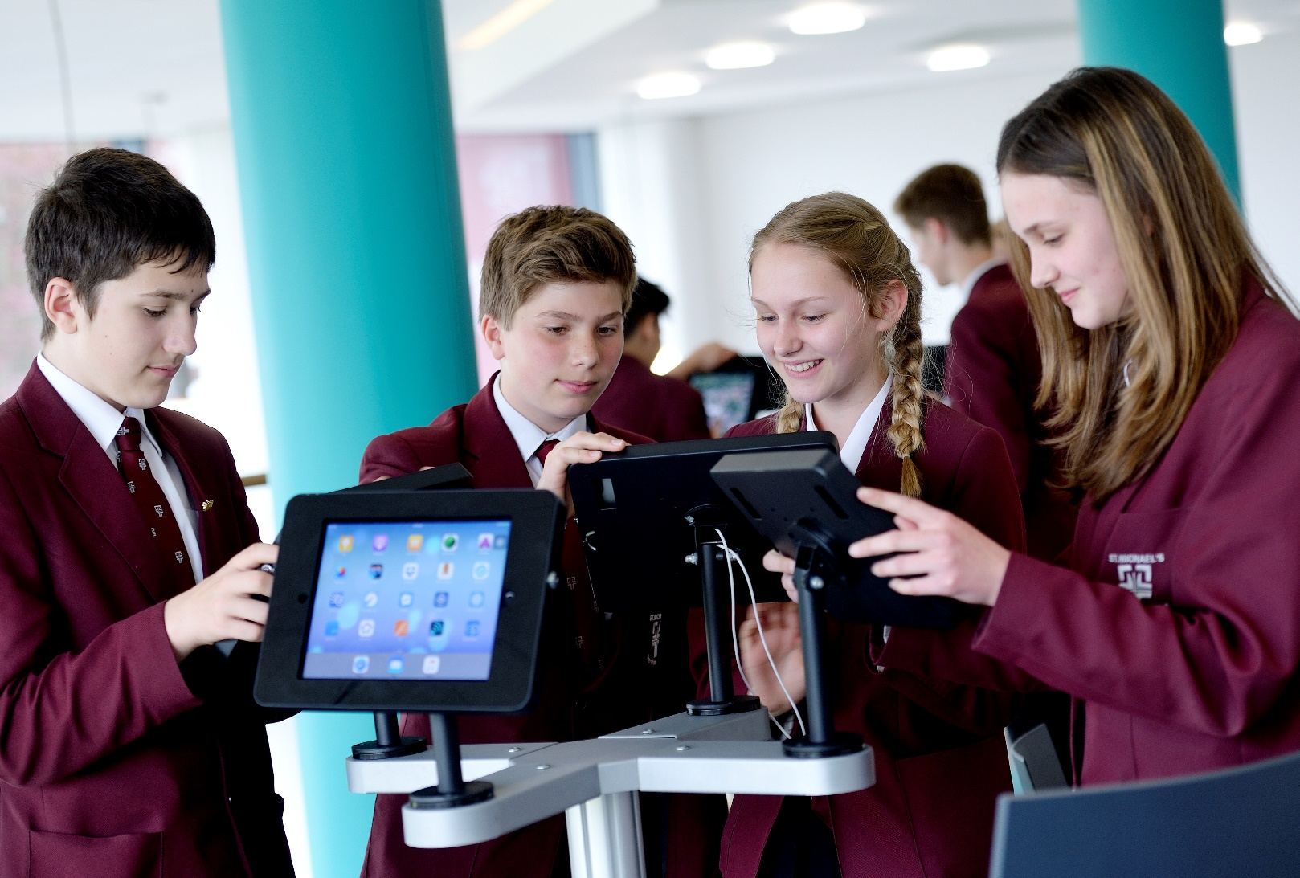
Application: Supplementary Information
Teacher of Mathematics
Salary: MPS (M1-M6)

Applicants are asked to provide a fully completed application form and a supporting letter (no longer than 2 sides of A4 in length in Arial point 12) that clearly sets out how your
experience to date prepares you for the advertised post (with reference to the enclosed
person specification).

Closing date for the receipt of completed applications: Tuesday 20 February at 09.00

Interviews: Week commencing Monday 26 February

Applications should be returned by email to: vacancies@saint-michaels.lancs.sch.uk

Applicants will be asked to produce original certificates for all education qualifications stated in the application form prior to the appointment being confirmed. All appropriate safeguarding and attendance at work checks will be requested.

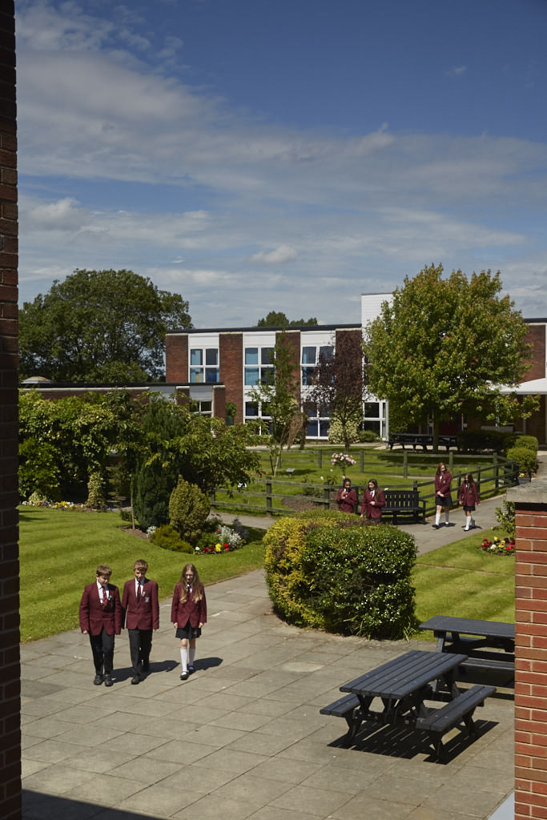
The applicant will be required to safeguard and promote
Teacher of Mathematics
Person Specification/Selection Criteria
the welfare of children and young people and be faithful to the trust deed.

Note: Candidates failing to meet any of the essential criteria will automatically be excluded

Section A: Qualifications, Experience and Professional Development

Training and Qualifications | E/D | Source
Supportive of the strong Christian ethos of the school  Practising Anglican | E  D | A/I  A/I/R
Qualified Teacher Status | E | A
Good Honours Graduate in relevant and appropriate discipline | E | A
Professional Development and Experience
Recent professional development relevant to the applicant’s current role | E | A/I
Teaching Experience
Relevant teaching experience in the secondary phase (KS3 & KS4) | E | A
Evidence of high levels of success in external examinations | D | A/R
Outstanding / good classroom practice | E | A/R/L

Section B: Professional Knowledge, Skills and Understanding

Ability to articulate a sound educational philosophy in line with St Michael’s whole school aims | E | A/I/
Thorough knowledge of the National Curriculum Mathematics and GCSE specifications | E | A/I/
Understanding and knowledge of outstanding practice in teaching | E | A/I/L
Development of initiatives to improve quality of learning and teaching | E | A/I/
Knowledge of recent and planned developments in education specific to mathematics | E | A/I/
Commitment to personal continuous professional development | E | A/R
Knowledge and understanding of the relationship between appraisal and CPD | D | A/I
Ability to use data effectively to assess prior attainment, set targets and monitor progress | E | A/I
Ability to use ICT skills effectively and awareness of their application in learning and teaching | E | A/I
Awareness of Health and Safety issues in class and on educational visits | E | A/I

Section C: Personal Skills and Attributes

Commitment and enthusiasm for young people, their learning and the subject | E | A/I/L/R
High expectations and aspirations for students | E | A/I/L
Excellent interpersonal and communication skills leading to great working relationships with students and other colleagues | E | A/I/R/L
Ability to collaborate and network effectively within and beyond school including parents and external providers | E | A/I/R
Ability to prioritise, plan and organise themselves and others to achieve objectives, having integrity and an eye for detail | E | A/I/R/L
Display high professional standards in dress, attendance and punctuality in line with the Staff Code of Conduct | E | I/R
Suitability to work with children and a satisfactory DBS clearance | E | A

KEY
E = Essential
D = Desirable
A = Application
L = Lesson Observation
I = Interview
R = References

Section D: Confidential References and Reports

Positive and supportive faith reference from the priest/minister where the applicant regularly worships | D
Positive recommendation from all referees, including current employer | E

Person Specification/Selection Criteria

Job Description for Teacher of Mathematics
Responsible to: Curriculum Leader for Mathematics / Pupil Manager

Our mission statement:
As a vibrant learning community we choose to
Serve God
Pursue Excellence
and
Celebrate the uniqueness of each individual

Job Purpose: To be an effective teacher (and tutor) who supports and challenges all pupils ‘to be the best that they can be’.

Main purpose
To work with the line manager for the curriculum area and where appropriate Pupil Manager in ensuring an environment for learning and teaching that empowers both staff and pupils to do their best and supports the Christian ethos of the school.
This job description is not a comprehensive definition of the post. Discussions will take place on a regular basis to clarify individual responsibilities within the general frame work and character of the post as identified below.
The conditions of employment of teachers in the School Teachers’ Pay and Conditions of Service Document apply to this post, whose holder is expected to carry out the professional duties of a teacher as circumstances may require, under the reasonable direction of the Headteacher.

Accountabilities:

- To take an active part in the spiritual and worshipping life of this Church of England High School including tutorial prayers, tutorial worship, other work with tutorial groups and Worship itself.

- To seek at all times to assist the school in the achievement of its aims, at all times supporting its Church of England foundation.

- To maintain a thorough and up to date knowledge of the teaching of your subject(s) and take account of wider curriculum developments which are relevant to your work.

- To do all you can to ensure that, as a result of your teaching, your pupils achieve well relative to their prior attainment, making progress as good as or better than similar pupils nationally and in the school.

- To teach pupils according to the needs of individuals, preparing, planning lessons and evaluating work in accordance with school and subject area policies.

- To take responsibility for one’s own personal professional development and use the outcomes to improve your teaching, seeking always to provide the highest quality of education for pupils.

- To set and mark home learning which is meaningful, relevant and complementary to classwork in accordance with school and subject area policies.

- To assess, monitor and record the progress of pupils in your teaching group and give them clear and constructive feedback.

- Comply with the school’s assessment and reporting procedure by writing reports and completing mark sheets as required. Maintain formative and summative records of pupils’ progress so that the assessment procedures of the school can be carried out.

- To participate with the Curriculum Leader and other appropriate colleagues, making an active contribution to the policies, aspirations and plans of the curriculum team and school in general including the development of specification, teaching materials and schemes of work.

- To be actively involved in school life, always acting in the school’s best interests.

- To carry out supervisory duties in accordance with school practices and policies.

- To participate in meetings with colleagues, parents and other bodies as appropriate.

- To produce an effective learning environment for all pupils by following the Behaviour for Learning Policy to ensure high standards of behaviour.

- To be responsible for the safety of those working in the classroom; this includes ensuring that the room is free from clutter and untidy storage, that faults are reported according to procedures laid down; in the case of teachers of practical subjects, this includes awareness of the dangers of equipment and materials being used, availability of first aid materials, and knowledge of procedures in case of accidents.

Therefore, choose
St Michael’s C.E. High School
A Church of England Academy
Astley Road
Chorley
Lancashire
PR7 1RS
Tel. 01257 264740
www.saint-michaels.com

