Primary Class
Teacher
Application Pack

Welcome to Atlantic Academy Portland

Thank you for considering our Academy for your next appointment.

We are passionate about excellence in education, giving pupils the very best start in life with a firm belief that excellent teaching transforms lives. Our core belief is that for all students to have high aspirations they must believe in themselves, be actively engaged in their learning and see the connection between what they learn today and who they want to become tomorrow.

Atlantic Academy Portland is an all through Academy with Reception to Year 11 (post 16 from 2018).

Staff development is vital to the progress of the Academy as we continue our journey to full capacity in 2018. Whatever your level of experience, there will be opportunities for career development and promotion either within individual academies or across the Trust. Excellent further professional development is offered by the academy, supported by the innovative and unique Aspirations training programs.

The Academy is located in stunning buildings, having benefitted from a £20 million plus full renovation program. It is situated on the beautiful Isle of Portland, at the heart of the Jurassic Coast, in Dorset. Within easy reach of Weymouth, Dorchester, Yeovil, Poole and Bournemouth. This really is an Academy at the very heart of the community. There is also the potential for onsite accommodation be made available at a subsidised rate.
The Academy will be sponsored by the Aspirations Academies Trust (www.aspirationsacademies.org) and be a member of one of their three clusters: The South Coast District, which consists of Jewell Academy Bournemouth (Primary, rated outstanding), Ocean Academy Poole (Junior, to be inspected) and Magna Academy Poole (Secondary, rated outstanding). The district members will work closely together sharing resources, expertise, CPD and providing specialist support where appropriate. Magna Academy Poole is also a newly designated NCTL Teaching School, providing many career development pathways and support for rapid progression. The opportunity to become an Aspirant Lead Practitioner, Lead Practitioner or SLE is available, please indicate this in your application if it is an opportunity you may wish to be considered for.

As a team we also believe in all staff aspiring to ‘Level 5’ leadership, as outlined by Jim Collins in ‘Good to
Great’, the key traits of which are outlined below:

Level 5 Leadership

• Paradoxical mix of personal humility and professional will
• Ambitious first and foremost for the organisation, not themselves
• Set up their successors for even greater success whereas egocentric leaders often set up their
successors for failure
• Display a compelling modesty, are self-effacing and understated as opposed to comparison
company leaders being egocentric which contributed to the demise or mediocrity of the company
• Fanatically driven, infected with an incurable need to produce sustained results – they are resolved
to do whatever it takes to make the organisation great, no matter how big or hard the decisions
• Display a workmanlike diligence – more plough horse than show horse

• Attribute success to factors other than themselves – when things go poorly they blame themselves
taking full responsibility
• One of the most damaging trends in recent history is the tendency to select dazzling, celebrity
leaders and to deselect L5 leaders
• This is an overwhelming empirical finding not an ideological one

You would be joining us at such an exciting time and become part of a vibrant learning community that
will offer you fantastic opportunities for your career development, both within Atlantic Academy and across the district. This really is a chance for you to be able to make your mark.

With outstanding facilities Atlantic Academy offers an excellent opportunity for ambitious, talented individuals looking to develop their career.

Yours faithfully

Jonathan Heap
Principal

If you would like to take your career to a very different level then please apply through TES online.

For an informal chat about the post or to arrange a visit please contact Melissa Heppell, Associate Vice Principal – Primary or mheppell@atlantic-aspirations.org

Closing date for applications: Monday 26th March 2018 - 12.00 pm

For more information please visit: www.aspirationsacademies.org or www.aatmagna.org

The Aspirations Academies Trust
The Aspirations Academies Trust (AAT) as a sponsor of primary and secondary age academies in England, is committed to raising students’ aspirations so that all young people reach their fullest potential and achieve the success they want for themselves.

The Aspirations Academies Trust in England benefits from QISA’s (The Quaglia Institute for Student Aspirations) remarkable record of more than 30 years of research and experience working with students, educators, and schools.

Aspirations is the ability to dream about the future while being inspired in the present to reach those dreams. The Aspirations Academies Trust was set up in England with the vision to combine the thirty years of educational research by Dr. Russ Quaglia on student aspirations with effective and innovative school improvement techniques in order to create truly outstanding schools that would fully prepare students to succeed in this exciting world.

Central to the philosophy of the Aspirations Academies Trust is the innovative Aspirations Framework developed by the Quaglia Institute for Student Aspirations (QISA) which outlines the belief that for all students to have high Aspirations, three Guiding Principles must be present: Self‐Worth, Engagement, and Purpose. These Guiding Principles direct the development of educational experiences from the individual classroom to the entire school building. The Three Guiding Principles, in turn, are lived out through 8 Conditions that emphasise relationships, active and engaging teaching and learning, and a sense of responsibility over one's own aims and goals.

The 8 Conditions are: Belonging, Heroes, Sense of Accomplishment, Fun & Excitement, Curiosity & Creativity, Spirit of Adventure, Leadership & Responsibility and Confidence to Take Action. Students who have high aspirations believe in themselves, are meaningfully engaged in their learning and the life of the school and work with intention toward their goals.

Our Aspirations Academies have a commitment to make certain that all young people achieve their fullest academic potential and become responsible citizens. To achieve this goal we are dedicated to promoting and putting into practice the Three Guiding Principles and 8 Conditions that foster student aspirations. Each Academy strives to ensure that all students have the opportunity to discover and appreciate their endless promise for a successful future.

The Aspirations Academies Trust considers that its beliefs and principles are applicable and effective with students from age 3 to 18. Each stage of a child’s education is extremely important ‐ pre‐school, primary and secondary ‐ and should, where possible be coherent across the phases of education in the practice of developing the principles and conditions central to the beliefs and aims of the Aspirations Academies Trust. For this reason, we support primary, secondary and, where possible, all through (Ages 3‐18) academies.

At whatever stage a child joins an Aspirations Academy, whether it is at the age of three or sixteen, the aim is to provide each individual child with the best possible life chance. This is done through the achievement of the highest level of qualifications, the development of skills essential to success in an interconnected and highly competitive world, as well as encouraging the highest aspirations, expecting every student to gain a place at university or enter skilled employment.

South Coast District
7

8
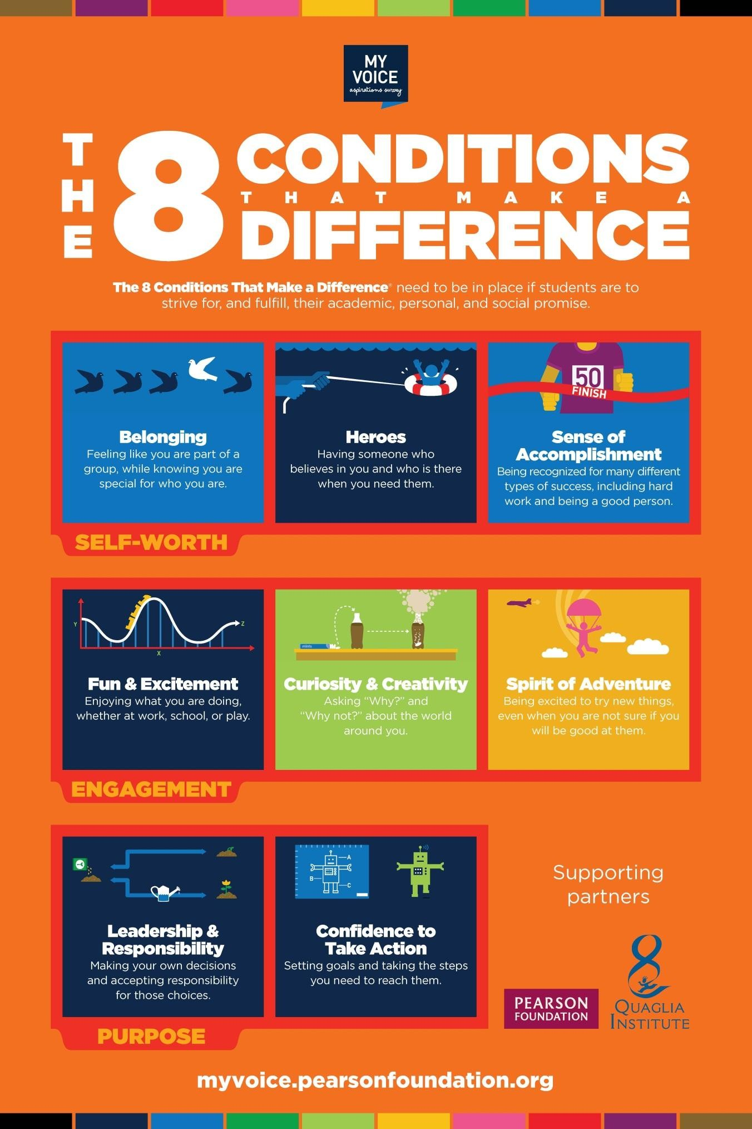

South Coast District

9
Our Academies

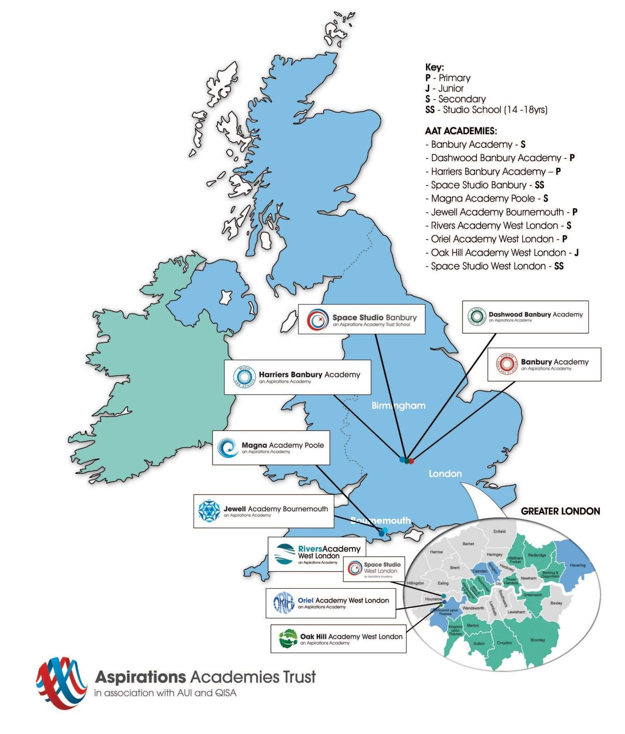
(2015)

South Coast District

Our Track Record
The Aspirations Academies Trust is led by educators who have achieved, through leadership and management of schools, outstanding levels of success. All Aspirations Academies are all expected to achieve the highest possible results for each and every individual student.
Over the past 15 years the educators who lead the Aspirations Academies Trust have achieved outstanding levels of educational success and outcomes in both secondary and primary schools, including:

  - Banbury Academy - 5+ GCSEs A*-C (inc. E + M) in 2013. Increased after 1 year as an Aspirations Academy to 65% from 49% the previous year. The best performance ever by the school. It is now one of the top 10 schools in Oxfordshire
  - Dashwood Banbury Academy after one year as an Aspirations Academy in 2013 achieved 88% Level 4 in Maths, Reading & Writing, an increase from 73% in 2012. And 29% Level 5 which was up from 9%. This is also in the top 9% of schools in Oxfordshire for KS1 and KS2 value added.
  - Harriers Banbury Academy after 1 year as an Aspirations Academy in 2013 achieved 100% Level 4 (96% 2012) and 25% Level 5 (21% 2012). This also puts it in the top 6% of schools in Oxfordshire for value added.

Dashwood Banbury Academy was the first of our academies to be inspected by Ofsted in January 2014 and was given a grading of Good in all areas. Harriers Banbury Academy has recently been inspected by Ofsted and was also given a grading of Good in all areas, having been Graded Satisfactory in the past.

Continuous Professional Development
We offer unique and bespoke training for staff at all levels. This includes the Aspirational Senior Leaders Programme. For teachers we have the Level 1 - Understanding Aspirations Programme, Level 2 – Aspirations and Outstanding Programme, Polishing Pedagogy Programme and Agents of Change Programme, complimented by various staff Coaching and Mentoring training. For support staff we offer an Understanding Aspirations Programme. Staff will be supported to develop a positive orientation to professional learning as reflective practitioners and will be empowered to take ownership and responsibility for their professional learning and development.

We strive to embed the voice of students (for example, through My Voice, iKnow My Class Surveys and student voice and leadership developments) and the active engagement of students in the process of CPD and staff professional learning.

Promoting Aspirations Project
CPD in AAT Academies will have a research orientation. All staff will be expected to engage annually in a Promoting Aspirations Project and make use of research reports to inform their practice. The Promoting Aspirations Project is undertaken over the course of an academic year. Staff can conduct their Promoting Aspirations Projects alone or in collaboration with a small group of colleagues from within their academy or across Aspirations Academies. Innovation Awards will be given to the best projects and they will be shared with other staff at the yearly forum when all staff from all academies come together for an exciting event.

South Coast District
10
11

Unique Resources

Available to our academies are some unique resources that include:

My Voice Surveys are designed to measure the 8 Conditions across an entire school. Available for students, staff, and parents, these online surveys take about 15 minutes to complete and provide survey administrators with real-time reports. By utilizing My Voice Survey Reports, teams of educators and students can work together to develop shared objectives and inspire meaningful improvements within their schools.

iKnow My Class is an online, formative course assessment that helps educators discover students' perspectives about themselves as learners, course content, and instruction. Survey questions are based on more than 20 years of aspirations
research, and are designed to help teachers promote the conditions that inspire students to achieve their fullest potential.

My Aspirations Action Plan (MAAP) focuses everything we know about educational "next practices" into an integrated, practical system. This revolutionary, online portfolio provides students with an active voice in their own learning by allowing them to set goals and track their academic achievement and personal growth along the way.

Using progressive gaming and mobile technology, this interactive and engaging platform also invites teacher participation so they can better understand their students' personal and academic aspirations, and guide their progress toward those goals. MAAP additionally allows optional access to parents, and selected students for peer mentoring.

Not just for students. We also have a staff MAAP so you can track your own personal goals and professional development.

Safe Recruitment Procedure

The AAT is committed to safeguarding and promoting the welfare of children and young people in its academies. In order to meet this responsibility, its academies follow a rigorous selection process to discourage and screen out unsuitable applicants. This process is outlined below, but can be provided in more detail if requested.

Disclosure
This post is classified as having substantial access to children, and appointment is subject to an enhanced police check of previous criminal convictions (DBS). Applicants are required, before appointment, to disclose any conviction, caution or binding over including ‘spent convictions’ under the Rehabilitation of Offenders Act 1974 (Exemptions) Order 1975. Non-disclosure may lead to termination of employment. However, disclosure of a criminal background will not necessarily debar individuals from employment – this will depend upon the nature of the offence(s) and when they occurred.

Shortlisting
Only those candidates meeting the relevant criteria indicated in the personal specification will be taken forward from application.

Interview
Longlisted candidates may be subject to a screening interview. Those shortlisted will take part in an interview with questions relating to the job description and person specification and may also have to take part in a selection exercise such as a lesson observation.
Where necessary, candidates will be asked to address any discrepancies, anomalies or gaps in their application form.

Reference checking
At least two references will be requested, normally from the previous and current employers. These may be contacted before the interview and in all case before an offer of appointment is confirmed.

