Parent Information Booklet
Written with the School Council

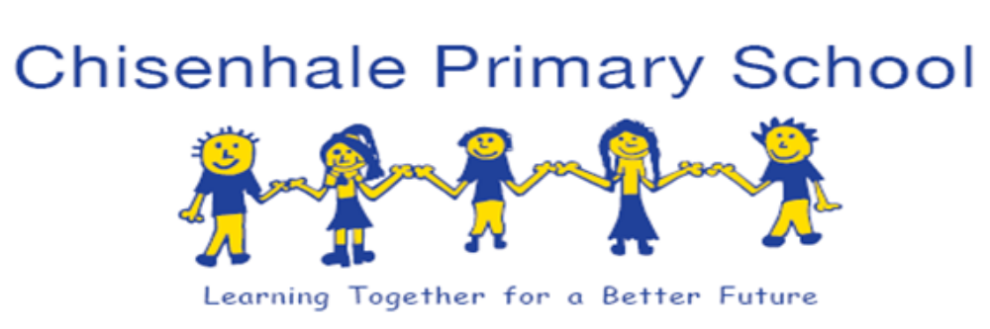
September 2017

Chisenhale Primary School

Welcome to our school
in some of the languages spoken by our children, families and staff

مرحبا بكم في مدرستنا Arabic
স্বাগতম আমাদের স্কুল Bengali
歡迎到我們的學校 Chinese
Velkommen til vores skole Danish
kom op onze school Dutch
Bienvenue dans notre école French
Willkommen in unserer Schule German
Καλώς ήρθατε στο σχολείο μας Greek
અમારી શાળા આપનું સ્વાગત છે Gujarati
हमारे स्कूल में आपका स्वागत है Hindi
Fáilte go dtí ár scoil Irish
Benvenuti nella nostra scuola Italian
私たちの学校へようこそ Japanese
Sveiki atvykę į mūsų mokyklą Lithuanian
Witamy w naszej szkole Polish
Bem-vindo à nossa escola Portuguese
Добро пожаловать в нашу школу Russian
Nabdaadi kan iskuul Somali
Bienvenidos a nuestra escuela Spanish
Okulumuza hoş geldiniz Turkish
ہمارے اسکول میں آپ کا استقبال ہے Urdu
Croeso i ein hysgol Welsh

Welcome to Chisenhale Primary School

In this booklet you will find some useful information about our school. This booklet was originally written with the School Council, who decided it was an important project to let people know about Chisenhale School. Children from years1-6 can stand for election: they write a manifesto and their classmates choose two representatives to vote onto the council. It’s a very important job and they have worked hard on this booklet (they did the pictures too) – so we hope you enjoy reading it!

The children’s writing is easy to see, because it’s in this lovely handwriting font!

Chisenhale School is a community school that is proud of its rich diversity and that works hard to enable its children to become responsible local, national and global citizens. Children have a wide range of responsibilities in the school, supported by a committed and dedicated team of staff and governors, as well as an army of supportive and tireless parents! We work closely with other schools in the area, with the local authority and with the charities and businesses that support us.

We have school policies on a range of issues, which are also available to parents. Please see the Chisenhale school website for copies of the policies referred to in this booklet and for other information about the school.

http://www.chisenhale.towerhamlets.sch.uk

Please don’t hesitate to contact the school if you need any further information
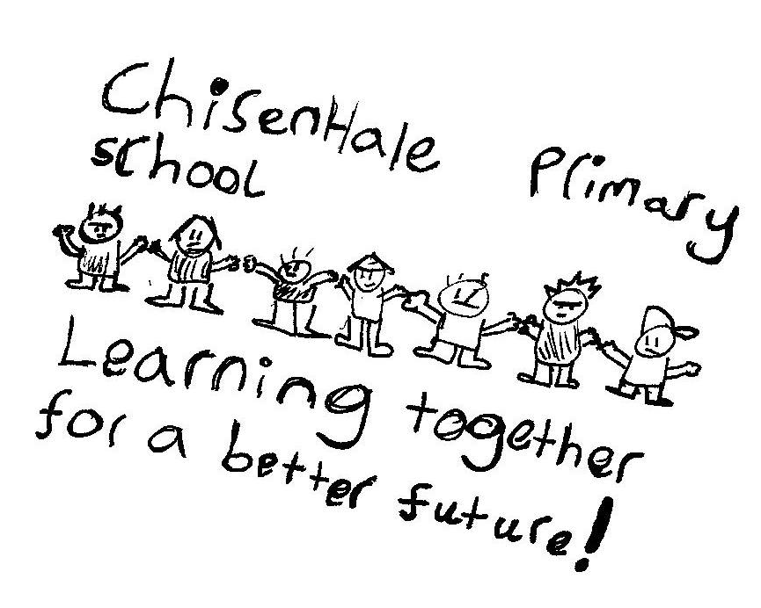
Our vision: learning together for a better future

The school aims to expand this vision by developing children:
- as successful learners
- as confident individuals
- as responsible citizens

Our most recent OfSTED – “GOOD” (June 2015)

As you will see from the report, the inspectors saw lots of positive work happening at Chisenhale and we were delighted that they agreed with our judgement that this is a GOOD school.

The improvements that the OFSTED inspectors recommend in the report, in order for the school to become outstanding, are the ones that we are already working on:

Improve teaching further in order to continue to raise pupils’ achievement, by ensuring that:
- teachers provide more opportunities for pupils to develop and practise their skills in tackling investigations and problem solving, especially in mathematics and science
- teachers consistently reinforce the school’s handwriting and presentation policy, and so continue to improve pupils’ written work in all subjects.

At Chisenhale we are constantly striving for excellence and we want to make sure that the school is doing everything it can to improve.
We believe that Chisenhale is a great place to be, with huge strengths:

- Partnership with parents and carers is a strength of the school and we value your continuing support. Parents’ response to the OFSTED was a real delight – lots of parents came in to help and many replied to the online questionnaire.
- Our creative curriculum is inspiring for children, staff and parents. It enables the children to make links between different areas of learning. The big bangs and grand finales are memorable learning experiences for the children and make learning fun.
- Our award-winning Grow Your Own Playground is part of our commitment to being a healthy school, which all members of the Chisenhale community are really proud of.
- We have a talented, hard-working and motivated staff team.
- We continue to offer a wide range of enrichment activities, including Golden Clubs on Friday afternoons, breakfast club and Night Owls playcentre, after school clubs (a range of sports, arts, coding and instrumental tuition).
- We are also enriched by our exciting partnerships with other organisations such as Teach East London Teaching Schools Alliance, Worshipful Companies of Weavers, Bakers and Musicians, Technology Will Save Us, Now Press Play, Chisenhale Art Gallery, MakeBelieve Arts, Unilever and Magic Breakfast.

Our school vision is Learning Together for a Better Future and through that we aim for all children and indeed for the members of the Chisenhale community to become:

Successful learners Confident individuals Responsible citizens

We will continue to work hard to make this vision a reality.

We know Chisenhale can achieve well above national results, especially when we all work together as a team. We are committed to improved progress and results, but also committed to our vision, which values a lifelong passion for learning and the role of the school in the community.

Contents
SUCCESSFUL LEARNERS
- Attendance
- Teaching and learning
- Organisation of classes
- Homework
- Assessment and SATs
- Chisenhale library
- Grow your own Playground project
- Trips
- Breakfast club and Night Owls playcentre
- After school clubs
- Tournaments
- Communication
- Secondary schools
- Lunchtimes
CONFIDENT INDIVIDUALS
- Children arriving and leaving
- Behaviour
- Lunchtimes
- School journey
- Lost property
- School uniform
- Medication
- All about awards
RESPONSIBLE CITIZENS
- School Council and Head Gardeners
- Governors
- Buddies
- Parental engagement
- Learning Mentor
- Chisenhale Parent Teacher Association (CPTA)
- Partnerships
SUCCESSFUL LEARNERS

Attendance – see also Attendance Policy
Attendance is very important! Any child who has less than 95% attendance is a concern to us. We know that children do get ill and have to have time off, but there are only 195 days of school each year, so each day they lose is an important one. Please support us in promoting good attendance at school.

Absence: If your child is off school for any reason, please inform the school on the first day of absence, by phone or a note. If we do not hear from you, a member of staff will ring to find out the reason for absence.

Unauthorised absence: When a parent gives no reason to the school for an absence or when the reason given is unacceptable, the absence will be recorded as unauthorised. Examples of unauthorised absences include: shopping trips, birthday treats, holidays during term time. No holidays in term time will be authorised. Families will be fined £60 per child per carer if they take children out of school in term time for three days or more, once they have been informed that the school will not authorise the absence. No term time leave can be granted except in exceptional circumstances. This is in line with the borough guidelines on absence from school.

Lateness: The school hours are 9.00am – 3.30pm. (Early Years Foundation Stage finishes at 3.20pm). For the well-being of your child, please ensure that they are brought to school and picked up at these times. We open the school gates at 8.45 so that children can have a calm start to the morning and can settle in, ready to start work at 9am. You will be contacted by the school office if your child is late in the mornings, or if you are persistently late in collecting your child.

Appointments:
Please make medical and dental appointments outside school hours wherever possible. If you need to collect your child early for an appointment, please send in a letter to your child’s class teacher and we will ask you to sign when you take your child out of school.
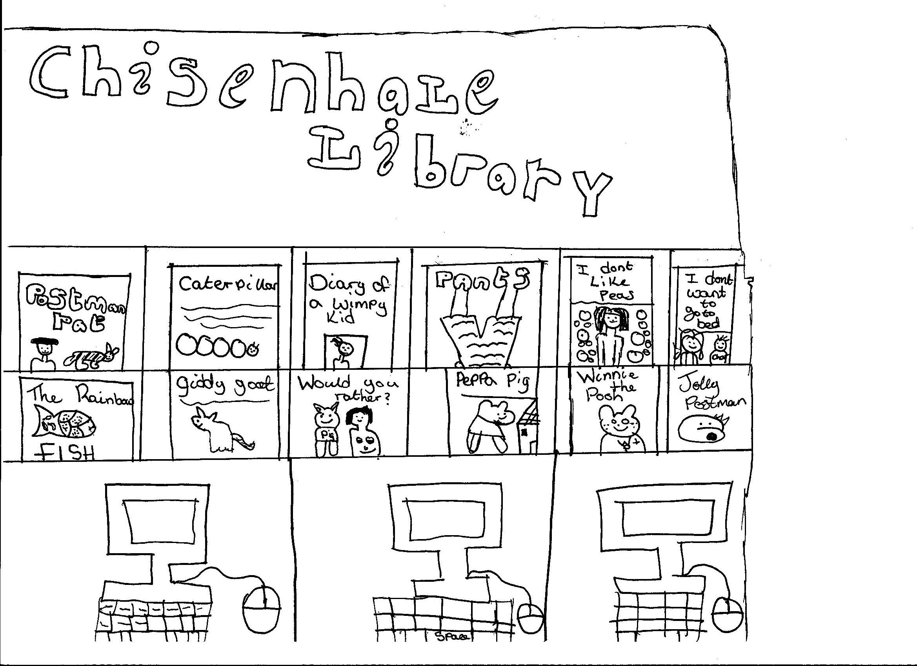

Teaching and learning – see also Teaching and Learning Policy
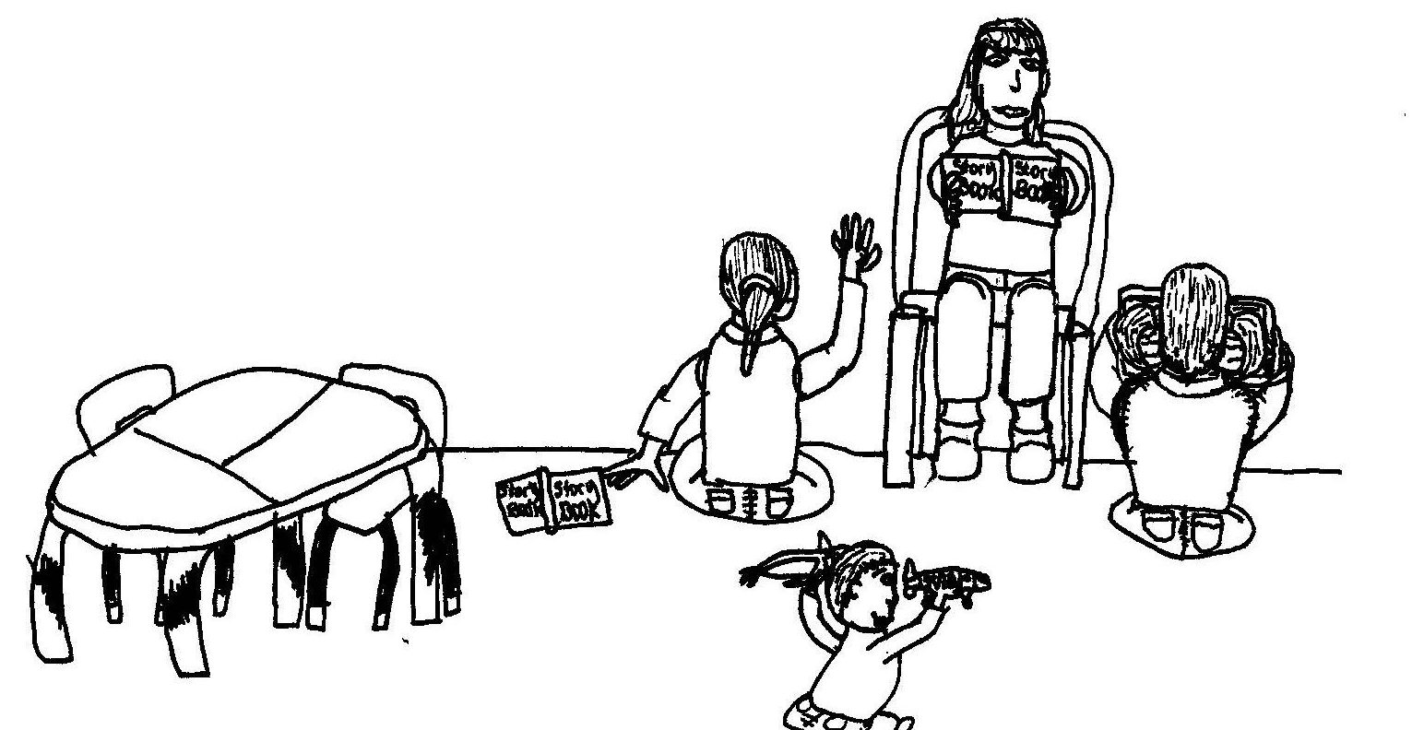
We work through topics, which last half a term or a term. Recent topics have included London, Saving the Planet, Treasure, Back to the Future, Food and Money. The topics enable children to learn through cross-curricular links, enriched by trips, visitors and a variety of real experiences. Topics start with a ‘big bang’ and end with a ‘grand finale’. In the Rubbish topic, for example, the children (and parents) were shocked to come in and find rubbish strewn everywhere! The children then collected it all, sorted it into different types of recycling and produced some inspiring writing about how rubbish makes them feel. At one grand finale, Upper Key Stage 2 invited different classes in to experience life in the Second World War: in the cabinet war rooms, in a bunker and aboard a ship bound for the D-day landings.

Some aspects of the curriculum are taught separately. We use the Letters and Sounds Phonics scheme and phonics is taught at least four times a week. For details of the class timetables and what is being taught this term, see the topic letters sent out to parents, copies of which are on the website.

All about teachers
School Council wrote:
We would like to talk to you about how good Chisenhale’s teachers are, because they are very fun and helpful. Sometimes teachers can challenge you and give you extra hard work for you to do at home. As homework they can also give you fun things to do, like experiments and art.

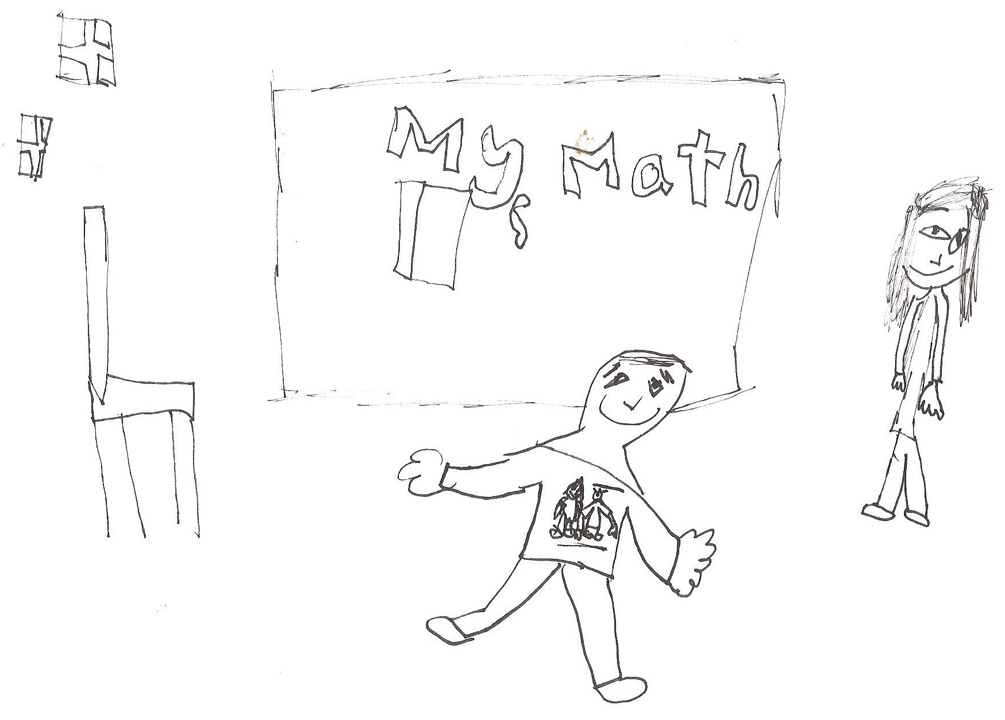

Organisation of classes

In the Early Years Foundation Stage we have a teacher and a nursery nurse in each class. The children learn through a play-based curriculum. They also have phonics, reading, writing and maths sessions to support their learning. Many of these are also play-based.

At Chisenhale we have twelve classes. We have 45 children in each year group so we arrange the classes into phase groups:

EYFS: Three mixed Early Years classes (Nursery and Reception)
KS1: Three mixed Key Stage 1 classes (Year 1 and Year 2)
LKS2: Three mixed Lower Key Stage 2 classes (Year 3 and Year 4)
UKS2: Upper Key Stage 2 are taught in 4 small classes, keeping Y5 and Y6 separate, because of the demands of the curriculum.

These are the children’s ‘home’ classes, but in KS1 and KS2 in the mornings they are taught literacy and numeracy in their own year groups (e.g. Year 1 or Year 2). There are two classes for each year so that children can be taught in smaller groups, with a real focus on their learning needs.

Each class has a teacher and a teaching assistant and each phase has an extra teacher, who is a phase leader. The phase leader supports teaching and learning across the two years, which includes supporting the teaching and support staff, team teaching and taking groups. The phase leaders are also responsible for aspects of the curriculum across the school, including maths, healthy schools, science and literacy.

Homework
We encourage all children to read at home every day – we know it makes a real difference to their learning. All children are given a book bag when they start school. Replacement book bags can be bought from the school office. Children can borrow books from the class library and also from the school library. We encourage families to use the Idea Store in Roman Road too.

Topic homework is now given out to last several weeks. This is to encourage the children to talk about the topic at home and to get the family involved. Topic homework will be celebrated in school, either in classes or through exhibitions, or with work being put on the website or ‘Frog.’

‘Frog’ is the school intranet. Every child has their own log in eg for Joe Blogg born in 2014 it would be Jbloggs14 and the password is Frog. Children are then encouraged to change the password, but if they forget they can ask their teacher to put it back to Frog again.

There is an I Am Learning page on Frog which is where the children can find their maths homework. We will develop the use of Frog over time. There are lots of possibilities for children to explore and develop their learning here.

Homework can include learning spellings or times tables, both of which are really useful. We also set projects linked to the topics, where the children take more time to find things out. This is a chance for the family to learn together and we really encourage parents to get involved.

We also give children the chance to do their Frog homework in school, if they can’t access a computer at home. This can be done during Night Owls Playcentre, or during break or lunch in school. If you have any questions, please talk to your child’s class teacher.

Assessments and SATs – see progress and attainment information on the website

Children are assessed every day in a number of ways, including through questions asked, marking their work and asking them about how they found the work – did they understand it all, part of it, or not at all? We call that assessment for learning.

We also have termly assessments of their work in phonics, reading, writing and maths. We then have meetings with the teachers to see whether pupils need to move groups, have extra support, or whether we need to talk to parents about a child’s progress. We also assess what has worked well and how we can use that to make our teaching even better.

The children also do tests set by the government. At the moment they are
Y1 – phonics reading test (the test is repeated in Y2 if the children don’t succeed first time)
Y2 – Standard Assessment Tasks (SATs) in reading, writing, maths
Y6 – SATs in reading, writing, GPS (grammar, punctuation and spelling) & maths

Your child will receive a report at the end of every year, telling you what levels the teacher thinks the child is working at, as well as information about the tests when they have been taken. The report will also tell you how your child is progressing and achieving in all other areas of the curriculum, as well as their behaviour and attitude to work. It’s very important that we communicate with families as much as possible about how children are progressing, so that we can work in partnership together.

CHISENHALE SCHOOL - END OF YEAR RESULTS 2017
These figures show the percentages of children reaching the expected levels last year and this year. We hope this information is helpful to you in understanding what children achieve across the school.

Phonics screening check provisional outcomes
 | Local Authority | National | Chisenhale
2015 | 78.3% | 76.8% | 77.8%
2016 | 81.0% | 80.6% | 80.0%
2017 | 82.1% | 81.0% | 86.0%

KS1 provisional outcomes (teacher assessment)
Percentage of pupils working at or above the expected standard:
 | Local Authority | National | Chisenhale
Reading | 76.4% | 75.6% | 82%
Writing | 71.6% | 68.2% | 76%
Maths | 77.3% | 75.1% | 79%
Science | 81.3% | 82.6% | 84%
RWM | 66.6% | 63.7% | 67%

Percentage of pupils working above the expected standard (working at greater depth /
higher standard):
 | Local Authority | National | Chisenhale
Reading | 24.9% | 25.2% | 32%
Writing | 17.1% | 15.6% | 21%
Maths | 22.7% | 20.5% | 27%
RWM | 12% | 11% | 16%

KS2 provisional outcomes
Percentage of pupils working at or above the expected standard:
 | Local Authority | National | Chisenhale
Reading | 74.2% | 71% | 86%
Writing | 80.8% | 76% | 82%
Maths | 80.7% | 75% | 89%
GPS | 83.1% | 77% | 75%
RWM | 66.6% | 61% | 73%

Average scaled scores for each subject:
 | Local Authority | National | Chisenhale
Reading | 104.4 | 104 | 105
Writing | Not available, as results based on teacher assessment
Maths | 105.4 | 104 | 108
GPS | 107.7 | 106 | 106

Percentage of pupils working above the expected standard (working at greater depth /
higher standard):
 | LA | National | Chisenhale
Reading | 24% | 24.5% | 16%
Writing | 20.2% | 17.7% | 20%
Maths | 26.5% | 22.6% | 18%
GPS | 39.3% | 30.9% | 25%

Chisenhale library
Our library was officially opened by local author David Lucas on 19th March 2012. It took many months of work by some very dedicated parent volunteers, to make it the inspiring place it is.

All children can borrow books from the library. There is also a weekly family library club Fridays 3.30 – 4.30pm, where families can come and read together, as well as to change books.

The Story Curtain was designed and made by local artists and parents Sara Heywood and Louise Nolan. It enables a whole class to have a story time hidden behind a vast panel of pictures, drawn and sewn by children and parents.

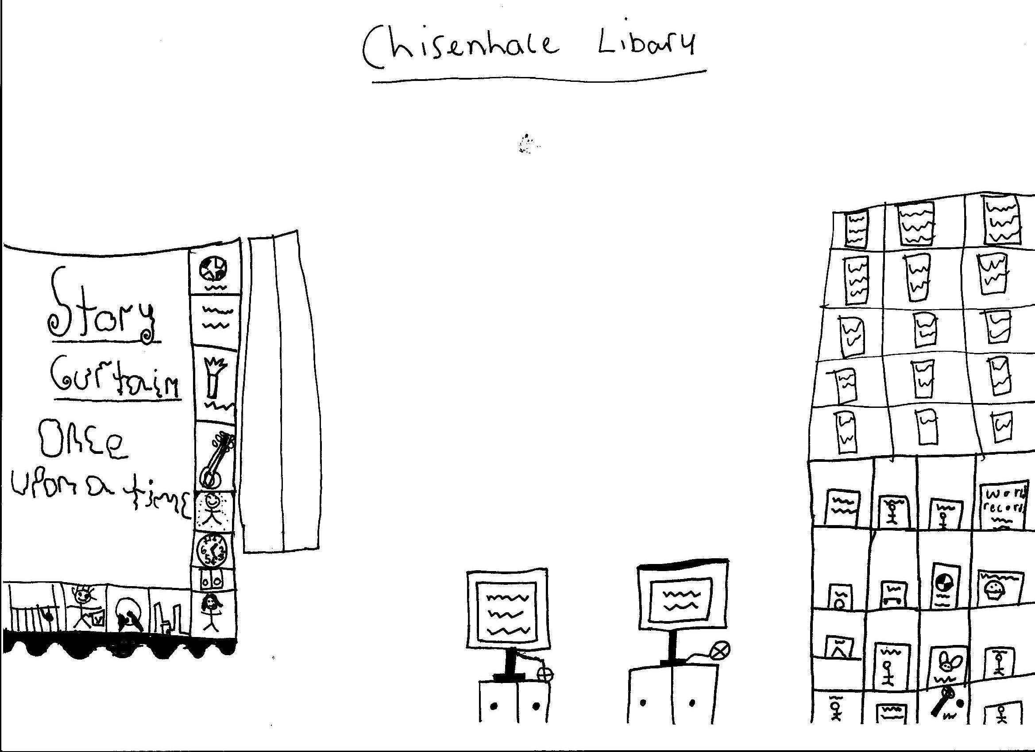

Grow your own Playground project
Parents have taken the lead in developing several outside areas of the school into an edible playground, where we grow lots of crops. Some of the food is used by our lovely school cook, Nigel. Some of the food is used by classes for cooking sessions. There is a family gardening club every Friday 3.30–4.30pm and all families are welcome to come along. It’s a great opportunity to get children involved, as well as for parents to meet and chat, whilst watering and weeding!

The Playground has won several awards and is a part of many networks, including Capital Growth and a project with Waitrose and the Food for Life Partnership. It is led by parent volunteers who have helped to make it a very special part of school life. Cassie Liversidge, who was a parent, is also paid as our Gardening Coordinator and she organises all the activities on offer. All children have the opportunity to engage in gardening activities, which are linked to the curriculum, for example in science. Every year one class grows wheat and then works with local bakers to turn it into bread – which they can take home to eat! Each class has its own planter on the roof and the best growers win the gardening cup at the end of the school year.
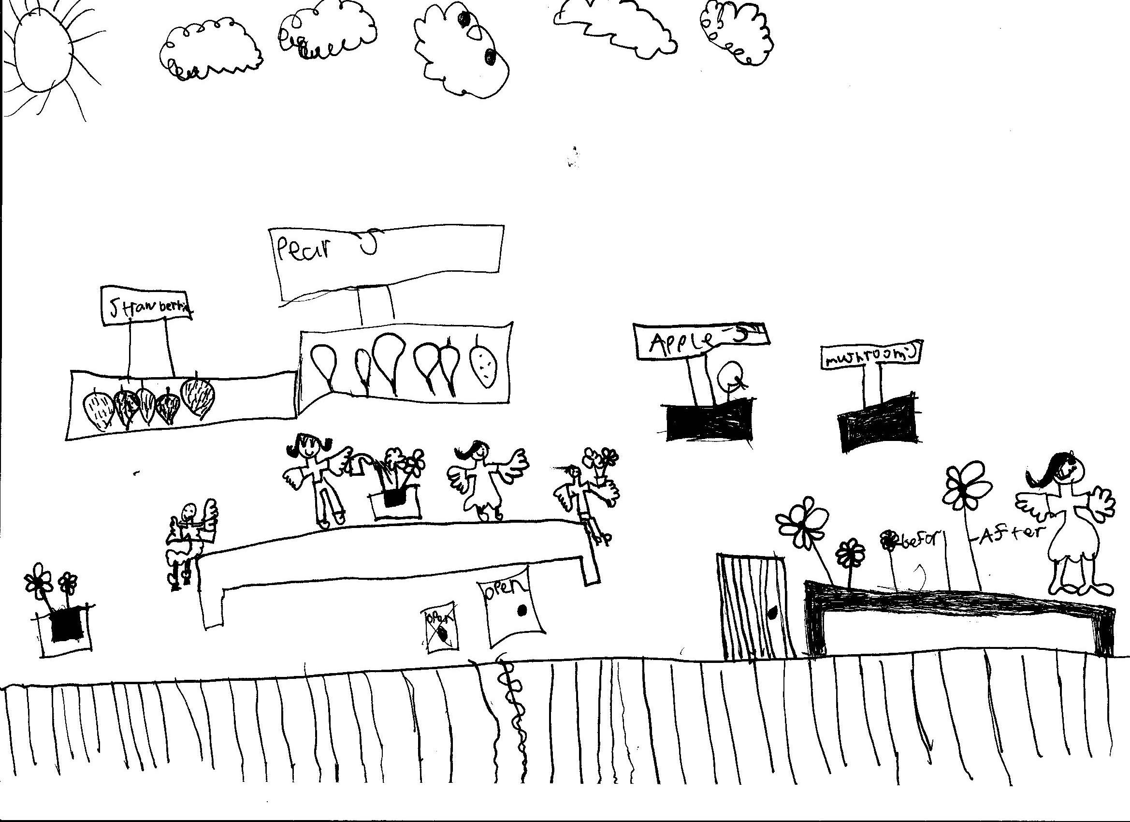

Trips
We believe that trips are an important part of children’s learning. Your child will go on local trips to the parks as well as on longer trips to museums or other places of interest linked to their topic.

We need you to sign a permission form for all local trips and we also send individual letters out for trips that require payment, or where your child will arrive back later than usual.

We often need parent helpers to make the trips possible – thanks to all of those who help out!

Breakfast club and play centre

Early Birds Breakfast Club and Night Owls Play Centre are open to all families in the school. The current costs are:
£2.50 per day for Early Birds Breakfast Club (7.45 – 9.00am)
£7.00 per day for Night Owls Play Centre (3.30 – 6pm)

Both are run by school staff and are popular with the children. Kim is the co-ordinator for Early Birds and Janette and Amanda share responsibility for Night Owls. You don’t have to attend every day, but days need to be agreed in advance. Money for each half term needs to be paid in advance too.

School Council wrote:
Play Centre is open until 6pm. It’s after school and it starts at 3.30pm. It’s for children when their parents are at work. All the children are nice and so are the staff. They play lots of games. In the summer we play downstairs. We play dodgeball and on the climbing frame.

Children come from Nursery to Year 6. You can collect your child at any time between 3.30 and 6pm. There’s a book on the side and you need to sign your name to take your child home.

We have toast with butter, fruit and biscuits.

After school clubs

We have a mix of free and paid-for after school clubs. Most clubs last for five weeks each half term and run from 3.30 – 4.30pm. If we have to charge, the costs are £3 per session but all clubs are free to families who are entitled to free school meals. Clubs have recently included football, tennis, art, coding and Italian.

We offer individual music tuition in Key Stage 2, including piano, drums, violin, clarinet, bassoon and flute. There are some private lessons and some paid for by the school.

We also do PE clubs at Morpeth Secondary School, some of which lead to borough wide tournaments. Recently we have done sessions in cross country, athletics and football. We have won borough tournaments in boys’ and girls’ football too.

School Council wrote:
Chisenhale has a selection of clubs run by staff, some of the clubs are football, cricket, opera and art and many more. These go on from 3-30 to 4-30pm .These still have health and safety rules because there is a massive space to play in. Some of these clubs actually have tournaments through the day and children win medals and trophies! Just bring in shorts, tracksuit bottoms or leggings, a T-shirt and trainers.

Communication
Communication is a key part of Chisenhale school life. We encourage parents to talk to staff, share ideas and participate in events as often as possible.

Staff:
In Early Years we encourage parents to stay until 9.10am to help settle their children into the day and parents come into the children’s classes to collect them.

From Year 1 onwards, your child’s teacher and teaching assistant, as well as other members of staff, will be in the playground at the end of each day to talk to you about your child, or any other aspects of school life, or to arrange an appointment. At the beginning of the day, there will be staff in the playground who can pass messages on to the teachers. We ask KS1 and KS2 parents not to go into classes first thing in the morning, so that we can start our learning straight away.

Chisenhale Chatter:
Every Friday, you will receive the Chisenhale Chatter newsletter with key information about events that have taken place over the week, awards and celebrations, along with the key dates of other events that are coming up. Copies are always posted on the website and also emailed to parents.

Emails and text messages
We will send you text reminders about important events and emails about events that might be of interest if you let us have an email address. We will also email you the newsletter every Friday to make sure you get it.
We need to have up to date mobile phone numbers to send you texts.
Please also give us your email address, so that we can send information out to you.
If you want to email school please use: info@chisenhale.towerhamlets.sch.uk

Display boards:
These are placed around the school playground area, displaying general information about the school, community and other local events.

Website:
Our school website http://www.chisenhale.towerhamlets.sch.uk includes:
- Access to Frog, which is a site only for children and parents of the school. There is access to children’s work, opportunities for children to do homework and follow their own interests, a chance for children to communicate with each other, polls and quizzes.
- school information contained in this booklet
- policies and procedures
- day to day school information

Assemblies
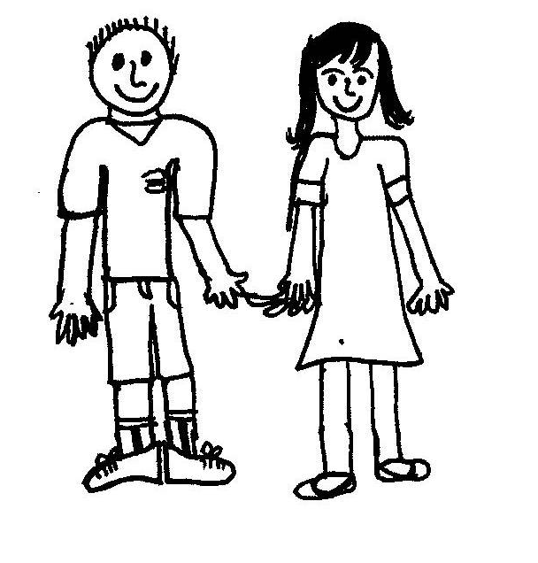
During the week, the children attend a range of assemblies, including whole school, phase, singing and celebration. Throughout the year, children have the opportunity to perform in their own class assembly to families and to the rest of the school. Alongside this, we also feel it is important to celebrate key events and festivals such as Harvest, Christmas, Eid, Diwali, Remembrance Day and Anti-Bullying week. Dates are always sent out in advance in the Chisenhale Chatter.
Rights Respecting School
Chisenhale Primary School aims to be a school where every aspect of a child is focused on and developed, including the area of well being. As part of our vision of ‘learning together for a better future’ we have achieved recognition as a “Rights Respecting School”. This is an award which is given to schools on behalf of UNICEF.
UNICEF is the world’s leading organisation working for children and their rights. In 1989, governments worldwide promised all children the same rights by adopting the UN Convention on the Rights of the Child (CRC). These rights are based on what a child needs to survive, grow, participate and fulfil their potential.
The ‘Rights Respecting School’ award (RRSA) will help our pupils to grow into confident, caring and responsible young citizens both in school and within the wider community. By learning about their rights the children will also learn about the importance of respecting the rights of others i.e. their responsibilities. Pupils have already started developing an understanding of their rights in school.

Secondary Schools - We have links with a number of local secondary schools. The table shows which schools Chisenhale children have gone on to in the past few years:

Secondary School | Sept 2012 | Sept 2013 | Sept 2014 | Sept 2015 | Sept 2016 | Sep 2017
Central Foundation Girls’ | 11 | 7 | 10 | 8 | 4 | 9
Bow School | 4 | 2 | 3 | 6 | 5 | 8
Morpeth | 7 | 12 | 12 | 10 | 16 | 9
Raines Foundation | 2 | 8 | 2 | 2 | 3 | 7
St Paul’s Way Trust | 10 | 3 | 4 | 1 | 2 | 3
Bishop Challoner Girls/Boys | 1 | 2 | 0 | 0 | 3 | 3
Mossbourne Victoria Park | N/A | N/A | 2 | 4 | 2 | 2
Swanlea | 1 | 1 | 1 | 2 | 1 | 1
Oaklands | 1 | 1 | 1 | 1 | 3 | 1
Bethnal Green Academy | 0 | 2 | 2 | 5 | 1 | 0
George Green | 0 | 0 | 0 | 1 | 0 | 0
Langdon Park | 2 | 2 | 0 | 0 | 0 | 0
Stepney Green School | 1 | 0 | 2 | 2 | 0 | 0
Other/Out of Borough/Independent | 4 | 5 | 6 | 3 | 5 | 2
CONFIDENT INDIVIDUALS

Children arriving and leaving
Beginning of the day:
The school gates on Vivian Road and Chisenhale Road (EYFS and KS1/KS2) gates will be open from 8.45am – 9.00.

In Early Years we encourage parents to come in and stay to settle your children. This is also a good chance to see what the children are doing and to have a great start to the day.

In KS1 and KS2 members of staff will be available in the school playground at the Chisenhale Road entrance, to pass on any messages to your child’s class teacher. If you want to arrange an appointment to see a member of staff, please go to the school office, or speak to them in the playground at the end of the day.

End of the day:
Early Years school gates on Vivian Road will be open at 3.20pm for you to come and collect your child.

Years 1-6 school gates on Zealand Road will be open at 3.30pm for you to come and collect your child.

Children will be brought down to the playground and will wait to be collected.

We have a one way system for the main playground, so please ensure you enter through the large school gates on Zealand Road and exit through the smaller gate on Chisenhale Road. This is to prevent children running out onto the road and to ensure you do not get held up.

If you pick your child up from Early Years, please then walk through the Early Years garden into the main playground, NOT through the school, to collect any older children. This is due to health and safety reasons, to help minimise the crush.

Picking up:
If your child is to be picked up by a different person, please notify a member of staff.

Year 6 children are able to walk home by themselves, but the school must have a letter of permission, written by a parent or carer. Year 6 children are not allowed to take their younger siblings home.

If older (secondary school-aged) siblings are to pick up your child, permission must be granted by the school, with written permission from the family in advance.

Bikes and scooters: At Chisenhale, we encourage your children to use their bikes/scooters. Please could you help your child to put them safely into the bike and scooter areas.
Behaviour
We offer encouragement and rewards for good behaviour. At Chisenhale we accept the principle that good behaviour is a necessary condition for effective teaching and learning to take place and so we seek to create an environment within the school that encourages and reinforces good behaviour.
We believe that children will strive to reach high standards of behaviour and therefore we aim to maintain high expectations through a consistent and positive behaviour management policy. We wish to ensure a happy and caring community, which encourages respect for others’ feelings, beliefs and possessions within a stable and caring environment. We understand that such a community needs a structure to support acceptable and agreed forms of behaviour.

At Chisenhale we aim to implement a positive behaviour management system in which all adults within the school consistently model the desired standard of behaviour. We expect children to take responsibility for their own behaviour and so give them every opportunity to be involved in its management. We encourage children to consider their rights and the rights of others and help them to understand that with these rights come responsibilities. We are working to become a Rights Respecting School and every class writes their own charter of rights. We had a mural designed and painted by the children, which illustrates our playground charter too.

We have a Behaviour Policy and we work to ensure that this is carried out consistently. We are now working towards children taking greater responsibility for their own behaviour. We communicate with parents when behaviour issues arise.

School Council wrote:
Chisenhale have many rewards for good behaviour. If you behave well, you’ll have a big grin on your face by the end of the day.

Lunch Time
Dinner Money
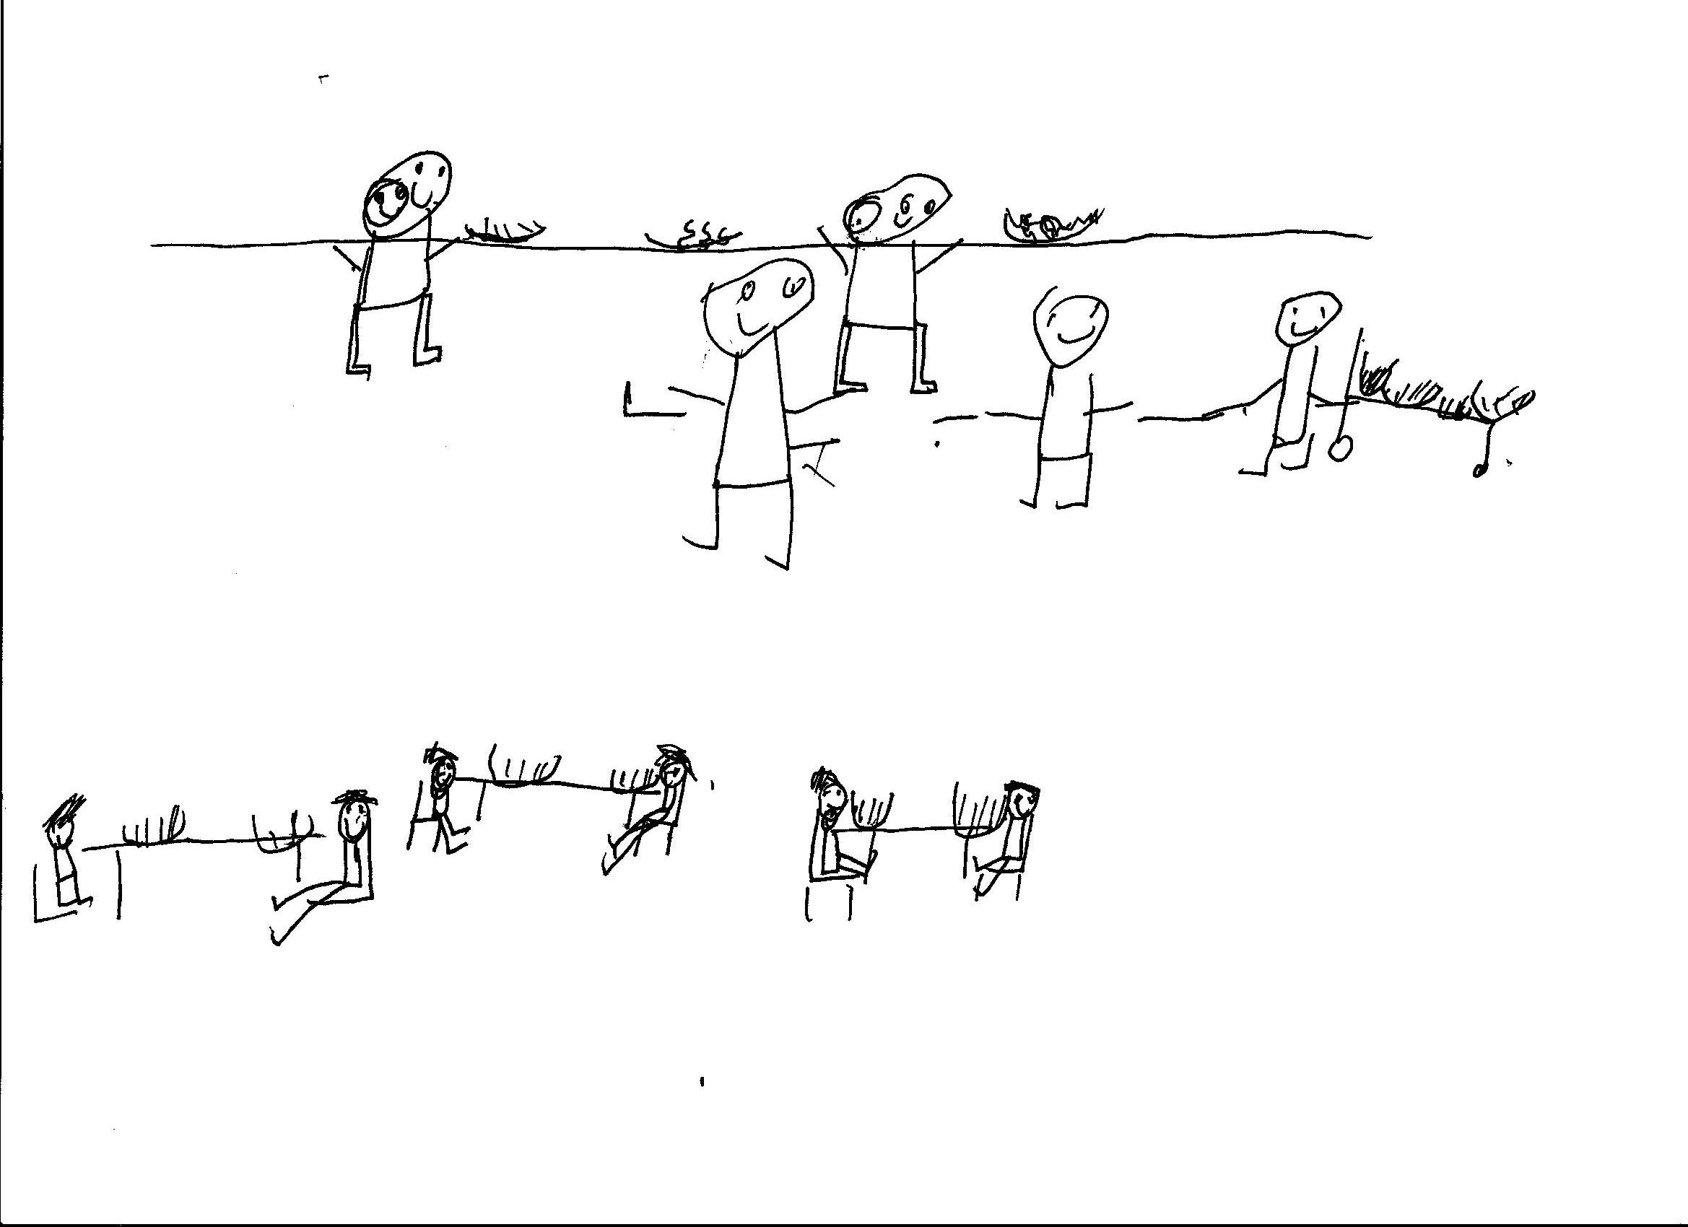
At present all children from Reception to Year 6 receive free school dinners, funded by the government. For Nursery children who are not entitled to pupil premium funding there is a charge of £1.90 a day (£9.50 a week) per child for school dinners. The money needs to be paid in advance to the school office on a Monday or Friday morning. If your child chooses to change from a school dinner to a packed lunch, they can do so on a half termly basis.

- School Dinners
These are prepared on site, by Nigel, our cook, and are selected to follow our healthy schools policy. A nutritionally balanced meal is served every day and children are encouraged to have salad or vegetables on their plate. We really encourage children to take school dinners.

- Packed Lunches
Children are encouraged to bring in a healthy packed lunch; so we do not allow any crisps, chocolate, cakes, biscuits, fizzy or flavoured drinks.

- Packed lunches for trips
We will provide school packed lunches for all trips, unless families let us know they want to bring in a packed lunch from home. Packed lunches must still be healthy (see above).

School Council wrote:
At lunch you can choose different foods but our school is healthy. You can choose packed lunch or school dinners.
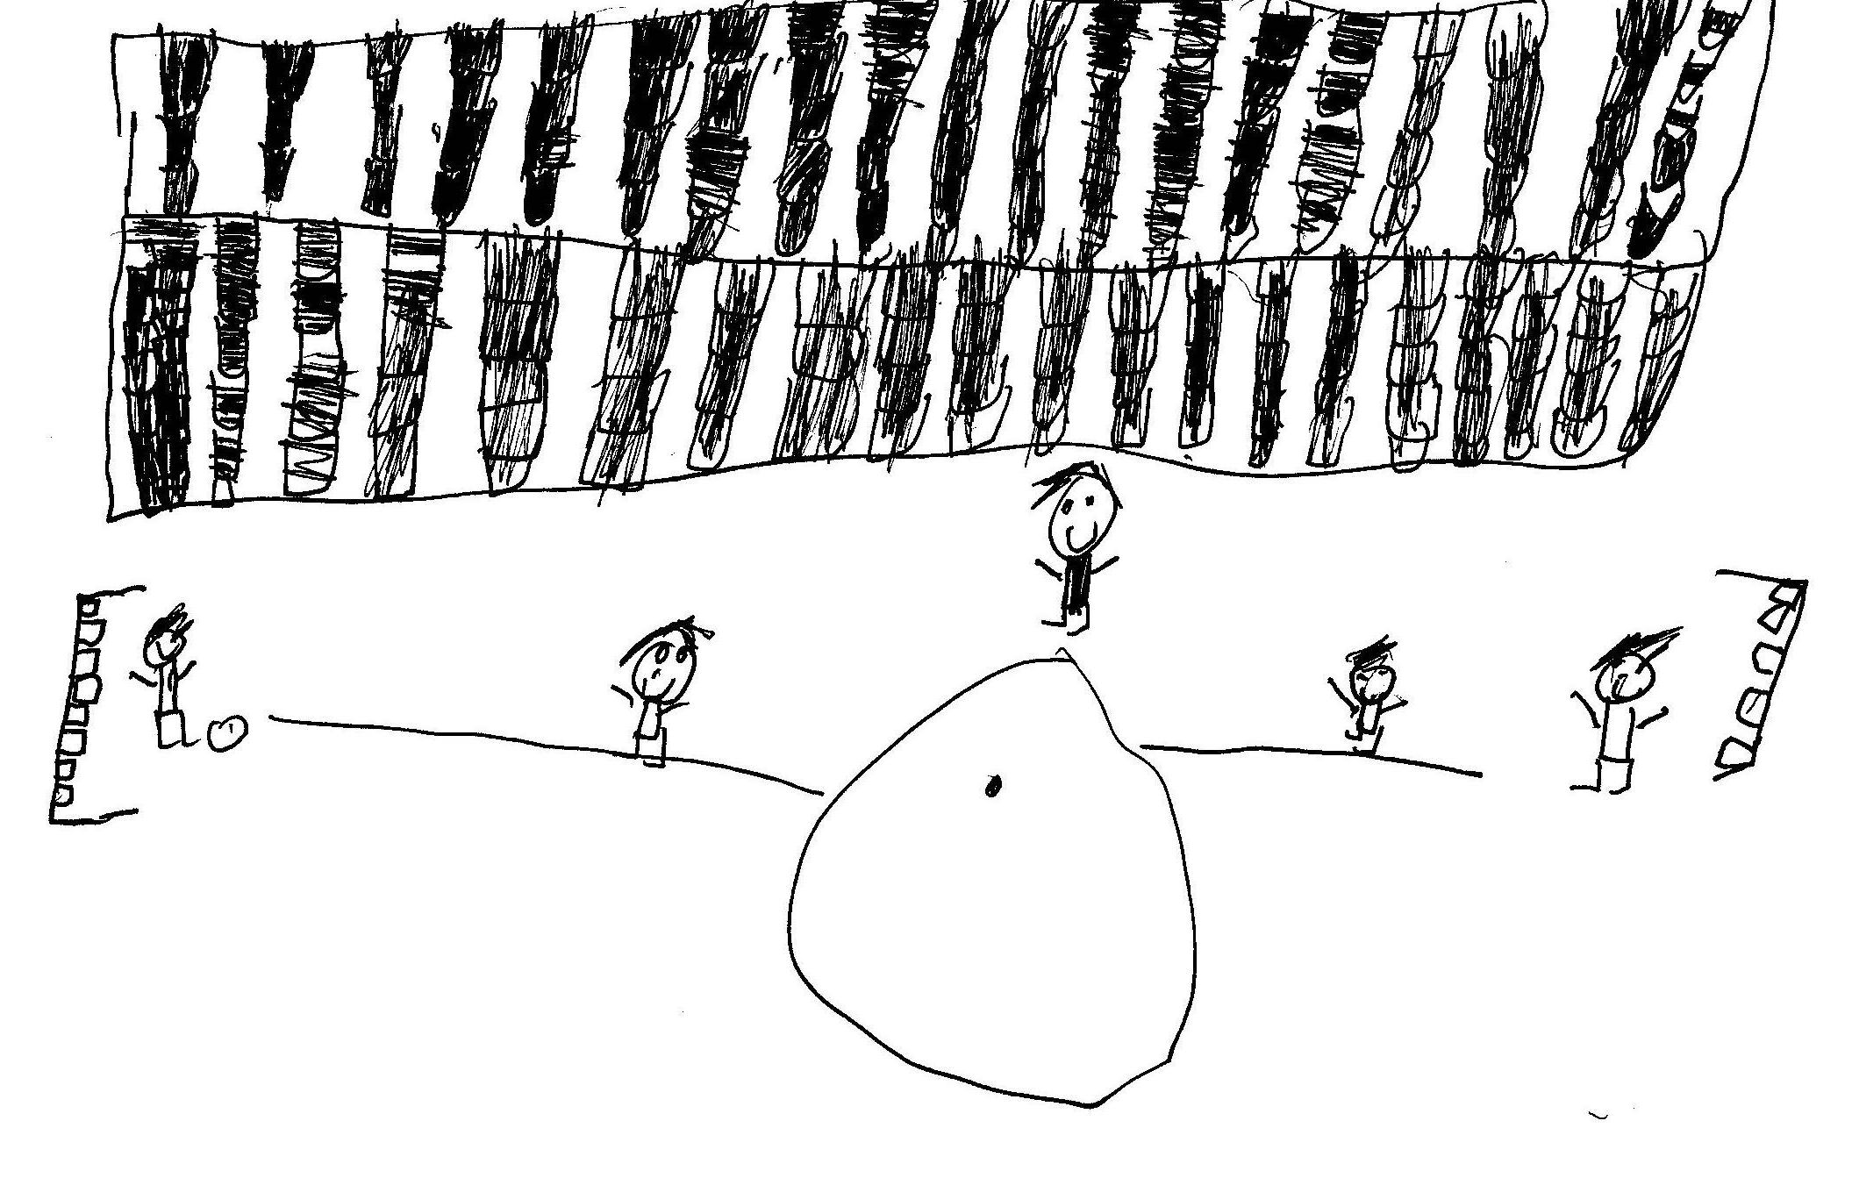
Some children play on the roof and some play downstairs in the bigger playground, which has climbing equipment.

Y6 School Journey
All Y6 children are expected to go on the school journey, as it is a really important part of their learning. We go to Devon for a week and stay in a large house, which is run by qualified staff. They take the children out to do outdoor activities – and they come back exhausted, but having really gained in confidence. Details of the school journey, as well as the cost, are given to families at the start of Year 6. We encourage families to pay weekly, to spread the cost over the year. This year school journey costs £160 or £80 for families entitled to free school meals. The school also contributes funding for the trip to keep the cost affordable for families.

When you’re in year six there is a trip to Devon. You stay there for a few days and you sleep in a bedroom with lots of beds. During the daytime there are all different activities to do like rock climbing, canoeing, raft building and camping.

Lost property
Lost property is stored in the library on the ground floor; and in the halls on the middle and top floors. Foundation stage lost property can be found in their cloakroom. To help locate any lost property, please label ALL items of clothing clearly, with your child’s name.

School uniform
The school believes that the wearing of school uniform promotes a positive attitude, a sense of community and belonging to the school and a suitable image in the eyes of the wider community. We place great emphasis on improving on our best and that combines with looking our best. We want pupils to be proud of wearing school uniform.

School uniform at Chisenhale, which should ALL be named, consists of:

- White shirt/polo shirt
- Navy or black trousers or skirt or a blue chequered summer dress
- Chisenhale School jumper/navy jumper
- Sensible school shoes/trainers

Items can be bought from local supermarkets as well as our own supplier, Khalsa, in Bethnal Green. We have examples of school uniform in the office for children to try on and we can order them online from Tesco for families.

Due to health and safety reasons, jewellery should not be worn in school. However, there are two exceptions:

- small stud earrings, for newly pierced ears, which must be covered up during PE/Games sessions

- jewellery may be worn in exceptional circumstances where items have religious or cultural significance or for medical reasons. Parents must discuss this with the headteacher as an individual case.

School Council wrote:
We need a uniform when we go out so if a child gets lost, people can look at the logo and they can take the children to Chisenhale. We think wearing school uniform supports the school.
The uniform colours are navy blue and white.
You can buy a Chisenhale cardigan, t-shirt and sweatshirt.
You can also buy book bags and water bottles from the school.

Children must have a change of clothing in school for PE/Games lessons, which should all be named and kept in a separate bag. The school kit consists of:
- White T-shirt
- Navy or black shorts or tracksuit bottoms
- Plimsolls or trainers

PE lessons occur on a regular basis, and we advise parents to ensure their children bring kits in on Monday and take them home on Friday for washing.

If a child forgets their PE kit, the school will provide them with a spare PE kit so they are still able to take part in the lesson.

SWIMMING: All children in KS2 will take part in swimming lessons during the school year. We use the Olympic Pool, which is a great opportunity for children. Please ensure your child is provided with:

- tight fitting swimming costume/trunks
- swimming hat
- towel

The swimming uniform is set by the swimming pool and they WILL NOT allow children to swim if they do not have the correct kit.

Medication
All medication, for example asthma pumps, epi-pens etc must be given to the office on the first day it is required. These will be labelled and kept in our medical room.

If your child requires medication during the school day, please ensure that it is taken to the office at the start of the day. A form will need to be filled in, in order for our trained first aider to administer the medication.

The school nurse will draw up a medical needs plan for all children who are on medication.

All about awards

Celebration Assembly and the Golden Book:
Each week we have a celebration assembly. Each class teacher will select two children:
Which children are helping others to achieve their rights?
Which children are developing their abilities to the full?

A celebration surprise is awarded and a postcard to mark their achievements is sent home.

School Council wrote:
Celebration assembly is good because we celebrate all different awards that people have earned. People go in the golden book for doing hard work.

Celebration days:
As a treat for all the children, we like to have celebration days throughout the year. These include Eid and Christmas. During this time ‘party’ food is welcome.

Birthdays:
Each child’s birthday is celebrated in school during our phase assemblies and every child will be given a school birthday card. Please do not send any cakes or sweets into school. Healthy treats such as fruit are always welcome.

Golden clubs:
These enrichment opportunities are a treat for all children at the end of each week for good behaviour and happen every Friday afternoon. All staff run a club to share their expertise and interests.

Some of the clubs are run by children themselves. Children can apply to school council to run a club and school council chooses which ones will run for the following term. Children who are Golden Club teachers are awarded a certificate and a book token, paid for by the Weavers fund, to promote greater responsibility in children.

Children choose a club each half term. Clubs have recently included: origami, coding, cooking, gardening, sketching, board games, sports, knitting, Arabic art, lego, podcast and science!

RESPONSIBLE CITIZENS
School Council
School Council wrote the first version of this booklet.

School council has two people from each class. The class chooses who we want to be our School council reps. There is a Chair and someone who takes minutes. We are like the parliament for the school. In School Council they help the playground, so it can be safe and have loads of toys. Sometimes there are bake sales or toy sales to make money for toys for wet playtimes.

We wanted parents and visitors to know all about our school.

School council is a great opportunity for children to develop citizenship skills. Any child who wants to become a member has to write a manifesto at the beginning of the year and then each class elects their representatives. They meet weekly with the Head and helped to develop the exciting playground, with the help of Asif Khan, a parent who is also an architect.

Head Gardeners
Two children from each class are voted in as Head Gardeners. They work with Cassie, our gardener, in the garden every week. They also go on trips and events, such as the Hampton Court Show, making a scarecrow. They have also been to the Westminster Abbey Harvest Festival!

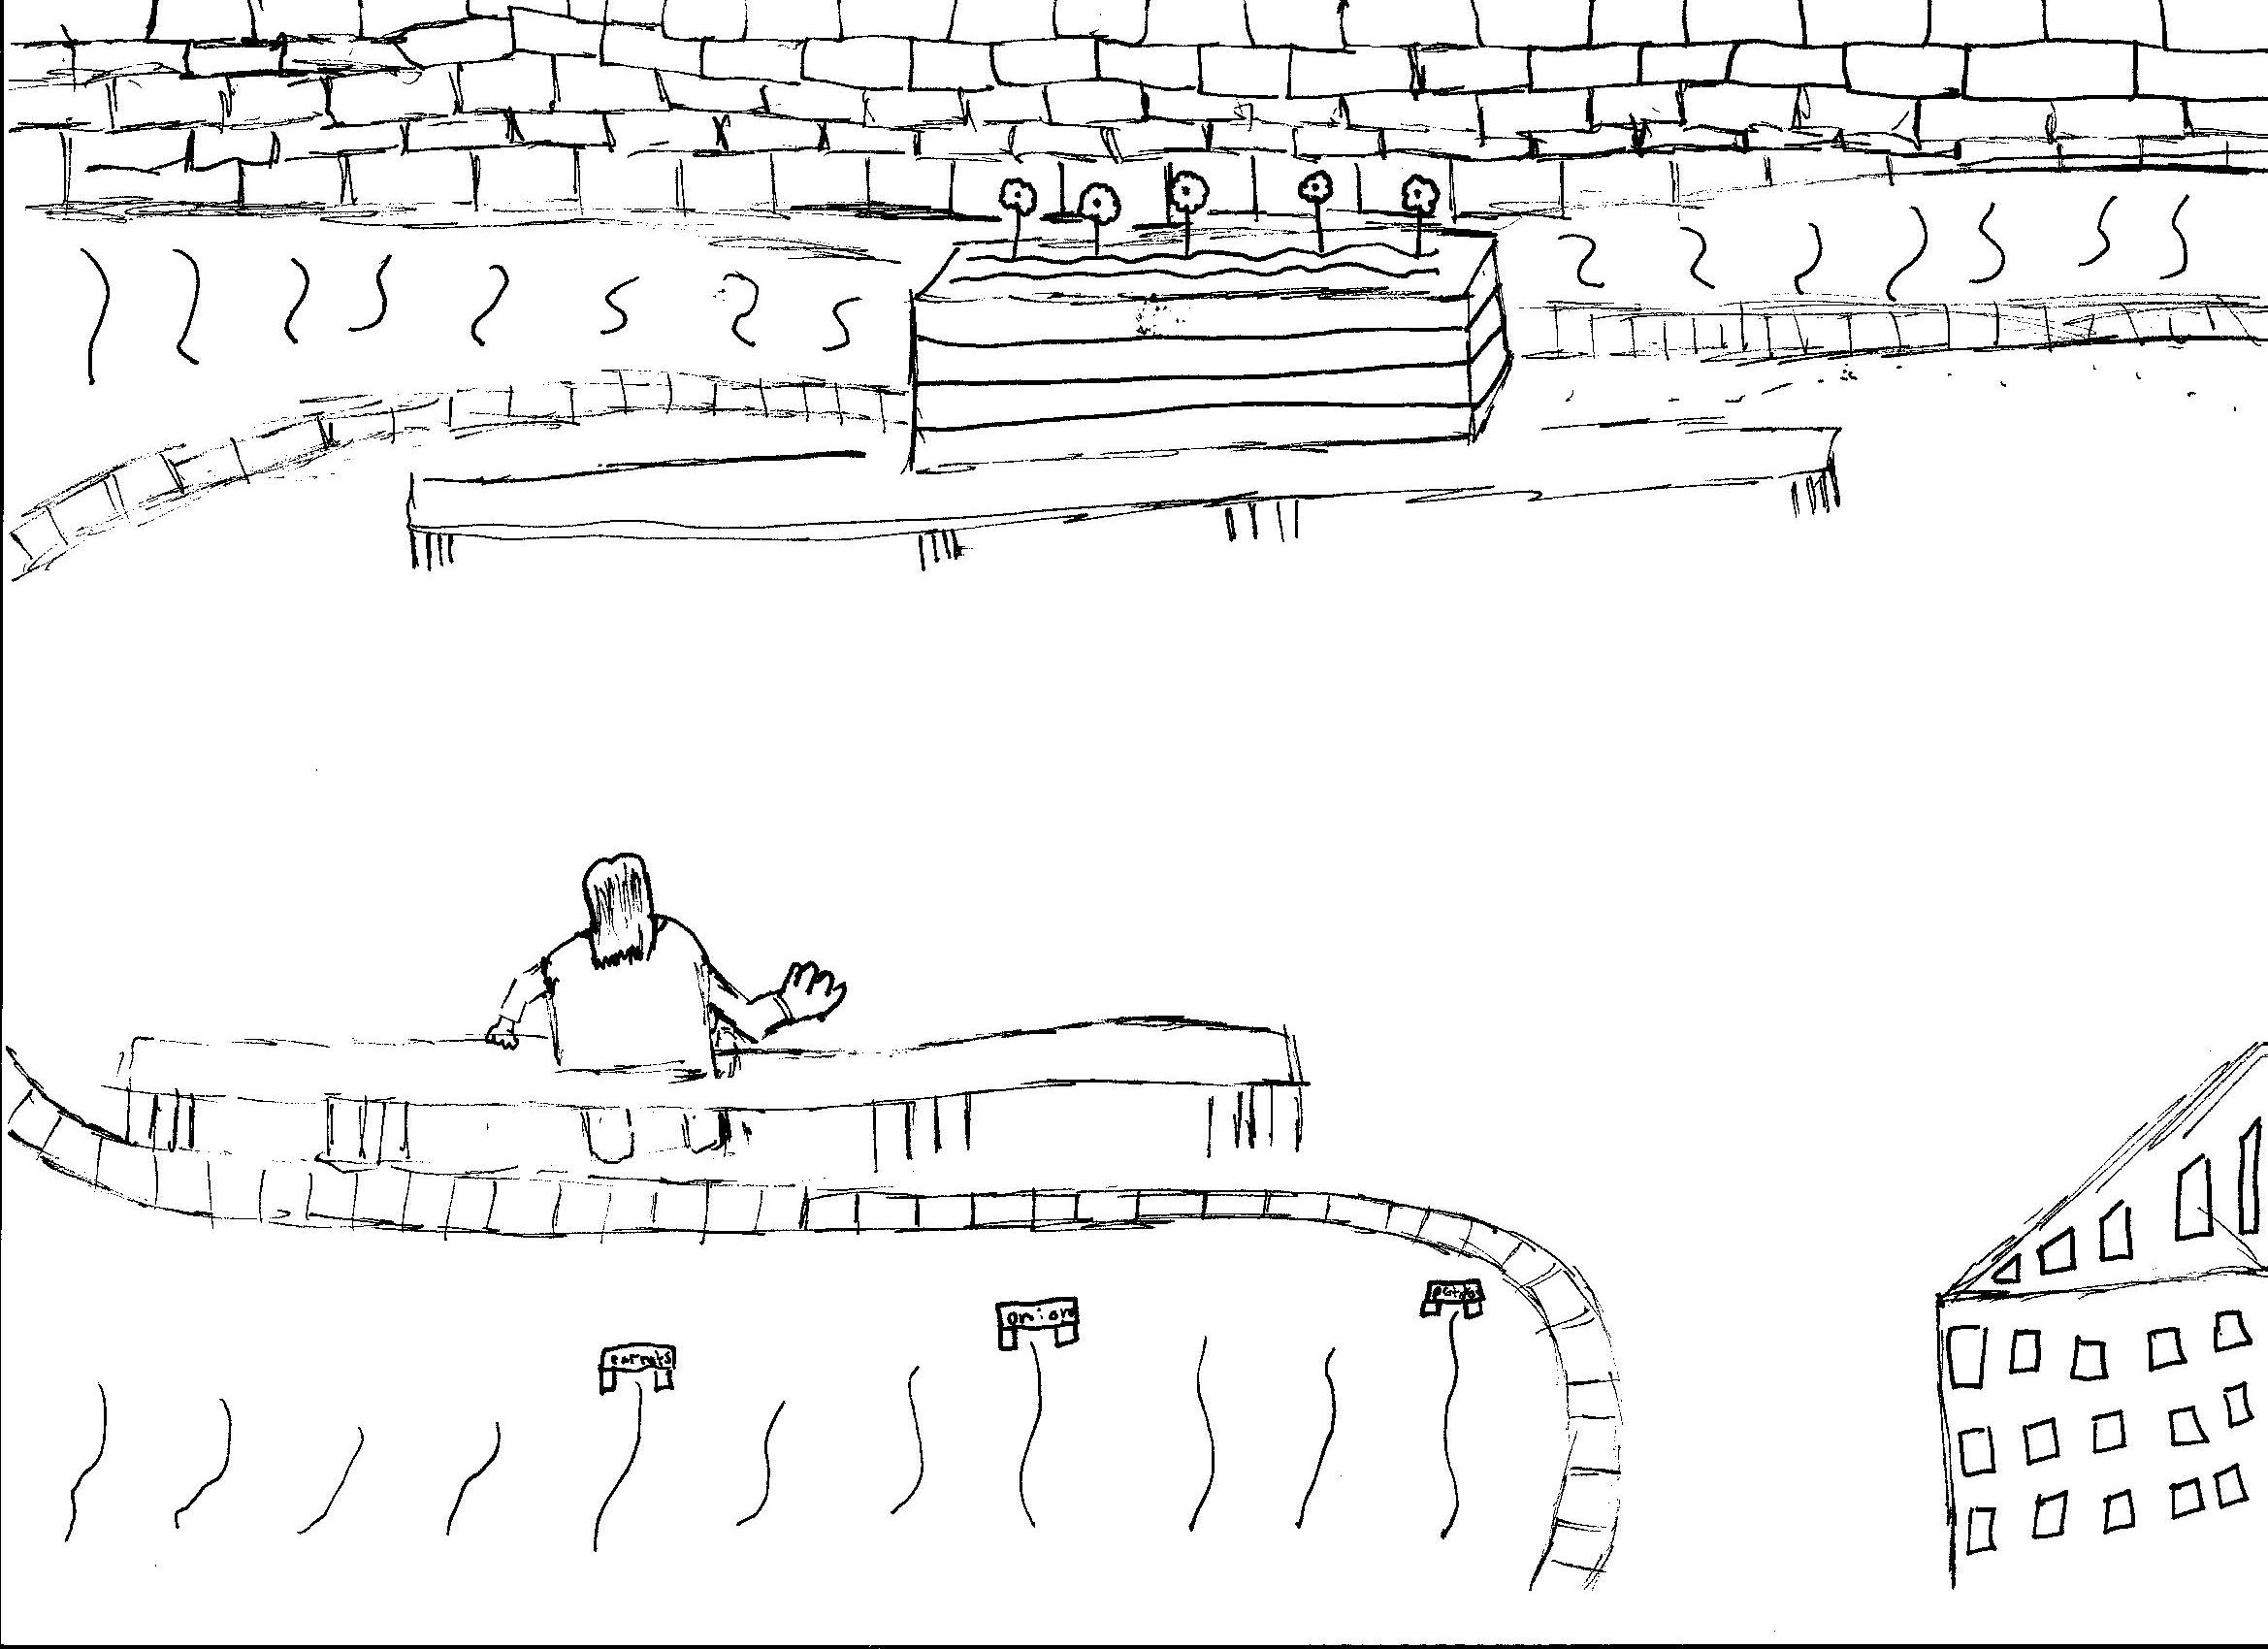

All about the Governors
School Council wrote:
The governors are the people who decide what to do in this school. Ms Taylor-Sezgin is on the governors too. They meet to decide what happens. They decide what lessons the children do, like maths, literacy, geography and science. You can find more information about them on the Chisenhale School website.

There is a tray in the main office, to leave any letters for governors, if parents want to get in touch. We have an enthusiastic and committed group of governors, who work hard to support the school. Currently the parent governors are:

Neil Cunningham (parent of Evie and Torin) - Chair of Governors
Silvia Sovic (parent of Natalie)
Katy Twyning (parent of Stanley)
Meika Dulman (parent of Gabby and Leon)
Tim Farrand (parent of Csanad and Zalan)

Tania Kaiser (parent of Lara and Danny) and Dan Wormald (parent of Andrew) are associate governors and are also parents at the school.

Learning Mentor
Jane Crouch is our learning mentor. She is available to support any child who has emotional needs or who just requires a bit of extra help to thrive at school. She also supports children with their learning in class, as well as working with children at lunchtimes.
Parental Engagement
Ruth Crossan, our Parent Engagement Officer, works hard to enable parents and families to play a part in their child’s education. Research shows that children do better at school when their parents are actively involved so we provide plenty of opportunities for parents to participate in school life at Chisenhale with regular courses, workshops and social events.

Parents play an important role in the school as governors, reading volunteers and members of the PTA. They also help run after-school clubs with staff, like the opera and gardening clubs and are welcomed into school to offer their expertise. For example, one parent runs a
play-writing workshop for year 6 pupils while another runs a cookery club for children.

Ruth is in school every day to support parents:
- Catch her in the playground before or after school to make an appointment
- leave a message for Ruth in the office
- email Ruth on: rcrossan.211@lgflmail.org
Chisenhale Parent Teacher Association (CPTA)
The CPTA runs a number of events through the year, which help to bring families together, as well as raising money for the school. All family members are welcome to take part – more volunteers are always needed.

Some of the events include:
- summer fete - winter fair - International food evening
- family film night - cake sales - pop-up restaurant

Partnerships
We believe strongly in working in partnership. These are some of our current partnerships:

Teach East London Teaching Schools Alliance – a partnership including Morpeth, George Green and Stepney Green Secondary Schools; Bonner, Olga, Hermitage, Ben Jonson, Globe, John Scurr, Bangabandhu, Redlands, Clara Grant and Malmesbury Primary Schools; Rachel Keeling Nursery, Phoenix Special School and the Institute of Education. This enables staff to work together to improve teaching and learning for all children.
Worshipful Company of Weavers – we are very lucky to be one of four schools supported by the Weavers’ Charity. We have a member of the charity on the governing body and have also benefitted from a number of grants, including recent ones for the library, for the early years garden and for the playground development - Chisenhill.
East London Schools Partnership (funded by Unilever) – this enables us to work with other schools, bringing children together in events such as the Elympics, where we held a special event at Mile End Stadium and a food festival, which was a day of performances and workshops. This also funds work with parents, including cooking, Strengthening Families parenting course and the work we do with Spitalfields City Farm
Chisenhale Art Gallery and Artists’ Studios – we are a partnership school, developing a number of joint projects: they are just across the road from us.
Magic Breakfast – provides a nutritious breakfast and resources for children attending breakfast club.
Mini Maestros – they provide a range of after school music lessons, all at Chisenhale
Now Press Play – we were one of the first schools to pilot their work and we continue to work with them to develop new ideas, as well as representing them at events such as BETT. They have developed learning experiences for children through wireless headphones, which enable children to really get involved in a different type of learning.
Technology Will Save Us – we have piloted several of their new products, which provide really exciting new opportunities for our children.

We hope you have enjoyed reading our booklet and that you found it helpful.
If you have any more questions, you can ask at the office, or ask any member of staff.

