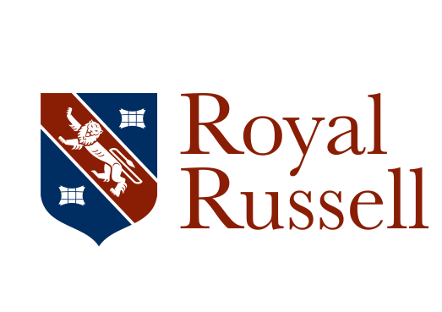

Job description
Person Specification – Post Graduate Sports Coach

Qualifications
- Good level of general education including GCSE Maths and English at Grade C or
above, or equivalent
- Good Honours degree in a sports specific or sports related course
- Level 2 Coaching qualification (desirable)
- Holds an umpiring/refereeing qualification or working towards

Experience
- Experience in teaching/coaching children in sports activities
- Good subject knowledge of a wide range of sports with specialism in Football or Hockey
- Plays at least one sport competitively at County standard or equivalent (desirable)
- Ability to coach a Summer sport of Cricket, Athletics, Tennis or Rounders (desirable)

Skills, knowledge and abilities
- Enthusiastic and committed to promoting high standards of sporting performance
- Proficient in Microsoft Office packages, especially Outlook, Word and Excel and ideally in the use of tablet technology
- Able to work on own initiative to a high standard, to prioritise conflicting demands and to deadlines
- Excellent interpersonal and customer-facing skills with a warm, friendly and professional manner, able to foster good working relationships with all members of the School community (staff, pupils, parents/carers, and representatives of other schools) either in person or on the phone

Other requirements
- Willing and flexible to assist with peaks in workloads including assistance with extra-curricular activities (after-School and some Saturday fixtures)

April 2017

