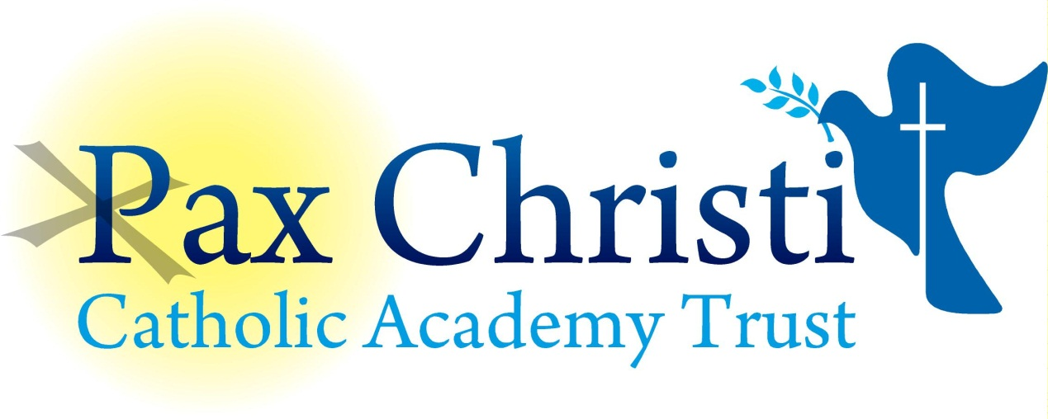

CHRIST THE KING CATHOLIC VOLUNTARY ACADEMY

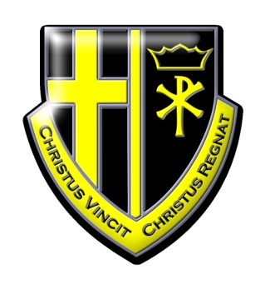

JOB DESCRIPTION

IT/Web Technician
NJE Grade 2

Current Post holder: | Vacant
Job Description Review Date:  Signed…………………………………………………………… | July 2017  Date………………………………………..
Job Purpose
This post holder will provide technical support and guidance to staff to understand programs, problem solve and generally support them in using software/hardware correctly in the classroom situation. This post will usually be focused on installing and maintaining Apple computer equipment in the media suite.

Line Management
Responsible to: Principal, Operations Director, Trust IT Director.
Responsible for: No staff

Specific Responsibilities
- Prepare classrooms for learning each day by ensuring ICT suites are ready for use, e.g. printers loaded with paper, printer cartridges checked etc.
- Provide in-class technical support for staff and students using ICT in the classroom.
- Keep up to date with ICT developments and liaise with the Senior IT Technician and Trust IT Director over future developments, internet, video conferencing, network expansion etc.
- Set up and maintain new computers and cabling under the direction of the Trust IT Director/Senior IT Technician.
- Maintain and fault find all computers around the school and organise where necessary if repairs are required. Make repairs to laptops and desktops if and when necessary.
- Carry out preventative maintenance of hardware, e.g. cleaning of computers, projectors, printers and mice.
- Advise Senior IT Technician when stock is running low for parts so that they can be replenished.
- Mount and install computer/AV equipment as and when required.
- Configure phones, extensions on phone and printer system and network ports in line with instructions.
- Maintain integrity of software, virus killing, re-installation when crashes occur etc.
- Ensure the continued operation of the School networks, setting up new accounts, maintain password integrity, and assist pupils and staff to access network resources.
- Installing new software and upgrades. Reimaging work stations as required.
- Assist the Trust IT Director in keeping the network secure.
- Provide technical support for staff training.
- Installation, maintenance and customisation of specialist software in line with the school development policy.
- Advise on technical aspects of system security.
- Maintain an inventory of all ICT equipment in the school, noting item model, make, serial number, location, condition, date of purchase etc.
- Provide on-site and remote IT support to remote sites.
- Work cooperatively as part of the ICT network team, covering absence, vacancies and supporting colleagues at times of heavy workload.
- Maintain content on academy/trust web based platforms.

Skills and Abilities
The post holder will be expected to demonstrate the following skills and abilities at all times during the discharge of their duties:

- Work on own initiative and to demonstrate the ability to solve unexpected or new problems in a methodical, efficient manner.
- Learn new skills and expand current skill set and to be able to pass on knowledge and techniques to others.
- Demonstrate good general interpersonal and communication skills.
- Deal with conflicting demands and work flexibly.

Whole Academy Responsibilities
- Be a positive influence on the climate and culture of the Academy and show a positive example at all times.
- Support the catholic ethos of the Academy.
- Be aware of and comply with policies and procedures relating to child protection, health, safety and security, confidentiality and data protection, copyright etc reporting all concerns to line manager.
- Be aware of and support difference and ensure equal opportunities for all.
- Contribute to the overall aims of the Academy.
- Appreciate and support the role of other professionals.
- Attend and participate in relevant meetings as required.
- Participate in training and other learning activities and performance development as required.
- Recognise own strengths and areas of expertise and use these to advise and support others.

General

To work in collaboration with other Pax Christi Academies, sharing good practice and supporting during time of absence and/or heavy workload.
- This job description contains the main accountabilities relating to this post and does not describe in detail all the tasks required to carry them out. All staff are expected to be flexible to ensure the most effective organisation and delivery of services.
- The duties and responsibilities of the post will evolve with the natural development of the Academy and/or Trust. Such changes are, therefore, a normal part of the post and the post holder must be prepared to undertake any other duties commensurate with the general level of responsibility of the post which may be determined from time to time subject to the proviso that any permanent, substantial changes shall be incorporated into the job description and evaluated as such.

