BARKING ABBEY SCHOOL
A Specialist Sports College
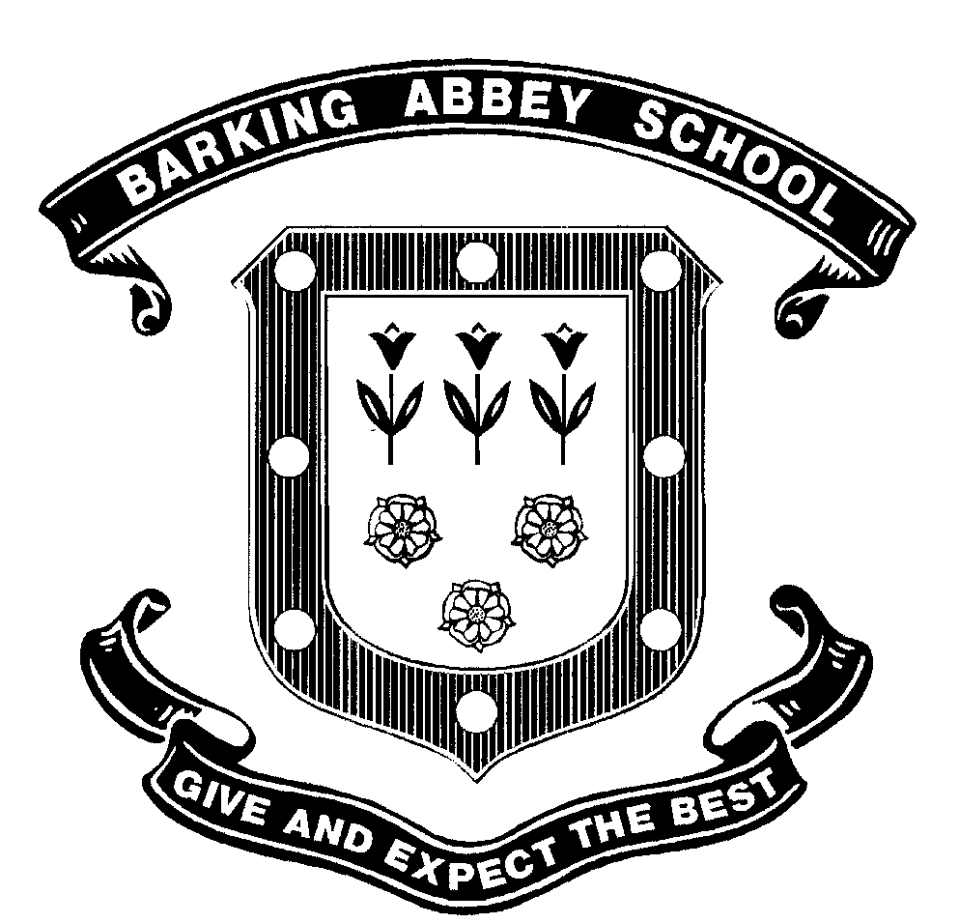

JOB DESCRIPTION
Job Title | Head of Girls Football Academy
Grade | P03
Department | Football Academy
Location | Upper & Lower location
Line Manager | Director of Sports Academies
Line Management of | Girls Football Coach

Purpose of the role

The Head of Girls Football Academy is responsible for Overall Management and Strategic, Technical & Commercial Development of the Girls Football Academy

The following indicate some of the principal tasks and responsibilities:

Main Duties
- The strategic development of the football academy.
- Development and administration of the player pathways to higher education in the UK or overseas.
- Development and implementation of the football programme.
- Development of external partnerships with public and private sector organisations.
- Coach Football Academy players and teams and assign the coaching roles across all age ranges and teams operated by the academy.
- The line management, co-ordination and development of the staff including one to one meetings and appraisals.
- Contribute to the overall strategic development of the school’s academy programmes.
- Deliver presentation on Football Academy programme to partners and potential new recruits.

Specific Roles and Responsibilities
- The Strategic Development of the Boys Football Academy
- The development and implementation of the Academy Development Plan.
- Ensure the Football Academy is meeting the technical, physical and education demands of professional associations, both nationally and internationally and UK Higher Education Programmes.
- The development of partnerships and relationships with UK Sport, Sport England, the FA and YST.
- The development of commercial relationships that further the aims and objectives of the academy.
- Developing good relationships with club coaches and school teachers.

- The Management and development of the Boys Football Programme
- Responsibility for the overall Football Programme.
- The development of the overall technical and physical programmes; including systems of play, positional targets and physical achievement targets.
- Development of the approach to objective and goal setting and individual development plans for each student.
- Management of the development of the game schedule including ‘Team Abbey’ model for all sections of the Academy.
- Take overall responsibility to ensure that shortlisting of potential student candidates is carried out to high standard in a timely manner.
- Plan and deliver individual player development sessions.
- Plan and deliver team sessions.
- Coach Academy teams in Football Leagues, Tournaments, Tours, School competitions and all other games on the team schedule.
- Mentor and support students in all aspect of their development as a student athlete
- Management of the recruitment process across all boys’ academy teams and the final approval for students to attend the Academy.
- Review the performance of all girls’ football coaching staff.

- The Development and Administration of player pathways post 18
- Ensure that students follow academic programmes that maximise the options available post 18.
- Ensure that systems are implemented to monitor student progress both on and off the field.
- Liaison with the Director of SA, Heads of Year at Barking Abbey regarding Academy students’ academic progress.
- Responsibility for the development and maintenance of the relationship between the Girls Football Academy and Higher Education institutions in the USA and UK.
- Advise Academy students on the pathways available and the requirements of each pathway.
- Assist Academy students in the application process for higher education and in the development of contractual agreements.
- Ensuring that all resources required are in place; player film, academic documentation, player profiles.
- Responsibility for the management and support of students moving on to the next stage of the player development pathway.

- Management and Development of Girls’ Football Academy staff
- Responsibility for the professional development of all girls’ football academy staff.
- Responsible for the allocation of specific coaching duties across all girls’ academy teams.
- Performance review of all teams and staff including one to one meetings and appraisals.
- Identifying opportunities to extend the experience of staff through working across the football community both nationally and internationally.

- Contribute to the Overall Development of the School’s Academy Programmes
- Support the Director of Sports Academies in the development of the Sports Academy Programme.
- Work cooperatively alongside the Head of boys’ Football Academy in the development of the overall Football Academy Programme
- Identifying new opportunities to enhance the profile of the academy programmes.
- Any other duties relevant to the development and administration of the Academy.

The above mentioned duties are neither exclusive nor exhaustive and the post holder may be called upon to carry out such other appropriate duties as may be required by the Head Teacher within the grading level of the post and the competence of the post holder.

The school will endeavour to make any necessary reasonable adjustments to the job and the working environment to enable access to employment opportunities for disabled job applicants or continued employment for any employee who develops a disabling condition.

This job description is current at the date below but will be reviewed on an annual basis and, following consultation with you, may be changed to reflect or anticipate changes in the job requirements which are commensurate with the job title and grade.

Employees Signature |  | Date
Line Managers Job Title |  | Date

BARKING ABBEY SCHOOL
A Specialist Sports College

PERSON SPECIFICATION

Knowledge & Skills | Criteria | Essential  Essential | Desirable  Desirable | Assessment Method  Application A  Interview I  Task T
 |  |  |  | A | I | T
Knowledge & Skills |  |  |  | √ | √
Knowledge & Skills | A full understanding of the BA student athlete model where academic progression is paramount | √ |  |  | √
Knowledge & Skills | High levels of communication skills, both orally  And written. | √ |  |  | √
Knowledge & Skills | Personable and enthusiastic with a strong work  ethic | √ |  |  | √
Knowledge & Skills | Extensive local knowledge with an ability to network effectively at all levels. | √ |  |  | √
Knowledge & Skills | Computer skills (in particular Word/ Excel/  Access). | √ |  | √
Qualifications | Level 4/ UEFA A License |  | √ | √
Qualifications | Level 3/ UEFA B License | √ |  | √
Qualifications | Youth Coaching Modules 1,2 & 3 |  | √ | √
Qualifications | Sports First Aid Qualification | √ |  | √
Experience | A minimum of 5 years coaching experience | √ |  | √
Experience | A successful track record of establishing strong relationships within the community, with colleagues,  officials, other football clubs and FA representatives. | √ |  | √ | √
Experience | Experience of working within the football  Industry. | √ |  | √
Experience | Experience of developing young players through the player pathway | √ |  | √ | √
Attitude & Personal Qualities | Honesty and Integrity. | √ |  |  | √
Attitude & Personal Qualities | Understanding the need to use discretion and respect confidentiality. | √ |  |  | √
Attitude & Personal Qualities | Commitment to safeguarding and promoting the welfare of children and young people | √ |  |  | √
Attitude & Personal Qualities | Understanding of the requirements of data protection and disclosure of information. | √ |  |  | √
 | Ability to demonstrate an awareness of equality and diversity and to promote these through working practices. | √ |  |  | √
 | Ability to work flexibly and outside of normal school hours. | √ |  |  | √
 | Current driving licence and car for travel and transport between The Upper and Lower School |  | √ | √
 | Willingness to work weekends and in the  Evening. | √ |  |  | √
 | Desire to be ambassador for Barking Abbey in public role. | √ |  |  | √

Barking Abbey is committed to safeguarding and promoting the welfare of children and is an Equal Opportunities Employer.
This post is exempt from the Rehabilitation of Offenders Act 1974 and a comprehensive screening process, including a Disclosure & Barring check, will be undertaken on all successful applicants.

