JOB APPLICATION FORM

POST TITLE:

REFERENCE NUMBER:

CLOSING DATE:

 |  |  |  | 1. Personal Details
 |  | Title: Mr/Mrs/Ms/Miss/Other:
 |  | Surname/Last Name: |  |  | First Names:
 |  | Address: |  |  | Telephone Number including international code if
 |  |  |  |  | applicable (Home):
 |  |  |  |  | Telephone Number (Mobile):
 |  |  |  |  | Email:
 |  | Post Code:
 |  | Address for Correspondence (if different to home |  |  | N.I. No:
 |  | address)
 |  |  |  |  | Department for Education Registration No:
 |  | Post Code:
 |  | Where did you see or hear about this post? |  |  | GTC Registration No:
 |  |  |  |  | If applicable
 |  |  |  |  | Date QTS received/expected:
 |  | Do you hold a current driving licence? |  |  |  |  |  | Yes |  |  | No
 |  | Is it a Full / Provisional / LGV / PCV licence?
 |  | Phase/s you are trained | EYFS | KS1 |  | KS2 | KS3 |  |  | KS4 |  | Special
 |  | to teach
 |  | Subject/s trained in

Raphael Independent School - Park Lane, Hornchurch, Essex. RM11 1XY

1

2. Educational / Technical / Professional Qualifications

(Please name any institute or professional body in full, rather than using initials)

Secondary Education

Where attained | Subjects / Qualifications | Year |  | Grade
 | Higher/Further Education
Where attained | Subjects / Qualifications | Year |  | Grade
 | Teacher Training
University: | School: | Full/Part Time:
Date started: | Date completed: | Course (PGCE, BEd, BA
 |  | with QTS, Schools Direct,
 |  | SCITT):
University/School address:
Telephone:

Raphael Independent School - Park Lane, Hornchurch, Essex. RM11 1XY

2

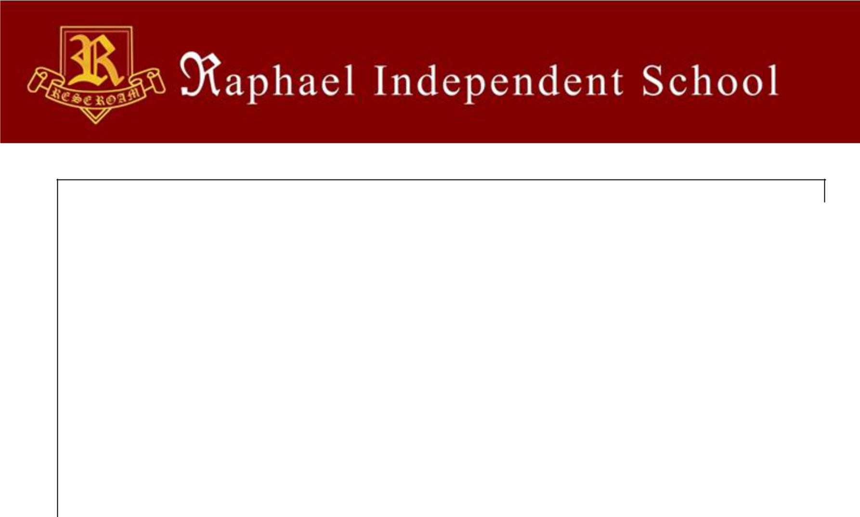

Teaching Practice

Name, address and type of | Name of Education | Age Range taught | Duration
school | Authority |  | From | To

3. Employment History

Please give details of all jobs held including part time and unpaid work, starting with your present / last employer.

Previous Employment
 | Name and full address | Jobs held and | Subjects/age | From | To | Salary/ | Reason
 | of school/employer | main duties | ranges taught | (exact | (exact | Grade | for
 |  |  | if applicable | date | date |  | leaving
 |  |  |  | please) | please)

Raphael Independent School - Park Lane, Hornchurch, Essex. RM11 1XY

3

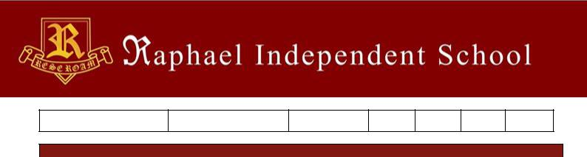

4. Relevant Knowledge, Experience & Skills

Please demonstrate using examples how your knowledge, experience and skills meet the job requirements described in the person specification. Please include your reasons for and your interest in applying to Raphael Independent School.

You may prefer to attach your supporting statement as a separate document. Your statement should be no longer than 3 sides of A4.

Raphael Independent School - Park Lane, Hornchurch, Essex. RM11 1XY

4

Raphael Independent School - Park Lane, Hornchurch, Essex. RM11 1XY

5

Raphael Independent School - Park Lane, Hornchurch, Essex. RM11 1XY

6

5. References

Please indicate two people who can provide references (these should be professional and include your last employer):

Name:

Address:

Tel. No.

E-mail:

Occupation:

Relationship (e.g. Line Manager/Headteacher):

Please note references will be taken up prior to interview for all shortlisted candidates.

Name:

Address:

Tel. No.

E-mail:

Occupation:

Relationship (e.g. Line Manager/Headteacher):

Please note references will be taken up prior to interview for all shortlisted candidates.

6. Relationship Declaration

All candidates for employment must state in writing whether they are the parent, grandparent, partner, child, stepchild, adopted child, grandchild, brother, sister, uncle, aunt, nephew or niece of an existing Director of Raphael Independent School. Are you related to an existing member of Raphael Independent School as described above?

Yes No

If yes, please provide the following details:

Surname/Last Name: First Names:

Address: Relationship:

Raphael Independent School - Park Lane, Hornchurch, Essex. RM11 1XY

7

7. Work Status

Are there any restrictions to your residence in the UK which might affect your right to take up employment with Raphael Independent School?

Yes No

If Yes, please provide details:

If you are successful in your application, would you require a work permit prior to taking up employment?

Yes No

Applicants should note that failure to declare any restrictions to employment or the need for a work permit could lead to termination of service.

8. Applicant Commitment to Safeguarding

Raphael Independent School is committed to safeguarding & promoting the welfare of children and young people, as well as adults at risk, in line with the ‘Safeguarding Children and Safer Recruitment in Education’ guidance issued by the Department for Education and expects all staff and volunteers to share this commitment.

Agreement Statement

By signing this declaration I confirm that I understand and agree with the schools’ commitment to safeguarding.

I confirm that I am not disqualified from work with children, or subject to any sanctions imposed by a regulatory body. I am aware that this post requires an Enhanced Disclosure from the Disclosure Barring Service (DBS).

Signature: __________________________________

Print Name:_________________________________

Date: ______________________________________

Raphael Independent School - Park Lane, Hornchurch, Essex. RM11 1XY

8

9. Declarations

Declaration

To the best of my knowledge and belief the information I have given is correct. I understand that my application will be disqualified or, if already appointed, disciplinary action considered, if I have knowingly given false information. I am also aware of and agree to accept the conditions set out in the accompanying information relating to provision of information of criminal convictions.

Signed: Date:

Declaration of Criminal Offences

The job for which you are applying involves substantial opportunity for access to children. It is therefore exempt from the Rehabilitation of Offenders Act 1974. You are therefore required to declare any convictions or cautions you may have, even if they would otherwise be regarded as "spent" under this Act. The amendments to the Exceptions Order 1975 (2013) provide that certain spent convictions and cautions are 'protected' and are not subject to disclosure to employers and cannot be taken into account. Guidance and criteria on the filtering of these cautions and convictions can be found on the Disclosure and Barring Service website. The information you give will be treated in confidence and will only be taken into account in relation to an application where the exemption applies. As the occupant of the post will have substantial access to children, a disclosure request will be made of the Disclosure and Barring Service Checks (DBS) to ascertain whether their records reveal any criminal convictions (including spent ones) relating to the successful applicant. All information given will be treated in the strictest confidence and will be used for this job application only. The disclosure of a criminal record will not debar you from appointment unless the selection panel considers that the conviction renders you unsuitable for appointment. In making this decision the panel will consider the nature of the offence, how long ago and what age you were when it was committed and any other factors which may be relevant.

Failure to declare a conviction may, however, disqualify you from appointment, or result in summary dismissal if the discrepancy comes to light.

Details of offence(s) | Place & Date of Judgement(s) | Sentence(s)

Data Protection Act 1998

I hereby give my consent for personal information (including recruitment monitoring) provided as part of this application to be held on computer or other relevant filing systems and to be shared with other accredited organisations or agencies in accordance with the Data protection Act 1998.

Signed: Date:

Raphael Independent School - Park Lane, Hornchurch, Essex. RM11 1XY

9

Raphael Independent School - Park Lane, Hornchurch, Essex. RM11 1XY

10

10. Equal Opportunities Monitoring

This page is not mandatory, but will Raphael Independent School monitor their obligations under the Equality Act 2010

To help us check that we are employing people fairly, please mark the appropriate sections below.

Asian |  |  | Black |  |  | Chinese or other ethnic group
Indian |  |  | Caribbean |  |  | Chinese
Pakistani |  |  | African |  |  | Any other | (please specify)
 |  |  |  |  |  | ethnic group
Bangladeshi |  |  | Any other |  | (please specify)
 |  |  | Black
 |  |  | background
Any other |  | (please specify)
Asian
background
Mixed |  |  | White |  |  | Rather not say
White and Black |  |  | English
Caribbean
White and Black |  |  | Irish
African
White and |  |  | Scottish
Asian
Any other mixed |  | (please specify) | Welsh
background
 |  |  | Any other White |  | (please specify)
 |  |  | background
Age (DOB) |  |  | Rather not say

Raphael Independent School - Park Lane, Hornchurch, Essex. RM11 1XY

11

Disability

The Disability Discrimination Act (1995) defines a person as disabled if they have a physical or mental impairment which has a substantial and long-term (i.e. has lasted or is expected to last at least 12 months) adverse effect on one’s ability to carry out normal day-to-day activities. This definition includes such conditions as cancer, HIV, mental illness and learning disabilities.

Do you consider yourself to have a disability according to the above definition?

Yes
No
Rather not say
Gender
Male |  | Transgender F to M
Female |  | Transgender M to F
 |  | Rather not say

Please return your completed application form by email only to:

admin@raphaelschool.com

Raphael Independent School - Park Lane, Hornchurch, Essex. RM11 1XY

12

