Job Description - Director of Sport

Key Responsibilities:

The Director of Sport has responsibility for all sport in the School. They will lead the teaching team and coaches to develop a full programme of sports across the School for pupils of all abilities. The Director of Sport will be a role model for all to enjoy sport and promote healthy lifestyles.

The Director of Sport will coordinate and teach PE and Games for boys and girls. They will work to ensure the highest standards of teaching and learning in PE and Games.

The Director of Sport will coordinate and participate in the sports fixtures and the sports clubs programme. Most sporting fixtures take place in the normal school week. Where there are occasional weekend fixtures, the Director of Sport is expected to attend.

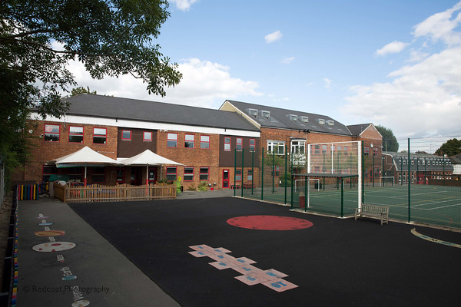

Specific areas of responsibility are:

Leadership
- Provide inspiration and strong leadership to the School to ensure the highest standards of learning in sport.
- Continue to develop the long term and medium term plans for Games, assessing and monitoring the quality of teaching/coaching standards in Games and PE.
- To create, review and develop any policies relevant to the subject.
- Promote high expectations in sports and set targets for ongoing excellence
- Manage a competitive and balanced fixture programme, ensuring fair team selection, promoting sportsmanship and appropriate equality of opportunity
- Ensure systems are in place for assessment of pupils’ learning.
- Strategically plan the development of sport by contributing to the School Development Plan through the creation of a subject action plan.
- To lead and provide INSET, supporting the needs of colleagues.
- Provide a model of sports development that allows for opportunities for both competition and an inclusive approach to participation
- Ensure good communication with the parent community, through effective sports fixture planning and provision.
- To use ICT effectively and provide ICT resources, where appropriate.
- Manage the sports budget effectively and efficiently.
- Provide up to date risk assessments, that are followed, regularly reviewed and ensure compliance.
- Keep abreast of any rule changes or guidance with regard to all relevant sports.
- Produce and maintain a Games Handbook to include policies and procedures for staff induction and reference.
- Take a lead in line managing and appraising of any part time sports staff.
- Maintain high academic standards.
- Develop strong links with other local schools, including running inter school tournaments, sporting workshops and festivals.
- Observe the teaching of sport throughout the School to ensure standards are at a consistently excellent level.
- Organise intra-school sports events.
- Liaise with external venues and coaching staff.

Teaching
- Adapt your teaching to the learning needs of your pupils.
- Promote a ‘Growth Mindset’ style by which pupils develop their skills
- Ensure effective teaching methodologies to suit a variety of learning styles.
- Ensure progression and high achievement.
- Be creative in your teaching and in your expectations of pupils.
- Foster a spirit of enquiry among your pupils.
- Set high expectations for yourself and your pupils.
- Maintain order and good discipline among pupils and safeguard their health and safety.
- Set, mark and record work to be done in school and, where applicable, for homework.
- Carry out all other duties, in and out of the classroom, including after and out of school activities and outings, care of the environment, display and overall care.
- Ensure resources and teaching methods are up-to-date with innovative use of IT.
- Know which pupils are on the SEN and academically more able registers and take their needs into account when planning lessons, carefully tracking their progress.
- Consult and be familiar with the School handbook and to ensure that its guidelines are followed.
- Ensure that pupils are correctly prepared for any music assessments
- Evaluate your teaching for its effectiveness, through reflection, research, reading, peer and colleague observation and by consulting pupils.
- Identify, track and provide proper learning experiences for the academically more able.
- Assist with swimming coaching.

Assessment Recording and Reporting
- To mark and monitor pupils’ work, in line with the School and subject marking policies
- Record pupil progress, in line with the School assessment policy
- Involve pupils in the self-assessment of their learning
- Write written subject reports, as outlined in the reporting policy
- Oversee the Games/ PE noticeboard and any electronic notices, including those relating to sport on the website

Administration
- Oversee all aspects relating to fixtures: liaising/corresponding with staff, pupils, parents, other schools, entering into School Calendar in a timely manner and booking/arranging transport.
- Be responsible for the sports budget.
- Ensure Sports Days, swimming galas and tournaments are well organised and delivered.
- Organise the taking of team photographs.
- Maintaining a record of results, and that suitable reports are written for the school magazine and website.

Teamwork

- Be supportive to all your colleagues.
- Liaise and carefully manage all sports staff
- Support new members of staff in your area of the school.
- Attend Key Stage or year group /phase meetings and read minutes.
- Work in a co-operative, diplomatic and flexible manner.
- Foster and maintain good working relationships, acting as a courteous, friendly and businesslike member of the school team.
- Undertake such additional duties as might be reasonably requested by the Head or other authorised person.

Policies
- Be familiar with policies of Woodford Green Preparatory School.
- Ensure all legal requirements regarding child protection and health and safety at work are met.
- Use risk assessments where appropriate.
- Promptly report all safety hazards and unsafe working practices.

Continuous Professional Development (CPD)
- Attend school organised CPD sessions whether they be twilight/whole day/off-site.
- Develop your use of ICT both as an organisational tool and as a means to deliver a better curriculum.
- Actively engage in the School’s Professional Development Programme.
- Analyse and identify your own areas of strength and areas for development and seek opportunities to learn.
- Take responsibility in overseeing the professional development of PE staff.

Communication
- To liaise with all those people who work within the areas that you oversee.
- To liaise with parents.
- To promote and maintain a good reputation for the School.
- To ensure that events for which you are responsible are properly planned, promoted and celebrated.
- To contribute to and read the daily bulletin on our intranet, ‘Dear Parent’ letters, eMagazine and the calendar.
- To deal with emails promptly as far as is possible without compromising the quality of your teaching.
- Maintain appropriate level of liaison with outside bodies and other agencies, where needed.

Finance
- To be familiar with the budget of your area and input into financial planning and strategic decision making.
- To obtain authorisation for expenditure.
- Ensure all sports equipment is kept in good order.

Extra-curricular activities
- Actively promote interest in sport outside the immediate physical and timetabled confines of the department.
- Contribute to the broader life of the school by supporting and leading curricular and extracurricular events.
- Marketing and external links, including public occasions
- Actively promote sport within the school community to encourage pupils’ interest in the subject area.
- Contribute to the positive promotion and marketing of the school in the local and wider community.

GENERAL RESPONSIBILITIES

Pastoral and Academic:
- To promote and safeguard the welfare of pupils.
- To help provide a safe and secure environment in which the child can learn and be happy at school.
- To comply with the School’s Safeguarding and Child Protection Policy and ensure that any concerns you have relating to the safety or welfare of children are reported immediately to the Designated Safeguarding Lead (DSL) or one of the Deputy DSLs or the Head.
- To keep up to date with pastoral care policies of the School and remain sufficiently aware of the personal profiles of individual pupils.
- To act professionally at all times, setting a good example to children through high standards of presentation and personal conduct, contributing positively to effective relationships with the children.
- To promote and aspire to the highest possible standards of teaching and learning so that as many children as possible can become successful learners.
- To ensure good management, sense of order and tidiness of the sports facilities so that the children may develop a sense of responsibility and pride in their learning environment.
- To ensure that all pupils adhere to the School rules.
- To create an atmosphere of trust and cooperation between home and school by working and communicating with parents/carers.

Professional:

- To act consistently, in a friendly and supportive manner with colleagues
- To attend staff briefings as required by the staff meeting schedule
- To attend staff meetings, open days, briefings, assemblies, INSET days, parents’ evening, parent meetings and other school events, as may be required
- To run a programme of before and after school sports activities
- To carry out supervisory duties, including playground and lunch supervision, as directed by the Assistant Head (Operations)
- To cover for absent colleagues, when required, as organised by the Assistant Head (Operations)
- To take part in day and/or residential trips, if necessary and reasonable
- To meet all deadlines for the efficient running of the school, such as in submitting planning or reports
- Work within the school’s policy to promote equality of opportunity for all pupils and staff, both current and prospective.
- To participate in any arrangements that may be made for teacher professional review
- To keep up to date with all school policies and procedures
- Ensure practice promotes and does undermine fundamental British values.
- At all times, to adhere to the school’s Code of Conduct for staff

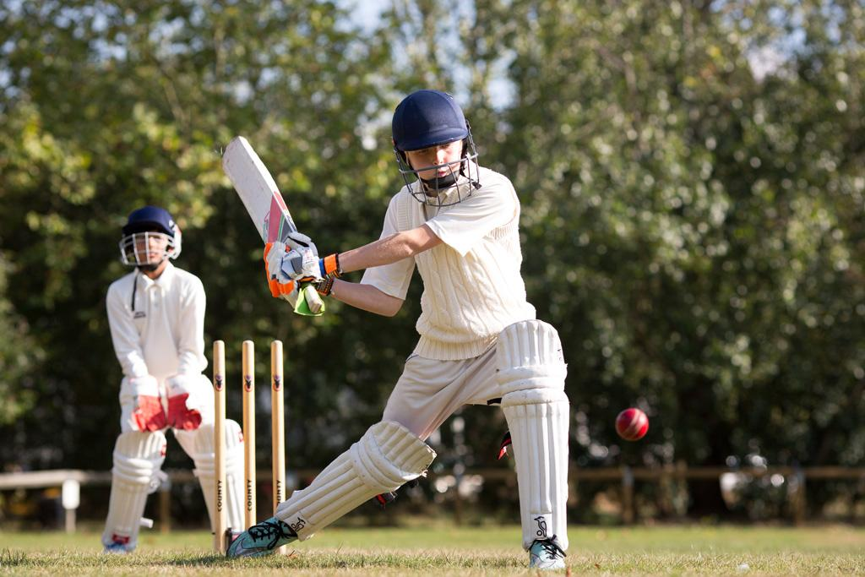

PERSONAL SPECIFICATION

The following outlines the key skills and experience required for this position. The selection panel will assess each candidate against the criteria listed below, expecting candidates to demonstrate knowledge and understanding of each area and show evidence of having applied (or awareness of how to apply) this knowledge and understanding in the school context.

The panel will use the following assessment tools: Application form; Interview/assessment activities; Reference and other employment checks.

Qualifications, Leadership and Experience | Essential | Desirable
Good degree in a relevant subject | ✔
Qualified Teacher Status | ✔
Proven track record in sports coaching | ✔
Experience at middle management |  | ✔
Advanced coaching qualification in at least one major sport |  | ✔
Ability and willingness to teach another academic subject |  | ✔
Aptitude to officiate at sporting fixtures and tournaments | ✔

Learning and Teaching , including IT skills | Essential | Desirable
Evidence of how children learn and effective teaching methods | ✔
Confidence in integrating IT systems into the sports curriculum |  | ✔
Practical application of coaching | ✔
Ability to evaluate the pastoral needs of pupils with their ongoing learning |  | ✔
Plan and deliver lessons which match the learning needs of all | ✔

Organisation - managing systems and resources | Essential | Desirable
Excellent personal organisation | ✔
Self-motivated and able to operate proactively | ✔
Able to prioritise needs when under pressure | ✔
Experience of overseeing an area of the budget |  | ✔
Seeks and delivers ways to communicate effectively |  | ✔
Track record of organising successful sporting events/tournaments | ✔

Personal Attributes | Essential | Desirable
Encouraging and maintaining the highest professional standards within the classroom and amongst the wider staff | ✔
Ability to maintain a positive outlook and sense of humour | ✔
Outward-looking, seeking to develop new opportunities for participation in sport | ✔
Continuous energy and encouragement to help motivate others |  | ✔
Ability to self-reflect and seek improvement | ✔
Demonstrates commitment, reliability and integrity | ✔

