February 2018

Dear Applicant,

Re: Post of Teacher of Maths

Thank you for your interest in the above post at Trinity Academy. Please find attached an applicant’s pack containing:

1. Job Description and Person Specification
2. Guidance on completing the application form
3. Information about Trinity Academy
4. Application form
5. Monitoring form

As you will see from the information, Trinity Academy is a new school and in applying for this post you will have an exciting opportunity to contribute to its aim of developing into one of the best schools in South London. Our staff and pupil groups are small but enthusiastic and hard working with high aspirations. Pupils are polite and well behaved and the Academy environment is one of calm and purposeful activity. Currently in temporary accommodation, we are all looking forward to moving into our new purpose-build school on the same site later in the year.

If you wish to have an informal discussion about this post, please email recruitment@trinityacademylondon.org

Please note that completed applications should be returned by e-mail to recruitment@trinityacademylondon.org by noon on 19 February 2018.

Thank you once again for your interest in this post and I look forward to receiving your completed application form.

Yours faithfully

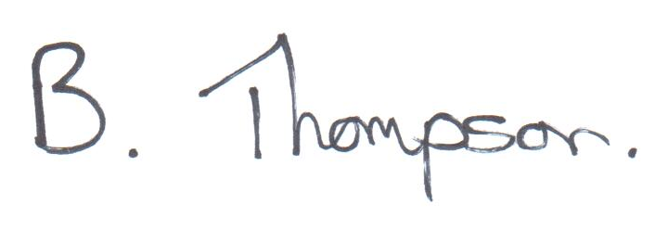

Ben Thompson BSc, MEd, NPQH
Headteacher

