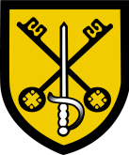
Holywell Church of England Academy

Holywell is a very popular, oversubscribed six form entry middle school for students from year 5 to year 8. We are a Church of England school in the Diocese of St Albans and we became an Academy in October 2012. Students are largely drawn from the two villages of Cranfield and Wootton. We benefit from very supportive and engaged parents. Our Ofsted inspection of 2014 reflected the very good quality of provision experienced by Holywell students and the excellent working environment for the professionals in this very strong team:

- Students in year 8 achieve standards above the levels expected for their age, making good progress because they work hard and are well taught.
- Disabled students and those who have SEN make good progress because the support provided is well-matched to their needs.
- Disadvantaged students achieve well because the extra funding to support them is used effectively.
- Students’ behaviour and safety are good.
- Students are keen to learn and to do well and there is a good working atmosphere in lessons.
- Support for students’ spiritual, moral, social and cultural development is very effective.
- Teaching is good and improving.
- Teachers use their good subject knowledge effectively to plan activities that interest and challenge students.
- The Head Teacher and senior leaders provide effective leadership within a caring school ethos.
- Governors use their experience and expertise well to hold the school to account.

The school has continued to make very strong progress since that inspection. Across the full range of Middle Leadership we have strong capacity as demonstrated notably by the quality and incisiveness of their Self-Evaluation. Challenging and detailed work scrutiny programmes also demonstrate the delivery of these high standards as a consistent experience for Holywell students.
The school has committed very significant funds to further enhance and expand our ICT infrastructure and range of hardware. We now have a ratio of one tablet or desktop computer to every two children in the school. We have recently installed superfast broadband – our own fibre line through to the Cranfield Town cabinet. We have been rolling out a programme of Interactive TVs as the standard for all classrooms.
Given the quality of provision at the school and the ever increasing level of oversubscription for places at Holywell, Central Bedfordshire funded a major building programme which has seen the school increase its size to 630 students. In 2017 the school will be engaged in fresh planning discussions for the next building programme to take our capacity from 600 to 720 students. That move to a six form entry middle school will begin to roll out in September 2018.
The most recent building programme was completed in good time for the jump forward in pupil numbers. This provided stunning new Library, school hall and Music suite. It has also provided three superb, state of the art classrooms. At that point, of the 25 classrooms in the school, 13 had been new build in the last four years or completely remodelled/re-built in that period.
We have close and highly effective links with partner Lower Schools, Wootton Upper School and Marston Vale Middle School, as well as very good working partnerships with a range of other Middle Schools. The closeness of this area’s educational community can be seen in the way that the Middle and Upper Schools are overwhelmingly filled with students from their partner Lower Schools. Around 95% of students at Holywell will transfer to Wootton Upper School enabling us to have a highly focused approach to transition work.
The school also benefits from close relations with the internationally renowned Cranfield University. (The school has a good number of students from around the world whose parents are following courses at the university. This allows us a great deal more diversity of pupil population than might otherwise be the case in Central Bedfordshire.)
Located only a few miles from junction 13 of the M1, the school has easy access to a wide range of national locations to support and enhance the curriculum in addition to those in Bedford itself. Cambridge, Oxford and London are each less than an hour away. Milton Keynes is a 15 minutes journey and Stratford on Avon an hour and a half.
The school is a popular centre for Initial Teacher Training – both University of Bedfordshire and the local SCITT. This reflects well established practice in professional development in the school, a welcoming staff and engaging pupil population. (In the last two years the school has had extended placement students in English, Maths, Science, RE, History, Geography, Art, Technology and PE). Holywell commits very seriously to spend and support staff CPD and is a driving force in CPD for and between Middle Schools.
“The school identifies and meets staff training needs well.” Ofsted October 2014
Most recent outcomes at KS2 place standards in the school high against both national and local standards. Levels of pupil progress are good to outstanding and we are very pleased with a continuing upward trend in these standards and progress data sets. Holywell was a leading school in the Bedfordshire family of Middle Schools, promoting the national GL testing regime. We use this externally set and marked regime to monitor and evaluate the quality of provision and the level of attainment and progress of students from entry in year 5 through to exit in year 8. These tests are confirming our judgement regarding the excellent outcomes for Holywell students. (See report on our website under ‘Pupil Progress’.)
The school is proud of its Church of England ethos. This places us firmly within that worldwide family, dedicated to the service of all in the local and wider community. Within this committed Christian character, we warmly welcome members of all faiths and none. For example, currently we benefit from students in our family from very active and devout members of the Muslim, Sikh and Hindu communities and from a wide range of different Christian communities. The school has actively implemented Values Education. This works in line with our key partner Lower Schools and also benefits greatly from parental engagement and support.
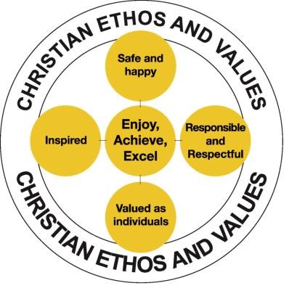
Extra-curricular provision in the school is outstanding. Every lunchtime and after school there are a wide range of clubs and teams taking place. These are well supported by our students. As a result we have a large number of highly successful sports teams in many varied sports – eg athletics, cross country, netball, rounders, hockey, football, rugby, cricket, badminton and table tennis. We also sustain an impressive variety of musical groups.

Holywell
March 2018

