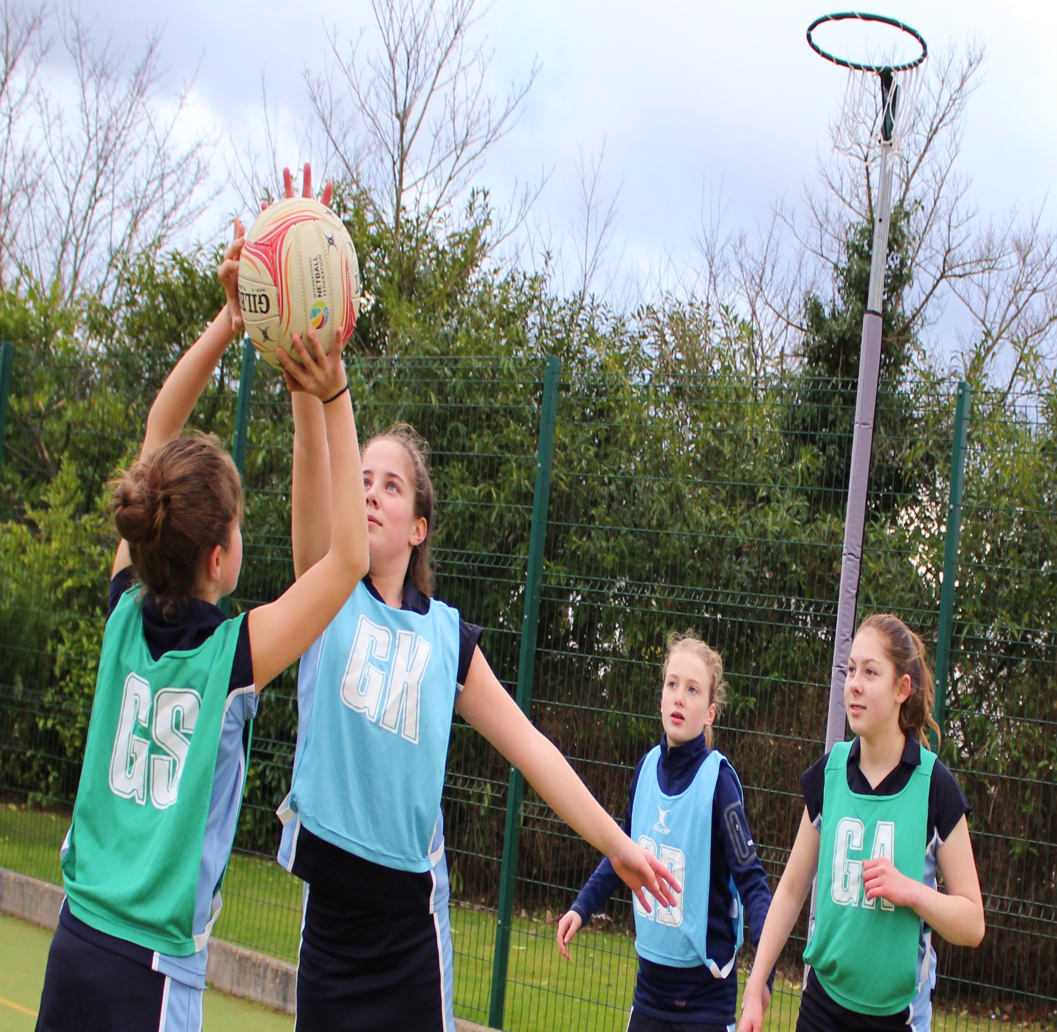

Second in Charge of Physical Education
Required for September 2018
Main/Upper Pay Range (Outer London), TLR 2b (£4,735)
We are looking to appoint a Physical Education Teacher who will hold the position of Second in Charge within the Physical Education Department
If you care about providing sporting excellence and opportunity for all and are committed to physical education within the curriculum and competitive and recreational extra-curricular provision then this is the job for you. You will be joining an already successful, forward thinking and innovative department and will have input into our continued development.
The PE department is a recognised department of excellence in the school with an innovative and engaging curriculum delivered across all key stages.
Hayes School is a high achieving, oversubscribed school, which provides excellent education for its students as well as exciting opportunities for professional and career development for staff. The school benefits from its proximity to central London and excellent transport links whilst bordering the beautiful Kent countryside.
“Teaching and achievement are outstanding.” (OFSTED, 2013)
“Students are extremely well cared for and thrive as a result of excellent teaching combined with highly personalised pastoral support.”
(OFSTED, 2013)
We can offer:
- Motivated students with outstanding attitudes to learning
- Outstanding student behaviour
- Excellent facilities for staff
- An excellent induction and support programme for new staff
- Recognised in-house leadership and teaching development programmes
- Opportunities to work with other schools through established partnerships
- A friendly working environment
This post is suitable for experienced teachers looking to build on their teaching and leadership in an outstanding department and school.
Closing Date: Monday 19th February 2018
Early applications are encouraged and we reserve the right to close the vacancy early if a suitable candidate is found.
The school is committed to safeguarding and promoting the welfare of children and young people and expects all staff and volunteers to share this commitment. Therefore, the successful applicant will be subject to Enhanced Disclosure and Barring Service check.

January 2018

Dear Applicant
RE: VACANCY FOR 2 i/c PE
Thank you for your enquiry about the post of Second in Charge of Physical Education at Hayes School.
I hope that this pack gives you all the information you need at this stage and that we can look forward to your application.
Should you wish to arrange a visit to the school or to have an informal discussion prior to submitting your application please do not hesitate to contact the school.
The closing date for all applications is Monday 19th February 2018.
Please send your completed application form and covering letter to vacancies@hayes.bromley.sch.uk
If you require any additional information or have any questions, please contact Pauline Osborn, PA to the Principal at pjo@hayes.bromley.sch.uk
Yours faithfully
Steve Whittle
Principal
HAYES SCHOOL
WELCOME
Our School
Hayes School is a high achieving, oversubscribed and well-disciplined 11-18 co-educational school with excellent accommodation and facilities set in very attractive grounds. We provide an outstanding education for our students as well as exciting opportunities for professional and career development for staff. Our 1700 students have a desire to succeed and to learn displaying excellent attitudes and behaviour. Relationships between students and staff are very good and staff enjoy opportunities to lead and participate in a wide range of extra-curricular activities and trips. (There are over 80 clubs and over 100 trips take place every year)
In June 2013, Hayes School was judged Outstanding by Ofsted:
- ‘Teaching, the curriculum and pastoral support meet the needs of students extremely well’.
- ‘Consistently good and, often, outstanding teaching over time ensures that all groups of students make excellent progress’.
- ‘The Sixth Form is outstanding’.
- ‘Students make outstanding progress across a wide range of subjects’.
- ‘Staff, students, parents and carers and the school’s governors are rightly proud of the school and the quality of education it provides’.
Attainment and progress at GCSE and A Level are high and significantly above local and national averages. In 2017, 77% of GCSE students achieved at least a Grade 4 in English and Maths. 58% of all grades were A*-B. The school achieved its best ever exam results at A-Level this year with 63% of all grades at A*-B and 89% at A*-C. Student progress at A-Level places the school within the top 25% of schools nationally (ALPS, 2017)
Our Sixth Form of 500 students is heavily oversubscribed and successful. ‘All Sixth Form lessons seen resulted in students making outstanding progress’ (Ofsted, 2013).
However, Hayes is not complacent. We have a relentless commitment to improvement. We judge everything we do by the standard “would this be good enough for my child?” All staff go the extra mile to provide challenge, support and opportunities for every child.
We are very proud of our school, of the opportunities we provide, and of our role in the community. We strive to build on our success creating an environment where each individual is valued: an environment that fosters tolerance and compassion, vibrant, caring relationships, life-long learning skills and a strong sense of moral purpose.

Our Facilities
Hayes School benefits from a beautiful campus comprising green spaces, trees and a variety of purpose-built teaching blocks. The School offers exceptional educational facilities, which are continually being maintained, extended and developed. We are currently raising funds to build a purpose-built fitness suite for use by students and staff.
Partnerships with London Scottish RFC, Saracens RFC and Crystal Palace FC support our academy programmes and provide students and staff with access to high quality coaching and expertise.
Our arts provision in art, music, dance and drama is outstanding – students excel and benefit from high quality teaching and a wide range of opportunity.
All teachers and students have access to ICT to enhance teaching and learning.
The school benefits from:
- A significant number of networked computer suites across the school
- Apple Mac computer classrooms
- Media and photography equipment including digital stills, video cameras, studio and dark room
- Industry standard machinery including laser cutters and CAD/CAM equipment
- State of the art audio-visual equipment to support high quality performances
- Interactive whiteboards and networked PCs in all classrooms
- A high speed wireless network across the campus
- A range of software and cloud-based apps to support the curriculum

Our students
Our students are a delight to work with. They are kind, caring and supportive of each other. We have “uncompromising aspirations” for all and encourage our young people to aim high and to live our motto “Excellence through Endeavour.” Hayes students want to do well and recognise that they need to work hard to achieve their own personal ambitions. The “Hayes Way” enables all students to demonstrate the behaviours for learning we expect and supports us in sustaining an environment where all are respected and can be safe, happy and successful.
We have a well-developed pastoral system and staff genuinely care about our students as individuals. We encourage students to participate in school life and to lead our school. There are countless opportunities to volunteer, mentor other students and participate in extra-curricular clubs, activities and educational trips and visits.

Our staff
We recognise and value the skills, knowledge and expertise of all our staff and are committed to supporting their professional development. We are a community of lifelong learners and enjoy modelling this to students. A bespoke core and optional training programme provides continuous professional development, which balances the needs of the school and the individual. Teaching and leadership development programmes are delivered in-house through our Teaching School and there are opportunities to mentor and support trainee teachers, participate in Lesson Study and our coaching programme.
An induction programme, staff buddies and active staff committee all contribute to helping staff new to the school to find their feet. All staff are willing to share expertise, resources and ideas and are a great source of support.
We are committed to working in partnership with other schools, both within and outside our Trust. We encourage and support further learning and research and there are opportunities for specialist career progression and to work with and support other schools through the Teaching School.
Staff regularly go the extra mile at Hayes to support students and to give their time to the broad extra-curricular programme, which includes sports, music, drama and a host of trips, exchanges, clubs and other activities.
We are a friendly team of teachers and associate (support) staff and look forward to welcoming you to our school.

The Impact Multi Academy Trust
Hayes School joined with Ravens Wood School in April 2017 to form the Impact Multi Academy Trust.
It is rare to see two high performing schools come together in the interests of providing better and more sustainable education and care for all of the children in their schools and community, but we believe this is what the Impact Multi Academy Trust is. Both schools are high performing and popular schools serving the same community. They are also driven by a commitment to improving their schools even further to deliver the very best education, care and life chances for all children.
We believe together the schools will be able to move faster and further towards delivering this mission. We are driven by educational and moral purpose as well as enlightened self-interest. We want Hayes and Ravens Wood Schools to retain their identity and compete, but also to collaborate to provide an outstanding educational experience that impacts on the life chances of all students. This is reflected in our Trust vision, mission and values.
We want to establish a community Trust and not only have staff and students working together but parents and carers and other members of the community.
There is an African proverb “If you want to travel fast travel alone. If you want to travel far travel together.” Together in collaboration, we will build on the strengths of both schools, address those areas that could and should be improved further, and travel both fast and far in the interests of all our students.

What do parents say about Hayes School?
"Hayes School produces wonderful young people"

“The school encourages the students to achieve the best they can, to reach their potential.”

“My children are comfortable and relaxed at school with good friends. They respect their teachers and enjoy their day. They never complain or moan about school. We are extremely happy with Hayes School.”

“I have been so impressed and grateful for the dedication shown by teachers to enable my son to achieve the best that he can.”
“Strong leadership and management starts from the top and filters throughout the whole school.”

“Hayes is an outstanding school that doesn't rest on its laurels. The school continues to strive to do better and with each passing year it does become even better.”

“The school has a family feel about it.”

“The leaders are regularly seen around the school talking to students which I think is great to see.”

“A huge range of opportunities and leadership activities is offered to children and they receive recognition for this.”

”Hayes as a place is a fantastic community and this school is at the heart of it.”

“The support my child has received both pastorally and academically has been brilliant. The teaching is fantastic and the good behaviour of all students is maintained.”

“I believe you have created a school environment which is what a school should be. Happy, safe, that allows students to be the best they can be and celebrates them for who they are.”

“Hayes has built a reputation that is the envy of many other schools. As parents, we are very grateful that our children attend Hayes, as this will stand them in good stead for their futures.”

What do staff say about working at Hayes School?
These are just some of the soundbites from some of our staff. For more information visit our website and click on Working at Hayes.
“Academic success is central to the vision and aims of the school, but this is not at the detriment of the absolute commitment to the development of the whole child. The pastoral support, the ACTIVE (PSHE) curriculum and the extra-curricular opportunities are truly outstanding.”

“Staff are highly motivated, committed to excellence and are always willing to support each other.”

“Hayes is a true community school, which everyone is proud to be part of. I feel very much a valued member of a vibrant team working here.”

“When I look back at my time at Hayes so far, it’s very rewarding to see how I’ve progressed professionally. Every year I have been encouraged to, and have taken on responsibilities that I never thought I could do when I began teaching here.”

“The organisation and effective set up of whole-school procedures make Hayes School both a fulfilling and straight forward place at which to work.”
“Students are incredibly dedicated and hardworking and are always pushing themselves to do their best. Working with students that are proactive, marvellously polite, well-mannered, and with high goals, is a really exceptional experience.”

“Since starting at Hayes, it has been clear that Teaching and Learning is at the very heart of everything at the school. I feel very supported here at Hayes, especially in developing teaching and learning practice.”
“Hayes School is the kind of school you wished you could have attended as a child. The possibilities and opportunities are endless!”

THE PHYSICAL EDUCATION DEPARTMENT
THE DEPARTMENT
The Physical Education Department consists of a friendly, highly committed and well qualified team of nine PE specialists. Physical Education has a high profile and staff and students recognise the value of the subject and its contribution to the school community.
Students experience a broad, balanced and innovative curriculum through which a variety of teaching styles and strategies enables students of all ages and abilities to feel a sense of achievement, progression and belonging. Students are taught in both single sex and mixed groups.
There is a wide ranging and comprehensive extracurricular programme and all students are encouraged to attend activities. Representative teams are selected and compete regularly in fixtures and competitions and the school enjoys county, regional and national success on a regular basis in a variety of activities. We also encourage the development of a broad and balanced extracurricular programme through participation in alternative sports such as Archery, American Football and Squash.
We currently offer BTEC level 3 National Diploma in Sport, GCSE and A Level Physical Education at examination level. We view this area as vitally important in the future development of the department and our increasing numbers prove it to be popular for the students. Our examination results are amongst the best in the country and compare nationally to some of the top educational institutions. Our recent results show that all students make significant progress in these areas. Our A Level cohort in 2017 included 29 students. 32% of our students achieved A* or A, with 50% achieving A*- B and 92% A* to C The appointed candidate will be required to contribute to the teaching and leadership of examination PE and experience in this field would be an advantage.
We endeavour to provide students of all abilities and ages the opportunity to excel and achieve in extracurricular sport. We have forged strong and progressive links with professional sports clubs including London Scottish, Saracens and Crystal Palace. These links provide opportunities to not only enhance the quality of provision for our students but also offer our elite athletes a pathway into professional sport. Recently, we have enjoyed some excellent sporting achievements and results with Senior Rugby reaching the latter stages of the National Cup, Kent Schools champions in football, Kent Cup winners in Basketball across a variety of age groups, Netball borough champions as well as national success in trampolining.
All members of the department are involved in running clubs, team practices and taking fixtures at lunchtime and after school. Our students are totally committed to Hayes School sport and many of our students stay till late in the evening to take part in the extracurricular programme the department offers (many of these sessions are led by professional coaches). The successful candidate would be expected to assume a major undertaking in a variety of extracurricular activities. A full UK driving licence is therefore desirable.
The school has good facilities including a sports hall, trampolining hall, four netball courts, extensive playing fields, and a floodlit all-weather pitch. Plans are also in place to build a multifunctional and state of the art fitness suite. The department has previously achieved the ‘Sportsmark’ Award from the English Sports Council and the AfPE Distinction accreditation in recognition of our outstanding academic achievements and sporting success in Physical Education.

PERSON SPECIFICATION
The person appointed to this post will:
- Have excellent subject knowledge
- Have a love of PE and desire and ability to convey this to students.
- Be an outstanding classroom teacher of PE, growing the academic success of the department specifically in examination PE.
- Ensure all students reach their potential and raise achievement through targeted intervention
- Demonstrate a good understanding of issues in PE
- Have a commitment to extracurricular activities and equal opportunities.
- Be able to monitor and support colleagues so that they consistently deliver high quality lessons.
- Work with a range of people including parents, local community clubs, Ofsted and the Governing Body.
- Ensure a dynamic and motivating approach to teaching and learning.
- Be able to extend and sustain the extracurricular programme offered.
- Be a good/outstanding classroom teacher;
- Have an enthusiasm and love for Physical Education
- Be highly motivated and committed to working as a team
- Monitor students’ progress via regular assessment, feedback and marking
- Provide appropriate support and promote high attainment in public examinations.
- Have a knowledge of IT and its use in teaching;
- Possess clear and effective communication skills;
- Have a commitment to equal opportunities;
- Demonstrate a commitment to continuous professional development;
- Be actively involved in the school's Initial Teacher Training Scheme;
- Support the development of students’ communication skills and promote their acquisition of lifelong learning skills.
- Ensure the needs of all students are met, including students with special educational needs and disabilities;
- Work productively and co-operatively with the line manager.

The school is committed to safeguarding and promoting the welfare of children and young people and expects all staff and volunteers to share this commitment.
Please note the appointment will be subject to satisfactory references, medical clearance and an Enhanced Disclosure and Barring Service check.

Teaching Staff – Selection Criteria
Qualifications & Training
Good Honours Degree or equivalent | Essential
Qualified Teacher Status | Essential
Evidence of relevant continuous professional development | Desirable
Professional Experience & Knowledge
Knowledge of assessment and target setting in your subject | Essential
Evidence of planning and developing resources | Essential
Have an understanding of current educational initiatives | Essential
Interest and expertise in netball | Desirable
Professional Expertise
Exhibit a range of teaching, learning and behaviour management strategies. | Essential
Be able to create a positive learning environment where expectations of students are high and behaviour is good. | Essential
Act as a role-model for students and staff through their personal and professional conduct | Essential
Have an understanding of how to improve results | Essential
Be reflective about your own practice | Essential
Be able to articulate ideas in both verbal and written form | Essential
Be committed to improving practice through professional development | Essential
Be able to cope with change, be flexible and handle uncertainty | Essential
Have an understanding of the features of an outstanding lesson | Essential
Potential to be an good or outstanding classroom teacher | Essential
Have good time management and personal organisation skills | Essential
Be willing to contribute to the wider life of the school | Essential
Personal Attributes
Be passionate about young people and their education | Essential
Have a commitment to raising standards and achievement | Essential
Show evidence of being able to build and sustain effective working relationships with students, staff, governors, parents and the wider community | Essential
Have an excellent punctuality and attendance record | Essential
Have a capacity for hard work | Essential
Special Requirements of the Role
Show a commitment to safeguarding and promoting the welfare of children and young people | Essential

EXPLANATORY NOTES

Application Procedure
1) Read carefully all the information about this post.
2) Complete the application form as fully as possible. You must use the school application form. If there is insufficient room on any section of the form, please provide the additional information on a separate sheet.
3) In section ‘details in support of your application’ please tell us:
  - Why you are applying for this post.
  - How your experience, skills, training and/or qualifications equip you for this position and specifically how you meet the person specification and requirements of the job description.
Early applications are encouraged and we reserve the right to close the vacancy early if a suitable candidate is found.

Appointment Process
1) Suitable applicants will be shortlisted for an interview.
2) If you are successful you will receive either a letter, email or phone call inviting you to attend an interview. It is therefore important that you give us a daytime telephone number and email address.
3) Candidates called to an interview will:
- Be given a tour of the school.
- Have an opportunity to meet with members of the department.
- Be expected to teach a lesson to students that will be observed by one or more members of the staff and usually include the Head of Department and/or Assistant Principal. Details of the lessons to be taught will be given in advance.
- Have a formal interview with the Head of Department and a member of the Senior Leadership Team.

Pre- Employment Checks
The successful applicant will be required to:
- Provide details of two referees who know you in a professional capacity, one of whom must be your current or more recent employer, Headteacher or mentor at your placement if you are still training. It is our usual policy to take up references before interview where possible. Employment is conditional on these references being deemed satisfactory.
- Provide proof of all relevant qualifications (GCSEs and A levels or equivalent), degree and teaching qualifications.
- Provide proof of eligibility to work in the UK.
- Undertake an Enhanced Disclosure and Barring Service check, and receive clearance. Please note that an enhanced check will reveal all criminal convictions on record, including those that might be considered ‘spent’.
- Complete a Health Declaration form and New Starter Health Assessment Questionnaire with our occupational health provider, Maitland Medical.

Conditions of Service
Employment is subject to a number of pre-employment checking procedures – these are given above.
This post is also subject to the School Teacher’s Pay and Conditions Document and the Condition of Service for School Teachers in England and Wales known as the Burgundy Book. The professional standards for teachers will also apply.
The job description may not be necessarily be a comprehensive definition of the post and may be subject to modification or amendment at any time after consultation with the post holder.

Salary
The salary will be in accordance with Main Pay Range or Upper Pay Range (as applicable) for Outer London.

Pension Scheme
Teachers, whether full or part time, will automatically be a member of the Teachers’ Pension Scheme unless they elect to opt out.

Policy on Equal Opportunities
The School is an Equal Opportunities employer and appointments are based on the applicant’s ability to meet the requirements of the position.
The School is opposed to any form of discrimination against any individual or group and welcomes the fact that our School includes a diversity of individuals from many races and cultures.
Behaviour which is discriminatory on the grounds of race, colour, culture, nationality, gender, sexual orientation, disability, religion will not be tolerated.
The school is also committed to safeguarding and promoting the welfare of children and young people and expects all staff and volunteers to share this commitment.

