Dear Colleague

Thank you for your interest in the position of a Temporary Science Teacher - Biology, at Holmes Chapel Comprehensive School & Sixth Form College. The purpose of this letter is to give you some general information about the school and some specifics about the post.

The Post

- Do you want to be part of something special, in a team that has a wealth of experience to guide and help you progress as a teacher?
- Do you want to teach students who want to learn, the majority taking triple science, and getting fantastic results?

We are looking for someone to teach KS3 and some KS4 Science.

Full time or part time applications will be considered.

This is an excellent opportunity to join an outstanding school and be part of something special; Results speak for themselves, regularly over 95% A* to C in all three sciences, and a strong uptake in the sixth form. Triple Science is extremely popular; with around 50% of the year group opting to take on the separate sciences. Share in the wealth of experience and expertise of colleagues; several being experienced mentors, examiners and school leaders.

As a Teaching School we have a long tradition of developing the next generation of Science teachers. This is an excellent opening for an ambitious and enthusiastic teacher looking to develop their career in an outstandingly successful and supportive school and faculty. As a school we pride ourselves on our friendly and inclusive atmosphere where staff support each other extensively.

The Science Faculty
As a National Teaching School we have a long tradition of helping train the next generation of Science teachers, and this extends to NQT’s and experienced staff. Our Lead teachers of Biology and Physics have years of experience in developing new colleagues, and are both examiners and experts in their subjects. You will get the best support possible.

The Science Faculty comprises Chemistry, Physics and Biology. The faculty currently has 11 full time teachers, all of whom teach the full range of ages and abilities from Year 7 to 11. All the Science teachers in the faculty teach all aspects of the Science curriculum throughout KS3. Technical support is given by a team of two technicians alongside a science administrator. Accommodation is comprised of 9 laboratories and one ICT equipped classroom within the faculty.
Our results speak for themselves. 95%+ A* to C in all three sciences, and a healthy uptake in the sixth form. We achieve results that are well above national averages and the average for similar schools. This is because of well-motivated, able students and a talented, very hard-working group of staff. Our ethos is simple and demanding: we believe we must stretch all students of all abilities. Therefore we do not set work to reflect students’ abilities but to develop them. Two OFSTED inspections confirmed our excellent teaching.
We run a two year KS3 course in years 7 and 8 based around the National Curriculum.
In year 9 students study areas of the KS4 National Curriculum.

At KS4 we offer all students Triple Science as an option to top up their core provision. Candidates therefore should be enthusiastic about challenging all students; preferably they should have considered some of the ways in which they can develop individual potential.
Our Scheme of Work at KS3 is based on the skills demanded by the National Curriculum. We review it annually but it certainly allows individual staff considerable freedom and flexibility in meeting those skills. We have developed a very good bank of resources to support our work. At KS4 we are following the AQA Specifications for Biology, Chemistry and Physics, and Combined Science - Trilogy. At KS5 we offer A Levels in Biology, Chemistry, and Physics.
The candidate appointed can expect to receive considerable support and advice from the faculty. We would all look forward to working with someone who feels s/he is or could be an inspiring teacher who could motivate students across the ability range and who could contribute to a faculty that is always eager to learn.

The School

Holmes Chapel Comprehensive School & Sixth Form College is a dynamic, innovative and ambitious Teaching School, National Support School and Academy with a national reputation for excellence. We work closely with the National College for Teaching and Leadership in modelling, promoting and disseminating best and next practice.

During 2011 Holmes Chapel Comprehensive School & Sixth Form College became both an Academy and a Teaching School. The future challenges and prospects afforded to all, especially by our Teaching School Status and position in a far-reaching alliance is central to our strategic vision.

Academic standards are outstanding, with 80% of last year’s Year 11 gaining 5 or more A*-C
grades including English and Maths at GCSE and a pass rate of 100% at Advanced Level.

The dashboard.ofsted.gov.uk. for HCCS shows that attainment and progress remain outstanding and it is our mission to make it world class.

As an outstanding school we are not subject to routine inspections. However at each HMI “interim assessment” our academic performance, student progress and attendance have been judged as `Outstanding’.

We, like most successful schools, maintain that success by regularly revisiting our values, vision and guiding principles in order to ensure that they remain apposite and relevant in a world that is changing so rapidly.

The ‘rainbow diagram’ below provides an immediate visual representation of “the basics” that contribute so much to the HCCS family and guide us as we strive for ever higher standards of progress and achievement.

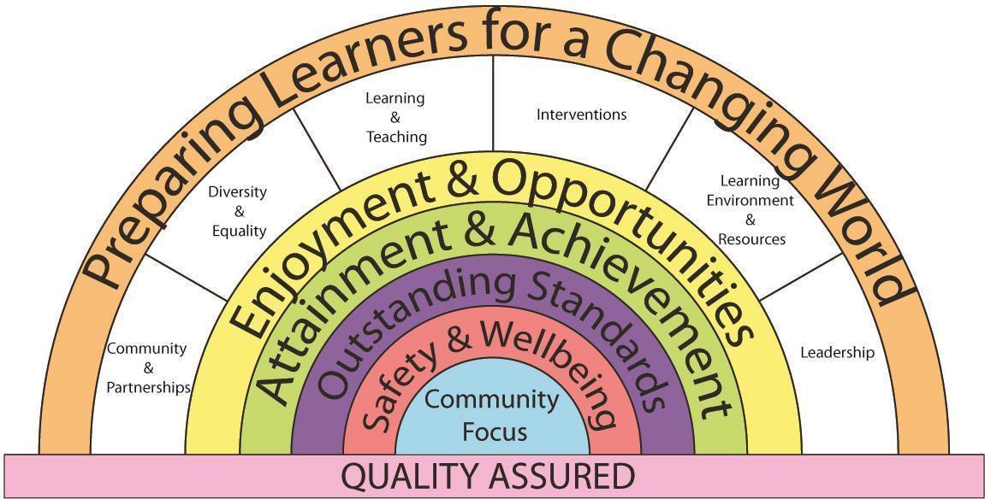

We have expressed our core values as a set of key principles which we use as our touchstones in designing our curriculum and in assessing its success and relevance to the needs of our learners.

Key Principles
The Curriculum at HCCS
1. Is about the development of the whole individual.
2. Ensures equality of opportunity in learning.
3. Provides personalised pathways and ways of learning.
4. Inspires drive, passion and commitment.
5. Promotes high standards, success and achievement.
6. Embodies responsibilities, entitlements, Safety & Wellbeing.
7. Develops respect, tolerance and courtesy.
8. Reflects the learners place in their communities.

The school serves a socially mixed, although generally prosperous rural community centered on the village of Holmes Chapel in Cheshire.
Currently numbers on roll are 1286, including 246 in the Sixth Form. Our intake in September 2016 was 195 students. We have around 82 teaching staff, including myself as Executive Head teacher.
We occupy an attractive site overlooking open countryside but close to modern, private housing estates and with easy access to the M6 at Junction 18. We have just completed building our new Sixth Form and Arts block with purpose built Theatre and our new 3G. AstroTurf pitch.

There are four super faculties within our school including:
iSTEM comprised of ICT, Science, Design & Technology and Mathematics.
Linguistics comprised of English and Modern Foreign Languages.
Performance Studies comprised of Arts and Physical Education.
Human Studies comprised of Humanities and Social Sciences

The Learning Support Team operates across all super faculties and subjects.

Teaching groups change as students’ progress through the school. In Humanities, all students are taught in mixed-ability groupings.

Year 7
Teaching groups are mixed-ability except in Maths, where students are set on entry, and
Modern Foreign Languages, which are set in February of Year 7.

Year 8 & 9
Teaching groups are set by ability in Science.

Years 10 & 11
Our curriculum consists of a core of Maths, English, Science and PE, together with options which are designed the meet the needs of our learners and which are tailored to provide maximum student satisfaction levels and a range of progression pathways.
In our Sixth Form College we offer a broad set of pathways made up from a choice of 30
Advanced Level subjects.

Learning Support is tailored towards the needs of individuals throughout the school including the sixth form and is very successful in doing so.

The school was awarded the Inclusion Quality Mark and OFSTED commented that at Holmes Chapel Comprehensive “Care, guidance and support are outstanding”. We are very proud of our support framework which everyone in our school community is committed to and lives by. Care and support for our students is provided by the Student Services Team and delivered across the whole school through our highly effective House System.

I hope it is clear from the skills and competencies required what will be expected from the successful candidate and what qualities we will be looking for in the applications and selection process. In applying for the post please write a separate, succinct (no more than 2 sides of A4) letter of application in which you address the skills and competencies required and also describe your teaching philosophy and style.

If you would like to discuss the position in advance, please feel free to contact the school and ask to speak to Sarah Bradney, HR Manager. The deadline for the closing date is Tuesday, 12th November, 4pm.

I look forward to reading your application and welcoming a creative, energetic and inspirational teacher to our school community.

Yours sincerely

D Oliver
Executive Headteacher

